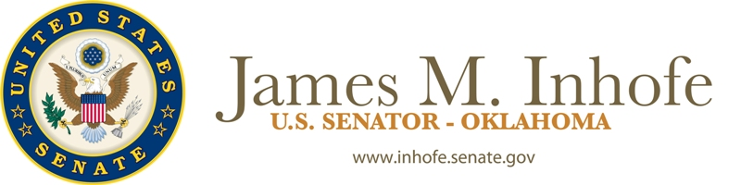

Biography of U.S. Senator James Inhofe (R)

As a member of the Oklahoma House of Representatives, minority leader of the Oklahoma Senate, mayor of Tulsa, congressman from Oklahoma’s First Congressional District, to his present role as Oklahoma’s senior U.S. Senator, Jim has served Oklahomans with pride and honor. Simply put, no one consistently represents common sense, conservative Oklahoma values more than Jim.

Jim considers one of his unique qualifications for office to be the 30 years he’s spent in the business community being over regulated by the federal bureaucracy. Throughout his political career, Jim has been a strong advocate for the principles of limited government, individual liberty, and personal responsibility. He believes that the federal government works best when it returns dollars, decisions, and freedom to our local communities and families.

During his tenure in Congress, Jim has forged a distinguished legislative record on a diverse range of issues: surface transportation and highway funding; environmental regulation and land management; strengthening and supporting America’s national defense; rural education funding; and improving America’s energy independence. In addition, Jim has sponsored legislation to reduce taxes and reform the tax code; reign in out of control federal bureaucracies; promote fiscal responsibility; and reform the way Congress works.

As chairman of the Environment and Public Works Committee, Jim played a key role in passage of the 2005 Highway Bill, shepherding the important legislation through the U.S. Senate. By doing so, he ended Oklahoma’s status as a ‘donor state’ as Oklahoma now receives more money than it sends to Washington in federal highway funding. This historic legislation also lessened the federal bureaucracy over highway trust funds by returning the decision-making process back to the states. Jim has also been a champion for restoring common sense and sound science to important environmental and regulatory issues like clean air mandates, wetlands, and endangered species.

From his post as the second ranking member of the Senate Armed Services Committee, Jim has gained a reputation as an expert on defense and national security issues. Not only is Jim a strong supporter of Oklahoma’s defense industry and military community, he has also been a tireless advocate for providing greater resources, the necessary equipment, and proper training to our military personnel fighting the War on Terror and combating global threats to our nation’s security. Jim has been to Iraq and Afghanistan as much as any other member of Congress since the beginning of the War on Terror.

Jim is a reform-minded leader whose efforts to change the House of Representatives’ arcane discharge petition rule brought him national attention and praise. The rule change eliminated much of the secrecy in the legislative process and prevented Congressional leaders from keeping popular bills bottled up in committee. Jim has taken that same approach to shine light on the workings of the United States Senate, by sponsoring legislation to end a Senator’s ability to anonymously and indefinitely obstruct the Senate’s consideration of nominations and legislation.

Jim was recently voted the “Most Outstanding Conservative U.S. Senator” by Human Events Newspaper and the American Conservative Union. He repeatedly receives various awards and recognitions, including the “Lifetime Service Award” from the Oklahoma Independent Petroleum Association, the National Taxpayers Association’s “Friends of the Taxpayer” Award, the “Hero of the Taxpayer Award” from Americans for Tax Reform, the American Farm Bureau’s “Friend of the Farm Bureau” Award, the Center for Security Policy’s “Keeper of the Flame” Award, the U.S. Chamber of Commerce’s “Spirit of Enterprise” Award, and an “A+” rating from the National Rifle Association.

Jim is a lifelong Oklahoman who grew up in Tulsa and graduated from the University of Tulsa with a degree in economics. He served in the U.S. Army and has been a small businessman working in aviation, real estate, and insurance for over 30 years. He was elected to the United States Senate in 1994 to complete the unexpired term of Senator David Boren, who resigned to become president of the University of Oklahoma. Jim was re-elected in 1996 and again in 2002.

Inhofe has been married 48 years to his wife, Kay, and has four grown children and twelve grandchildren. During his service in Washington, he commutes back home to Oklahoma almost every weekend.

###

