
Go Local–Ohio Southeast
Browse for local services and providers across Southeast Ohio.
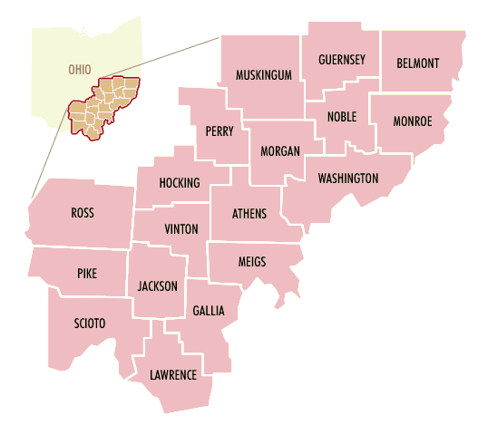
Are you …
looking for a medical specialist in your area?
curious to find out more about your medical condition?

Then…
Go Local – Ohio Southeast http://medlineplus.gov/ose

Find information about…  hospitals  clinics  medical specialists  support groups  and more local health services… | Questions? Comments?  Debi Orr  Health Sciences Library  Alden Library  Ohio University  Athens, OH 45701  (740) 593-2680  HealthInfo@ohio.edu
Go to http://medlineplus.gov for information about…
a wide variety of medical concerns:
diabetes
cardiovascular care
cancer
obesity
and many many more!

