Learn About Your Health
Find the health information you need on
MedlinePlus. Learn about diseases, drugs, research, and other important health issues. Read health information in your native language.
http://medlineplus.gov

Use What You Learn
Everyone can use good health information. With MedlinePlus, you can:
- Help a friend or family member make a health decision
- Learn more about treatment options for many health conditions
- Know what questions to ask your doctor
- Find doctors, dentists, and hospitals in your area!

Need Help?
Librarians can help you find the health information you need so you know the right questions to ask your doctor and make good decisions. Visit your local public library, call the NN/LM office toll-free at 800-338-7657 or visit the web site at
http://nnlm.gov


About MedlinePlus
MedlinePlus is a web site that offers free, high quality health information in English, Spanish, and more than 40 other languages. Trained professionals choose materials that are current, accurate, and reliable.
MedlinePlus was created for consumers by the National Library of Medicine.


This brochure was developed by NN/LM staff; it may be freely reproduced from the Internet at:
http://nnlm.gov/training/resources/mptri.pdf
Updated: June 2008
http://medlineplus.gov

Have you or a family member ever been in a situation like this?

Maria’s doctor told her she has diabetes. She wants to find out more about the medications to help her manage her disease.



Julian hurt his knee while mountain biking. He wants to know his options including arthroscopic surgery and other treatments.

Clara has to do a school assignment about the causes of asthma and how to treat it.

What You Can Find

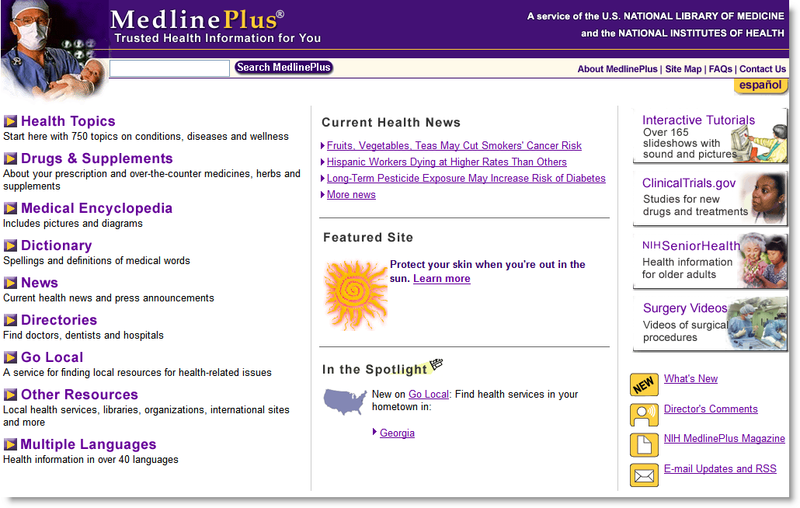
Health Topics
Get information about diseases, health conditions, and staying well.
- Find out what a disease does to your body and how to treat it.
- Learn about clinical studies that you can join to help find a cure.
- Locate organizations that sponsor support groups and information about a particular disease or condition.
- New! Find health information in more than 40 languages on many health topics.

Drugs and Supplements
Find out about your prescription, over-the-counter medicines, herbs, and supplements.
- Learn how to take a drug and what it does to your body.
- Find out about the side effects of a drug.
- Find information about safety and effectiveness of herbs and supplements.

News
Read the latest news about research that affects your health.
- Covers many health topics like cancer, high blood pressure, and vitamins.
- New articles are added every day, and stories are available for up to 90 days.

MedlinePlus Homepage: http://medlineplus.gov

Special Features
Interactive Tutorials are slideshows that tell you about a health condition or medical test.

Easy-to-Read pages use plain language to help you understand diseases and conditions.

Email Announcement Lists alert you when new topics are added to the web site.

Medical Encyclopedia
Perfect for doing homework for school! The encyclopedia has pictures and diagrams to help you understand medical words, tests and procedures.
Important!
Be sure to talk to your doctor or nurse if you have questions about your health!

