NIFC News | National Interagency Fire Center  3833 S. Development Ave.  Boise, ID 83705  http://www.nifc.gov
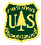
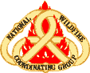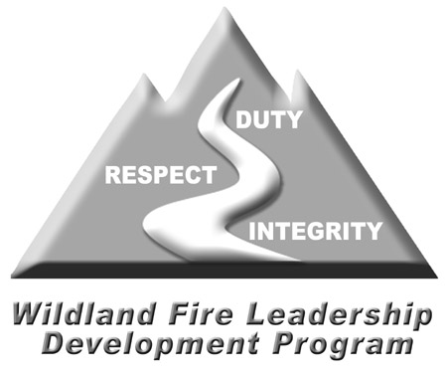
www.fireleadership.gov
For more information, call:
Jennifer Smith, 208.387.5456
John Wood, 530.226.2723

April 20, 2009
For Immediate Release

WILDLAND FIRE AGENCIES ANNOUNCE 2008 LEADERSHIP AWARDS

Boise, Idaho – Six individuals from the wildland fire service were chosen to receive the sixth national Paul Gleason Lead by Example Award. The recipients were selected for demonstrating valued leadership traits during or in support of wildland fire operations.
The annual award was created to honor Paul Gleason, a wildland firefighter whose career spanned several decades before he succumbed to cancer in 2003. Gleason is best known for developing the LCES (Lookout, Communication, Escape Routes, Safety Zones) concept that became the foundation of wildland firefighter safety. Throughout his career, Gleason led and mentored firefighters, studied and taught wildland fire, and worked to improve firefighter safety. The awards highlight Gleason’s influence on and contribution to wildland fire management, while honoring those who demonstrate the spirit of leadership for which he was known.
The award is sponsored by the Wildland Fire Leadership Development Committee under the National Wildfire Coordinating Group, an interagency, intergovernmental group that works to improve policy, standards, and safety in wildland and prescribed fire management. The Gleason Award is based on three categories: motivation and vision; mentoring and teamwork; and innovation or initiative. Individuals and groups from federal, state, local and tribal agencies are eligible for the award.
--- More ---

Award Recipients for 2008

MOTIVATION & VISION

Rich Dolphin
Lincoln NF/Smokey Bear RD
Smokey Bear IHC
901 Mecham Drive
Ruidoso, NM 88345

Rich Dolphin’s dedication and perseverance created lasting changes to the fire organization at local and national levels. Dolphin’s actions speak volumes as a leader at many levels—serving as Superintendent of a highly proficient Interagency Hotshot Crew (IHC) in Region 3; serving as the Chair of the National Interagency Hotshot Crew Steering Committee; developing a national standard for IHC crew vehicles and Type 6 engines; developing a national standard for the upgraded IHC Squad Leader position description; continual support of the Wildland Fire Leadership Development Program; as a participant in the foundational doctrine initiative; and commitment to assisting local municipal/volunteer fire programs and interagency cooperators.

Bequi Livingston
USFS – Southwestern Region 3
333 Broadway Boulevard SE
Albuquerque, NM 87102

Bequi Livingston was involved with improving surroundings in the wildland fire service during a 30-year involvement. She was awarded this honor because of her work with the Dude Fire Staff Ride and development of the FireFit program. The Fire Fit program offers a comprehensive national fitness program to improve firefighter safety and health and reduce injuries. Believing that we must learn from our past, Livingston developed a website that addresses Lessons Learned through Serious Accident Investigations, Facilitated Learning Analyses, and After Action Reviews. Livingston’s passion and continued commitment to the health and safety of wildland firefighters is an inspiration.

MENTORING & TEAMWORK

Cyndie Hogg
5517 W. Panther Butte Street
Marana, AZ 85658

As a NAFRI course coordinator, Cyndie Hogg began and finished the effort to build the two senior level leadership courses for the wildland fire service, L-480 Incident Management Team Leadership and L-580 Leadership is Action. Starting with nothing but a general set of guidelines and a diverse collection of Incident Management Team (IMT) Incident Commanders and IMT Section Chiefs, Hogg helped forge these individuals into a team with a mission - the L-480/L-580 Steering Group. These individuals were from all different agencies and certainly brought their various agendas and diverging opinions into the process. She also had to balance the expectations of the NAFRI mission and the NWCG Leadership Committee. At the beginning of the process there were many "nay sayers" in the wildland fire service regarding the need for leadership development opportunities in general, and especially for those who had been around long enough to qualify at the Type 1 or 2 IMT level. Now in 2008, only five years later, there are two very high quality leadership programs for our senior leaders. Through your perseverance and quiet leadership, you have guided the Steering Group into the role of being advocates for these programs.

Gary Hawkins
USFS – Land Between the Lakes NRA
100 Van Morgan Drive
Golden Pond, KY 42211

The most noticeable aspect of Gary Hawkins nomination was the passion at which his fellow workers speak of his career and values. Anyone that can foster that level of enthusiasm must possess a superb talent for teaching and leadership. The ability to serve as a respected role model to other firefighters, while remaining humble and willing to help others learn, is not any easy task. Hawkins found a way to display these values to co-workers and still educate them with your knowledge and experience. As a mentor, Hawkins passed experiences and work ethic on to peers and younger firefighters. He should not only be commended for the level of integrity exhibited throughout his career, but also the ability to pay it forward to the next generation of wildland firefighter.

John “JP” Harris
727 Bel Air Drive
Vista, CA 92084

In a long and distinguished career, JP Harris demonstrated commendable leadership, motivation, and vision in a wide array of activities related to fire suppression tactics and firefighter safety. Even after retiring from the Los Angeles County Fire Department with 38 years of service, he continued to make significant expertise available to the fire community as a whole through participation in training course development and presentations, safety seminars, and wildfire staff rides, often done without compensation. Harris took a special interest in new fire academy recruits and, with the information provided, strives to mentor and develop a solid foundation of understanding about firefighter safety and effectiveness.

INNITIATIVE & INNOVATION

James D. Barnier
Wisconsin Division of Forestry
1242 River Road
Wisconsin Dells, WI 53965

James Barnier developed an innovative system to generate a new set of behavioral indicators using existing weather data sources as well as educated the field in learning to interpret this new system. As part of this effort, he also oversaw the development of a website that facilitates the quick and easy access to such information in an easy-to-understand format. This has not only been helpful to Barnier’s home agency, but also serves as an important link with other agencies in Wisconsin, forming the basis for an increasing level of communication and understanding with them.

###

