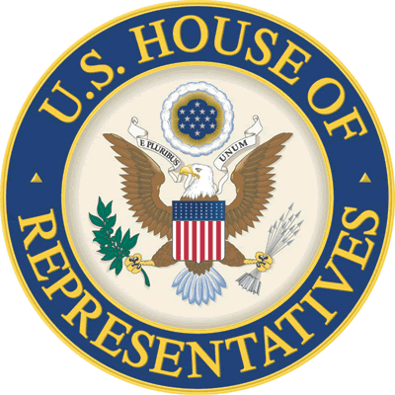 | office of  congressman Paul C. broun  10th District of Georgia  3706 Atlanta Highway, Suite 3B  Athens, Georgia 30606  (706) 549-9588 Office  (706) 549-9590 Fax
privacy act release

Contact Information: Please provide your mailing address. If either your physical or mailing address is located outside the 10th Congressional District of Georgia, please explain in your statement below.

PREFERRED TITLE: MR. MS. MRS. DR. OTHER: __________________________________________________

NAME: ____________________________________________________________________________________________________________________________________________________________________________

ADDRESS: _________________________________________________________________________________________________________________ COUNTY: ____________________________________________

CITY: ________________________________________________________________________________ STATE: __________________ _____________________ ZIP: _______________________________________

DAYTIME PHONE: _________________________________________________________ ________ MOBILE PHONE: __________________________________________________________________________

FAX: _________________________________________________________________________________ E-MAIL: ___________________________________________________________________________________

Alternate Contact: If you would like to authorize another person to communicate with us in reference to your case, you must state his or her name and phone number. If an attorney represents you, please note here.

ALTERNATE CONTACT PERSON(S): ____________________________________________________________________________________________________________________________________________

Identification: Not all the following identification pertains to your concerns. Please provide your social security number, date of birth and any other identification relevant to your case.

SOCIAL SECURITY NUMBER: ________________________________________ DATE OF BIRTH: _____________________________________________________

VA FILE NUMBER: ________________________________________________ CLAIM NUMBER(S): ____________________________________________________

USCIS RECEIPT NUMBER: ___________________________________________ OTHER: ______________________________________________________________

Federal Agency: Please specify which branch of the United States Government is involved in your particular case.

AGENCY OR DEPARTMENT: ____________________________________________________________________________________________________________________________________________________

Your Statement: Below or in an attached letter, please provide a statement regarding the nature of your problem and the assistance you need from this office. Please attach copies of any documents important to your case.

STATEMENT: _____________________________________________________________________________________________________________________________________________________________________
_______________________________________________________________________________________________________________________________________

_______________________________________________________________________________________________________________________________________

_______________________________________________________________________________________________________________________________________

_______________________________________________________________________________________________________________________________________

_______________________________________________________________________________________________________________________________________

_______________________________________________________________________________________________________________________________________

_______________________________________________________________________________________________________________________________________

_______________________________________________________________________________________________________________________________________

Pursuant to the requirements of the Privacy Act, PL 93-579, I hereby authorize Congressman Paul Broun and his staff to access my records

And I respectfully request their assistance in resolving my case.

SIGNATURE: ___________________________________________________________________ DATE: _________________________________________________

