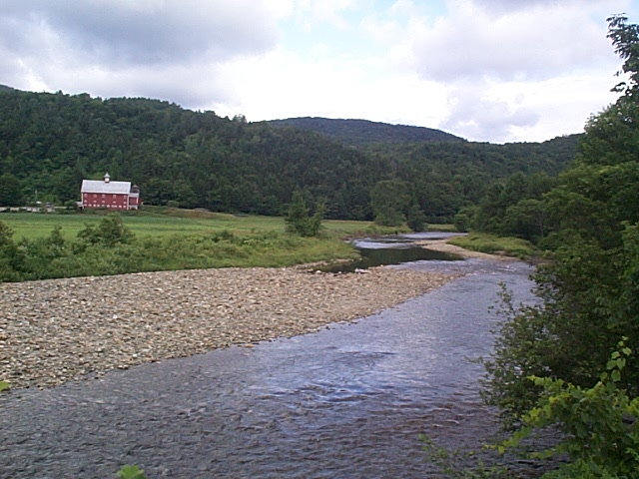
The White River Partnership

Our Goals
- Locally Led Watershed Assessment: We are engaging local citizens in identifying priority areas for restoration activities.
- Stream Corridor Restoration: We are using natural channel design to restore stream function and process.
- Outreach and Education: We are working with partner organizations to develop school programs.
- Economic Sustainability through the Community Collaborative: We are developing an informational map to link businesses and educate citizens and visitors.
- Capacity Building: We want to build a long lasting, independent organization that facilitates communication between government agencies and their citizens.

White River Watershed
MISSION
Helping local communities balance the long-term cultural, economic and environmental health of the White River watershed through active citizen participation.

Montpelier
The White River, located in Central Vermont, has its headwaters in the Green Mountains. It flows southeasterly in to the Connecticut River and provides critical habitat for Atlantic salmon restoration.

Restoration Action in our First Year

- Business Plan;
- Green Up (river cleanup) event on Third Branch;
- Created the “DownStream” stream team;
- “River Days” educational event at the Rochester School;
- Over 100 school children helped planted trees along the river;
- Developed water quality monitoring protocol for use in the schools;
- Created the Forestry Work group;
- Published two newsletters;
- Preliminary membership campaign;
- Developed by-laws and an incorporated non-profit;
- Restored one mile of river; and
- Planted one half mile of trees along the river.

Funding – Total Funding = $570,000

The Partners
Private citizens, Vermont Institute of Natural Science (VINS), Vermont Agency of Natural Resources, Two Rivers Ottaquechee Regional Planning Commission, National Wildlife Federation, Trout Unlimited, USDA Forest Service: Washington Office, Green Mountain National Forest & State and Private Forestry, Silvio Conte National Wildlife Refuge, US Fish and Wildlife Service, George D. Aiken Resource Conservation and Development, Natural Resource Conservation Service

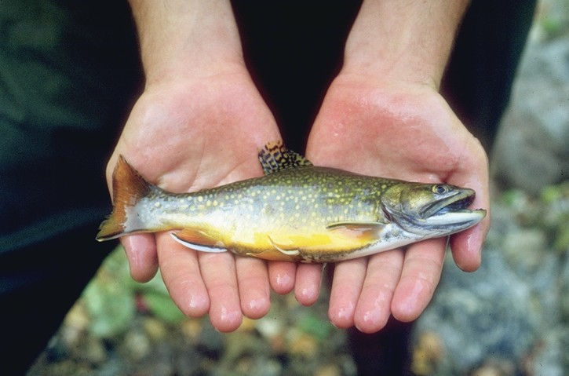

For more information contact: Amy Sheldon, (802) 767-4261 ext. 519 or wrpamy@together.net and Steve Roy, (802) 747-6739 or sroy@fs.fed.us

