Pacific Coast
Watershed Partnership
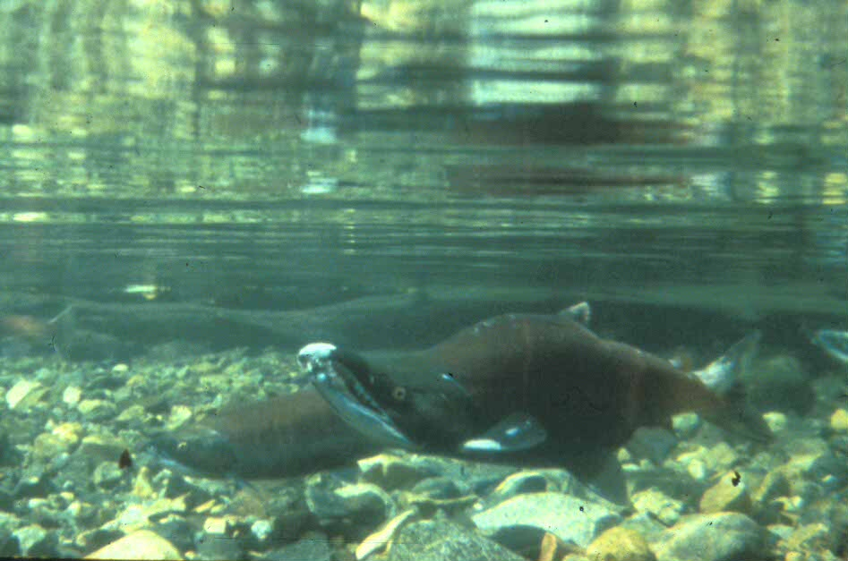
Located in the coastal watersheds and estuaries of western Oregon and Washington, the Pacific Coast Watershed Partnership is trying to save wild salmon and the international flyway of migratory birds. We are linking key estuaries, wetlands and uplands to restore the habitat necessary for their survival.
ability of natural resources to sustain those activities. Every Oregon Congressional district and 80% of Washington’s are within the area enhanced by the partnership. Most of the watersheds are in public ownership. Within them lie potentially productive estuaries, broad flat valley bottom streams, and flood plains that are in private ownership. Restoring these watersheds can only happen when we work together to bridge science and practical applications.

Restoration efforts are designed to recover and protect salmon and other aquatic species, migratory birds, and water quality to contribute to the livable environment that has been the hallmark of the Pacific Northwest. Over 23 federal, state, and private partners are working together to demonstrate visible and measurable results.
The future of the Pacific Coast is one where people and their activities, livelihoods, and communities are in balance with the

Vision of the Future
- Healthy and diverse salmon populations - premier-fishing opportunities
- Rivers run clear and cold and support people and wildlife
- We live in balance with ecosystem potential

- Livability ranking - highest in the nation
- Highly sought eco-tourism destination
- Waterfowl and wildlife abound

Restoration Action in our First Year
- Leveraged funds with Ducks Unlimited and other partners at a 10 to 1 ratio ($855,000 to $9,872,000)
- Restored 6720 acres of key wetlands, estuaries, riparian areas and upland habitats
- Strategically planned restoration for phase 1 areas (includes the Siuslaw and Coquille Rivers, and lower Columbia estuary. Phase 2 includes coastal Washington and Puget Sound
- Orchestrated strategic restoration and partnered efforts through completed business plan
Restoration over the next decade

- Restore 20,000 acres of wetlands, 45,000 acres of riparian habitat, 3,000 miles of streams, 15,000 miles of roads, 300,000 acres of upland habitat
- Improve livability in the Northwest
- Recover internationally acclaimed and imperiled fish, such as the salmon
- Create and protect an intact migratory bird flyway
- Improve water quality
- Enhance biodiversity
- Involve others in restoration choices

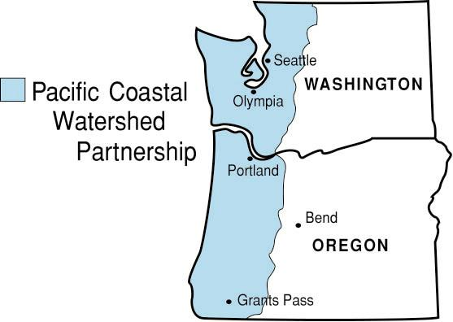

Why Partner for Restoration Action?
There is power in working together. Not only can we mutually help each other achieve restoration goals, we can save money and share skills, staff, and time. We are working on an ecological jewel of the nation that also has international significance – and so we need to do business smarter, and capitalize on restoration opportunities and restoration innovations.

Focused restoration action requires a commitment to action itself. Where we have agreement, we can restore watersheds ridge to ridge. We can see tangible results in water quality and recovered fish and bird populations that define a quality of life. What would the Pacific Northwest be without pure water, salmon, and abundant wildlife?

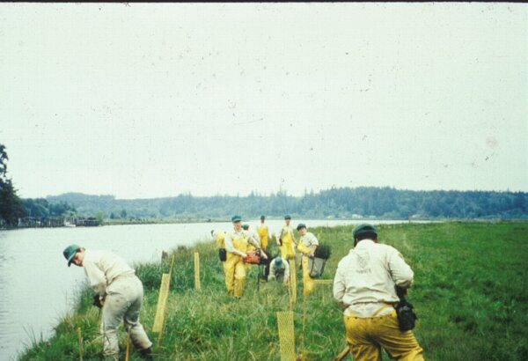
Working as a team, we anticipate developing innovative restoration techniques, building active collaborative relationships, and improving salmon runs through the protection of healthy watersheds and the restoration of degraded areas.

Partners restore riparian vegetation

Strengths of the Pacific Coast Watershed Partnership
- Targets priority areas using the latest science
- Protects and restores natural processes
- Leverages funds to accomplish more than any single entity can

- Restores whole watersheds
- Focuses action on critical areas
- Promotes sustainable community land use
- Uses existing forums, doesn’t create a new bureaucracy

*Partners to date: Bureau of Land Management, Local landowners, USDA Forest Service, Ducks Unlimited, Inc., State of Oregon, Siuslaw Watershed Council, State of Washington, Soil and Water Conservation Districts, Coquille Watershed Council, Dungeness River Management Team, Natural Resources Conservation Service, Farm Service Agency, Sport Fisherman, Skagit Watershed Council, USDI Fish and Wildlife Service, USDC National Marine Fisheries Service, Bonneville Power Administration, Audubon Society, Native American Tribes, OR Department of Environmental Quality, Environmental Protection Agency, Pacific Coast Joint Venture
For more information contact: Project Coordinators Robert Alvarado, 503-808-2901, ralvarado@fs.fed.us or Jeff Uebel, 503-808-2847, ruebel@fs.fed.us.

