
New York City Watershed Study

The Catskill, Delaware, and Croton Watersheds in New York State provide high quality, unfiltered water to over 9 million people. Privately owned forests make up the majority of these watersheds and are of paramount importance to the integrity of the watershed and the long-term stewardship of this water supply. People have also lived and worked in the watershed for generations in farming and natural resource industries. The USDA Forest Service has been working with a variety of partners since 1994, to implement a comprehensive watershed forestry program aimed at finding a balance between watershed protection and economic viability. The New York City Watershed Filtration Technology Study adds a new research dimension to this ongoing effort. The goal of the study is to develop a technology that could significantly reduce municipal water treatment costs. Preliminary results from research at the Forest Products Laboratory (FPL) have shown that filters made from wood and agricultural fibers can remove significant amounts of heavy metals, oils, phosphates, and pesticides from water. The efficiency of the filters can be improved by simple chemical modification of the fiber. For example, oxidation of Douglas-fir fiber with nitric acid has greatly improved the fiber’s ability to remove heavy metals.
MISSION
- Improve economic viability of forestlands
- Improve the economic viability of the forest products industry
- Benefit local communities
- Protect water quality
- Enhance sustainable forest management.

The Partners:

USDA Forest Service, Forest Products Laboratory, and Northeastern Area State and Private Forestry, Environmental Protection Agency, U.S. Geological Survey, NYC Watershed Agricultural Council, Watershed Forestry Program, NYC Department of Environmental Protection, University of Wisconsin–Madison, Cornell University, Ècole Polytechnique Federale de Lausanne, Catskill Watershed Corporation, Cranberry Institute, Watershed Agricultural Council, Odbek Industries, Inc.

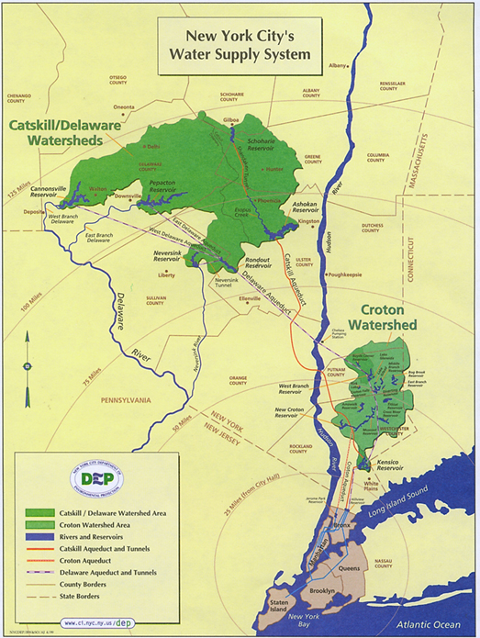

Restoring our Drinking Water-Restoration Research
Researchers are asking whether simple, safe, environmental filters such as wood can remove toxins from our water supply. How effective will these filters be, and can they be efficient and economical enough to do the job well?
This study will improve technologies currently being used to filter municipal water sources and storm water discharges.

Restoration Outcomes
The production of wood fiber filters could also help to diversify local economies by providing a local industry that could offer jobs while making use of non-merchantable forest products and waste materials. Results to date indicate that the filtering system has a 30% to 40% level of efficiency in reducing soluble heavy metals and phosphorus. The capacity of wood fibers to remove pollutants will improve with new techniques for chemically modifying the fibers.

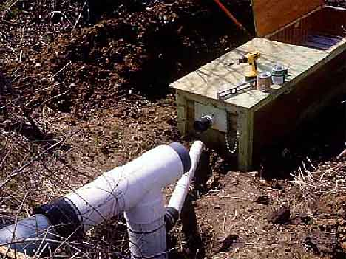

Funding
The USDA Forest Service funded $203,647 of this project. Partner contributions totaled $86,300, for total revenue of $289,947.
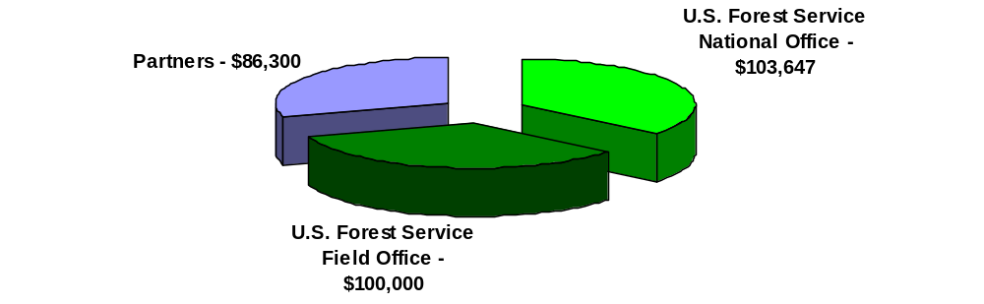

This technology is nested in an ongoing New York City watershed restoration project of about $3M of which $800,000 is provided by Northeastern Area State and Private Forestry. These Funds have supported technical assistance to private forest landowners for Watershed Forestry Plans, establishment of educational programs through four “Model Forest”, implementation of a riparian forest buffer restoration program, and projects to support the diversification of the local natural resource economy. In addition, the Northeastern Area staffs a full-time Liaison to the Watershed Agricultural Council.

For more information contact: James Han, 608-231-9423 or jhan@fs.fed.us

