Chattooga River
Watershed

Located in the states of Georgia, North Carolina, and South Carolina, the Chattooga River Watershed project builds on exisiting research and relationships developed by the Chattooga River Ecosystem Management Demonstration Project in 1993-95. That project determined sedimentation sources, fecal pollution, impacts from reductions in harvesting, and changes in forest types were of primary concern in the watershed.

This 180,000-acre watershed is comprised of 122,000 acres of National Forest System lands, includes the Chattooga Wild and Scenic River, the Ellicott Rock Wilderness Area, the Overflow Wilderness Study Area, and the Blue Valley Experimental Forest.
It ranges in elevation from 880 to 4880 feet, has an annual rainfall of 80 inches, includes over 3000 miles of streams and 500 miles of roads, and is readily accessible to over 25,000,000 people.

MISSION
To maintain and restore high quality water and aquatic habitats through the relocation and improvement of recreation facilities, roads, trails, and conservation education

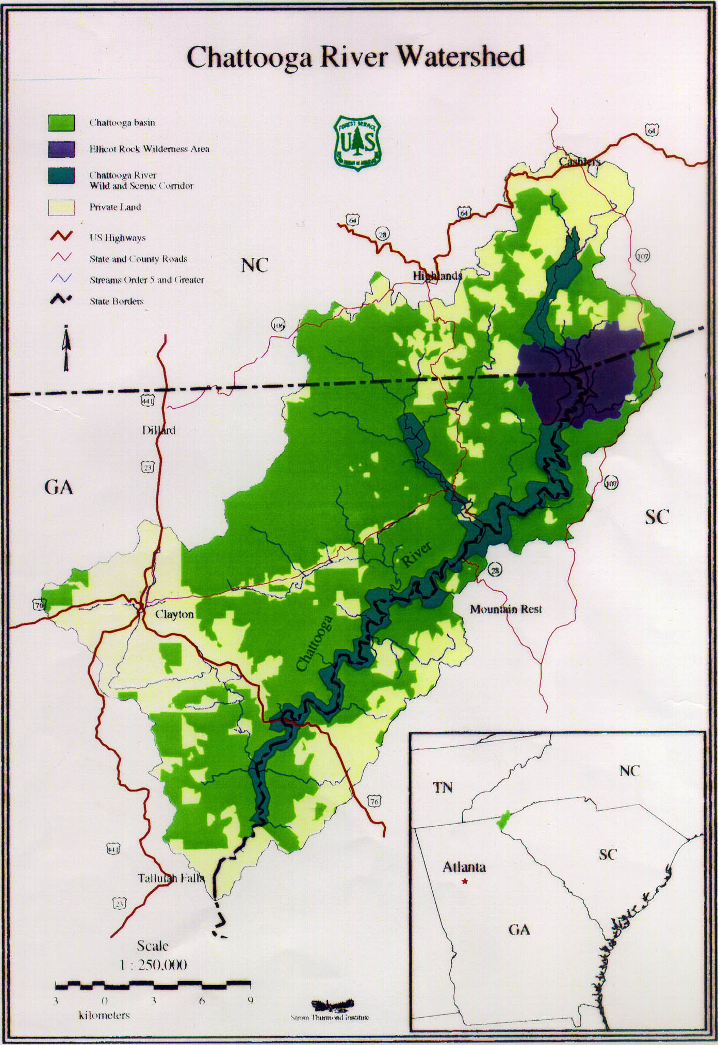
Our goals

The strength of this project depends on achieving the measurable positive outcomes that we have established as our goals. Research efforts funded by and involved in this project will provide information to assist in quantifying actual benefits to our customers. As this project matures, this information will serve future managers in this watershed and in other areas to help make sound investments in restoration.

The Challenges
The issues identified with this project include the current condition of the watershed, risk of increased degredation of the water quality, and the long term health of the river and watershed. In addition to ‘on the ground’ conditions, the other issues identified include the management of the area under three forest plans, three state governments, and the percentage of private land ownership.

Restoration Action in our First Year
In March 2000, the first project was completed. This project was a stream-bank stabilization project initiated on the West Fork of the Chattooga River. Funds from the watershed project were utilized to supplement a grant received through the National Fish and Wildlife Foundation to complete this effort. Other accomplishments this first year include the following, which summarize completed or contracted work for completion this year:

- Conservation Fund purchased and transferred to Forest Service 225 acres (1 mile of stream both sides along West Fork Chattooga Wild and Scenic River)
- Maintained and rehabilitated 42.5 miles of trail
- Maintained and rehabilitated 132.9 miles of road
- Rehabilitated 20 recreation sites
- Completed 50 soil and water projects
- Surveyed 26.8 miles of stream for inventory
Funding
National Forest funds totaled $2,500,000 in Fiscal Year 2000. Contributions to date from partners are shown at left and total $3,553,200. Conservation Fund purchace and addition to wild river was $3.3 million

Our partners
Key partners for this project include: the States of Georgia, North Carolina, and South Carolina; Rabun County, Ga., Oconee County, S.C., and Macon and Jackson Counties, N.C.; Tallulah R.D., Chattahoochee N.F., Highlands R.D., Nantahala N.F., and Andrew Pickens R.D., Sumter N.F.; Coweeta Hydro. Lab., Center for Aquatic Technology Transfer, Clemson University, Bent Creek Experimental Forest, San Dimas Technology and Development Center, University of Georgia, University of Minnesota, Chattooga Watershed Conservancy, Western Carolina University, Environmental Protection Agency, NRCS, Oconee County Soil and Water Conservation District, the Foothills Resource Conservation And Development Council, Partners for Trout, South Carolina Department of Natural Resources, and numerous additional partners as listed in Appendix A of the Chattooga Watershed Business Plan. For more information contact: Ray Johnston (404) 347-4807, rjohnston@fs.fed.us or Tom Speaks (770) 297-3010, tspeaks@fs.fed.us

