Appendix G: Inspector General Summary of Serious
Management Challenges

Archived Information

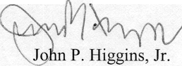

UNITED STATES DEPARTMENT OF EDUCATION
OFFICE OF INSPECTOR GENERAL
THE INSPECTOR GENERAL
MANAGEMENT CHALLENGES OF THE DEPARTMENT OF EDUCATION
FEBRUARY 2003
We are providing the management challenges for the Department of Education in accordance with the Reports Consolidation Act of 2000 (PL 106-531). More detailed information about our work is available on our website, www.ed.gov/offfices/OIG.



400 MARYLAND AVE., S.W. WASHINGTON, D.C. 20202-1510
Our mission is to ensure equal access to education and to promote educational excellence throughout the Nation.
