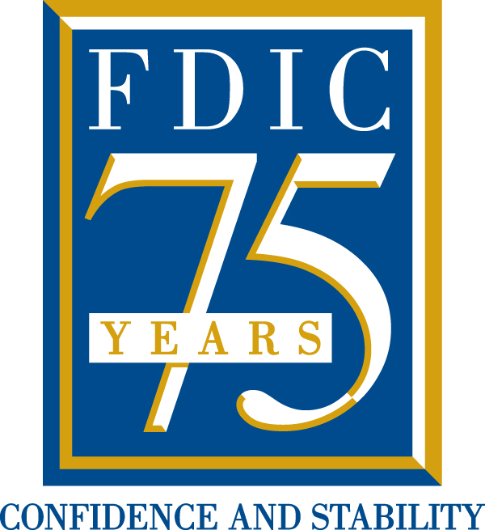


The Chairman’s Award: Nomination Form
Form due to LuReynolds@fdic.gov by October 31, 2008
Section A
Name of Nominee:
Nominee’s Current Position and Affiliation:
Nominee’s Contact Information:
 | Phone # with area code | Fax | E-mail
 | Street | City, State | Zip Code
Section B
 | Please complete Section B if you are not nominating yourself.
Your Name:
Your Position and Affiliation:
Your Contact Information:
 | Phone # with area code | Fax | E-mail
Section C
Please describe the nominee’s organization structure and the services the organization provides.
Describe why the nominee became involved in financial literacy.
Describe the ways in which the nominee reached consumers. Please be as specific as possible.

Describe how the work was innovative.

Describe the results and how the work was effective. Evidentiary support may be submitted (up to five pages).

Following the nomination, the awards committee may contact the nominee to request additional
background information (such as a résumé or vita). Additional information about this
award can be found on the FDIC Web site at http://www.FDIC.gov/anniversary. Thank you.

