Veterans Health Administration Warning System
Published by VA Central Office

July 22, 2003

Item: Soft SkinTM protective sleeve manufactured by Span America to cover Geo-Matt® seat cushions and mattresses.

Specific Incident: A patient in locked psychiatric ward used a plastic cover on a Geo-Matt® wheelchair cushion to commit suicide. The patient removed the protective sleeve/covering on the cushion and placed it over their head/face resulting in suffocation. The wheelchair seat cushion was purchased with the plastic cover in place for incontinence protection. It is worth restating that plastic trashcan liners, sleeves, wraps, dry cleaning bags, etc., present similar suffocation hazards.

Action: Within 5 business days from the date of this Patient Safety Alert:
1. If this product is present in any areas you consider to be high risk for self-harm, remove the plastic cover.
2. Remove any other plastic covers, sleeves, wraps, liners or bags that are accessible to the patient from areas classified as high risk for self-harm.

Source: VISN 15

Contact: Bryanne Patail at the National Center for Patient Safety Staff (734) 930-5890 or Bryanne.Patail@med.va.gov

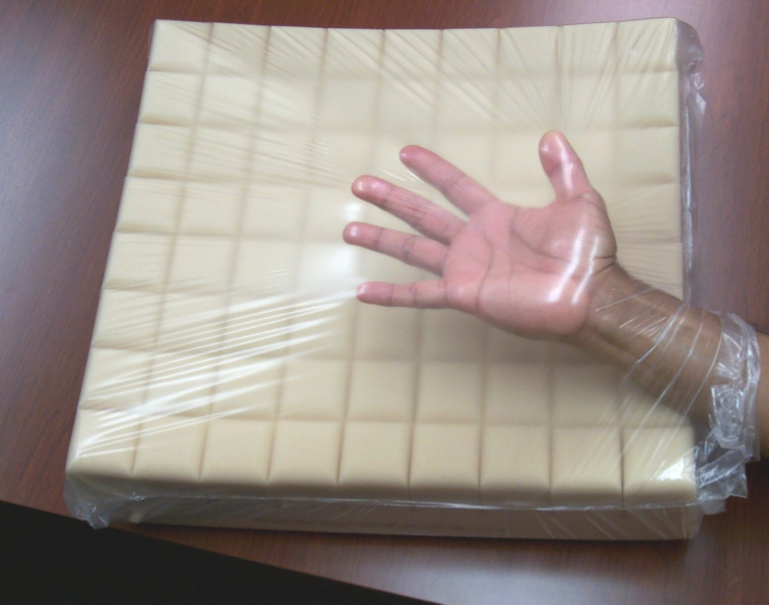
Picture of Soft SkinTM on Geo-Matt® Wheel Chair cushion.

