Veterans Health Administration Warning System
Published by VA Central Office

August 15, 2001

Item: Risperidone oral medication syringe (pipette).

General Information: Graduated markings on the risperidone syringe (pipette) that comes in the medication box are opposite of the markings on syringes we use in USA. The graduated markings, on the plunger, of the (3 ml) pipettes, start at 3 ml (on the tip end) with intervals of negative (-) 0.05 ml per division; compared to a standard (3 ml) syringe, where the markings are on the barrel, which starts at 0 cc/ml, (on the tip end) with intervals of positive (+) 0.1 ml per division. (See attached Pictures)

Specific Incident: Janssen Pharmaceutica risperidone pipettes caused a “close call”: “nurse was drawing up a dose of 0.25 mg of risperidone liquid (1mg/ml) and instead of drawing up 0.25 ml of the liquid, she drew up 2.5 ml (2.5 mg) and nearly administered to the patient”.

Suggestions: 1. Consider using oral tablets.

- For those inpatients that cannot tolerate tablets, have pharmacy prepackage unit dose liquid.

3. Advise the caregiver to use USA standard, oral syringe by replacing the pipette that comes in the box with an oral syringe (that cannot be attached to a needle or IV tubing).

4. Alert all staff that passes medication, that the devices that come in the box for, liquid risperidone are considered pipettes by the company, although would normally be thought of as syringes by our frontline users. The markings are opposite of the syringes we are used to, and they are on the plunger of the pipettes. If possible, DO NOT USE THEM.

- We are working with ISMP and the company to encourage the company to provide a new pipette that meets USA standards. Replace your liquid risperidone stock when the new pipettes come out.

Source: VISN 16

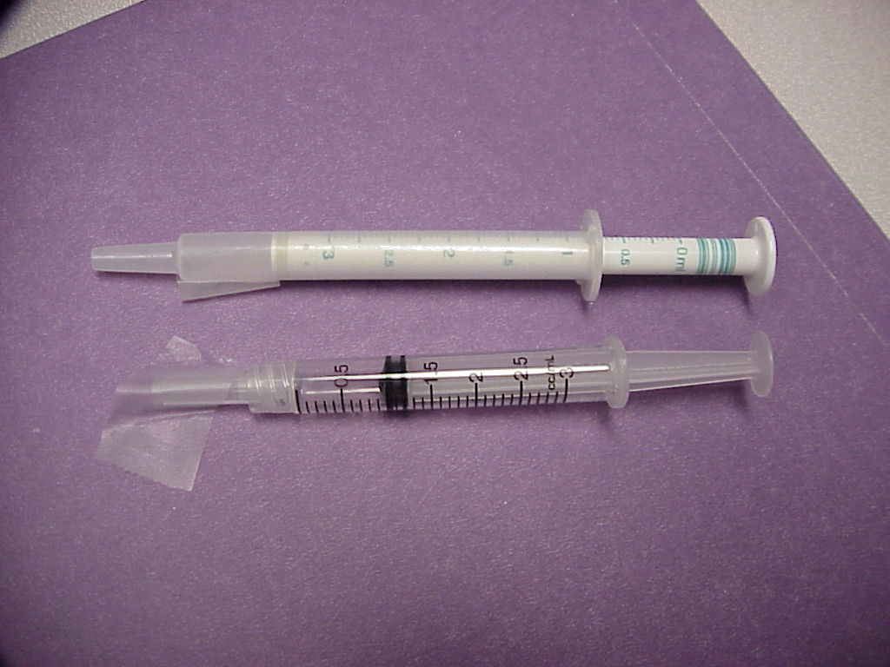

PIPETTE (DO NOT USE)

SYRINGE (FOR INJECTIONS)

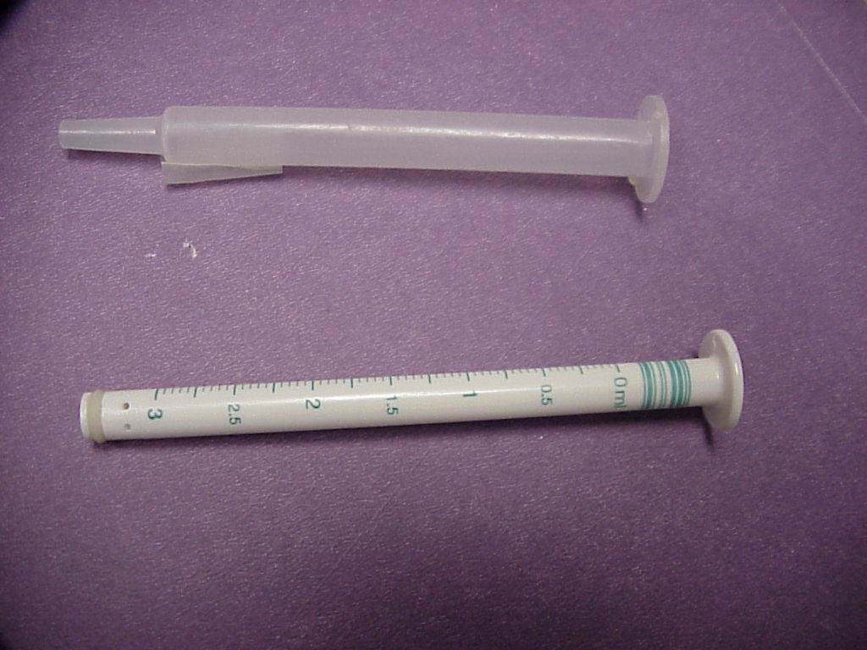

PIPETTE (DO NOT USE THESE)

THIS TYPE RECOMMENDED FOR ORAL DRUG ADMINISTRATION, SINCE IT CANNOT BE ATTACHED TO NEEDLES AND/OR IV LINES, AND THE GRADUATED MARKINGS ARE THE SAME AS SYRINGES

Contact: For additional information, please contact Bryanne Patail, at NCPS: Phone: 734 930 5890. Fax: 734 930 5877.
E-mail: Bryanne.Patail@med.va.gov

