Veterans Health Administration Warning System
Published by VA Central Office

AL05-06 February 28, 2005

Item: Louvered heating, ventilating and air conditioning (HVAC) grilles in locked Behavioral Health Units.

General Information: Louvered grilles covering HVAC openings (Photo 1) located in locked mental health units may be used as an anchor point for a noose made from clothing or other flexible material.

Specific Incident: A mental health patient in a locked Behavioral Health Unit used an article of clothing to hang from a louvered grille and the grille supported the full weight of the patient.

Action: By March 31, 2005:
1. Survey all locked Behavioral Health Units to determine if louvered grilles are present that may be used as an anchor point.
2. If louvered grilles are present in these Behavioral Health Units upgrade them by installing a woven wire cloth grille (Photo 2) or replace them with a suitable grille that cannot be used as an anchor point. Breakaway grilles should not be used as the broken parts may be used for other purposes.

Source: VISN 15

Addl Information: A grille cover such as the one shown in photo #2 may be fabricated on site by engineering service personnel. Woven wire cloth (e.g. stainless steel type 304) may be placed over the existing grille, riveted in place with the frame secured with tamper proof screws. Some manufacturers sell suicide deterrent supply grilles (e.g. Carnes Company, Models RSPA41 or RSPA42 or Anemostat Products Model SV2, http://www.anemostat.com/a-catalog/sec_sv2.htm); however others may also be available. These examples are provided for information only and are not intended to represent an endorsement of any one product.

Contact: Joe DeRosier, Program Manager, VA National Center for Patient Safety, telephone: (734) 930-5888
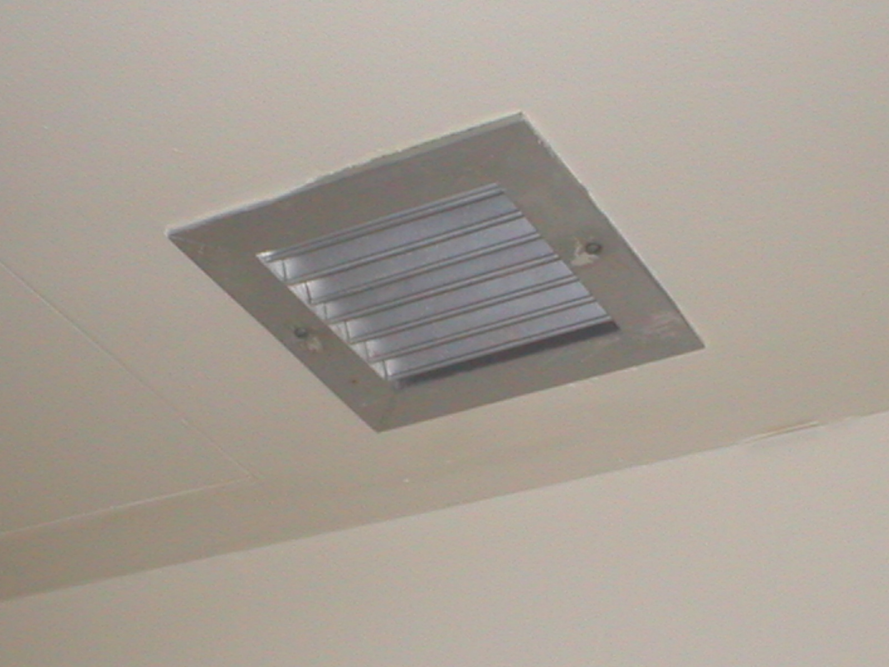 | 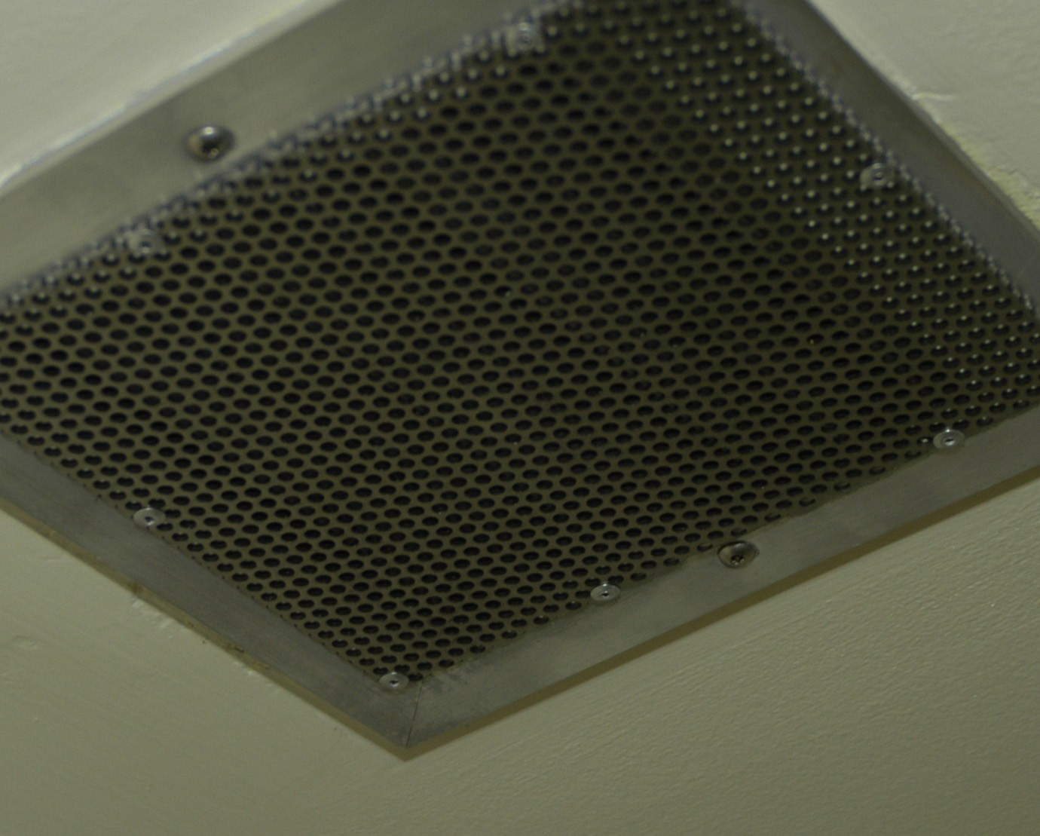
Photo 1: Louvered HVAC grille  mounted using standard slotted screws. | Photo 2: Mesh grille, fabricated  in-house, mounted with tamper  resistant screws.

