Veterans Health Administration Warning System
Published by VA Central Office

August 28, 2001

Item: Hemodialysis Catheters: Ash Split and Vaxcel

General Information: These long-term indwelling catheters may crack and/or form small blisters (blebs), if wrong disinfectants and/or cleaning solutions are used.

Specific Incident: Ash Split Model # 28 cm tip to cuff, catalog # ASPC 28: There have been 3 reported incidents with cracking of the catheter on the external portion near the hub. (See picture below). Patients presented with bleeding at catheter site, complaints of nausea, vomiting, and shortness of breath; these are indicative of possible embolism.
Cracks/holes may develop here.

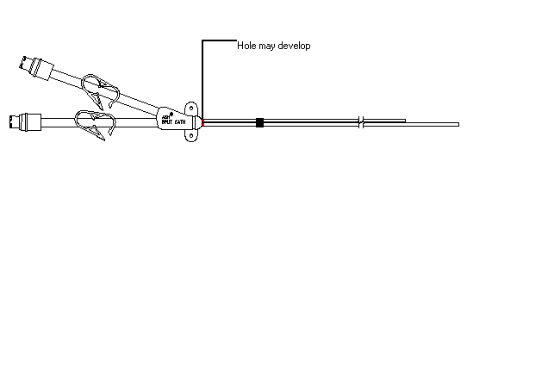

Vaxcel Model # MOO1455100, catalog # 45-510, 45-520: 3 patients were found to have small blisters (blebs) on their catheter near the hub. Which did not result in cracks or leaks. No patients suffered any complications from their catheters.

We are not exactly sure why these cracks and blisters occurred; the manufacturers suspect the type of disinfectants and/or cleaning solutions, might have caused these cracks and blisters (blebs).

Suggestions: 1. Do not use Alcohol, Acetone, Hydrogen Peroxide and other ointments, on these catheters. If these agents are not necessary in the unit, remove them from the premises.

2. Prior to insertion/installation in patients: Inspect each catheter for small blisters (blebs), cracks and defects as you remove them from the sterile packaging. If any defect is found prior to installation, stop and sequester the catheter and its packaging and call your risk manager and/or patient safety officer.

- During use site Care: a. Inspect the catheter at each patient’s visit.
b. Use only manufacturer’s recommended Iodine based antiseptic solutions.

- During use monitor patient’s symptoms: Inspect catheters, for cracks and blisters, of patients who present with complaints of nausea, vomiting and shortness of breath.

Source: VISN 1

Contact: For additional information, please contact:
Bryanne Patail, Biomedical Engineer at:
National Center for Patient Safety (NCPS).
Phone: (734) 930 5890. Fax: (734) 930 5877 E-mail: Bryanne.Patail@med.va.gov

