Veterans Health Administration Warning System
Published by VA Central Office

November 7, 2003

Item: Roche Diagnostics Corp. CoaguChek PT Test Strips
- Catalog # 3116247 (professional use)
- Catalog # 3116239 (patient self test)
- Catalog # 1937642 (packaged 48 strips per box)
- Catalog # 1937634 (packaged 12 strips per box)
Lot #s 591, 619, 600 and 583. Extended to all lots with an expiration date of on or before March 1, 2005.

General Information: FDA initiated a Class I recall (# Z-1293-03) of the Roche CoaguChek PT Test Strips on September 12 and September 29, 2003 due to a packaging defect. The defect involved the opening scoremark intruding into the sealed pouch containing the product. This defect may allow air and moisture to enter the sealed pouch causing erroneous readings when the strips are used. There were approximately 563,000 units distributed nationwide and internationally.

Actions: Inspect all CoaguChek PT test-strip foil pouches before use to verify pouch integrity, regardless of the lot number. Refer to the attached photographs to help identify defective packages.
1. If the foil pouches appear to be compromised do not use the test strips and notify Roche Diagnostics Point of Care Technical Service at (800) 428-4674 within the U.S., or visit the CoaguChek Web site at http://www.coaguchek-usa.com. To receive replacement product, fax the replacement request form to Roche Diagnostics at (800) 722-7222 within the U.S.
2. If the foil pouches appear to be intact run duplicate tests, if the test strip lot number is lower than lot 670. Duplicate test results should be within +/-1.0 international normalized ratio (INR) of each other for values less than 4.5 INR. If values are greater than +/-1.0 INR or greater than 4.5 INR, consult with the physician or pathologist at your facility.

Source: FDA, ECRI, Roche Diagnostics Corp.

Contact: Bryanne.Patail@med.va.gov Phone # (734) 930-5852

Or Roche at 1 (800) 428- 4674

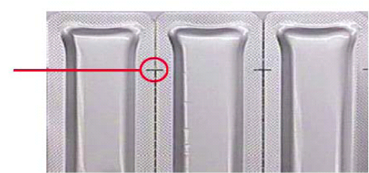
Roche Diagnostics Corp. CoaguChek PT Test Strips

CORRECT

This is an example of the backside of an acceptable pouch. Please note the correct placement of the “easy open” notch.

INCORRECT
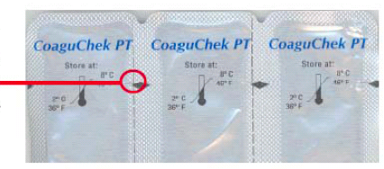

This is an example of an affected pouch. Please note the incorrect placement of the “easy open” notch. The printed diamond should not be used as an indicator of the defect.

For more information please visit this link http://www.coaguchek-usa.com/private/downloads/files/9_30updateuprcckteststrip.pdf

