TYPICAL SPENT FUEL TRANSPORTATION CASKS

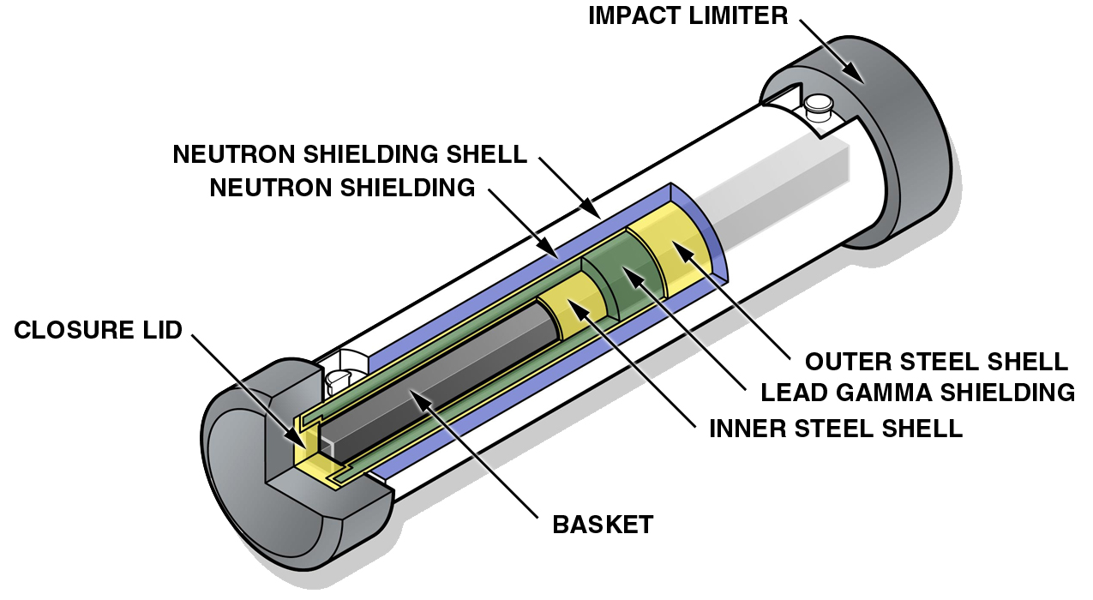

Generic Truck Cask for Spent Fuel

Typical Specifications
Gross Weight (including fuel): 50,000 pounds (25 tons)
Cask Diameter: 4 feet
Overall Diameter (including Impact Limiters): 6 feet
Overall Length (including Impact Limiters): 20 feet
Capacity: Up to 4 PWR or 9 BWR fuel assemblies

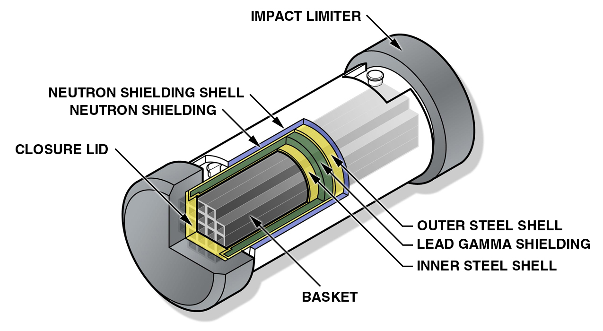

Generic Rail Cask for Spent Fuel

Typical Specifications
Gross Weight (including fuel): 250,000 pounds (125 tons)
Cask Diameter: 8 feet
Overall Diameter (including Impact Limiters): 11 feet
Overall Length (including Impact Limiters): 25 feet
Capacity: Up to 26 PWR or 61 BWR fuel assemblies

