
U.S. Department of Health and Human Services
Administration for Children and Families
Administration on Developmental Disabilities
370 L’Enfant Promenade, SW
Mail Stop: HHH 405D
Washington, DC 20447

Dear Colleague:

The U.S. Department of Health and Human Services will celebrate National Women’s Health Week on May 9-15, 2004 and its signature event, National Women’s Check-Up Day, on May 10, 2004. The celebration complements and supports our efforts to help all women including those with developmental disabilities, take advantage of important preventive health care services and furthers the President’s long-range initiative to expand health care services through local health centers for people without health insurance.

Last year, more than 1,000 events, proclamations and health screenings occurred in every state and thousands of women received preventive health information and services. The Department hopes to expand the impact of this year’s national Women’s Health Week by inviting your organization and others across the national to become National Women’s Check-Up Day providers or to host an event during the week. As a provider, you would agree to provide or encourage women in your community to make appointments for preventive health services on May 10, 2004. Services could include blood pressure checks, pap tests, mammograms, diabetes tests, HIV/AIDS tests, and other health screenings. As an event host, you would agree to host an event in your community to improve understanding and awareness of women’s health issues during May 9-15, 2004 and reduce the health disparities among women with developmental disabilities. You are encouraged to partner with other grantees or medical entities to provide support and training in the area of health for women with developmental disabilities. All providers and event hosts will be listed on the National Women’s’ Health Information Center Web site and may order free promotional and educational materials at http://www.4woman.gov/whw.

At ADD, we believe that this venture is a crucial means in which to encourage women with developmental disabilities to address their health issues. To sign up as a National Women’s Check-Up Day provider or as an event host, you may complete the appropriate form and submit no later than March 15, 2004 or visit the National Women’s Health Week Web site at http://www.4woman.gov/whw. Your organization’s ability to engage hard-to reach populations and your experience in health issues will be very important to our success.

Sincerely,
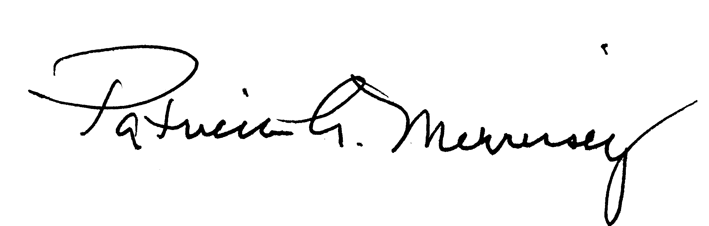
Patricia A. Morrissey, Ph.D.
Commissioner

