X. Characteristics and Financial Circumstances
of TANF Recipients
This chapter reports on the demographic characteristics and financial circumstances of families who received cash assistance and families who discontinued receiving assistance under the Temporary Assistance for Needy Families (TANF) program during the period of October 1999 – September 2000. It also includes the characteristics data of the Separate State Program – Maintenance of Effort (SSP-MOE) recipient families. This chapter is available on the Internet at http://www.acf.dhhs.gov/programs/opre/particip/index.htm#characteristics.
It is important to note that States are now spending considerable proportions of their TANF funds on various services to families who are not receiving cash assistance -- particularly those who have left or avoided cash welfare for work. These data are limited to those who received cash assistance at sometime during the observation period.
The data referenced by this document were obtained from a statistically valid sample of TANF and SSP-MOE cases within the national TANF/SSP-MOE Database. Data are presented for all States, the District of Columbia, Guam, Puerto Rico, and the Virgin Islands.
The Personal Responsibility and Work Opportunity Reconciliation Act of 1996 (PRWORA) established a new TANF program to replace the Aid to Families with Dependent Children (AFDC) program. The new welfare law also established State data reporting requirements for the TANF program. The Department of Health and Human Services (DHHS) issued final regulations implementing data reporting and other aspects of PRWORA in April 1999.
The TANF statute requires States to collect TANF data on a monthly basis and report them to DHHS on a quarterly basis. These data include disaggregated case record information on the families receiving assistance, families no longer receiving assistance, and families newly-approved for assistance from programs funded with TANF funds. Effective with the October-December 1999 quarter, all States, the District of Columbia, Guam, Puerto Rico and the Virgin Islands were required to implement the quarterly reporting requirements in the final TANF rules. The 54 States and Territories transmitted data on 8,391,790 active cases and 649,794 closed cases to the national TANF database for fiscal year (FY) 2000. Oregon transmitted its closed cases after preparing this report.
In Appendix 10:1 there are SSP-MOE recipient characteristics for 23 States who reported data on their SSP-MOE families. SSP-MOE eligible families may be quite different among the 23 States as well as within a State where there are multiple SSP-MOE programs. For example, a State may have a two-parent SSP-MOE cash assistance program as well as an SSP-MOE program that provides transportation assistance to other families. Multiple SSP-MOE programs are reported as a single combined program. About 60 percent of the States reported serving multiple types of families. It is for these reasons that it is not possible at the national level to compare characteristics of SSP-MOE recipients with those of TANF recipients.
Under the TANF data reporting system, States have the option to submit either sample data or universe data to DHHS. Thirty States submitted universe data, from which DHHS randomly selected approximately 275 active cases and 100 closed cases for each State each month to prepare this report. The remaining 24 States submitted sample data. A total sample of 198,415 active cases and 54,340 closed cases was used to compile 54 tables for TANF recipient characteristics. The statistical data in this report are estimates derived from samples and, therefore, are subject to sampling errors as well as non-sampling errors. Statistical specifications can be found in Appendix 10:2, the reliability of estimates.
Implementation of the final rules of TANF/SSP-MOE data collection requirements posed significant initial challenges to States and DHHS. In cases where a few States submitted questionable data, the data from those States were eliminated from the tables. In cases where numerous States reported questionable data or unusually large numbers of “unknown” or “other” categories, DHHS urges caution in drawing conclusions on the basis of the data.

Summary
This summary describes TANF recipient characteristics in October 1999 - September 2000. Wherever possible, the recipient characteristics were compared with those in the preceding year, October 1998 - September 1999. As presented in Exhibit I, separate characteristics data are presented for active cases, newly-approved cases, child-only cases, and closed cases for October 1999 - September 2000. In Appendix 10.1 there are SSP-MOE recipient characteristics for 23 States who reported characteristics data on their SSP-MOE families. Because SSP-MOE eligible families may be quite different among these 23 States, it was not possible on a national level to compare characteristics of SSP-MOE recipients with those of TANF recipients.

The TANF Family
The average monthly number of TANF families was 2,269,000 in FY 2000. The estimated total number of TANF recipients was 1,579,000 adults and 4,385,000 children. The average monthly number of TANF families decreased in almost all States and reflects an overall 14 percent decrease from 2,648,000 families in October 1998 - September 1999.
California had the largest number of TANF families with a monthly average of 501,000, which accounted for almost a quarter of the U.S. total TANF families. New York ranked second with a monthly average of 258,000. California and New York had a combined monthly average of 759,000, accounting for a third of the U.S. totals. Of the $9.5 billion paid to TANF eligible families in cash assistance during FY 2000, California alone paid $2.9 billion, which accounted for 30 percent of the U.S. total cash payments. New York made total cash payments of $1.4 billion. The combined TANF cash payments of California and New York accounted for almost a half of the U.S. total TANF cash payments.
The average number of persons in TANF families was 2.6 persons. The TANF families averaged two recipient children. Two in five families had only one child. One in ten families had more than three children. The average number of children in closed-case families was only 1.8. Nearly one in two closed-case families had one child, and seven percent had more than three children.
Sixty percent of TANF families had only one adult recipient, and four percent included two or more adult recipients. In 17 States and two Territories, there were no two-parent family cases to be used in calculating the work participation rate. These States placed two-parent families under Separate State Programs. About 35 percent of TANF families had no adult recipients, up about 5.4 percentage points when compared to the October 1998 - September 1999 period. Although the percentage of child-only cases on the welfare rolls has continued to increase in the past several years, the total number of child-only cases has actually declined by about 200,000 since FY 1996.
Nearly half of child-only families had a parent in the household. Of those child-only families with a parent present, about 42 percent had a parent on SSI and 26 percent had a parent in unknown citizenship/alienage status. Only 11 percent had a parent in sanction status because of refusing to comply with work requirements, not attending school, or not cooperating with child support. The reasons were unknown for the remaining 21 percent that had a parent not in the assistance unit.
There was little change in the racial composition of TANF families. African American families comprised 39 percent of TANF families. White families comprised 31 percent of the families and 25 percent were Hispanic. Of TANF families, 1.6 percent were Native American, and 2.2 percent were Asian. Of all newly-approved families, 39 percent were African American families, 37 percent were white families, and 20 percent were Hispanics. Of all closed-case families, 36 percent were African American families, 38 percent were white families, and 21 percent were Hispanics.
Of TANF families, 80 percent received food stamp assistance, which is consistent with previous levels. Those families received an average monthly food stamp assistance of $224. Of closed-case families, about 71 percent received food stamp assistance in the month of closure.
Almost every TANF family was eligible to receive medical assistance under the State plan approved under title XIX of the Social Security Act.
The proportion of families that received a reduction in assistance for the reporting month was 23.6 percent distributed as follows: sanction (6.1 percent); recoupment of a prior overpayment (8.7 percent); and other (8.8 percent). Over 50 percent of sanctions were due to a failure to comply with work requirements. “Other” could include reasons for a reduction in assistance, such as length of time on assistance or the application of a family cap.
The reasons for TANF families no longer receiving assistance were employment at 19.7 percent, State’s policy at 12.1 percent, family served by a Tribal program at 10.5 percent, failure to cooperate with eligibility requirements at 22.2 percent, sanction at 6.5 percent, and voluntary closure at 2.3 percent. However, understanding the reasons for case closure is limited, in that States reported 26.4 percent of all cases closed due to “other” unspecified reasons. For example, while independent studies of the reason for families leaving welfare typically find that somewhat over half leave as a result of employment, States reported only 19.7 percent of cases closing due to employment, clearly an understatement of the true rate. Many closures due to employment are coded as failure to cooperate or as some other category because at the point of closure the agency often is unaware that the client became employed.

The TANF Adults
Most TANF adult recipients were women. Men represented ten percent of adult recipients. The average age of TANF adult recipients was 31.3 years. Of TANF adult recipients, seven percent were teenagers and 18 percent were 40 years of age or older. Nearly 93 percent of adult recipients were the head of the household. There were about 138,000 teen parents whose child was also a member of the TANF family. In other words, 14 percent of teen recipients were teen parents. Only 12 percent of adult recipients were married and living together. This does not include those families that receive benefits under a separate State TANF program.
African American adults comprised 38 percent of adult recipients. White adults comprised 33 percent of adult recipients and 24 percent were Hispanic. Of adult recipients, 1.8 percent were American Indian or Alaska Native, and 2.6 percent were Asian.
There were about 700,000 non-recipient adults in child-only cases. Of all non-recipient adults living in the child-only case household, 55 percent were parents, 38 percent were caretakers and seven percent were other persons. Of such non-recipient adults who may not be eligible to receive assistance, 30 percent received SSI benefits, 21 percent were in unknown citizenship/alienage including undocumented or non-qualified aliens, and only seven percent were in sanction status. In 42 percent, the reason that the adult was not included in the assistance unit was unknown.
Most TANF adult recipients were U.S. citizens. Non-citizens residing legally in this country were eight percent of TANF adults. Half of TANF adult recipients completed a formal education of 12 years or more. About 20 percent of adult recipients had less than ten years of education.
Of TANF adult recipients, 26.4 percent were employed. There was little difference in the employment rate between male recipients and female recipients. Employment slightly decreased by about four percent when compared with 27.6 percent in FY 1999. Half of TANF adult recipients were in the labor force, i.e., seeking work but not employed, and a quarter of adult recipients were not in the labor force. On the other hand in newly-approved families, 19.7 percent of adult recipients were employed. In closed-case families, 37.9 percent were employed.
Work participation was mandatory for almost three of every five adult recipients. Of TANF adult recipients, about seven percent were exempt from the work participation because they were single custodial parents with a child under 12 months. Nearly 11 percent were exempt because of a sanction, part of an ongoing research evaluation or an approved welfare reform waiver. Ten percent were exempted by the State from the work participation status because of a good cause exception, e.g., disabled, in poor health, or other. About eight percent were exempt teen parents who were required to participate in education.
Overall, 45 percent of all TANF adult recipients participated in some type of work activities during the reporting month. In other words, 26 percent worked in unsubsidized jobs, five percent did job search, and another 14 percent were engaged in subsidized employment, job skills training or work preparation activities. (Some TANF adults did two or three work activities. Also, some adults participated who were work exempt.) Their average number of hours per week participating in work activities was 25 hours.
In addition to 37 percent who were exempt from work participation, it appears that at least 20 percent of adult recipients who were required to participate did not participate in mandatory work activities.

The TANF Children
TANF recipient children averaged about 7.8 years of age. Thirteen percent of recipient children were under two years of age, while 39 percent were of preschool age under 6. Only eight percent of the children were 16 years of age or older.
Most recipient children were children of the head of the household in TANF families, and only eight percent were grandchildren of the head of the household. Of all TANF recipient children in child-only cases, 62 percent lived with parents and 23 percent with grandparents who did not themselves receive assistance.
The racial distribution of TANF recipient children was slightly changed in recent years. African American children continued to be the largest group of welfare children, comprising about 40 percent of recipient children. About 27 percent of TANF recipient children were white and about 27 percent were Hispanic. The percentage of African American children on TANF remains unchanged. The percentages of white and Hispanic children are up 1.0 percentage point, however, when compared to October 1998 – September 1999.

Financial Circumstances
Of TANF families, 98 percent received cash and cash equivalent assistance, with the average monthly amount of $349 under the State’s TANF program. The monthly cash payment to the TANF families averaged $285 for one child, $356 for two children, $423 for three children and $516 for four children or more. Some TANF families who were not employed received other forms of assistance such as child care, transportation, and other supportive services.
One in every four TANF families had non-TANF income. The average monthly amount of non-TANF income was $580 per family. Sixteen percent of TANF families had earned income with the average monthly amount of $675. Eight percent of TANF families had unearned income, with the average monthly amount of $277. Similarly, 22 percent of newly-approved families had non-TANF income with the average monthly amount of $478. Of all closed-case families, 40 percent had non-TANF income, with the average monthly amount of $830.
A quarter of TANF recipient adults had earned income. Their average monthly earned income increased to $668 from $598 in FY 1999, an increase of about 12 percent. Six percent of adult recipients had unearned income averaging about $291 per month. Three percent of recipient children had unearned income, averaging about $166 per month.
Ten percent of TANF families received child support, averaging about $174 per month. One in ten TANF families had some cash resources (e.g., cash on hand, bank accounts, or certificates of deposit) averaging about $252 per month. Such family’s cash resources were defined by the State for determining eligibility for and/or amount of benefits.

AFDC/TANF Trends in the 1990’s
Because of the rapid decline in the caseload beginning from a record high of 5.0 million families in FY 1994 to 2.3 million families in FY 2000, the question has been raised as to whether the current caseload has changed significantly after PRWORA. An examination of longer-term trends is helpful in beginning to understand how the welfare client population has been changing.
A number of major changes in the characteristics of welfare recipients have occurred in the 1990s including the number of child-only families, the racial composition of welfare families, the age of adult recipients, the age of the youngest child, the percent of unborn children, and the employment rate of adults. These trends in AFDC/TANF recipient characteristics are presented in Exhibit II.

Child-only Families
In FY 2000, there were about 782,000 child-only cases, which accounted for 35 percent of the total caseload. The number of child-only families increased steadily throughout the mid 1990’s, reaching a peak of 978,000 families in 1996. Through 1998 the number of child-only families decreased to 743,000, although their proportion of the caseload continued to increase slowly to 23 percent.

Racial/Ethnic Composition of Families
The racial composition of welfare families has changed substantially over the past ten years. In FY 1990, it was 38 percent white, 40 percent African American and 17 percent Hispanic. In FY 2000, however, it was 31 percent white, 39 percent African American and 25 percent Hispanic. Viewed over the decade there has been a shift from white to Hispanic families, which is consistent with broader population trends. This shift has been accelerated since 1996 and is particularly pronounced in California, New York and Texas. Thus, in FY 2000, 70 percent of all Hispanic welfare families were in three large States (California, New York and Texas), as compared to 65 percent in FY 1996. In California, the proportion of Hispanic welfare families increased to 45 percent in FY 2000 from 38 percent in FY 1996. In addition, the proportion of African American families has trended up slightly since FY 1996 following a decline that preceded FY 1996. The result of these changes is that over the past decade the proportion of welfare families that were minorities has increased from three-fifths to just over two-thirds, primarily driven by the relative growth in Hispanic families.

Age of Adult Recipients
Throughout the decade the average age of adults has gradually increased from 29.7 in 1990 to 31.3 in 2000. Between 1990 and 2000, the proportion of older adults over 39 years increased most dramatically from 13 to 18 percent of adult recipients. Slightly less than half of this growth occurred in the three years after TANF was enacted compared to the six prior years.

Employment Rate
The employment rate of adult recipients has increased significantly in the past five years. In FY 2000, 26 percent of adult recipients were employed, about 2.4 times the 1996 employment rate of 11 percent and four times the rate of the early 1990’s.

Age of the Youngest Child
Between 1990 and 2000 the proportion of families with a youngest child who was a toddler, i.e., aged one or 2, declined sharply from 30 to 20 percent. At the same time the proportion of families whose youngest child was age six or older increased sharply from 36 to 45 percent. Furthermore, this trend was accelerated after 1996 with 63 percent of the growth over the decade occurring in the later three years.

Conclusion
Ultimately, the question of whether national caseloads are becoming, on average, more disadvantaged as caseloads decline, is far less important than whether local welfare agencies are addressing the challenges recipients are facing as well as becoming more adept at helping clients respond to barriers. This is clearly happening as a result of welfare reform. Indeed, the popular perception that caseloads are becoming "more disadvantaged" may likely be a product of welfare agencies examining their caseloads more closely then ever before, making considerably greater effort now to help all their cases escape dependency. This expanded appreciation of client characteristics at the local level is helping agencies to design more helpful programs.
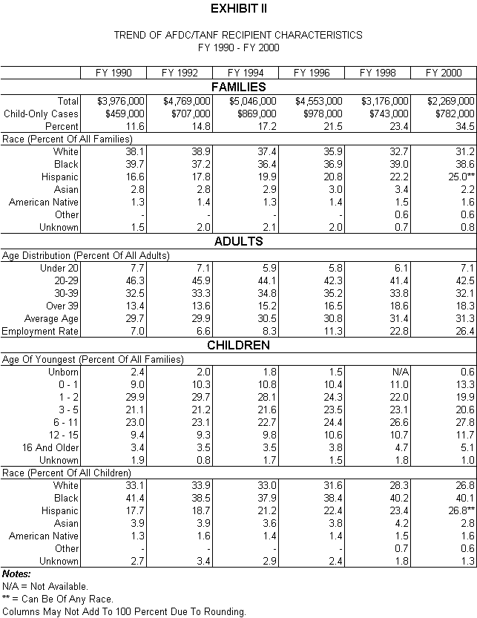

Appendices
TANF Families and Households
Table 10:1 Percent Distribution of TANF Households by Number of Persons in the Household
Table 10:2 Percent Distribution of TANF Families by Number of Recipients
Table 10:3 Percent Distribution of TANF Families by Number of Adult Recipients
Table 10:4 Percent Distribution of TANF Families by Number of Recipient Children
Table 10:5 Percent Distribution of TANF Families with No Adult Recipients by Number of Recipient Children
Table 10:6 Percent Distribution of TANF Families with One Adult Recipient by Number of Recipient Children
Table 10:7 Percent Distribution of TANF Families with Two Or More Adult Recipients by Number of Recipient Children
Table 10:8 Percent Distribution of TANF Families by Ethnicity/Race
Table 10:9 Percent Distribution of All Adults Living in the Household by the Family Affiliation
Table 10:10 Percent Distribution of TANF Teen Recipients with Teen Parent Status
Table 10:11 Percent Distribution TANF Child-Only Cases with Parents: Reason for Parents Living in the Household but Not in the Assistance Unit
Table 10:12 Percent Distribution of TANF Families Receiving Assistance (Medical, Food Stamps, Subsidized Housing, Subsidized Child care)
Table 10:13 Percent Distribution of TANF Families with Child Support and Cash Resources
Table 10:14 Percent Distribution of TANF Families by Reason for Grant Reduction
Table 10:15 Percent Distribution of TANF Families by the Federal Time-Limit Exemption Provision
Table 10:16 Percent Distribution of TANF Families by Type of Family for Work Participation
Adult Recipients
Table 10:17 Percent Distribution of TANF Adult Recipients by Age Group
Table 10:18 Percent Distribution of TANF Male Adult Recipients by Age Group
Table 10:19 Percent Distribution of TANF Female Adult Recipients by Age Group
Table 10:20 Percent Distribution of TANF Adult Recipients by Ethnicity/Race
Table 10:21 Percent Distribution of TANF Adult Recipients by Marital Status
Table 10:22 Percent Distribution of TANF Adult Recipients Receiving Disability Benefits
Table 10:23 Percent Distribution of TANF Adult Recipients by Relationship to Head-of-Household
Table 10:24 Percent Distribution of TANF Adult Recipients by Education Level
Table 10:25 Percent Distribution of TANF Adult Recipients by Citizenship Status
Table 10:26 Percent Distribution of TANF Adult Recipients by Work Exemption Status
Table 10:27 Percent Distribution of TANF Adult Recipients Participating in Work Activities
Table 10:28 Percent Distribution of TANF Adult Recipients by the Average Number of Hours Per Week Participating in Work Activities
Table 10:29 Percent Distribution of TANF Adult Recipients by Employment Status
Recipient Children
Table 10:30 Percent Distribution of TANF Recipient Children by Age Group
Table 10:31 Percent Distribution of TANF Male Recipient Children by Age Group
Table 10:32 Percent Distribution of TANF Female Recipient Children by Age Group
Table 10:33 Percent Distribution of TANF Youngest Recipient Child by Age Group
Table 10:34 Percent Distribution of TANF Recipient Children by Ethnicity/Race
Table 10:35 Percent Distribution of TANF Recipient Children Receiving Disability Benefits
Table 10:36 Percent Distribution of TANF Recipient Children by Relationship to Head-of-Household
Table 10:37 Percent Distribution of TANF Recipient Children in Child-Only Cases by Relationship to Head-of-Household
Table 10:38 Percent Distribution of TANF Recipient Children by Education Level
Table 10:39 Percent Distribution of TANF Recipient Children by Citizenship Status
Financial Circumstances
Table 10:40 TANF Families Receiving Cash Assistance and Average Monthly Amount by Number of Recipient Children
Table 10:41 TANF Families with Income by Type of Non-TANF Income
Table 10:42 TANF Adult Recipients with Income by Type of Non-TANF Income
Table 10:43 TANF Recipient Children with Unearned Income
Closed Cases
Table 10:44 Percent Distribution of TANF Closed-Case Families by Reason for Closure
Table 10:45 Percent Distribution of TANF Closed-Case Families by Number of Family Members
Table 10:46 Percent Distribution of TANF Closed-Case Families by Ethnicity/Race
Table 10:47 Percent Distribution of TANF Closed-Case Families Receiving Assistance (Medical, Food Stamps, Subsidized Housing, Subsidized Child care)
Table 10:48 Percent Distribution of TANF Closed-Case Adult Recipients by Age Group
Table 10:49 Percent Distribution of TANF Closed-Case Recipient Children by Age Group
Table 10:50 Percent Distribution of TANF Closed-Case Youngest Child Recipient by Age Group
Table 10:51 Percent Distribution of TANF Closed-Case Adult Recipients by Marital Status
Table 10:52 Percent Distribution of TANF Closed-Case Adult Recipients by Education Level
Table 10:53 Percent Distribution of TANF Closed-Case Adult Recipients by Employment Status
Table 10:54 TANF Closed-Case Families with Income by Type of Non-TANF Income
Appendix 10:1 -- SSP-MOE Recipients
Table 10:55 Percent Distribution of SSP-MOE Families by Number of Family Members
Table 10:56 Percent Distribution of SSP-MOE Families by Type of Families for Work Participation
Table 10:57 Percent Distribution of SSP-MOE Families by Number of Recipient Children
Table 10:58 Percent Distribution of SSP-MOE Families By Ethnicity/Race
Table 10:59 Percent Distribution of SSP-MOE Families Receiving Assistance (Medical, Food Stamps, Subsidized Housing, Subsidized Child care)
Table 10:60 Percent Distribution of SSP-MOE Adult Recipients by Age Group
Table 10:61 Percent Distribution of SSP-MOE Adult Recipients by Marital Status
Table 10:62 Percent Distribution of SSP-MOE Adult Recipients by Education Level
Table 10:63 Percent Distribution of SSP-MOE Adult Recipients by Work Exemption Status
Table 10:64 Percent Distribution of SSP-MOE Adult Recipients Participating in Work Activities
Table 10:65 Percent Distribution of SSP-MOE Adult Recipients by Employment Status
Table 10:66 Percent Distribution of SSP-MOE Recipient Children by Age Group
Table 10:67 SSP-MOE Families Receiving Cash Assistance and Average Monthly Amount by Number of Recipient Children
Table 10:68 SSP-MOE Families with Income by Type of Non-SSP Income
Table 10:69 Percent Distribution of SSP-MOE Closed-Case Families by Reason for Closure
Appendix 10:2 -- Reliability of Estimates
Table 10:70 Average Monthly TANF Active Caseload, Sample Size, Sample Fraction and Percent by Which Estimate of 50 Percent Might Vary from True Value at the 95 Percent Confidence Level
Table 10:71 Total Number of Annual TANF Closed Cases, Sample Size, Sample Fraction and Percent by Which Estimate of 50 Percent Might Vary from True Value at the 95 Percent Confidence Level
Table 10:72 Approximate Standard Error of Estimated Percentages of TANF Families
Table 10:73 Significance Differences for Percentage Values between the United States and States with Samples of 3000
Table 10:74 Significance Differences for Percentage Values between States with Samples of 3000

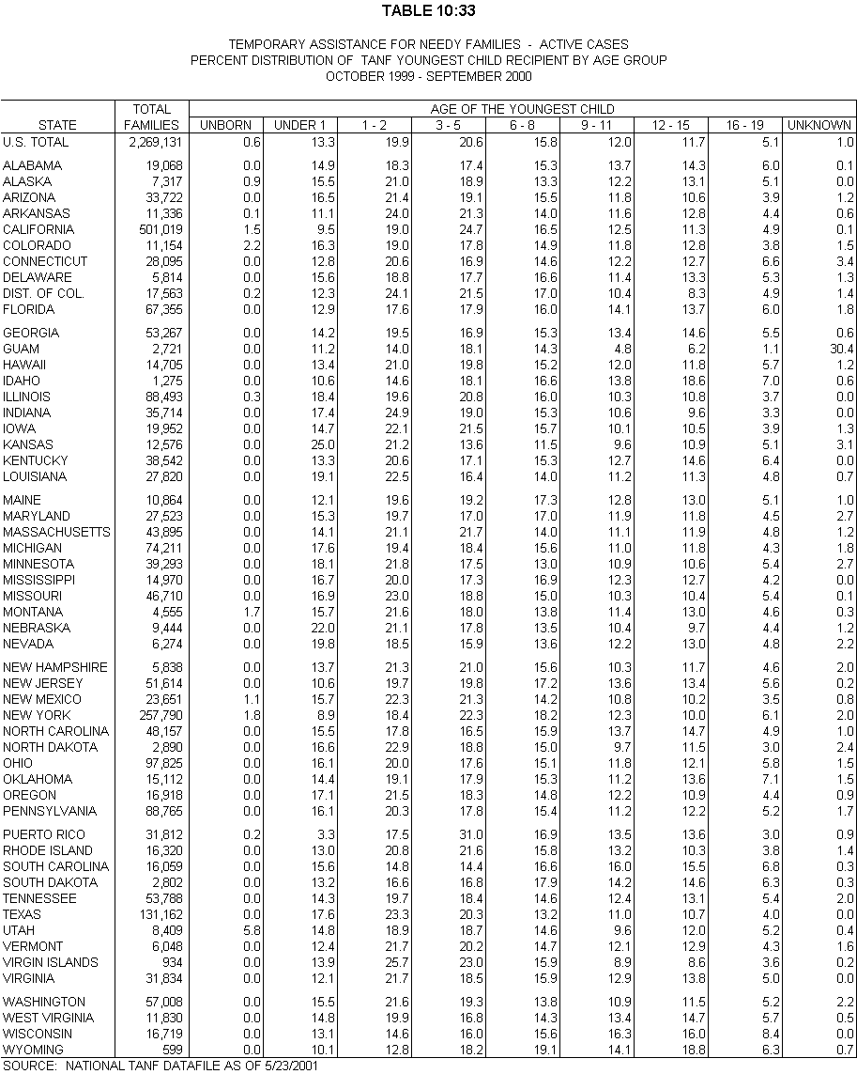
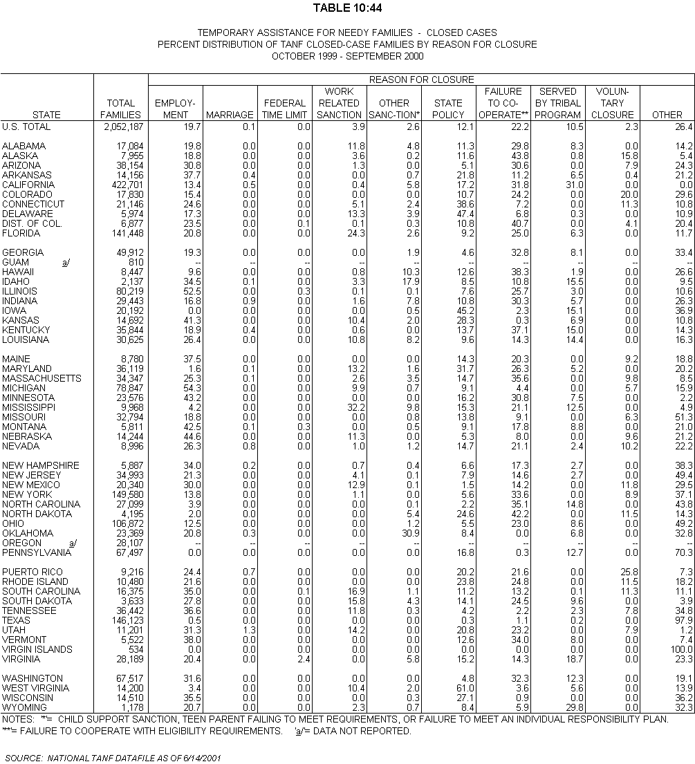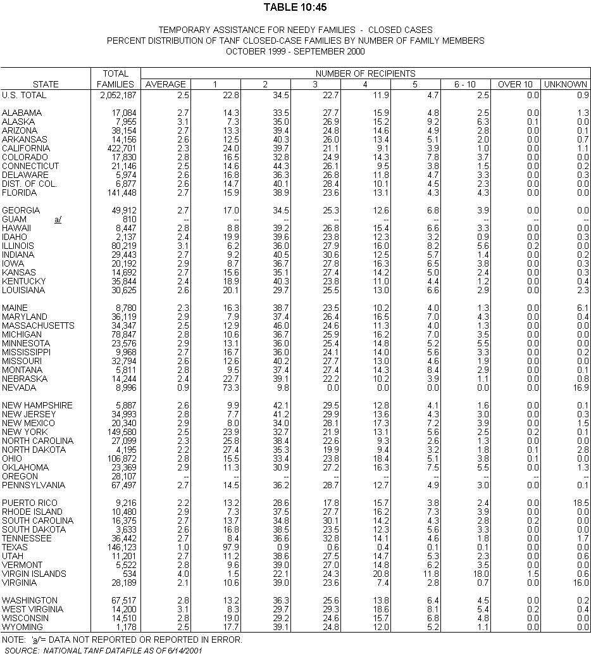
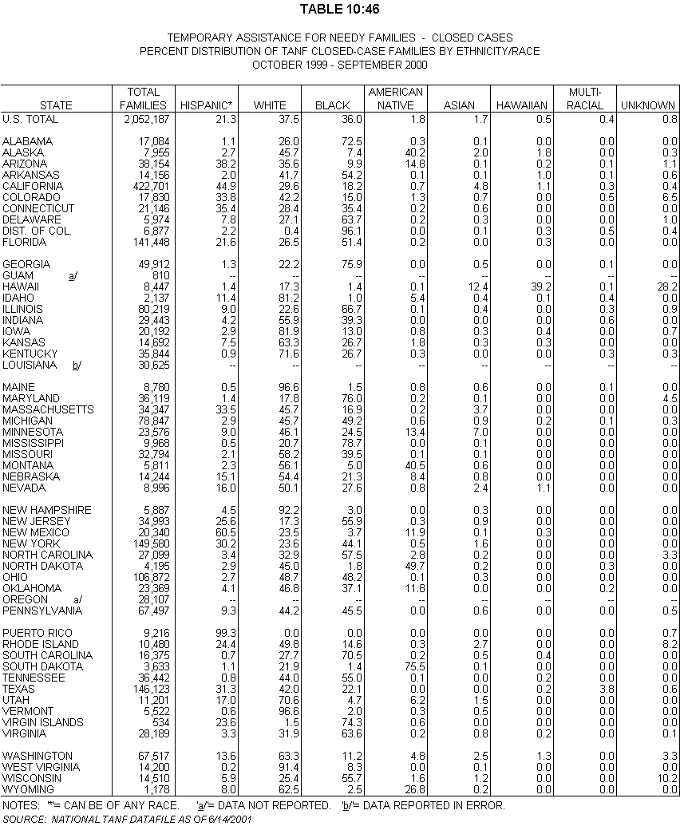
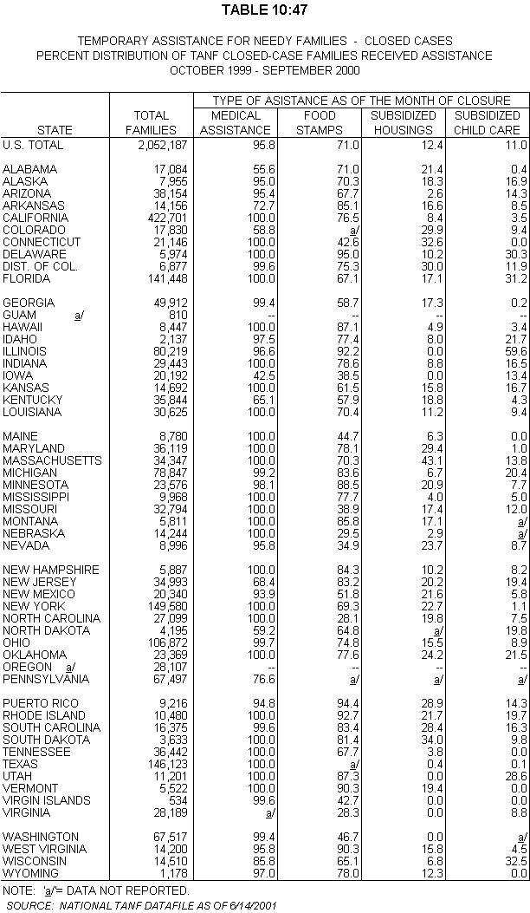

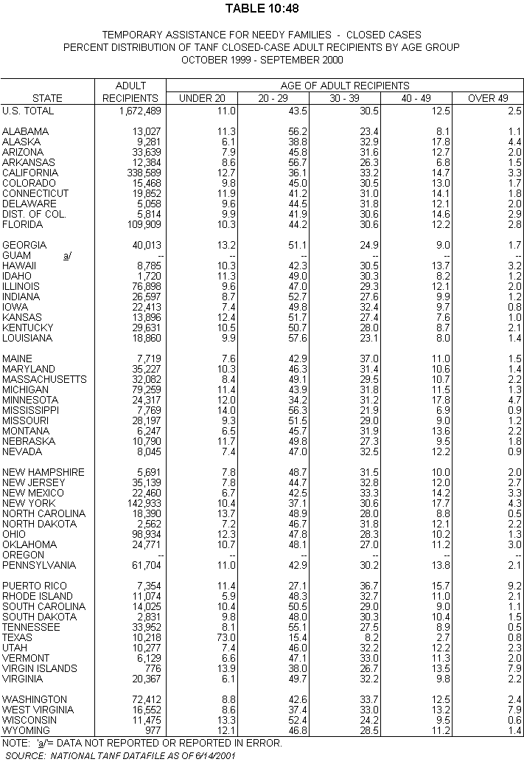
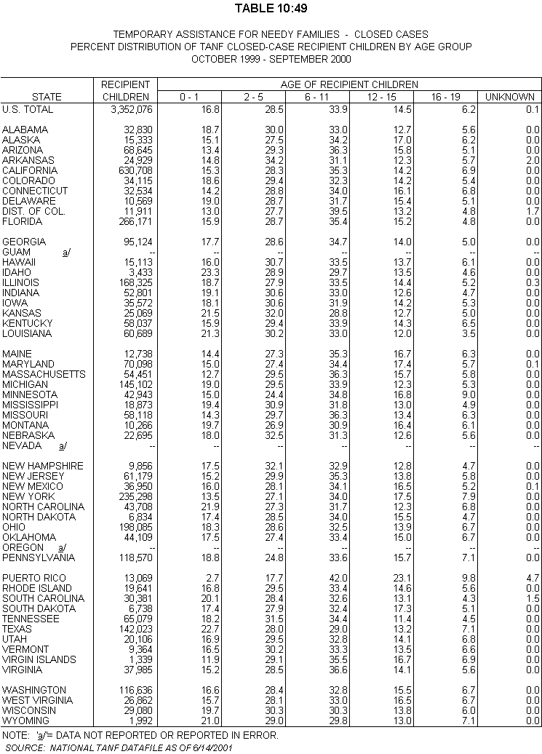
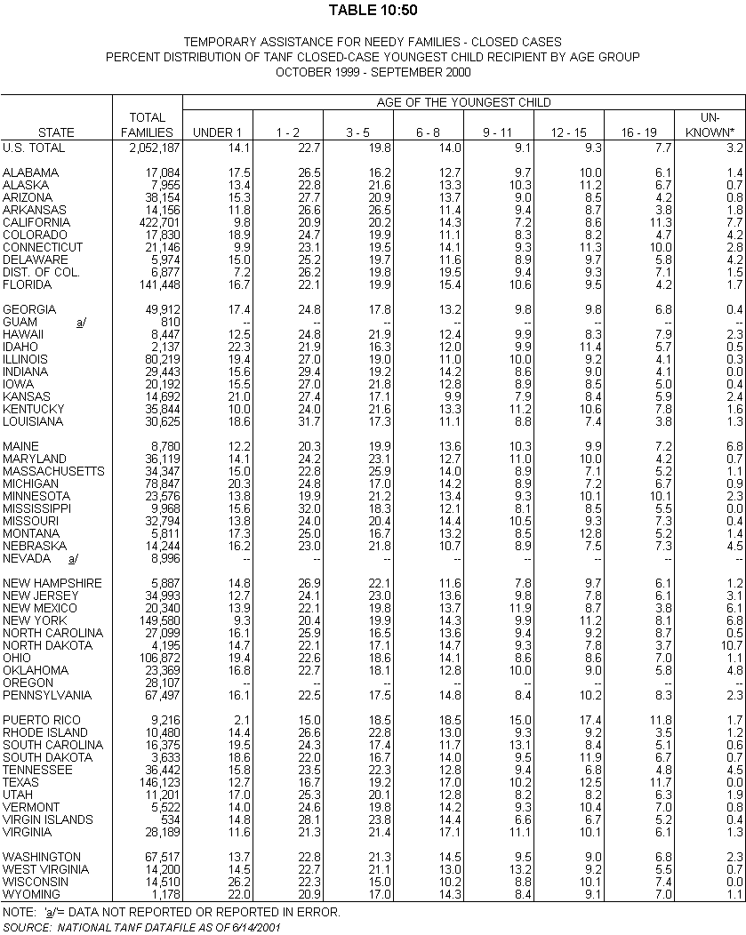
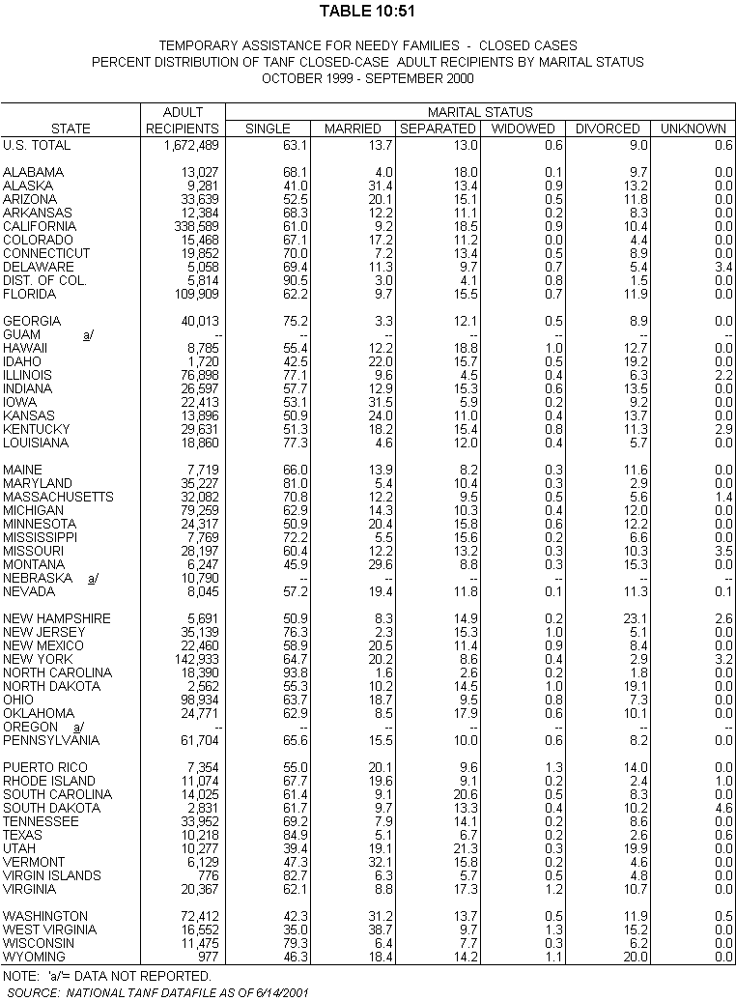
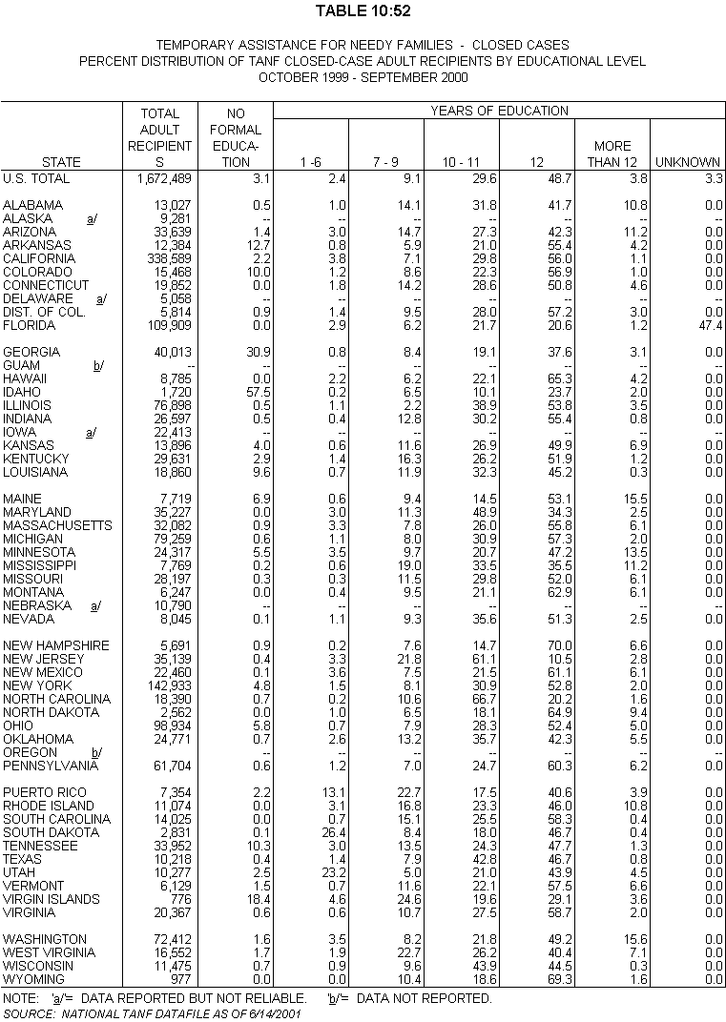
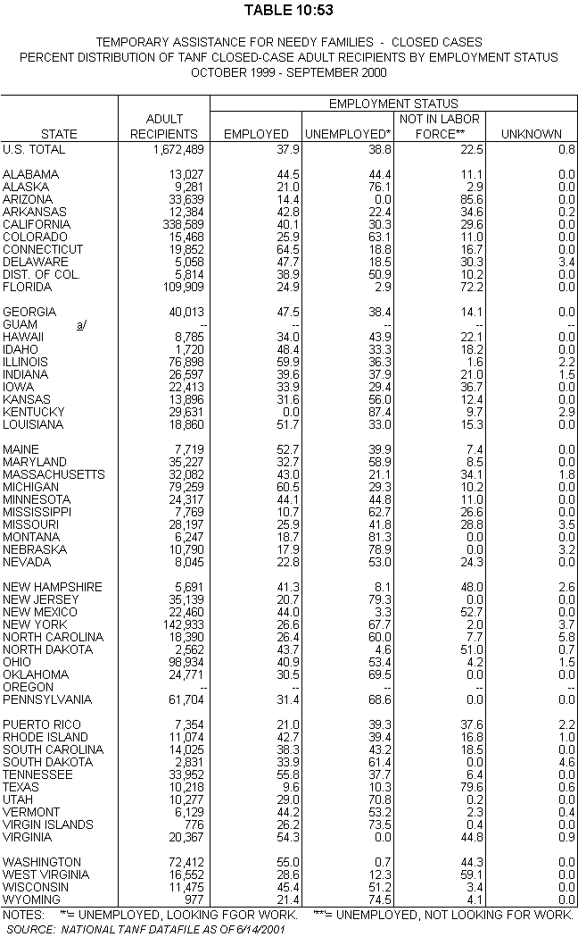
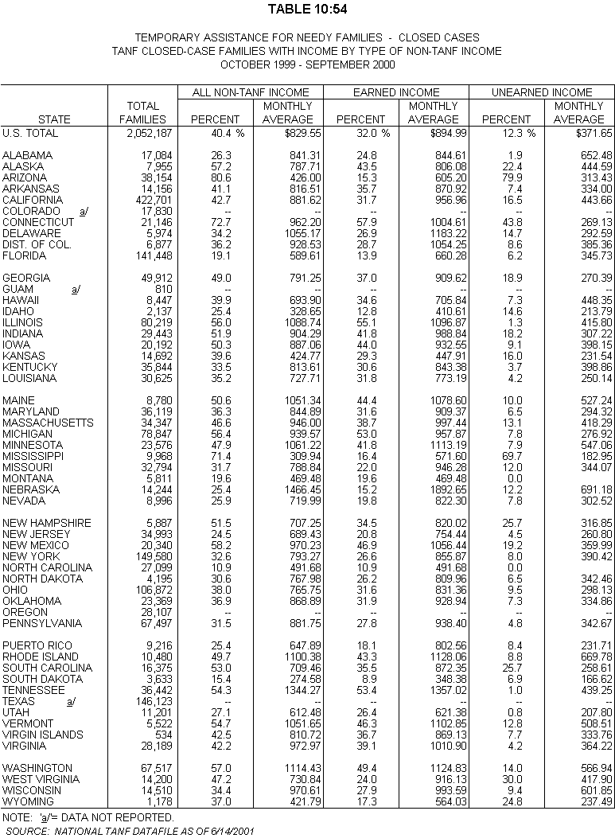

Appendix 10:1

SSP-MOE Recipient Characteristics

Appendix 10:2

Reliability of Estimates
All States, the District of Columbia, Guam, Puerto Rico and Virgin Islands were required to submit TANF data on the demographic characteristics and financial circumstances of families receiving assistance and families no longer receiving assistance under their TANF program. During FY 2000, all 54 States and Territories transmitted 8,391,790 active cases and 649,794 closed cases onto the national TANF database. Under the TANF data reporting system, States have the option to submit either sample data or universe data to DHHS. Twenty-four States submitted sample data. The remaining 30 States submitted universe data, from which DHHS randomly selected approximately 275 active cases and 100 closed cases each month. A total probability sample of 198,415 active cases and 54,340 closed cases was used in the TANF recipient characteristics study for FY 2000.
The statistical data are estimates derived from samples and, therefore, are subject to sampling errors as well as nonsampling errors. Sampling errors occur to the extent that the results would have been different if obtained from a complete enumeration of all cases. Nonsampling errors are errors in response or coding of responses and nonresponse errors or incomplete sample frames.

Standard (Sampling) Errors
For FY 2000, the average monthly caseload, annual sample sizes, average monthly sample sizes, sampling fractions and the percentage points by which estimates of the total caseload for each State might vary from the true value at the 95 percent confidence level are shown in Table 10:70 and 10:71.
Table 10:72 indicates the approximate standard error for various percentages for the U.S. total caseload. These standard errors are somewhat overstated because they are calculated assuming a sample of 14,855 cases out of a total of 2,269,131 cases or 0.65466546 percent of the average monthly caseload. California is the State with such a small sampling fraction. To obtain the 95 percent confidence level at each percent in Table 10:71, multiply the standard error by a factor of 1.96.
For example, national estimates of 50 percent should not vary from the true value by more than plus or minus 0.8036 percentage points (0.41 x 1.96) at the 95 percent confidence level. To obtain the 99 percent confidence level, multiply the standard errors by a factor of 2.58.

Nonsampling Errors
Every effort is made to assure that a list of the universe or the sample frame is complete. It is possible, however, that some cases receiving assistance for the reporting month are not included. There is no measure of the completeness of the universe.
Data entries are based on information in the case records. Errors may have occurred because of misinterpretation of questions and because of incomplete case record information. Errors may also have occurred in coding and transmitting the data. There are no measures of the reliability of the coded information. For some data elements, obviously incorrect or missing information was recoded as unknown in the data processing.

Standard Errors of Subsets
For tables based on subsets of the populations, e.g., one-adult or two-adult families, the approximate standard errors can be computed by the following method: (a) determine the assumed sample size of the subset by multiplying the number of cases in the subset by 0.0065466546; (b) divide the sample size of all families (14,855) by the assumed sample size of the subset; and (c) take the square root of the result and multiply it by the standard errors of the total caseload shown in Table 10:71.
For example, for child-only cases the approximate standard errors of percentages can be found by multiplying the data in Table 10:71 by the square root of 14,855/5,117 or 2.9031. The sample size of 5,117 is determined by 781,546 x 0.0065466546.

Standard Errors for State Estimates
The method used above can be adapted to calculating standard errors of State estimates. First, divide the national sample size of all families (14,855) by the State sample size shown in Table 10:69. Then take the square root of the result and multiply it by the standard errors shown in Table 10:71. For example, for Florida the approximate standard errors of percentages can be found by multiplying the data in Table 10:71 by the square root of 14,855/3,275 or 2.1298.

Statistically Significant Differences
Table 10:72 shows the percentage values at which differences between national and State estimates become significant at the five percent confidence level based on annual State samples of 3,000 active cases.
Table 10:73 shows the percentage values at which differences between State estimates become significant at the five- percent confidence level based on annual State samples of 3,000 active cases.

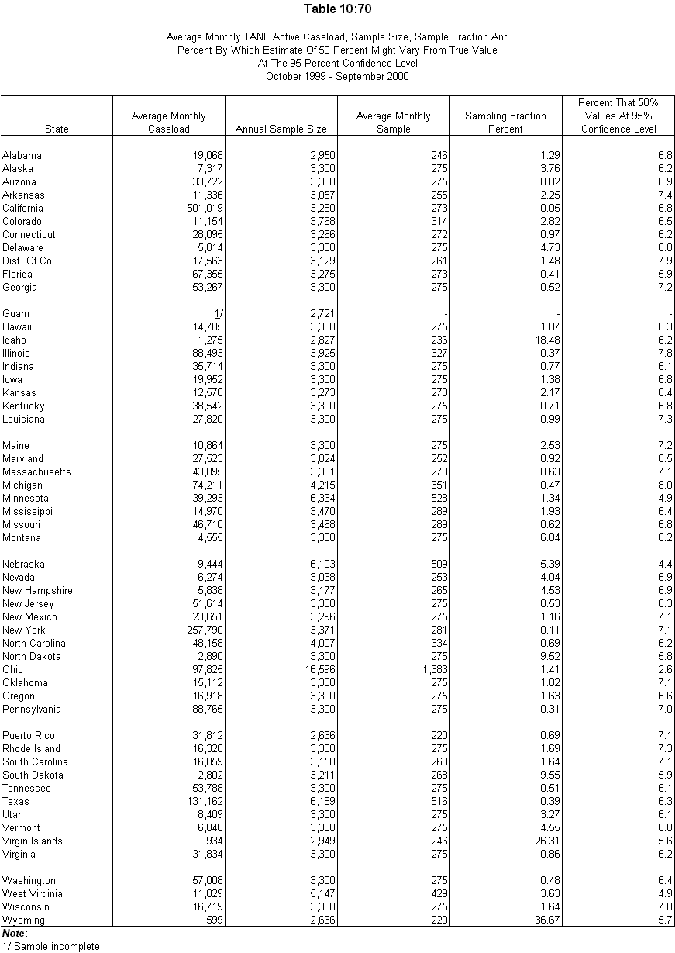
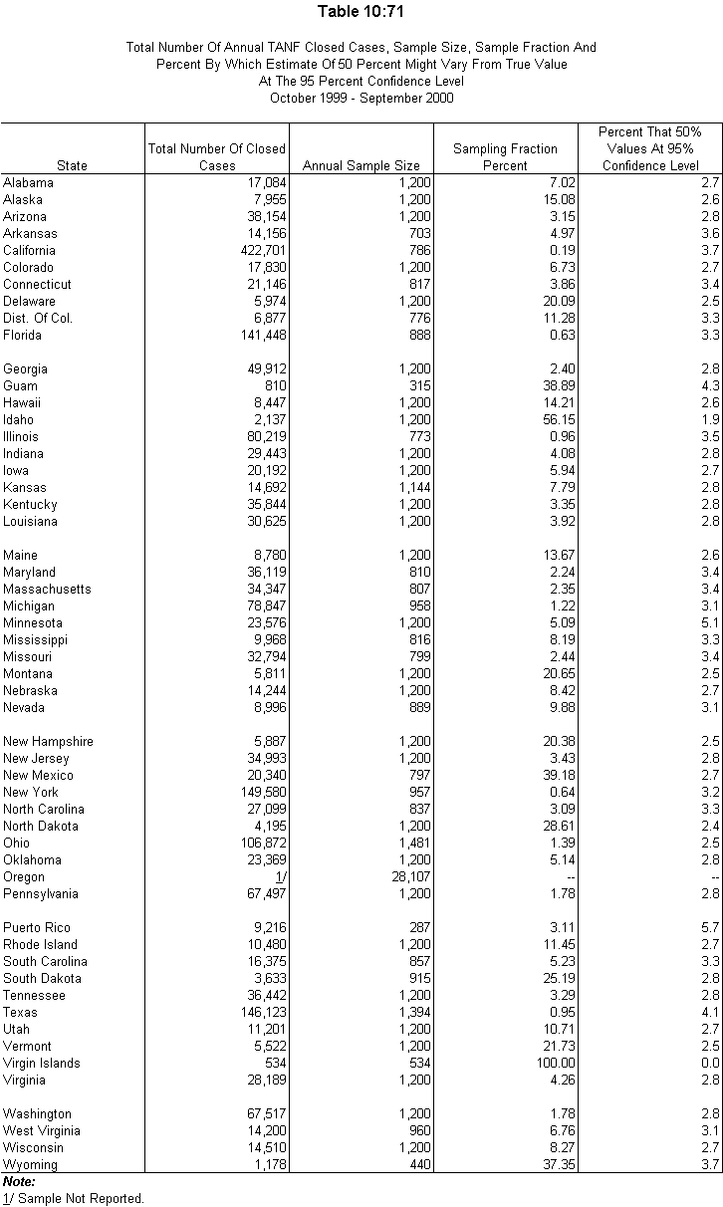
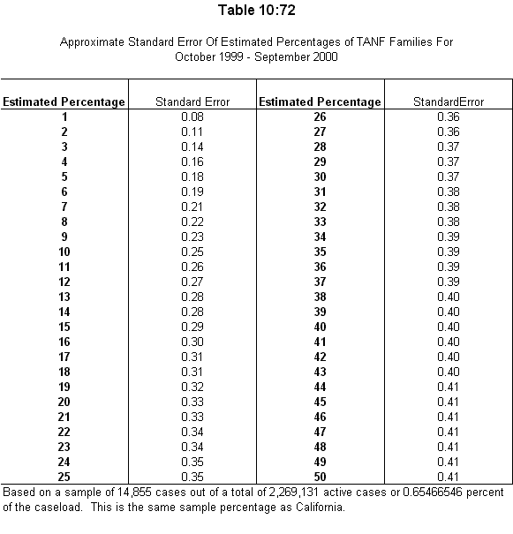
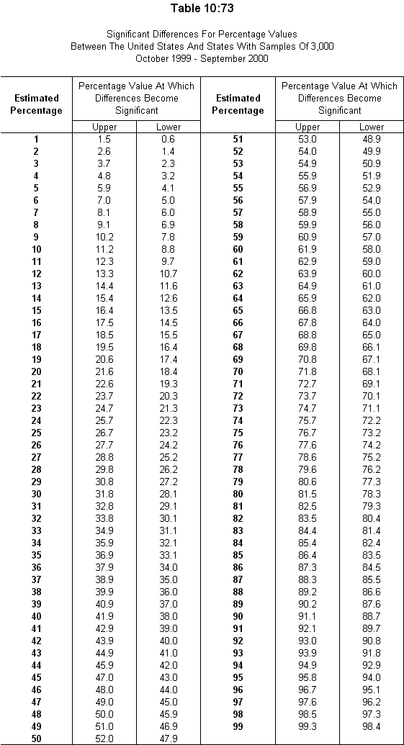
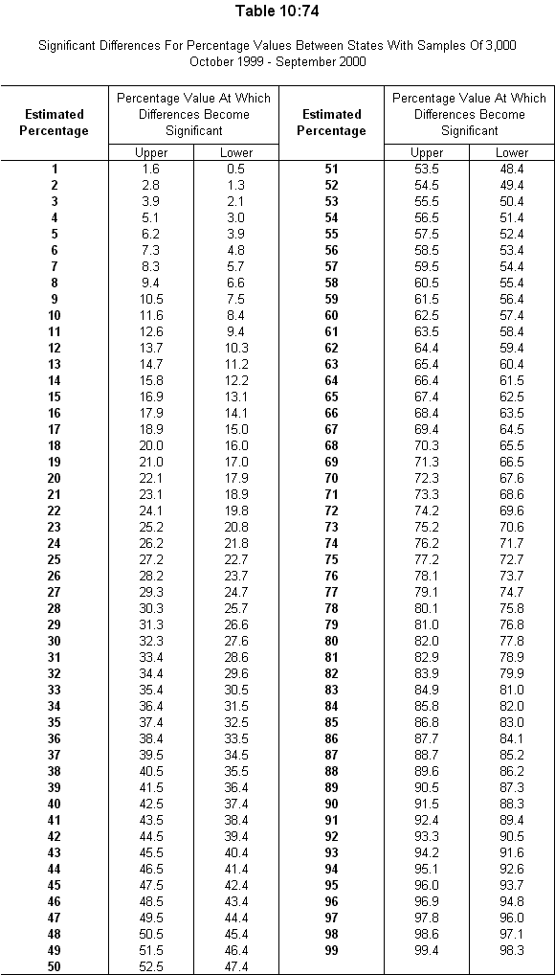

 NOTE: The work participation activity data may be somewhat different from those presented in "Section III - Work Participation Rates," because TANF recipient characteristics in this section were prepared using (1) sample cases of 3,300 randomly selected for States who submitted the universe data, and (2) the data transmitted by States as of May 23, 2001.

