GUIDE TO INSPECTIONS OF

LOW ACID CANNED FOOD MANUFACTURERS

Part 3-Containers/Closures

TABLE OF CONTENTS

Introduction pg.1
Coding of Containers pg. 2
Empty Container Handling pg. 2
Container Closing pg. 2
Metal Cans
Container Structure pg. 2
Double Seam Structure pg. 3
Double Seam Formation pg. 3
Seam Guidelines (Specifications) pg. 4
Seamer Maintenance and Adjustment pg. 4
Container Defects pg. 5
Double Seam Evaluation Requirements
Visual Seam Examination pg. 6
Double Seam Examination pg. 7
Visual and Double Seam Examination
Records pg. 7
Post Process Container Handling pg. 8
Glass Jars

Container Structure
Glass Container pg. 8
Metal Closure pg. 8
Vacuum Formation pg. 9
Vacuum Closures pg. 10
Closure Evaluation Requirements
Visual Examination pg. 10
Physical Examination pg. 11
Visual and Physical Examination Records pg. 12
Other Quality Control Equipment pg. 12

Retortable Pouch
Container Structure and Sealing Method. Pg. 12
Critical Factors in Sealing Pg. 13
Semirigid Trays and Bowls
Sealing Method pg. 13
Critical Factors in Sealing pg. 13
Container Defects-
Pouches/Semirigid Containers/Heat Sealed Packages pg. 13
Seam Evaluation Requirements pg. 14
Visual Seam Examination pg. 14
Physical Examination pg. 15
Visual and Physical Examination Records pg. 16
References pg. 16
Attachments pg. 18

INTRODUCTION

The Guide to Inspection of Low-Acid Canned Foods consists of three separate documents; Part 1 covers Administrative Procedures\Scheduled Processes; Part 2 covers Manufacturing Procedures/Processes and Part 3 covers Container/Closures. In addition to providing guidance for inspections of low acid canned foods (LACF) manufacturers, the guide(s) also contains background and general information on LACF regulations and procedures.
In addition to the information and instructions provided in IOM Subchapter 530, 21CFR 108 and 113, and applicable compliance programs, direct attention to areas covered in this Guide when covering LACF manufacturers. Another good reference is the Food Processors Institute 'Canned Foods' manual, which should be available from anyone in your district who has attended a Better Process Control School.
At the current time DEIO has available, for loan only, the following NFPA manuals:

1. Thermal Processes For Low-Acid Foods in Metal Containers (NFPA Bulletin 26-L, 13th Edition)
2. Thermal Processes For Low-Acid Foods in Glass Containers (Bulletin 30-L)
3. Flexible Package Integrity Bulletin (Bulletin 41-L)
4. Guidelines for Thermal Process Development for Foods Packaged in Flexible Containers
5. Continuous Rotary Sterilizers-Design and Operation (Bulletin 44-L)
6. Automatic Control Guidelines For Aseptic System Manufacturers and Companies Using Aseptic Processing and Packaging for Preserving Foods (Bulletin 43L)

DEIO also has a supply of Institute for Thermal Processing Specialists (IFTPS), 'Protocol for Carrying Out Heat Penetration Studies'.
The AOAC Chart "Classification of Visible Can Defects (Exterior)" is helpful when performing field exams. Districts should have this chart available (usually the labs have them).
The sampling schedule for canned and acidified foods is in the Investigations Operations Manual and the Guide to Inspections of Low Acid Canned Food Manufacturers , Part 2

CODING OF CONTAINERS

See Guide to Inspections of Low Acid Canned Food Manufacturers Part 2, pg. 46.

EMPTY CONTAINER HANDLING:

Empty containers for low acid canned food processing are typically received in bulk quantities, packaged to avoid container damage in transit, by the food manufacturer. For example, metal cans are typically received on pallets with a cardboard divider between each can layer or nested in paper sleeves on pallets; glass jars are received in boxes with separate compartments for each jar; plastic bowls and cups are received nested in cardboard boxes; and empty pouches are received securely packed in cardboard boxes.
It is important that empty containers are handled during receipt and processing in a manner that precludes container damage. For example, if the flange of a metal can is damaged during shipment, receipt, or filling, it can result in a can seam defect. Therefore, it is important that the LACF manufacturer has a program for inspecting incoming containers for defects prior to the filling operation. This inspection program should include a visual examination and when appropriate, a tear down examination for defects that could affect product and/or package integrity. Incoming container inspection programs range from a small manufacturer checking every container before filling, to large manufacturers that may follow a statistically valid sampling plan (e.g., mil-standard 105E) to inspect their incoming containers for defects.
During the inspection determine if the firm has a program and/or procedure for handling and inspecting incoming containers and if the program is followed. Also, inspect empty containers prior to filling for damage that may result in container defects. Any damage should be noted, and follow-up visual examination of finished containers should be performed to determine if the damage caused defects in the containers. Evidence of container damage causing defects in the finished containers should be reported on the FDA-483 if no corrective actions had been taken by the firm on the affected lots. (Reference individual container type sections of this guide for definitions and discussion of container defects.)
Empty containers (except pouches) should be inverted and cleaned prior to fill. Typically containers are cleaned using vacuum, air, or a water spray to remove possible foreign material prior to filling.

CONTAINER CLOSING:

After filling the container, a can cover (end or lid) is placed onto the container and seamed. The closing operation is what produces a hermetic seal; i.e., a seal designed to be secure against the entry of microorganisms. For cans, to secure the hermetic seal an appropriate sealing compound is applied to the inside of metal can ends at the curl; and for glass jars the sealing compound is applied to the metal closures during container lid manufacturing. It is very important that the seam is adequate to prevent entry of microorganisms. A brief description of the different container types and closing operations for these container types is as follows:

METAL CANS

Container Structure:
The container structures that help form and become a part of the finished double seam are the body flange and the end curl (refer to Attachment 1). Attachment 1 also illustrates and defines double seam terminology:
Flange: The flange is the edge of the body cylinder that is flared outward resulting in a rim or ledge. The flange is formed into the body hook during double seaming and becomes interlocked with the cover hook. The width and radius of the flange are determined by the container manufacturer and are designed to form a proper body hook when using the container manufacturer's specifications for the double seaming operations.
End Curl: The end curl is the extreme edge of the can end (cover) that is turned inward after the end is formed. It is the structure used to form the cover hook and is designed to provide sufficient metal and proper contour for a good cover hook, and easy feeding of end units into the closing machine.

Double Seam Structure:
The double seam structure is judged by measurement and evaluation of specific components comprising the seam. These measurements are based on guidelines provided by the container manufacturer to the low-acid canned food manufacturer to assist in maintaining acceptable seams during production. The final evaluation of the double seam can only be made by a visual inspection of the torn down seam in conjunction with the measurements. The seam measurements that can be performed to evaluate the double seam are as follows (refer to Attachment 2):
Countersink: The countersink is the distance measured from the top of the double seam to the end panel adjacent to the inside wall of the double seam.
Seam thickness: Seam thickness is the maximum dimension measured across or perpendicular to the layers of material in the seam. This measurement is one, but not the only indication of the tightness of the double seam.
Seam width (length or height): Seam width (also referred to as seam length or seam height) is the dimension measured from the top to the bottom of the double seam (parallel to the hooks of the seam).
Body and cover hook: These are internal measurements. As previously referenced the body hook is formed from the body flange, and the cover hook is formed from the end curl during the double seaming operation. These structures, observed in a cross section, have an interlocking relationship to each other.
Overlap: The degree or length of interlock between the body hook and cover hook is known as overlap.
Tightness: Seam tightness is judged by the degree of wrinkling at the end of the cover hook. During double seam formation, the cover curl is guided around and up under the body flange. This crowds the cut edge of the curl into a smaller circumference, resulting in a wavy cut edge with accompanying wrinkles around the seam. The second operation in the formation of the double seam presses the body and cover hooks together to such a degree that the wrinkles should be ironed out sufficiently to ensure a hermetic seal.
In a completed double seam, any remaining wrinkles help to indicate double seam tightness. Tightness rating is a numerical designation which indicates the relative freedom from wrinkles or % smoothness of the cover hook. Refer to Attachment 3.
After the coverhook is removed, the can body should be examined for body wall impression or what is commonly referred to as pressure ridge. This impression is caused by the seaming roll pressure during the seaming operation. Visual inspection of the pressure ridge provides additional assurance of the tightness of the can seal. The body wall impression or pressure ridge should be visible and complete around the inside periphery of the can body where the coverhook was removed. Refer to Attachment 4.

Double Seam Formation:
The seal for the metal can is made in two operations, hence the term "double seam". The can seamer (or closing machine) has four basic parts that are directly involved in forming the double seam. These parts are:

1. Seaming Chuck: A flat round plate which fits inside the can cover and supports the can against the seaming rolls.
2. Can Lifter or Base Plate: a round plate which lifts the can and can end to the seaming chuck and applies upward pressure during the seaming cycle.
3. First Operation Seaming Roll: A roller adjacent to the seaming chuck that has a deep, narrow groove (forming tool).
4. Second Operation Seaming Roll: A roller adjacent to the seaming chuck with a wide and shallow groove (tightening, flattening tool).
These four basic parts of the can seamer are adjustable, and precise adjustment is critical in obtaining a well formed double seam.

The double seaming operation is a form of metal spinning. The sequence of steps in the two-seaming-roll operation is as follows:
1. Either the can is placed on the can lifter (base plate) and the cover is automatically placed on the can; the can cover is placed on the can as it moves onto the can lifter; or if the cover is placed on the can during the clinching operation, the can with the cover is placed on the can lifter.

2. The base plate raises the can and cover onto the seaming chuck tightly clamping the cover onto the can.
3. The first operation seaming roll(s) is brought into contact with the can and cover, and the metal spinning groove forms the first operation seam. The first operation seam can be defined as curling the cover (end) hook around the inside of the body hook to form a loose interlock of the can end and can body.
4. The second operation seaming roll(s) is brought into contact with the can and cover, and the metal spinning groove forms the second operation seam. The second operation seaming roll flattens the seam and seals the can.

Attachment 5 illustrates the sequence of operation in seaming a can end onto a can body. Attachment 1 illustrates a completed double seam and details double seam terminology.

Can double seamers are generally of two types:
The can spin type: The seaming rolls are stationary and the can spins as it is held between the base plate and the seaming chuck. In this type of seamer the base plate and chuck both spin at a high rate of speed while the stationary rolls swing in to make contact with the can and cover and then swing back out after the seaming operations are complete.
The can stationary type: The can, base plate and chuck are all stationary and one or two first and second operation seaming rolls roll around the stationary can forming the double seam.
With either type of double seamer, a can may be placed by hand onto the base plate, or fed mechanically onto the base plate in the seamer.

First Operation Seaming
The first roll seaming operation is the most critical part in the formation of a good seam. The second roll seaming operation simply flattens the closure fold made during the first roll seaming operation; so deficiencies in the first seaming roll operation cannot be corrected during the second roll seaming operation.
The first operation roll has a narrow and deep groove profile. The body hook and cover hook are determined by the first operation roll and the base plate pressure. Upward pressure on the base plate should be sufficient to force the cover right onto the chuck and hold the can firmly in contact. The first operation seaming roll then engages the cover and curls the cover curl (which becomes the cover hook) into the flange of the body which then becomes the body hook in the finished seam. In a good or normal first operation roll, the cover hook is rounded at the bottom and is in contact with the body of the can. The ends of the cover hook and body hook are essentially parallel. There should be no curvature in the extremities of the cover and body hooks. Refer to Attachment 11.

Second Operation Seaming:
The second operation roll has a shallow and flat profile in comparison to the narrow and deep groove profile of the first operation roll. The second operation roll flattens the fold resulting from the first operation and presses the folds together tightly enough to compress and force the sealing to flow into the seam voids. Refer to Attachment 6.

Seam Guidelines (Specifications)::
Can seam guidelines (specifications) are provided to the low acid canned food manufacturer by the supplier of the container and end being used. The guidelines detail the measurements, in thousands of an inch, of each attribute of the double seam for both the first and second seaming operations. They also provide a set-up aim or ideal starting dimensions for the set up of the seamer. The operating limits set the range for good practice. Attachment 7 provides an example of a seam guideline.
It is extremely important to understand that seam guidelines by themselves cannot be used for determining the quality of a double seam. The seam guidelines are to be used in setting up the double seams initially and maintaining seam integrity during production. Final acceptability of the double seam should be based on total evaluation of the seam by a qualified person and not on dimensions alone. Good seaming practice requires constant visual examination, frequently scheduled tear-down evaluation, machine maintenance, and immediate correction of unacceptable conditions.
Since seam guidelines will vary depending on the source of the container (i.e., Crown Cork & Seal, Ball, Siligan, etc.), the guidelines should always be provided by the container manufacturer. If the LACF manufacturer cannot provide a copy of the appropriate seam guidelines, they have nothing on which to evaluate the double seam. This can be listed as an objectionable condition on the FDA-483.

Seamer Maintenance and Adjustment :
It is important that the LACF manufacturer has in place a preventative maintenance program for the seamer. Under normal use conditions, the seaming rolls, bearings, base plate, chuck etc. can become worn resulting in the possibility of defective double seams. Seaming rolls are evaluated and changed routinely because they wear during production, thus altering the groove profiles. For example, a badly worn first operation roll can result in a loose first operation seam and when a normal second operation roll pressure is applied, can cause droops (see Attachment # 8) in the finished double seam.

Adjustment of Closing Machine to Correct Out-Of-Guideline Measurements and/or Defective Seams:
Whenever the set-up aim or operating limit checks indicate that seams are not meeting the guidelines or when an obvious seam defect is found on visual inspection, the manufacturer must know what steps to take to correct the condition. The FDA investigator must also be aware of seaming conditions that could result in container defects in order to evaluate whether the firm took the appropriate corrective action. Evaluation of the firm's actions are made through review of their container records. Container records will be discussed later in this section.
If an obvious and recurring can seam defect is found on visual inspection and in a second sample, it usually signifies that some mechanical fault has developed and the production line should be stopped in order to take corrective action. Product from previous production that may have been affected should also be isolated.
The most critical attributes to consider in judging the quality of the double seam are overlap and tightness (wrinkle). If one of the can seam measurements (i.e. body hook) is slightly beyond the specified guidelines but the rest of the seam is evaluated and the overlap and tightness (wrinkle) are within specified guidelines, then adjustments to the seamer can be made at the next scheduled shut-down. In this instance, the manufacturer should identify the out-of-guideline measurement and document they have evaluated the rest of the double seam, but did not find immediate corrective action necessary. However, if overlap measurement or tightness rating evaluation are below the minimum guidelines a resample from the questionable seaming station should be made. If the resample continues to show out-of-guideline measurements in overlap and/or wrinkle the machine should be stopped and adjusted.
A LACF manufacturer should have experienced, competent personnel to adjust the seamer and evaluate double seams.

Container Defects - Metal Cans:
Container defects are seam abnormalities that are generally serious and may result in the loss of the hermetic seal. Following is a description of some of the more common container defects:
Droop (Refer to Attachment 8): A droop is a smooth projection of a double seam below the bottom of a normal seam. The droop may occur at any point of the double seam. If the container has a side seam it is common to have a slight droop where the double seam crosses over the lap of the side seam. This area of cross over is referred to as the "juncture". A slight droop at the juncture may be considered normal, however, if the droop is excessive the overlap may be too short or non-existent. Some possible causes of droops are listed in Attachment 8.
Vee or Lip (Refer to Attachment 8): "Vees" or "lips" are projections of the double seam below the bottom of a normal seam that resemble a "V" shape. There is usually no overlap of the cover hook with the body hook and these defects usually occur in small areas of the seam. The probable causes for "vees" or "lips" is the same as for "droop".
Sharp seam (Refer to Attachment 9): A "sharp seam" refers to a sharp edge at the top inside portion of the seam. Usually a sharp seam is noticeable at the side seam juncture in a three piece container, however, a sharp seam can be felt at any point along the inside top of the seam. The sharp seam is caused by a portion of the end (cover) being forced over the top of the seaming chuck during double seaming. A sharp seam can usually be felt more easily than seen. A sharp seam can be the first indication of a more serious defect known as a cut-over.
Cut-over (Refer to Attachment 9): A "cut-over" is a seam defect where the top of the inside portion of the seam has become sharp enough to fracture the metal. As in the definition of "sharp seam", this condition usually occurs at the side seam juncture of a three piece container. Some possible causes of both sharp seams and cut-overs are listed on Attachment 9.
Jumped seam or Jump over (Refer to Attachment 10): A jumped seam or jump-over is a portion of the double seam which is not rolled tight enough. This defect occurs adjacent to the side seam or juncture area in a three piece container and is caused by the seaming rolls jumping at the juncture. Wrinkles will be left in the coverhook at the point where the rolls jumped. During examination of the seams the area immediately adjacent to either side of the juncture should be carefully inspected for excessive wrinkle. Possible causes of a jumped seam are listed on Attachment 10.
Deadhead or spinner (Refer to Attachment 11): A deadhead or spinner (also referred to as slips or skids) is an incomplete seam caused by the chuck spinning in the countersink during the seaming operation. Some causes of deadheads are listed on Attachment 11.
Mis-assembly: A "mis-assembly" is the result of the can body and the can end having been improperly aligned in the closing machine. Therefore, the seam is completely disconnected partway around the can. The most common cause of a mis-assembly is incorrect closing machine timing or settings.
False seam (Refer to Attachment 12): A "false seam" is a seam or portion of the seam which is completely unhooked, and in which the folded cover hook is compressed against the folded body hook. A false seam is not always detectable in an external examination. Some causes of false seams are listed on Attachment 12.
There are other terms that more specifically describe a false seam condition. They are:
Knocked down flange: which is usually caused by a bent can flange before double seaming.
Damaged end curl: is a defect resulting when the end curl is flattened in one or more spots, causing the curl to fold back on itself. This is usually caused by handling damage to ends or improper cover feed.
Can body buckling: The can body directly under the double seam is buckled or twisted.
Possible causes are:
1. Excessive baseplate pressure
2. Improper pin-gauge height (distance between base plate and chuck)

Cocked body (Refer to Attachment 12): A "cocked body" is a can manufacturing defect. It occurs when the can body blank is manufactured out of square causing an unevenness at the lap or juncture in three piece cans.
Cut seam (Refer to Attachment 13): A "cut seam" is a fractured double seam where the outer layer (cover hook) of the double seam is fractured. Possible causes are listed on attachment 13.
Fractured embossed codes: "Fractured embossed codes" are fractures through the metal end of the can at the code mark. Possible causes for the fractured metal are:
1. Mis-alignment of male and female coding dies.
2. Intermixing of new and old type code characters.
3. Improper matching of male and female type code characters.
4. Too deep a code mark.

Broken chuck: A "broken chuck" defect occurs when a portion of the seaming chuck lip has broken and results in an excessively loose seam at the broken part due to a lack of backup support for the seaming roll. Possible causes are:
1. Severe jam in the closing machine.
2. Seaming rolls binding on chuck.
3. Metal fatigue in chuck lip.
4. Prying against the seaming chuck to clear a jam.

FDA, in cooperation with the Association of Official Analytical Chemists, published a brochure titled "Classification of Visible Can Defects". The brochure defines metal can defects in three categories. They are:
1. Critical: Defects which provide evidence that the container has lost its hermetic seal (e.g., holes, fracture, puncture etc.)
2. Major: Defects that result in cans which do not show visible signs of having lost their hermetic seal, but are of such magnitude that they may have lost their hermetic seal.
3. Minor: Defects which have had no adverse effect on the hermetic seal.
The brochure also provides a pictorial of can seam defects and rates the defects as critical, major and minor. If you cannot locate a copy of this brochure in your district, contact your servicing lab.

Double Seam Evaluation Requirements:

Visual Seam Examination (Non-Destructive Test):
21 CFR Part 113.60(a) requires a visual examination of at least 1 can per seaming head by a qualified container closure inspector at intervals of sufficient frequency. The regulation requires that double seamed containers be visually inspected for gross closure defects such as sharp seams, cut-overs, deadheads, false seams, droops and broken chuck. The frequency of the visual examination should be made at intervals not to exceed 30 minutes (of operational time); and additional visual examinations must be performed immediately following a jam in a closing machine, after closing machine adjustment, or after startup of a machine following a prolonged shut-down. An example of a prolonged shut down may be when the plant ceases production at 6:00 PM and restarts production at 8:00 AM the next day.

Double Seam Teardown Examination Requirements (Destructive Test):
The double seam teardown examination is a destructive test. Tools that are used to perform this test include a seam micrometer, countersink gauge, can opener and nippers. Optional equipment for seam teardown examinations include a seam saw, seam projector and seam scope. Although it is not imperative the investigator carry this equipment to each LACF inspection, it is very important that they know how to operate this equipment and read measurements from the micrometer, seam projector or seam scope. It is also important that the investigator know how to determine the tightness or wrinkle rating of the cover hook. Knowledge of the procedures used to perform double seam teardown examination are essential to evaluating the firm's knowledge and ability to do this examination. Attachment 14 explains the procedure for using a seam projector for examining a cross section of the seam. Attachment 15 explains the can seam micrometer and procedure for use, and Attachment 16 explains the use of a seamscope for the same exam.
The requirements for double seam examinations are specified in 21 CFR Part 113.60(a)(1). The regulation states that teardown examinations shall be performed by a trained closure technician at intervals of sufficient frequency to ensure proper closure. The teardown examinations shall be made on the packer's end double seams on at least 1 can from each seaming head to ensure maintenance of seam integrity. Sufficient frequency is defined in the regulation as intervals not to exceed 4 hours (operational time).
The regulation allows for 2 different methods of double seam examination; the "micrometer" method or the "optical" method.
If the processor is using the micrometer method the regulation requires that 3 measurements are taken at points approximately 120⁰ apart around the double seam. On 3 piece cans the first measurement can be taken directly across from the side seam and the next two measurements are then taken 120⁰ to either side of the first measurement. On 3 piece cans the measurements must be taken at least one-half inch from the side seam juncture as the juncture may interfere with a true seam measurement.
Micrometer measurements are made and recorded in thousandths of an inch. The high and low measurements are recorded on the double seam teardown examination record. If the manufacturer is using the micrometer method the required

measurements are:

Cover hook length
Body hook length
Width (also referred to as length or height)
Tightness (by observation for wrinkle)
Thickness

Optional measurements are:
Overlap (by calculation)
Countersink

The regulation specifies the formula used to calculate overlap when micrometer measurements are used:

CH + BH + T (.010in)* - W, where
CH = cover hook
BH = body hook
T = cover thickness *(general practice use .010 inches for tin plate thickness)
W = width

Measurements used to calculate the overlap should not be averaged. In fact, the lowest values should be used to determine the worst case scenario. For example, to calculate the worst case scenario you should use the lowest measurements for CH and BH and the highest measurements for W.

If a seam scope or seam projector is used (optical method) to make the seam measurements, the required measurements are:
Body hook length
Overlap
Tightness (observation for wrinkle)
Thickness (determined by micrometer measurement if the optical instrument cannot read this value)

Optional measurements are:
Width (also referred to as length or height)

Cover hook
counter sink

Visual Seam and Double Seam Teardown Examination Record Requirements:
The regulations require that the results of visual seam and double seam teardown examinations along with any corrective action taken shall be recorded. 21CFR Part 113.100(c) details

the minimum requirements for visual and double seam examination records as follows: "Written records of all container closure examinations shall specify the product code, the date and time of container closure inspection, the measurements obtained, and all corrective actions taken." Records must be signed or initialed by the container closure inspector and reviewed by management with sufficient frequency to ensure that the containers are hermetically sealed.
Sufficient frequency can be defined as, at least prior to shipment of the product. However, FDA investigators should encourage LACF processors to review the container records at the same time as the thermal processing records; or not later than 1 working day after the process, and prior to shipment of the product.
Attachment 17 and 18 respectively, are examples of a visual examination record and double seam teardown examination records.
When reviewing visual and double seam examination records it is important the investigator knows how to interpret the information provided on the records. For example, if a visual or teardown examination found a defective container or measurements outside of guidelines, the processor should have taken a repeat sample from the questionable seaming station to evaluate before any machine adjustments are attempted. If the repeat sample shows the same defect or out of guideline measurement then the processor will have to determine whether the nature of the defect is of sufficient magnitude to warrant immediate shut down of the production line to make adjustments, or to continue processing until the next scheduled break in the production period.
Some examples under which processing could continue with little risk to the product are:
1 . If visual inspection indicates a slight sharpness, especially in the junction area.
2. If the container guidelines require body hook measurements in the range of .072" - .088" and 1 measurement was taken and recorded as .071 for a low and .076 for a high. All other measurements are within guidelines including overlap, wrinkle, and pressure ridge.
3. When the thickness guidelines require a range of .046" to .052" and measurements show thickness up to .053", but the cover hook displays a 100% wrinkle (tightness) rating. Refer to Attachment 3.
Some examples under which processing should be shut down and corrective action taken are:
1. During visual seam examination a cut-over is found around the periphery of the inside of the seam.
2. During visual seam examination and on a repeat sample, vees or lips are found protruding below the bottom of the double seam.
3. Evidence of skidding or deadheading.
4. During both initial and repeat teardown examination on one seaming head, calculated overlap is below the minimum guideline requirement.

Good seam formation cannot be judged solely by mechanical means or measurements. The evaluation of good double seams requires experience and skill. This is why it's important for a firm to have experienced and well trained can seam mechanics. If observations indicate the individual(s) performing can seam examinations lack adequate training or skills this should be discussed with plant management.

Post Process Container Handling

See Guide to Inspections of Low Acid Canned Food Manufacturers, Part 2, pg. 44.

Glass Jars:

Container Structure:

Glass container:
There are 3 basic parts to a glass container (Refer to Attachment 19):

1 . Finish: The finish is the very top part of the jar that contains threads or lugs that contact and hold the cap or closure. Specific areas identified in the "finish" are sealing surface, glass lug, continuous thread, transfer bead, vertical neck ring seam and the neck ring parting line.

2. Body: The body of the container is that portion which is made in the "body mold". It is the largest part of the container and lies between the finish and the bottom. The characteristic parts of the "body" are the shoulder, heel, side wall, and mold seam.

3. Bottom: The bottom of the container is made in the "bottom plate" part of the glass-container mold. The designated parts of the bottom area are normally the bottom plate parting line and the bearing surface.

Metal closure:
Among the terms commonly used for describing parts of metal vacuum closures are the following (Refer to Attachment 19):
Face: The outside of the cap
Reverse: The inside of the cap
Panel: The flat center area in the top of the cap.
Radius/Shoulder: The rounded area at the outer edge of the panel connecting the panel and skirt.
Skirt: The flat side of the cap. The skirt may be smooth, knurled, or fluted and serves as the gripping surface.
Curl: The rounded portion at the bottom of the skirt that adds rigidity to the cap and serves to protect the cut edge of the metal.
Lug: A horizontal inward protrusion from the curl that seat under the thread or lug on the finish of the glass container and holds the cap in position.
Coatings: Coatings and inks used on the inner and outer surfaces of the cap to protect the metal from attack, adhere gasket materials, and decorate the closure.
Gasket: The actual sealing member of the cap which must make intimate contact with the glass finish at the proper point to form an effective seal. Gaskets are made of either rubber or plastisols.
Safety Button or Flip Panel: A raised, circular area in the center of the panel which is used only for vacuum packed products and serves two principle purposes which are detection of low or no vacuum packages and an indicator to the consumer of a properly sealed package.

Vacuum Formation:
Almost all low-acid foods packaged in glass containers are sealed with vacuum-type closures. The vacuum within the package and the overpressure in the retort on the outside of the cap play an important role in forming and maintaining a good seal. There are two basic types of cappers which apply caps while forming a vacuum in the container:
1. Mechanical Vacuum Capper: applies the cap to the jar in an evacuated chamber (usually used on dry products and rarely on low-acid processed foods).

2. Steam Flow Capper: the container is subjected to a controlled steam flow that displaces the headspace gases from the jar by a flushing action. The steam is trapped in the headspace as the cap is applied, then condenses to form a vacuum which helps hold the closure in place.

There are four primary factors that affect vacuum formation (however, 1-3 are considered critical factors only if designated critical by the process authority):
1. Headspace: There must be sufficient void or headspace at the top of the container to allow adequate steam to be trapped in the container for forming a vacuum, and to accommodate product expansion during retorting. The correct amount of headspace varies with products, processes, and package design, but a rule-of-thumb in the industry is that it should be not less than 6% of the container volume. Inadequate headspace can result in displacement or deformation of the closure during retorting.

2. Product fill/sealing temperature: Product filling temperature affects the final vacuum in the container (due to product contraction upon cooling). The higher the product temperature at the time of sealing, the higher the final package vacuum. Higher filling temperatures also result in less air being entrapped in the product.

3. Residual air in the product: Air can have a direct effect on the final package vacuum and should be kept at a minimum for good sealing. The more air that is trapped in the product, the lower the vacuum. Expansion of residual air in the container during processing can exert pressure against the closure and adversely affect seal integrity. Air in the container can also impede heat penetration into the container during retorting.

4. Capper vacuum efficiency: Capper vacuum efficiency refers to the ability of a steam flow capper to produce a vacuum in sealed glass containers. The most convenient, routine check on the vacuum efficiency of a steam-flow capper is the "cold-water vacuum check." This measurement is required by 21CFR 113.60(a)(2), and must be performed before actual filling operations, and results must be recorded.
The method of cold-water vacuum check requires a series of jars to be filled with cold tap water to the approximate headspace that will be maintained with the product to be run. A series means 4 to 6 containers for a straight-line capper, and 1 container for each capping head on a rotary capper. The capper is allowed to warm up to operating temperature and normal steam setting and these jars are then sealed in the capper. The jars are then opened and re-run through the capper and then checked for vacuum. By running the jars through the capper the first time the water is de-aerated, and thus a truer vacuum reading is obtained after the second run. Vacuum is measured using a standard vacuum gage. The range of vacuum is recommended by the container manufacturer, but typically should be 22 inches or more.

Vacuum Closures:
Currently, two primary types of vacuum closures are used on low-acid food products (refer to Attachment 20):
1. Lug type closure: This closure is the predominate vacuum-cap type. It is a convenient closure because it can be removed without a tool and forms a good reseal for storage.
Structurally, the lug cap consists of a steel shell and can have four, six, or eight metal lugs depending on its diameter. Normally it contains a flowed-in plastisol gasket.
During closure application the headspace is swept by steam and lug caps are secured to the glass finish by turning or twisting the cap onto the finish to seat the lugs of the cap under the threads on the glass finish.
With this lug type of closure the top of the glass finish makes contact with the gasket on the inside of the lid. In most instances the lids are heated with steam to soften the compound and facilitate sealing. Both the lugs and vacuum hold the cap in place on the glass finish, but vacuum is the most important.
2. Press on-Twist off (PT) closures: This closure is in widespread use on baby foods as well as other products. Structurally, the PT cap consists of a steel shell with no lugs. The gasket is molded plastisol on the inside vertical wall and covers a sealing area extending from the outer edge of the top panel to the curl of the cap. These closures typically have a safety button or flip panel.
The cap is first heated to soften the plastisol. It is then pushed directly down on the glass finish after air is swept from the headspace with steam. The glass threads form impressions in the skirt of the cap gasket and allow the cap to be cammed-off and on. The PT closure is held in place on the finish primarily by vacuum, with some assistance from the thread impressions in the gasket wall when the cap is cooled.
3. Plastisol-Lined Continuous Thread (PLCT) Cap: The PLCT cap consists of a metal shell with a threaded skirt curled at the end. It contains a flowed-in plastisol gasket on the inside that makes intimate contact with the top of the finish when the cap is screwed onto the jar finish. The PLCT cap may be used in both steam and non-steam applications. Security measurements on this type of container closure can be performed. However, pull-up cannot be determined.

Closure Evaluation Requirements:
Generally closure application inspections are performed either visually (non-destructive), or by cap removal (destructive). It is important to know the tests and observations on the different types of closures as well as the defects that can occur (refer to Attachment 21).

Visual Examinations (Non-Destructive):
As with metal cans, requirements for visual examination of closures for glass containers include regular observations for gross closure defects of at least one container from each capper head by a qualified container closure inspection person.
Required frequency of the visual examination is as often as necessary to ensure proper closure and should not exceed 30 minutes of operational time. Additional visual examination must be performed immediately following a container jam, machine adjustments or a prolonged shut down. An example of a prolonged shutdown may be when the plant ceases production at 6:00 PM and restarts production at 8:00 AM the next day.
Gross closure defects for glass jars include:
Loose or cocked caps: "Cocked cap" is a condition of the lug-type cap and is caused by a lug failing to seat under the glass thread. It is apparent during a visual examination as it usually results in an unlevel or tilted cap.
Cap tilt: On PT and lug caps, the cap should be approximately level, not cocked or tilted, and seated well down on the finish. This is judged in relation to the transfer bead located at the bottom of the container finish . The distance between the bottom of the closure and the transfer bead should not exceed 3/32"
Crushed lug: A crushed lug on a lug-type cap may or may not be visible during a visual examination as it does not necessarily result in a tilted cap. It is caused by a lug being forced down over the glass thread during the closure process. The lugs appear bent inward.
Stripped cap: On a lug-type cap, a stripped cap refers to a lug cap that has been over-applied to the extent that the lugs have been stripped through the glass threads on the finish. On visual examination the lugs appear scrapped or scratched.
Low vacuum by visual examination

Physical Examination (Destructive):
The regulation requires that physical or destructive testing be performed by a trained closure technician at intervals of sufficient frequency to ensure proper closure. Sufficient frequency is defined as intervals not to exceed 4 hours of continuous closing machine operation. 21 CFR Part 113.60(a)(2) also requires that for glass containers with vacuum closures, capper efficiency be checked by measurement of the cold water vacuum (See Vacuum Formation section). The regulation requires that the cold water vacuum check be performed before actual filling operations, and the results recorded.
Physical examinations can include:
Vacuum: Generally there will be vacuum in the package when it comes out of the capper and the panel of the cap will be concave. For a PT cap, there must be at least 3" vacuum after capping to avoid loose caps. Determining vacuum is a destructive test and a standard vacuum gauge is used.
Temperature: The temperature of the product should be within the normal range for the product being run or as specified by the process authority. The product temperature should be recorded in conjunction with the vacuum.
Headspace: Generally, headspace should not be less than 6% of the container volume at the sealing temperature.
Gasket: After the cap is removed there should be a visible, continuous, and even impression in the plastisol gasket on the underside of the lid. The impression is made by tight contact with the glass finish.
Cut-thru: "Cut-thru" is a term used to describe when the top of the glass finish has pushed completely through the gasket compound to the metal coating. A cut-thru can result in a leaking seam and requires immediate corrective action.
Removal torque: Removal torque is the force required to remove the cap. It is typically measured using a torque meter. Removal torque is considered a valuable quality control check but is not recommended as a control for cap application.
Pull-up (Refer to Attachment 22): Pull-up is a non-destructive test for measuring the position of the closure lug on the threads of the glass finish. It is the distance between the leading edge of the cap lug and the vertical neck ring seam on the glass finish in 1/16 inch increments. When measuring this position, first find the vertical neck ring seam on the glass finish remembering the vertical neck ring does not always correlate with the two vertical seams on the glass finish. Then measure the distance from the vertical neck ring seam to the leading edge of the nearest cap lug. A lug positioned to the right of the vertical line is referred to as positive (+) and to the left of the vertical line as negative (-). A positive measurement means the cap has been properly applied. A negative lug position can indicate an over-application of the cap and may result in a stripped cap. Generally, a cap lug will be about 1/4 inch to the right of the vertical line, however, the distance can vary and measurements between 0" to 8/16" can still result in a good security value. It is not recommended that pull-up measurements replace the "security" measurements described below, but are useful once the relationship between pull-up and security has been established.
Security (Refer to Attachment 22): Security values (lug tension of an applied closure) are the most reliable measurement of proper lug cap application. Security value ranges are supplied by the closure manufacturer to the processor. Generally, if measured values are always higher that the range specified, it indicates a secure package with some degree of over-application. If measured values are always lower than the range specified usually indicate under-application. Some factors that may affect the measured values are, type of plate, compound, and glass surface treatment applied by the container manufacturer.
Security measurement is a destructive test. There is no requirement as to the number of containers that should be tested; however, being a destructive test there are practical limits to the number of containers that one would test. A security test is performed as follows:
-Mark a vertical line on the cap and a corresponding line on the container.
-Turn cap counter-clockwise until the vacuum is broken.
-Reapply the cap until the closure is finger- tight.
-Measure the distance between the marked vertical lines in 1/16 inch increments.
Security is considered positive if the line on the cap is to the right of the line on the container and negative if the line on the cap is to the left of the line on the container. A high positive security can indicate under application; a negative security value can indicate over application. The cause of negative security should be determined and corrective action taken immediately.
Security can be measured at the capper and after processing and cooling. The range of measurement, however, should be lower after processing due to compound sink that occurs with heat and high pressure.

Visual and Physical Examination Record Requirements:
21 CFR Part 113.60(a) requires that observations made during visual seam examinations be recorded. Any defects found during the examinations shall also be recorded as well as steps taken for corrective action.
21 CFR Part 113.100(c) outlines the minimum required information for the visual and physical examination record by stating "Written records of all container closure examination shall specify the product code, the date and time of container closure inspection, the measurements obtained, and all corrective actions taken." The regulation requires that the records be signed or initialed by the container closure inspector and reviewed by management with sufficient frequency to ensure that the containers are hermetically sealed.
Sufficient frequency can be defined as prior to shipment of the product. However, FDA investigators should encourage LACF processors to review the container records at the same time as the thermal processing records or not later than one working day after the actual process, and prior to shipment or release of the product.
Refer to Attachment 23 which is an example of glass examination records.

Other Quality Control Equipment:
Other equipment including mechanical headspacers (which control headspace limits in the container) cocked-cap detectors and ejectors, and dud detectors (which detect low vacuums) are commonly found on glass-container closing lines and can affect sealing of the container. For example, if a headspacer is incorporated in the processing line, it is imperative that it is set properly. A headspacer can contribute to product overhanging the finish by dripping liquid and product on the glass finish, which may affect good sealing. Cocked-cap detectors/ejectors and dud detectors, if used, maintained, and set properly, can serve as useful tools in the evaluation of defective seals and sealing problems.

Retortable Pouch

Container Structure and Sealing Method:
Preformed pouches are received by the food processor from the pouch manufacturerer, who has sealed 3 sides under ideal conditions at the pouch manufacturing plant. The pouches are filled by hand, in a straight line fashion or on a rotary carousel. After filling the packer's end seam is fusion sealed by the food manufacturer. Prior to sealing, the two sides of the pouch are pulled taut by mechanical grippers to assure that the two sealing surfaces are smooth and parallel to avoid wrinkle in the seal area. It is very important to prevent food, grease, moisture and other containants from becoming entrapped in the seal area; such contaminants can prevent or weaken a fusion seal.
Two common types of heat sealers are hot bar (also called bar or conductance) and impulse sealers:
1. Hot bar: (jaw type sealing with one or two heated opposed bars) is the most widely used method for heat sealing. Each heated bar contains a heater element that heats up and remains hot during production. A thermocouple is implanted in each bar near the surface which is connected by wire to the instrument control panel where the temperature near the sealing surface is digitally displayed. The steel bars are usually covered with teflon to prevent plastic contamination of the bars. Often there is a second cold bar station where the sealed pouch is pressurized by a set of cold bars to set the seal.
2. Impulse bar: Heating and cooling dwell times are achieved with one set of sealing bars at one station. Impulse sealers have 2 bars covered with a resilient surface such as silicone rubber. A taut Nichrome ribbon (wire) covered with an electrically insulating layer of thin heat resistant material ,such as Teflon coated fiberglass, is laid over one or both of the resilient bars. The bars press the two sealing surfaces through the Nichrome ribbon for a few seconds which heats the wire to the desired temperature for heat sealing. After the specified heating dwell time, the voltage (heat) is turned off and the resilient bars and pouch seal cools (cooling dwell time). The bars are then opened and the sealed pouch removed.
Retort pouches can also be produced on site. This is typically called a "form/fill/seal" operation, where a multi-layered laminated web of polyester/polypropylene/aluminum foil is run along a horizontal plane and molded into concave (bowl) shapes. The pouches are then filled and a continuous web of multi-layer plastic is fed from an overhead roller on top of the filled pouches. The top web is then heat sealed onto the pouches by heat sealing bars that descend from above. A vacuum is pulled on each pouch just prior to sealing the two material webs. After sealing, the individual pouches are cut from the web by a cutter wheel as the web exits the vacuum heat sealer.

Critical Factors in Sealing:
Critical factors in heat sealing the retort pouch include:
1. Seal bar temperature
2. Pressure exerted on the seal by the sealing bars
- Dwell time (time seal bar pressure is exerted on seal)

These critical factors are interdependent. For example, increased production line speeds and shorter dwell time can be compensated for by increased seal bar temperature.
It is also very important to ensure that the seal area is not contaminated with food, grease, moisture or some other contaminant which may contribute to a weak or defective seal. The sealing surface should be smooth, parallel, wrinkle and contaminant free.
During inspections, investigators should determine if the food processor has validated the heat sealing equipment being used to assure that the seal bar temperature, pressure and dwell time parameters are adequate to create a well fused seal. Validation can be accomplished by burst testing a number of filled and sealed pouches using different heat sealing parameters and choosing the most ideal parameters (seal bar temperature, pressure and dwell time) for production runs.

SEMI-RIGID RETORTABLE TRAYS AND BOWLS:

Sealing Method:
Semi-rigid trays and bowls are filled and sealed in a manner similar to the form/filled/sealed web system previously described under pouches. The trays are filled and vacuum heat sealed using hot seal bars. Some of these fill/seal machines include a nitrogen gas flush just before fusion heat sealing a plastic or plastic/foil closure onto the container body.

Critical Factors in Sealing:
Critical factors in attaining a good heat seal with semi-rigid trays are similar as those for retort pouches. They are:
1. Seal bar temperature
2. Seal bar pressure
3. Seal bar dwell time
4. Smooth, continuous, non-contaminated sealing material surfaces

CONTAINER DEFECTS - POUCHES AND SEMI-RIGID RETORTABLE TRAYS / BOWLS AND PAPERBOARD HEAT SEALED PACKAGES:
National Food Processors Association (NFPA) has developed a Flexible Package Integrity Bulletin (BUL 41-L) that defines three classes of defects for flexible packages. These are:

Class I Defects:
Class I defects are defined as critical. They are gross closure or package defects that result in a hole or leak through the package including a leaky seal. Some of the more common Class I defects for pouches and semi-rigid containers are:
Channel leaker: A patch or pathway of non-bonding across the width of the seal, creating a leak.
Cut: A mechanical slash or slicing that goes into the package with a loss of hermetic seal.
Fracture: A break through the packaging material.
Leaker: A container that is unsealed or exhibiting evidence of lost integrity.
Non-bonding: Failure of two sealant films to combine during the sealing process.
Notch leaker: A leak at a manufactured notch used for easy opening.
Puncture: A mechanical piercing that goes into the package with a loss of hermetic integrity.
Swollen package: A package the shape of which has been altered due to gas formation within the package.

Class I defects for paperboard heat sealed packages are similar to those for pouches and semi-rigid containers and include channel leaker, cut, puncture, and swollen packages. Additional Class I defects for paperboard heat sealed packages are:
Corner leaker: A leak occurring in one of the corners of the package.
Perforation leaker: Leakage through or around a perforated area.
Pull tab leaker: Leakage through or around pull tab.
Seal leaker: Product leaking along the seal.

Class II Defects:
Class II defects are defined as major. These defects show no sign of visible leakage but are of such magnitude that the container may have lost its hermetic seal. Class II defects for pouches and semi-rigid containers are:
Abrasion: A scratch partially through the surface layer(s) of the package caused by mechanically rubbing or scuffing.
Blister: A void within the bonded seal caused by entrapped grease or moisture vaporizing during seal formation and then condensing.
Compressed seal: A seal formed by excessive pressure and/or heat and evidenced by cracking and delamination.
Contaminated seal: Foreign matter in the seal areas, such as water, grease, or food.
Delamination: A separation of the laminate materials forming the package.
Misaligned seal: Improper seal position.
Seal creep:. Partial opening of the inner border of seal compromising seal width.
Wrinkle: A fold of material in the seal area.
Crushed package: Alteration of the packages' original dimensions caused by force.
Uneven impression: Impression from seal bar is uneven around the periphery of container. This could be due to uneven thickness of container flange resulting in uneven pressure during heat sealing.
Seal width variation: Seal width varies from specification around the periphery of container.

Class II defects for paperboard heat sealed packages are as defined above: abrasion; crushed; and misaligned seal.

Class III Defects:
A Class III defect is defined as a defect that has no adverse effect on the hermetic seal.
NFPA in cooperation with FDA and the Association of Official Analytical Chemists published a pictorial brochure titled "Classification of Visible Exterior Flexible Package Defects. The brochure along with NFPA BUL 41-L provide valuable information concerning flexible package defects. The FDA investigator should be familiar with the information contained in these documents.

Seam Evaluation Requirements:
21 CFR Part 113.60(a)(3) specifies that for closures other than double seamed and glass containers, appropriate detailed inspections and tests shall be conducted by qualified personnel at intervals of sufficient frequency to ensure proper closing machine performance and consistently reliable hermetic seal production. The regulation also states that records of such tests shall be recorded.
Part 113 does not specify what tests are required. The following guidelines are used by the LACF industry for performing both visual and destructive tests for flexible and semi-rigid containers.
1. FDA Bacteriological Analytical Manual (BAM), 7th Edition/1992.

2. NFPA Flexible Package Integrity Bulletin, BUL 41-L with an accompanying Flexible package Defect Pictorial Guide, 1989. (As previously mentioned.)

3. Military Specification "Packaging and Thermal Pocessing of Foods in Flexible Pouches".

4. USDA Regulations 9, CFR Parts 318 and 381 "Canning of Meat and Poultry Products" dated 12/19/86.

5. 1982 USDA bulletins "Test Cycles for Small Size Semirigid Containers", "Test Cycles for Small Size Flexible Retortable Pouches" and "Test Cycles for Large Size Flexible and Semirigid Containers".

Visual Seam Examination (Non-Destructive Test):
As with metal cans and glass jars, 21 CFR Part 113.60(a) requires that regular observations shall be made during production runs for gross closure defects. The top seal of 1 container from each seaming head or lane (for pouches) shall be visually examined at intervals of sufficient frequency and the results recorded. The frequency of the visual examination should not exceed 30 minutes of operational time and additional visual examination must be performed immediately following a jam in the closing machine, after closing machine adjustment, or after startup of a machine following a prolonged shut down. A prolonged shut down can be when the plant ceases production at 6:00pm and restarts production at 8:00 am the next day.
Visual and destructive testing methods and frequencies for flexible and semi-rigid containers are outlined in the guidelines referenced above. For example, NFPA BUL 41-L recommends the following examinations:
Retort pouch: Visual on-line examination of the retort pouch container and seals at a rate of 1 pouch from each filling station at start-up and every 30 minutes thereafter. The visual examination includes a "squeeze test" whereby 1 pouch is manually kneaded 10 times in succession. After kneading, the seal areas are examined for evidence of product leakage or delamination.
Plastic containers with heat sealed lids: BUL 41-L recommends a visual examination for defects every 15 minutes; and at intervals of 30 minutes recommends the sides of each plastic test container be manually squeezed to cause the lid to bulge 1/8 inch. The seal area is then visually examined for defects such as contamination and non-bonding.
Paperboard cartons: BUL 41-L recommends that for web fed systems, the material web be checked at 15 to 30 minute intervals for correct alignment of the longitudinal seal. After sealing the cartons should be checked for proper alignment of transverse seals and for evidence of container defects.

Physical examination (destructive and non-destructive testing):
As stated previously, 21 CFR Part 113.60(a)(2) states that for closures other than double seams and glass containers, appropriate detailed inspections and tests shall be conducted at intervals of sufficient frequency to ensure proper closing machine performance and consistently reliable hermetic seal production. For physical testing of the reliability of the hermetic seal the regulation does not specify test methods or frequency of testing. Again, we rely on the guidelines, previously referenced, that have been published for these containers. Some of the common destructive and non-destructive testing methods for flexible and semi-rigid containers that are described in the guidelines are as follows:

Destructive testing:

Burst testing (Refer to Attachment 24): The burst test is a good overall test for seal integrity (especially for retortable containers). The test stresses a package uniformly in all directions and identifies the location of the weakest point and the pressure at which it fails. The burst test can be used for retort pouches to test the seal strength along the two sides and one end as well as all four sides.
Vacuum or bubble test (Refer to Attachment 24): The vacuum or bubble test (also referred to as air pressure testing), is performed inside a transparent vacuum chamber such as a bell jar connected to a vacuum source. A vacuum is pulled on the inside of the chamber for a period of time and a container or seal leak is indicated if the container fails to swell to normal dimensions. This can also be done with the container submerged under water in the bell jar (bubbles emanating from the container would indicate a leak). This test is most commonly used for aseptically filled containers with fusion or peelable lidstock.
Tensile (seal strength) testing (Refer to Attachment 24): The tensile test is used to measure seal strength of the retort pouch. The test involves taking 3 strips (1"x3") from the seal area of the pouch and attaching the two ends of each strip to a tensile testing device. The device slowly pulls apart the seam and the force required to separate the seam is measured. The disadvantage of tensile testing is it tests only sampled portions of the seam area. For this reason, it is used only for surveillance of material sealability and to spot check equipment operations and sealing conditions.
Drop testing (Refer to Attachment 25): The drop test (also referred to as an immediate container abuse test) is commonly used to test the package and seal integrity of flexible containers, and semirigid trays and bowls. This test was designed to simulate the dropping of individual containers under a controlled and reproducible basis. After drop testing, each container is visually inspected for evidence of leakage. After the visual inspection, the container is then "peel tested". Peel testing is described below.
Peel testing (Refer to Attachment 26): The peel test is intended to measure the pounds of force necessary to peel a fused or sealed lid off a plastic container body. For the form/filled/sealed plastic containers, the peel test is conducted by peeling back the lid on each container held at a 45 degree angle and observing the area for a general frosty appearance on both the lid and sealed surfaces. This frosty material is polypropylene residue from the lid sealing layer. The presence of this material on the flange, around the periphery of the container, indicates a well fused seam. Peel testing can be performed by hand or with the use of a tensile testing device. This test is often performed after drop testing as previously described.
Residual Gas testing (Refer to Attachment 27): The quantity of residual gas in retortable flexible pouches and semirigid plastic containers is normally measured prior to retorting. Too much residual air can exert excessive pressure on the inner seal area during retorting, which results in weakened seals and reduced heat penetration to the product cold spot. To much air in the product can also shorted the product shelf life.
Electroconductivity testing (Refer to Attachment 27): Electroconductivity testing tests a container's ability to prevent the flow of electric current through the package. A tight inner layer of plastic material will not allow the flow through of electric current unless there is a hole or crack in the plastic material. Electroconductivity tests are commonly run to confirm leaks in packages detected by other non-destructive tests such as incubation.
Dye testing: Dye tests are usually conducted to identify the location of micro size holes in food packages that have tested positive for leaks by electroconductivity, incubation or biotest methods.

Non-destructive testing:

Incubation testing : Incubation testing involves the storage of finished product samples for a week or more at temperatures within the range required for growth of spoilage microorganisms. The growth of microorganisms indicates either insufficient processing or a loss of hermetic seal.
Biotesting: Biotesting is a means of challenging a containers's ability to prevent leakage under the worst case conditions of processing and/or storage. Biotesting involves filling containers with a broth or other food conducive to growth of gas producing microorganisms and then subjecting the container to processing or abuse, followed by immersion in a solution heavily contaminated with the target spoilage organism. The containers are then incubated. After incubation, a leak would be evidenced by a swollen container.
On-Line non-destructive tests: There are a number of on-line non-destructive tests designed to detect leaks in semi-rigid and flexible packages after filling and sealing. Most of these tests involve the measurement of pressure differential between the pressure inside the container and the external pressure. After establishing a set differential pressure, any change in pressure would indicate a leak.
These test methods although not required by regulation, are presented in detail in various guidelines, as previously referenced.

Visual and Physical Seam Examination Record Requirements:
The regulation requires that observations made during visual and physical examinations be recorded. Any defects found during the visual examination shall also be recorded, as well as steps taken for corrective action.
Although the regulation does not specify what test methods or frequency of examination is required, it does say that tests will be performed and "Records of such tests shall be maintained. 21 CFR Part 113.100(c) requires the written container closure records must specify the product code, date and time of container closure inspection, any measurements obtained, and all corrective actions taken. These records must also be signed or initialed by the container closure inspector and reviewed by management with sufficient frequency to ensure adequate hermetic seal production.

REFERENCES

"Canned Foods, Principles of Thermal Process Control, Acidification and Container Closure Evaluation", 1988 and 1995, The Food Processors Institute, Washington, DC.

Flexible Packaging Used in the Thermal Processing and Aseptic Filling of Low Acid Foods, Brian Hendrickson, 1989.

Food and Drug Administration State Training Branch Course Manuals, "Low Acid Canned Foods", U. S. Department of Health and Human Services, Food and Drug Administration, 1996.

Food Packaging Principles and Practice, Gordon L. Robertson, Marcel Dekker, Inc., New York 1993

NFPA Bulletin 41-L, "Flexible Package Integrity Bulletin" The Flexible Package Integrity Committee, National Food Processor's Association, 1989, Washington, D.C.

Pictorial Poster "Classification of Visible Exterior Can Defects", Published by AOAC, 1984

Pictorial poster of flexible package defects, The NFPA Flexible Package Integrity Committee, 1989

Report by Meal Ready-To Eat (MRE) Task Force, Office of the Deputy Chief of Staff for Logistics Headquarters, Dept. of the Army, The Pentagon, Washington, D.C., July 1986.

Test Cycles for Large Size Flexible and Semi-rigid Containers, USDA, Washington, D.C., 1982.

Test Cycles for Small Size Flexible Retortable Pouches, USDA, Washington, D.C., 1982.

Test Cycles for Small Size Semi-rigid Containers, USDA, Washington, D.C., 1982.

The FDA Bacteriological Analytical Manual (BAM), 7th Edition, 1992, Published by AOAC International.

The Wiley Encyclopedia of Packaging Technology, Second Edition, Aron L. Brody and Kenneth S. Marsh; John Wiley & Sons, Inc., New York, 1997.

Title 21 Code of Federal Regulations Part 113-Thermally Processed Low-Acid Foods Packaged in Hermetically Sealed Containers.

Title 9 Code of Federal Regulations Part 318-Canning of Meat and Poultry Products, December, 1986.

"Top Double Seaming Manual", Department of Food Science and Technology of Oregon State University, 1977.

U.S. Military Specification, MIL-PRF47073E, Packaging and Thermal Processing of Foods in Flexible Pouches, 30 November, 1995.

ATTACHMENTS:

1. Metal Can Flange/ Metal Can End Curl/ Double Seam Structure and Terminology
2. Double Seam - Countersink/Thickness/ Width/Body Hook and Cover Hook/Overlap/Cover Hook Wrinkles
3. Seam Tightness Evaluation
4. Body Wall Impression
5. Formation of the Double Seam
6. Stages in the Formation of the Double Seam-1st and 2nd Operation Roll
7. Example- Double Seam Guidelines
8. Can Seam Defects - Droop, Lips, Vees
9. Can Seam Defects - Sharp Seams, Cut-Overs
10.Can Seam Defect - Jumpover
11. Can Seam Defects - Deadheads, Spinner, Slips and Skids
12. Can Seam Defects - False Seam/ Knocked Down Flange/Body Buckle/Cocked Body
13. Can Seam Defect - Cut Seam
14. Can Seam Projector
15. Can Seam Micrometer
16. Seamscope
17. Example-Visual Seam Examination Record-Cans
18. Double Seam Examination Records - Cans
19. Glass Container Structure and Terminology/ Metal Vacuum Closure Structure and Terminology
20. Metal Vacuum Closures
21. Glass Container Defects
22. Security Test/Pull-Up Test
23. Example-Glass Closure Evaluation Records
24. Sealed Pouches and Semi-Rigid Containers-Burst Test/Bubble Test
25. Sealed Pouches and Semi-Rigid Containers-USDA Drop Test
26. Sealed Pouches and Semi-Rigid Containers-Peel Test
27. Sealed Pouches and Semi-Rigid Containers- Residual Gas Test/Electroconductivity Test

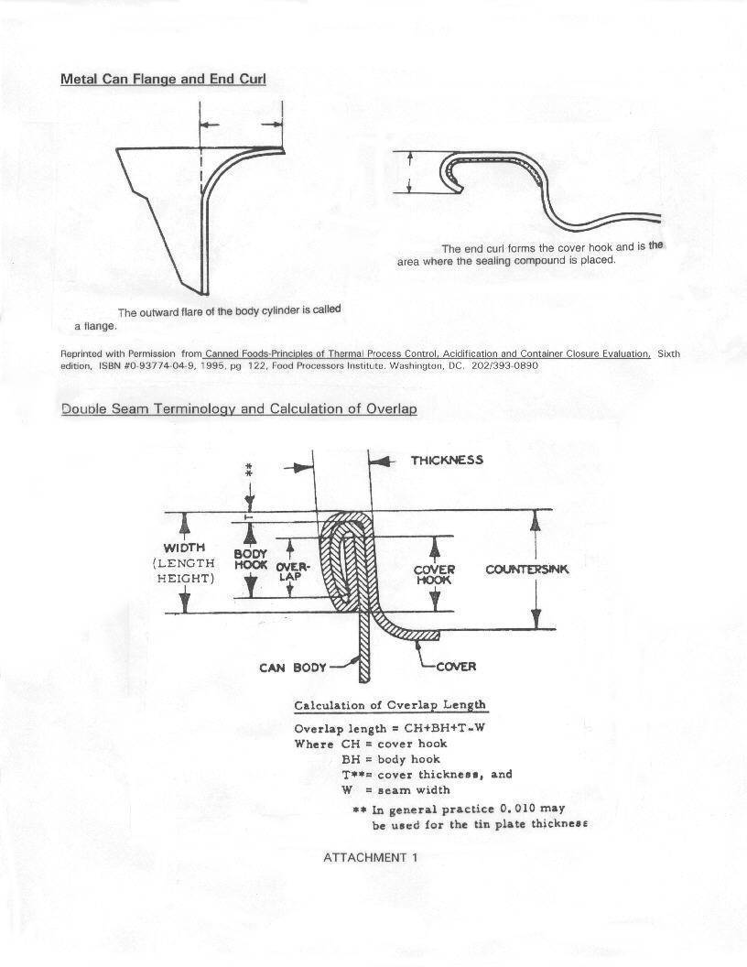

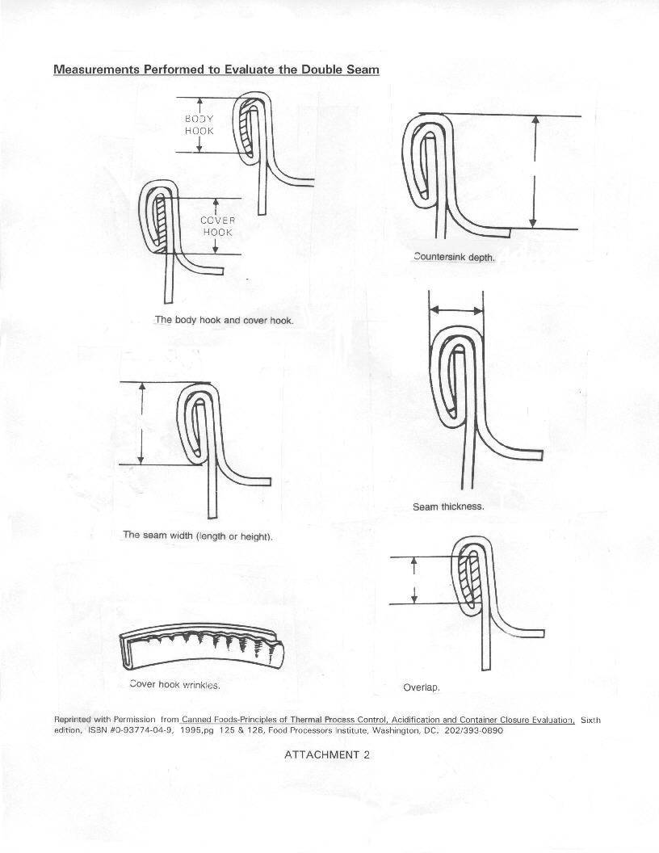

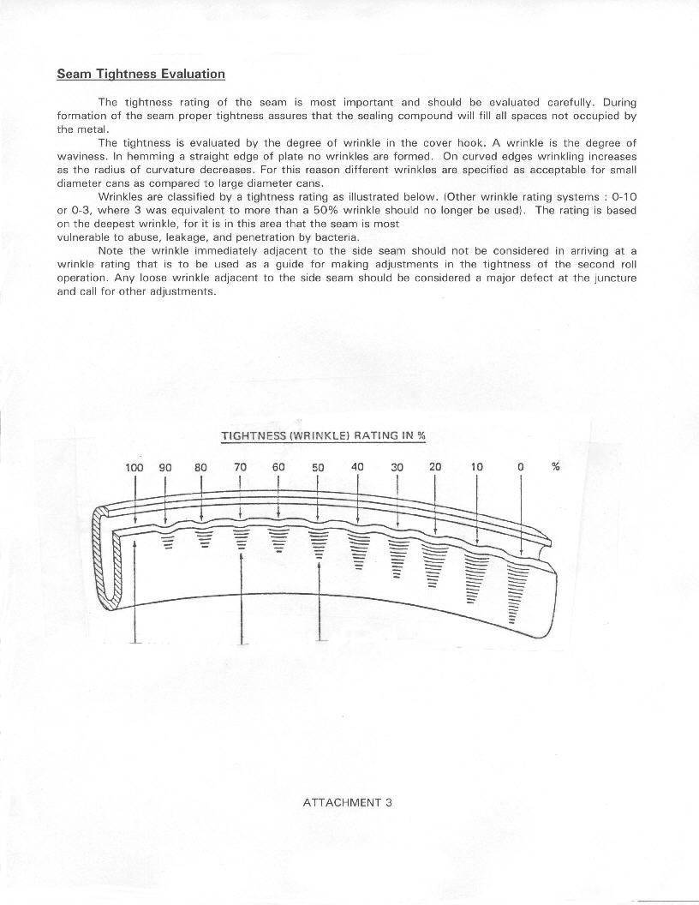

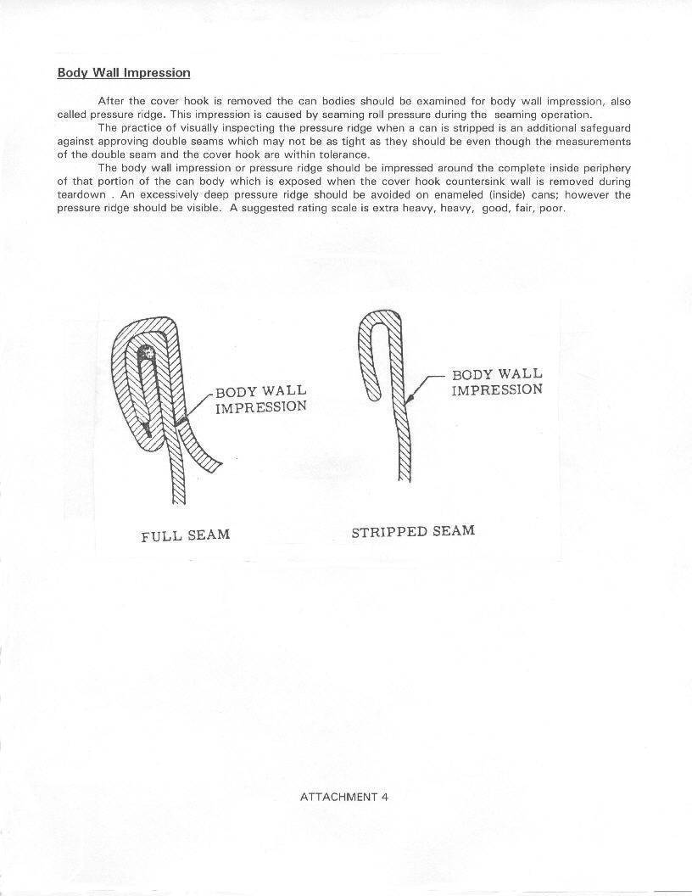

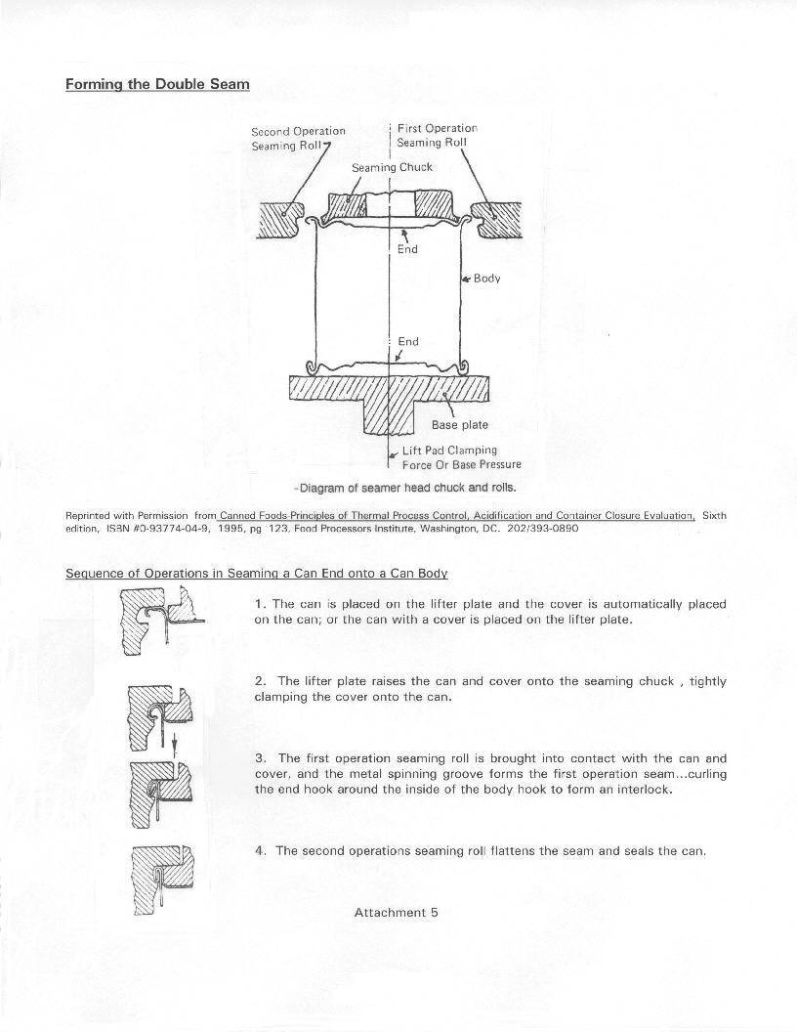

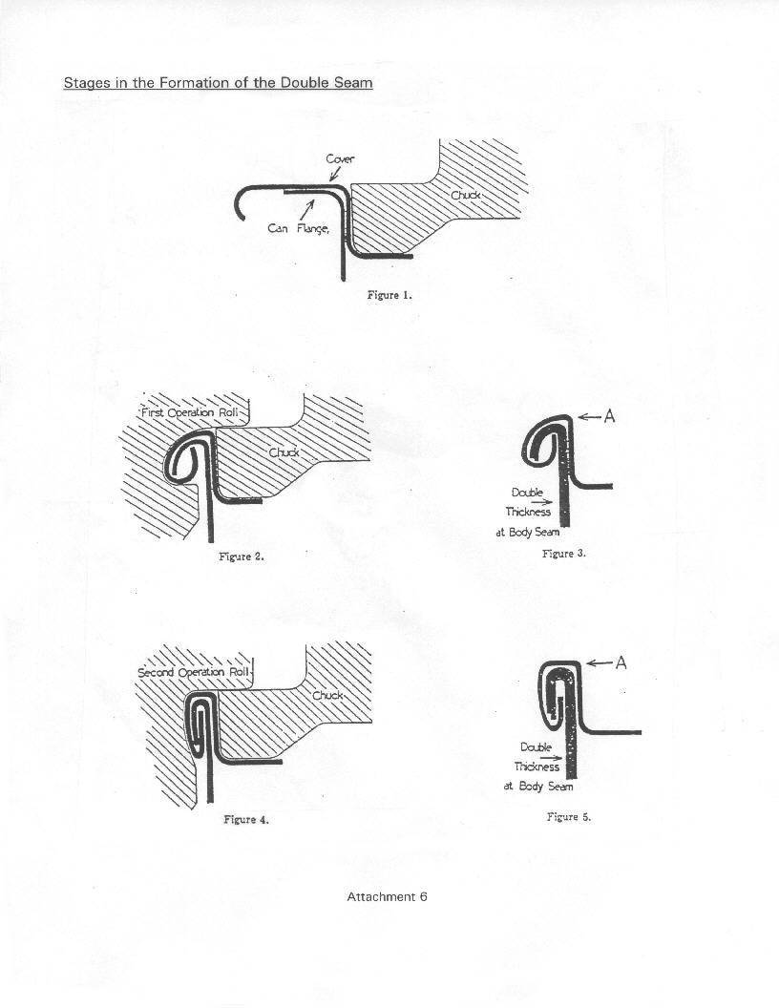

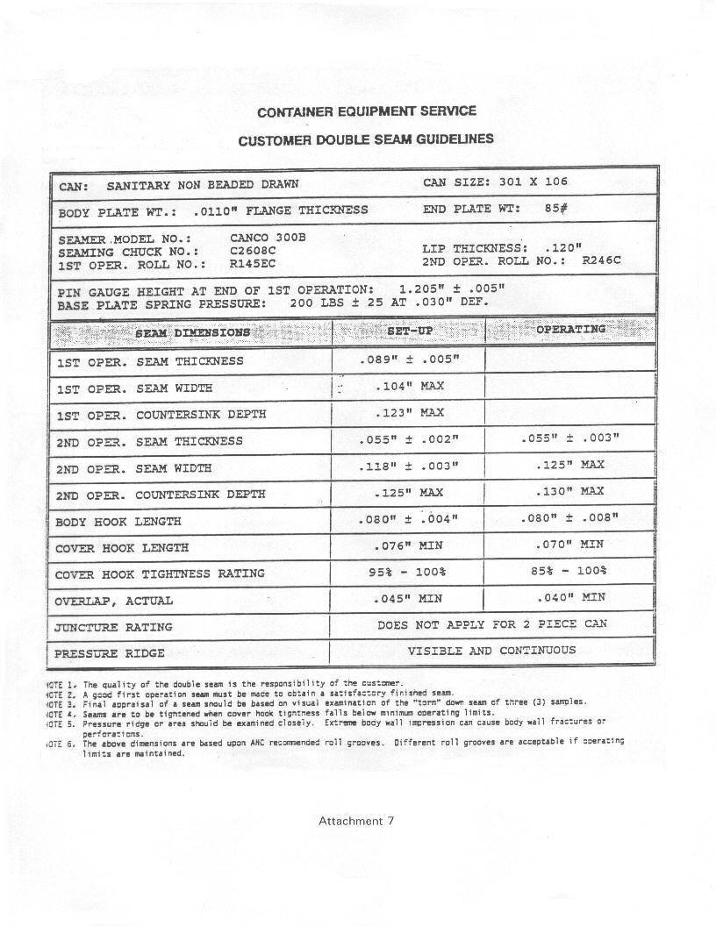

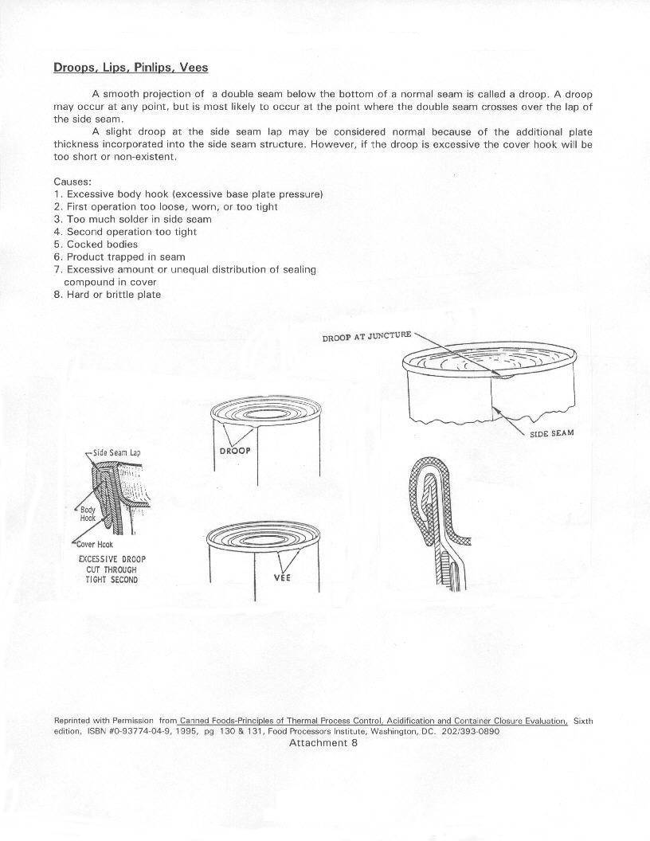

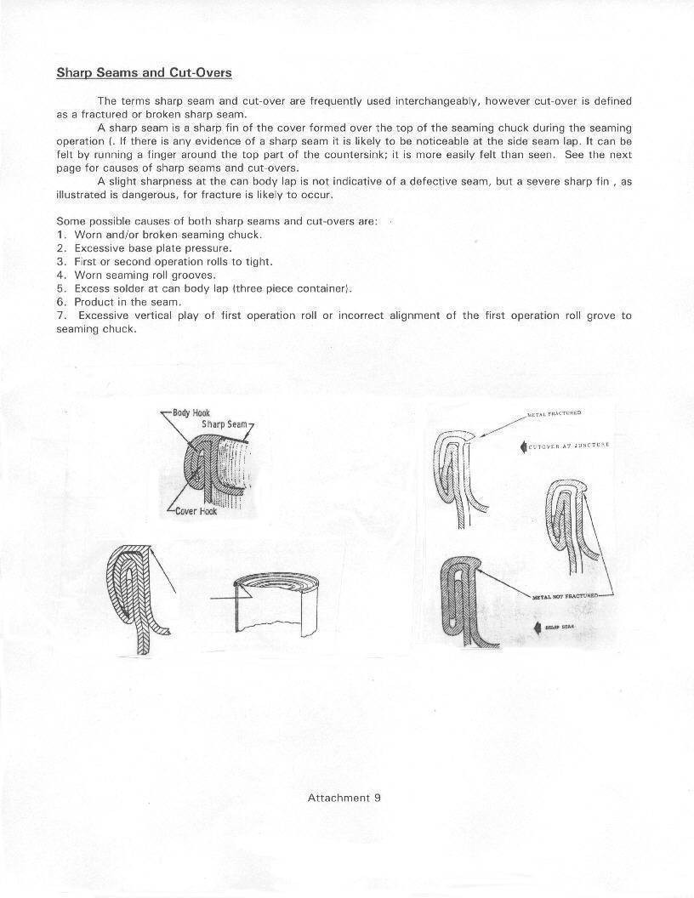

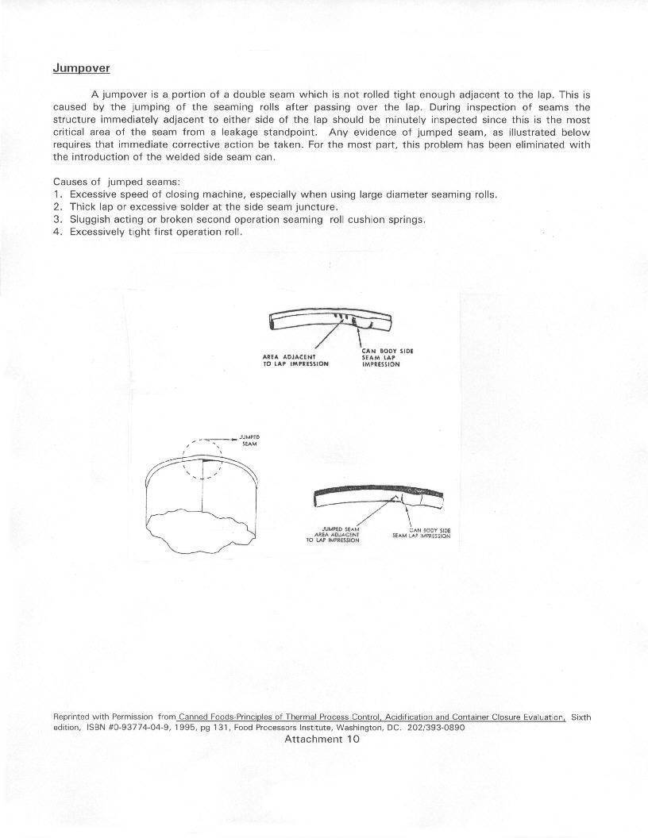

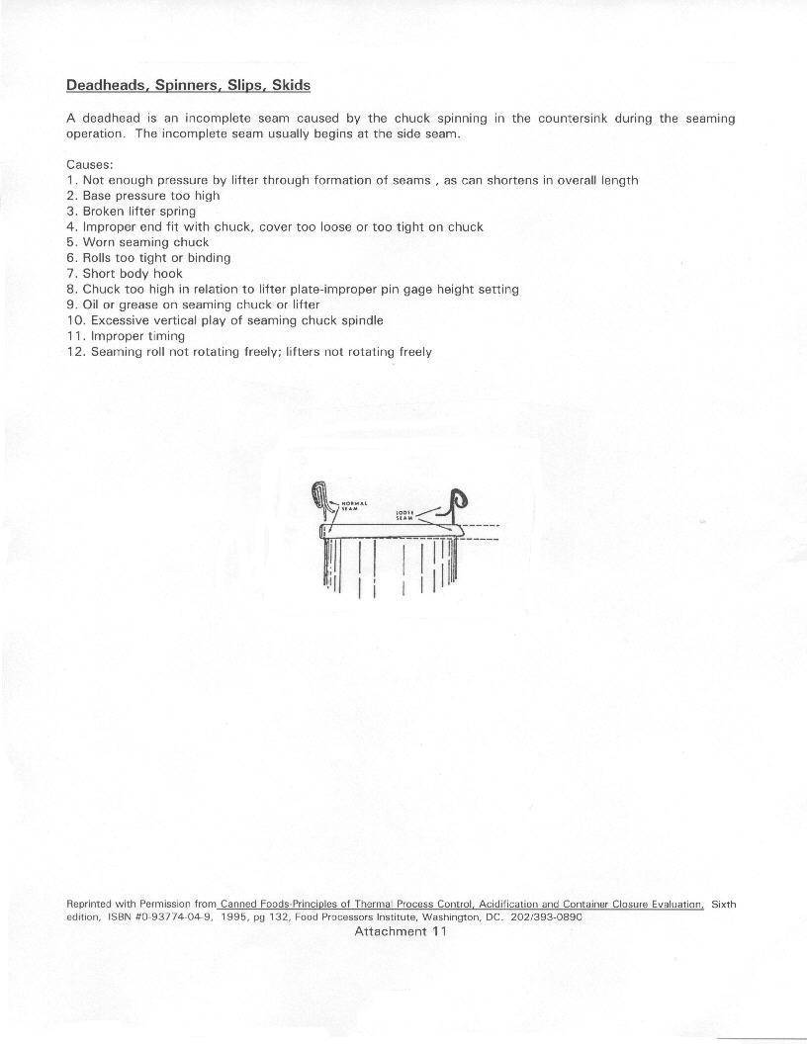

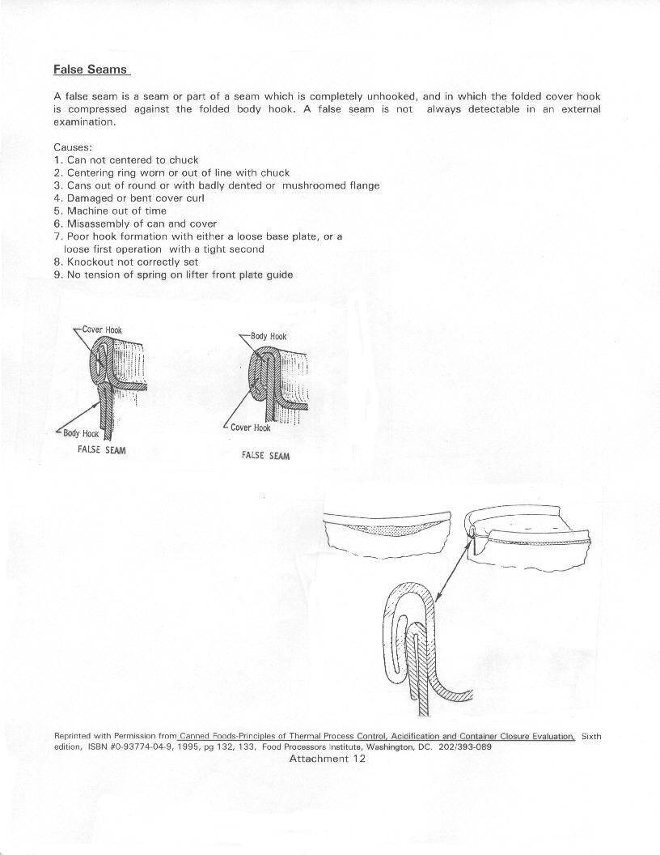

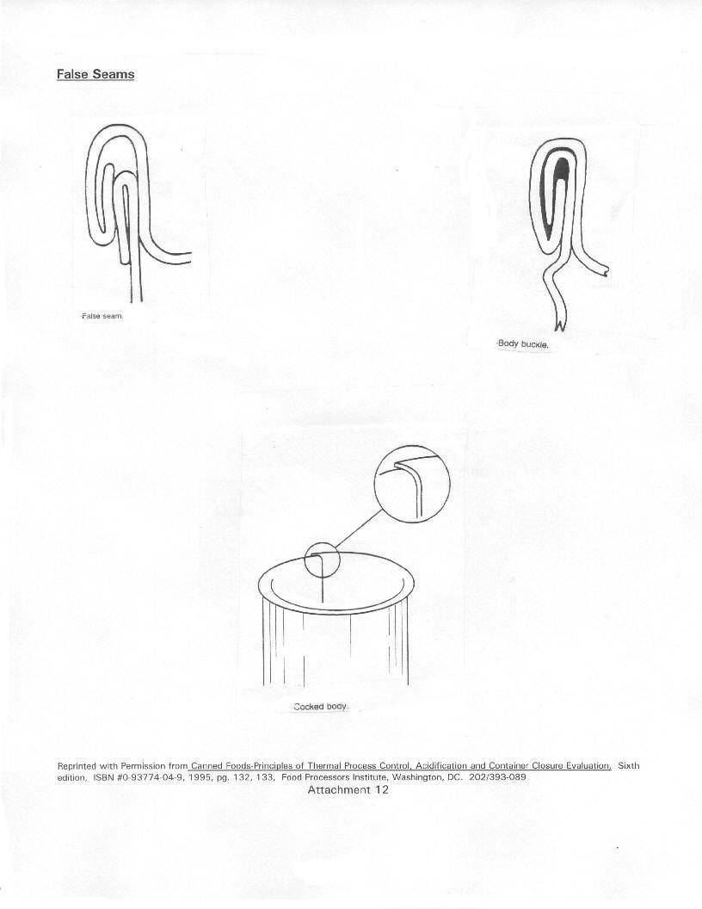

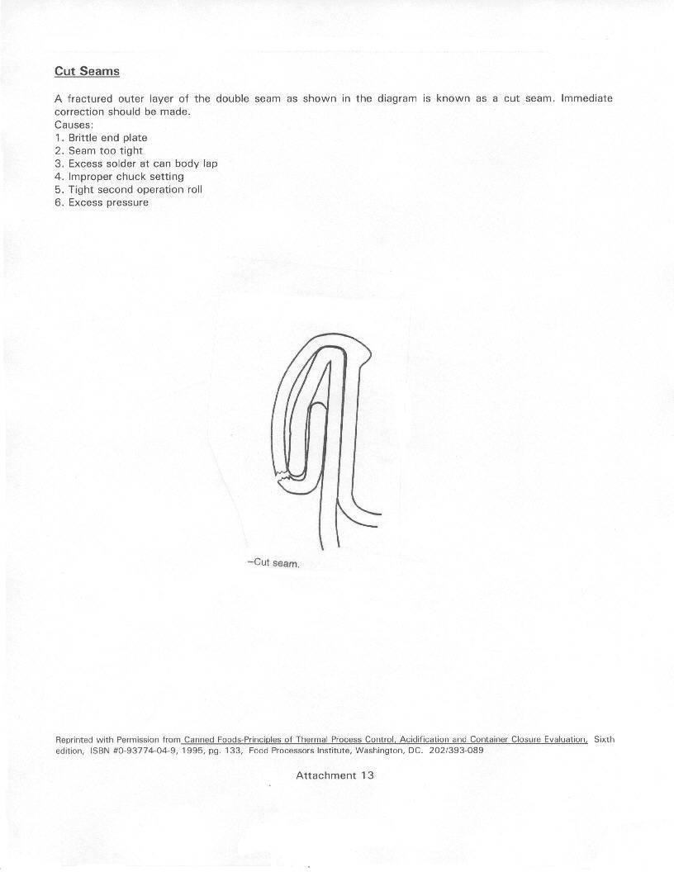

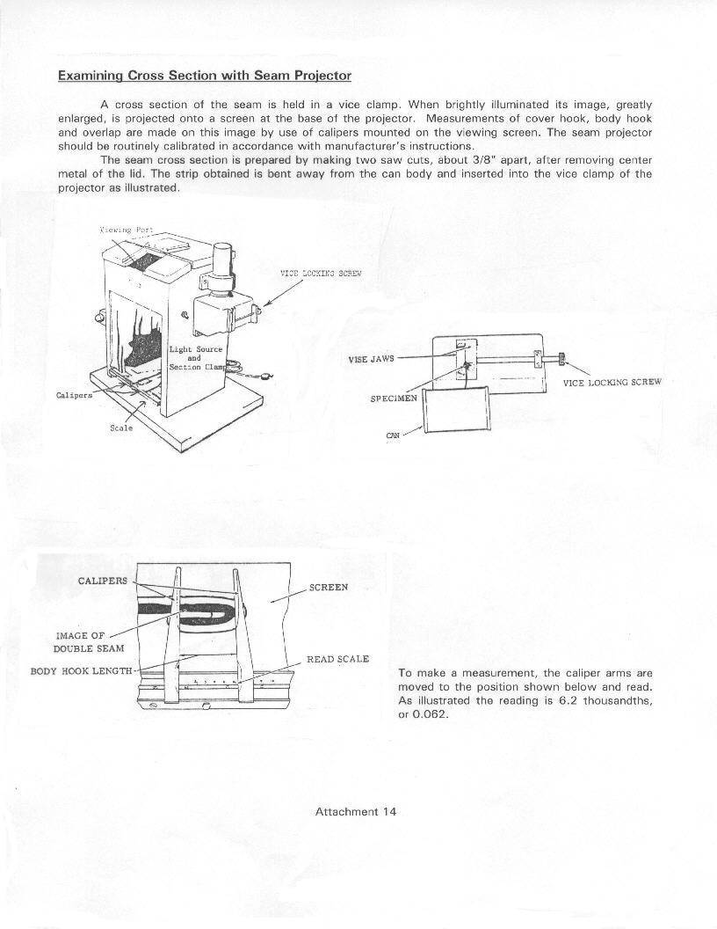

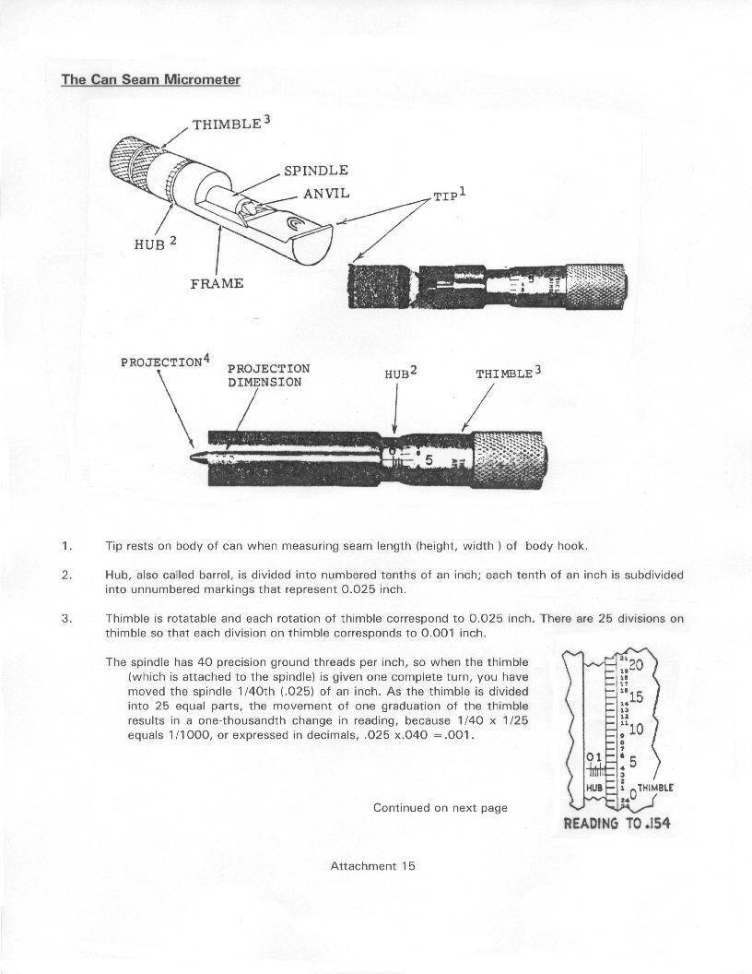

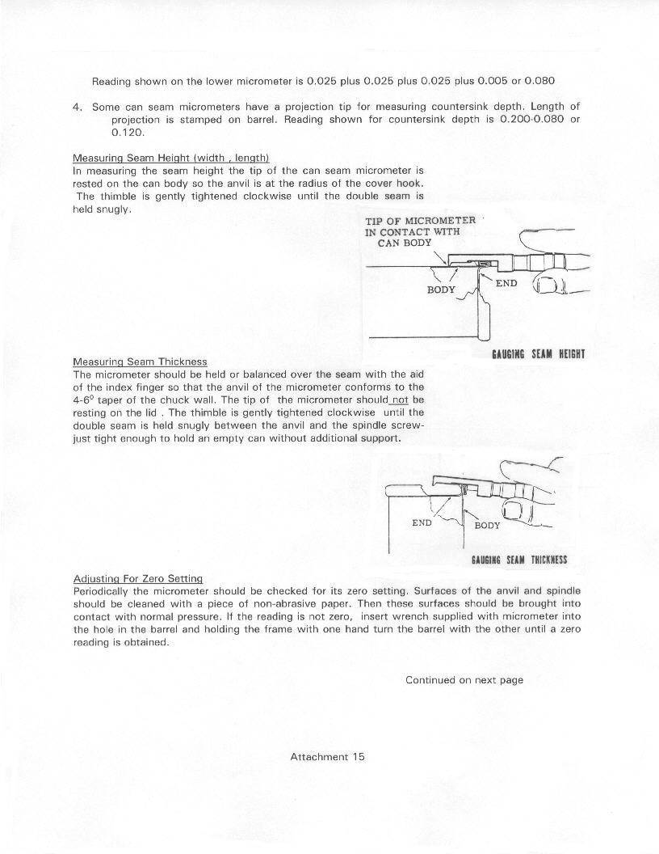

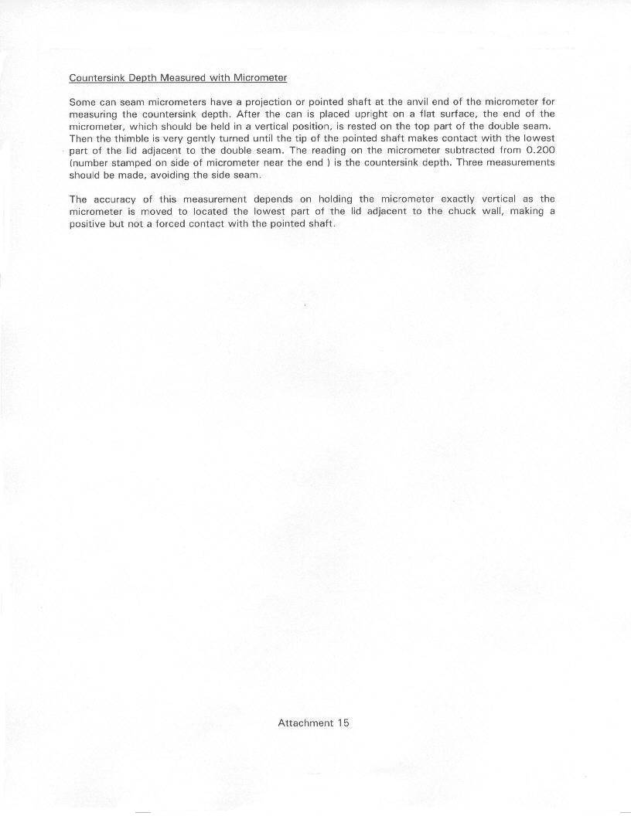

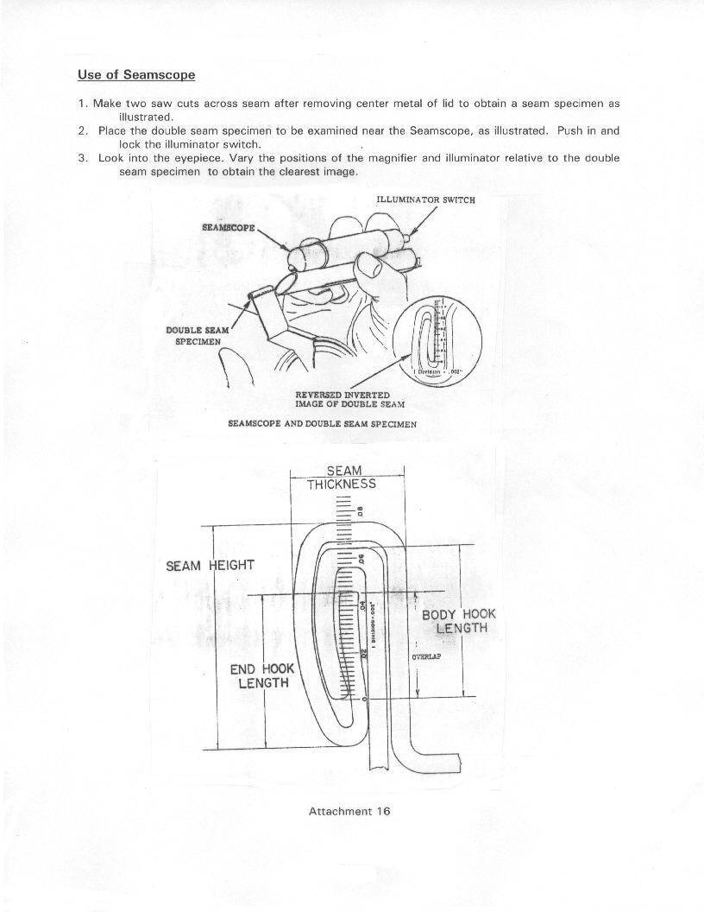

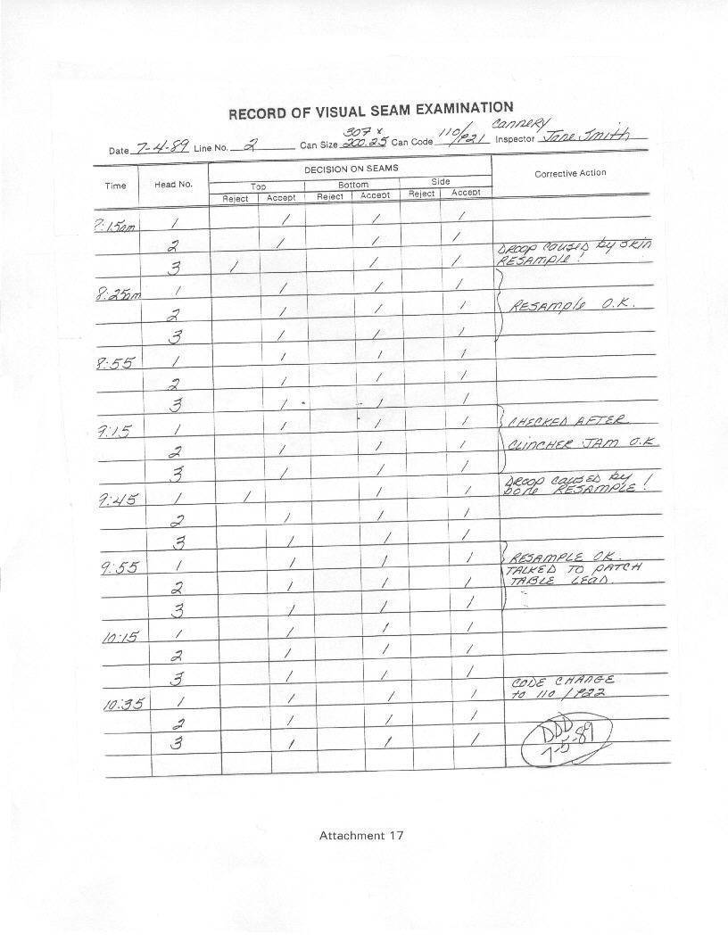

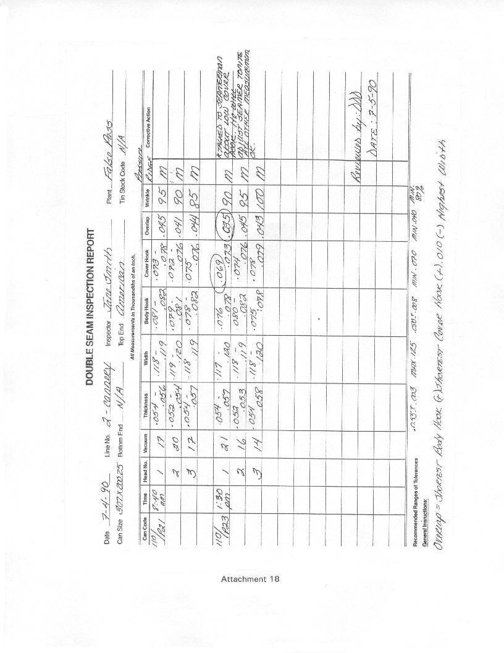

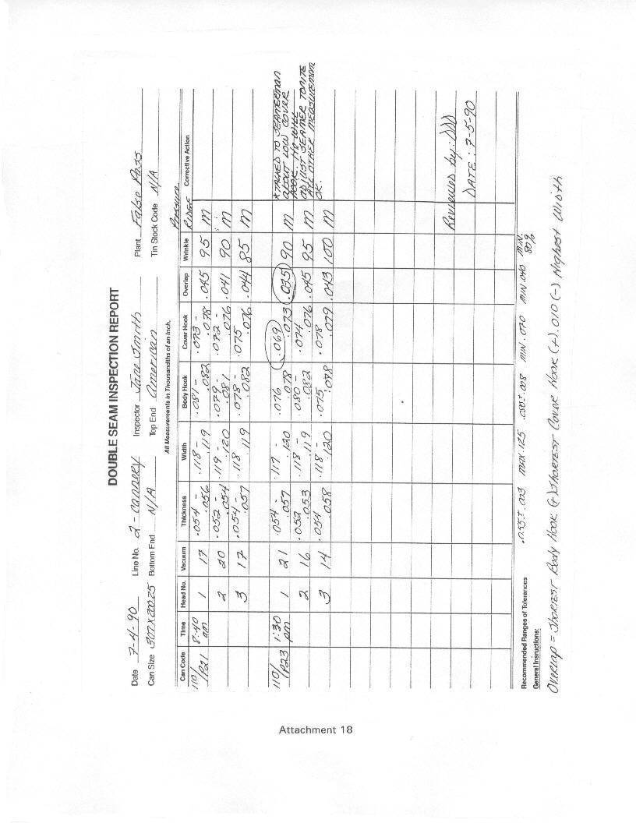

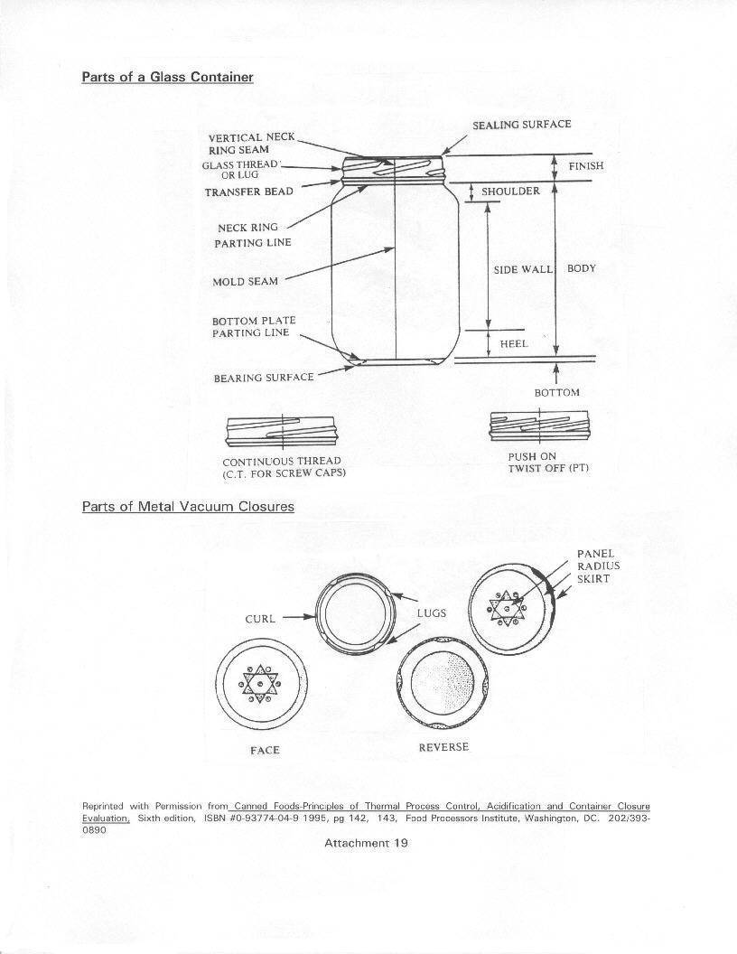

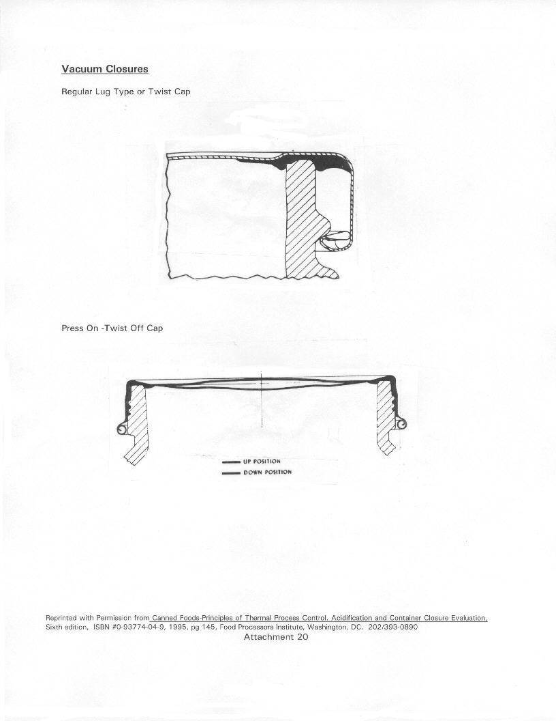

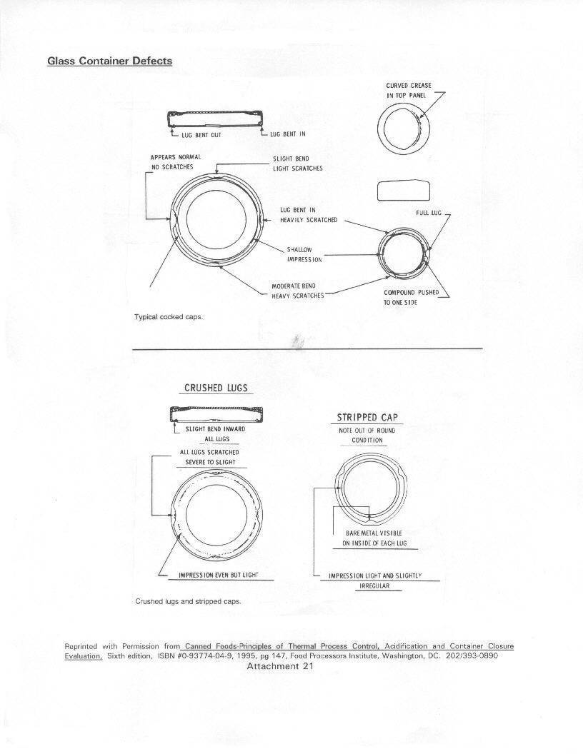

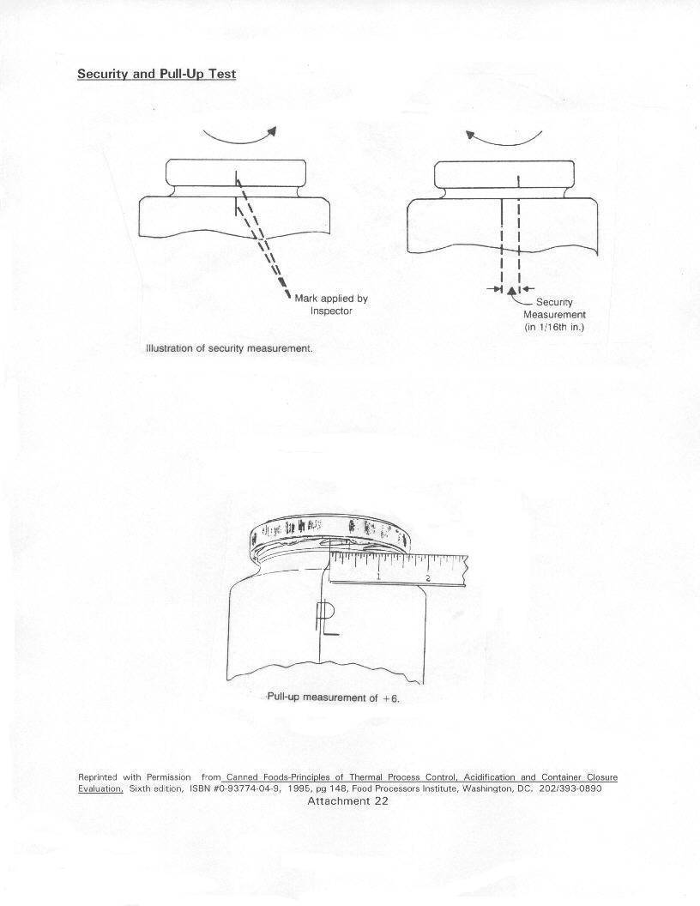

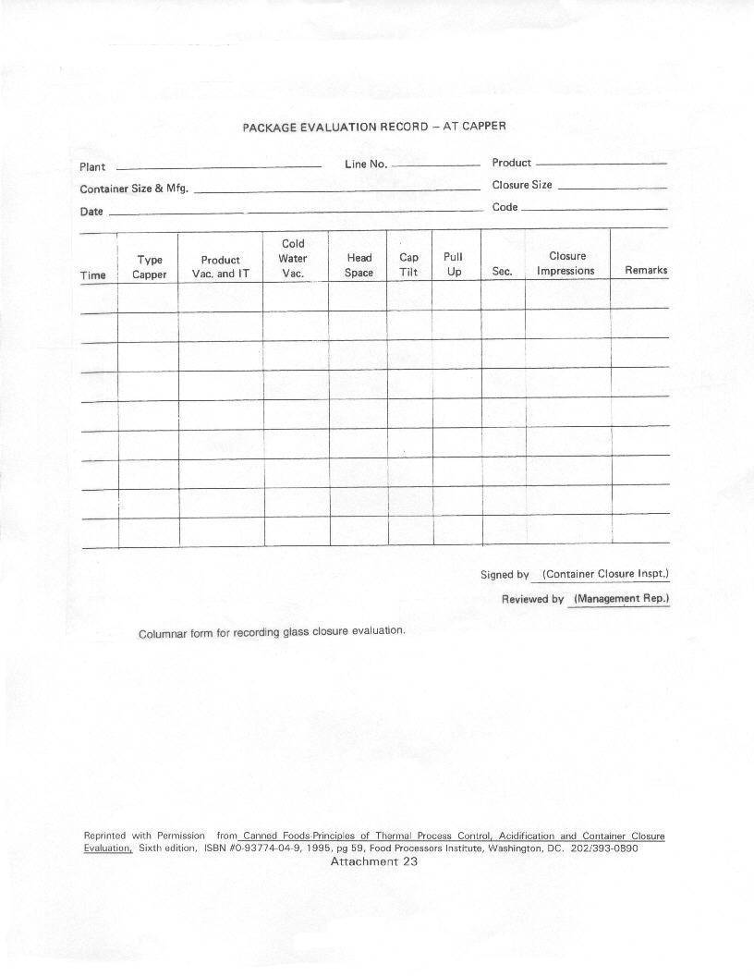

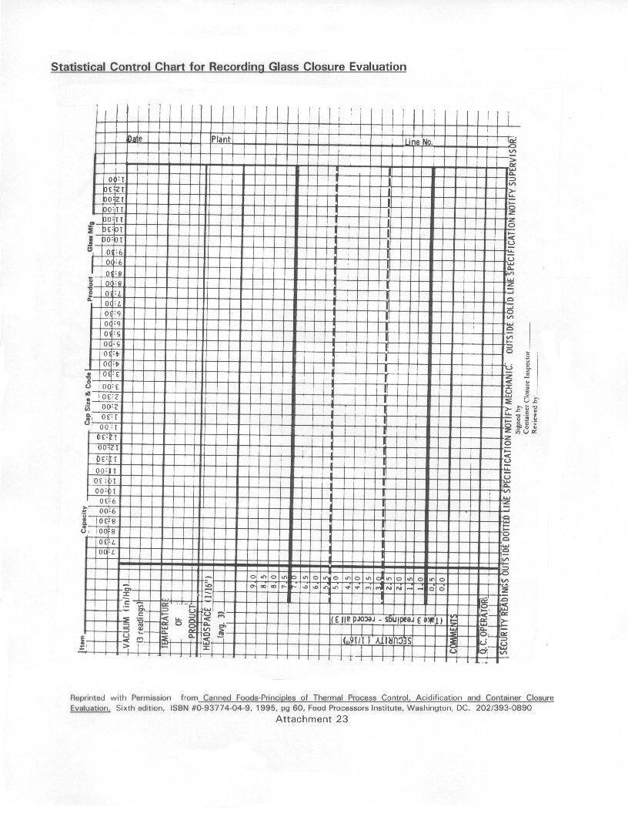

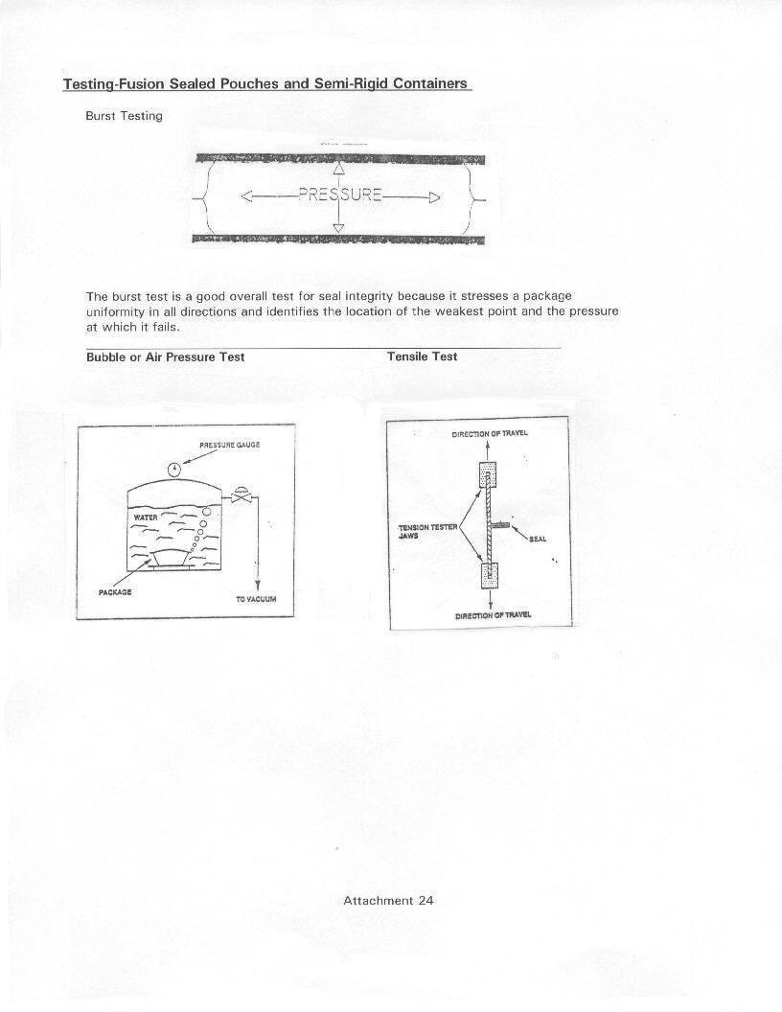

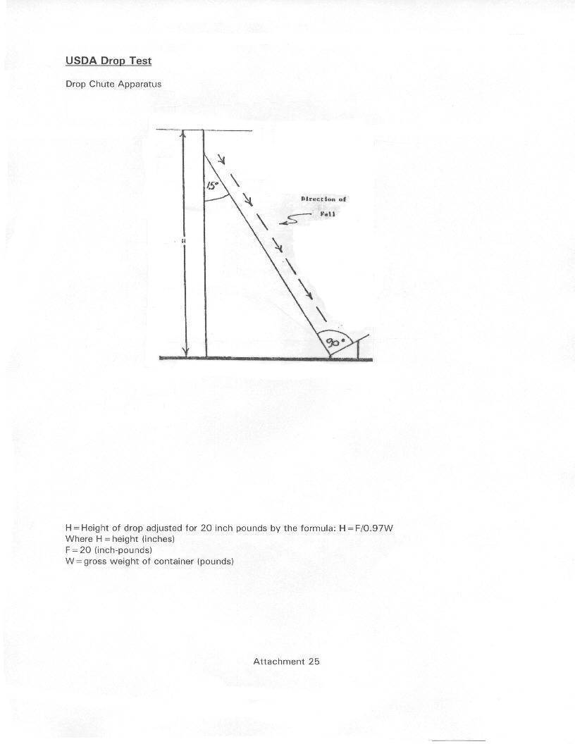

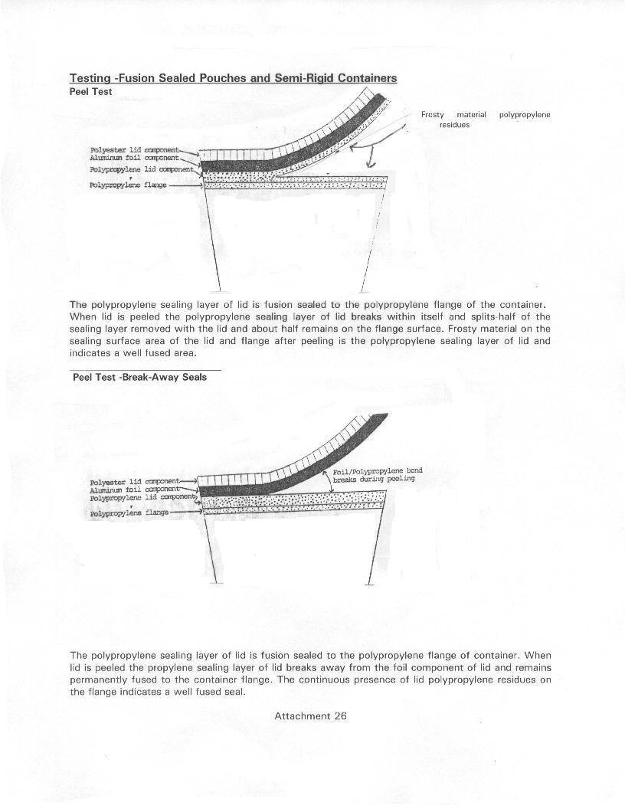

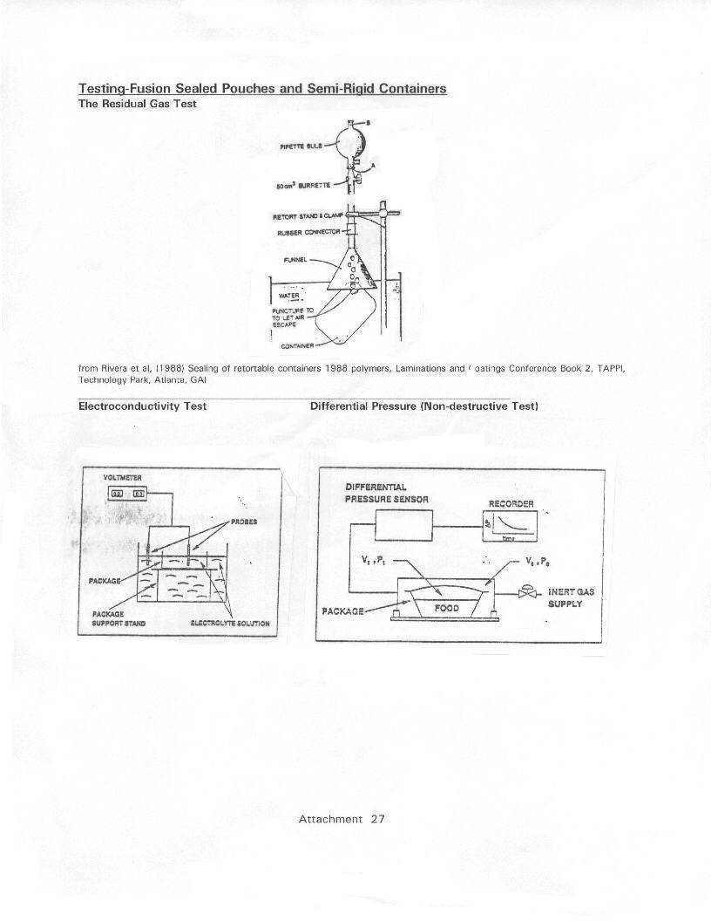

¹ Note: This document is reference material for investigators and other FDA personnel. The document does not bind FDA and does not confer any rights, privileges, benefits or immunities for or on any person(s).

