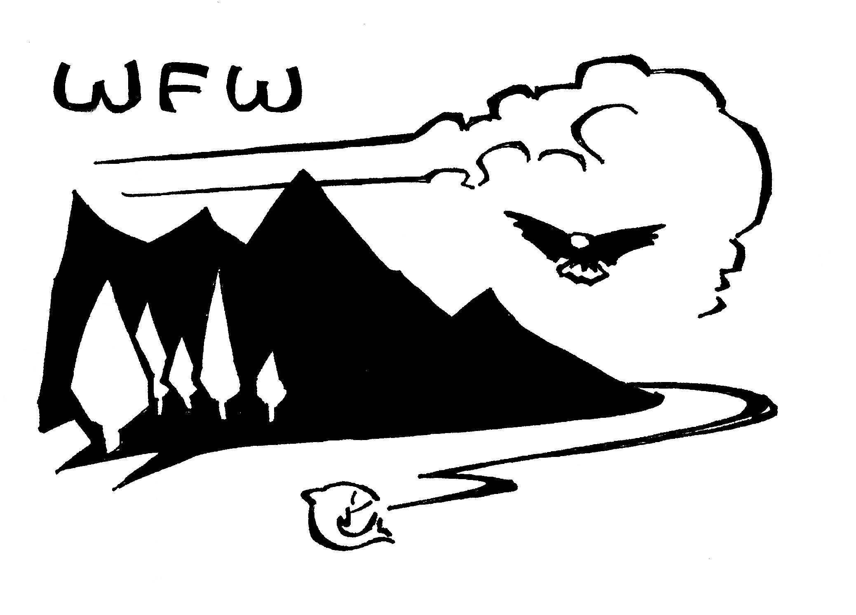 | Forest Service, US Department of Agriculture  WATERSHED – FISH – WILDLIFE – AIR – RARE PLANTS ::: WFW  MONTHLY WFW STAFF NEWSLETTER  SPECIAL EDITION :: AWARDS  SPRING 2007

CONTENTS

72nd North American Wildlife & Natural Resource Conference
Portland, Oregon :: March 19 - 23, 2007

Lloyd Swift Award, USFS
Richard Holthausen
Jack Adams Award, USFS
Steve Widowski
FS/BLM Conservation Project Award
Barry Wiley, USFS and Melissa Garcia, BLM
FS/BLM Conservation Partner Award
David Burton
Wings Across the Americas, USFS
International Cooperation Award
Distribution, Ecology, and Life History of the Pearly-eyed Thrasher
Research & Management Partnership Award
Birds and Burns Network
Habitat Conservation Awards (2)
Cooper River Corridor
South Patrol Road Restoration Partnership
Midewin National Tallgrass Prairie; The Wetlands Initiative

USDI Fish & Wildlife Service (FWS Region 2)

Fisheries & Habitat Conservation Award
Amy Unthank

31st National Wild Turkey Federation (NWTF) National Convention
Nashville, Tennessee :: February 23 - 25, 2007

Land Stewardship Award
Southern Region, Chuck Myers RF
Wheelin' Sportsmen National Wild Turkey Federation’s (NWTF)
2007 Agency Achievement Award
USDA Forest Service - Zimmerman and Myers
Making Tracks Awards:
Habitat Project – Individual
Steve Blatt
Habitat Project – Group
Tellico Ranger District, Cherokee NF and Partners
Conservation Program
Shawnee NF

7th Annual Mule Deer Foundation National Convention
Reno, Nevada :: January 20, 2007

Mule Deer Conservation Award
Rich Thurman

23rd Rocky Mountain Elk Foundation Conference
Reno, Nevada :: February 22 – 25, 2007

Elk Country Wildlife Habitat Improvement Achievement Award
Fishlake National Forest, Utah
Elk Country Individual Achievement Award
Craig Grother
Elk Country Land Protection Award
Not awarded this year
Elk Country Conservation Education Award
Not awarded this year

Hydrologist of the Year - USDA Region 9
Eastern Region Honors Awards :: November 29, 2006

Bonnie Ilhardt

Submit your information
Disclaimer & Non-Discrimination Statement

AWARDS
Over the past few months awards have been presented across the nation. This special edition of the WFW Newsletter spotlights the various award winners.
Congratulations to everyone. Your hard work is greatly appreciated.

72nd North American Wildlife & Natural Resource Conference

HOLTHAUSEN RECEIVES COVETED LLOYD SWIFT AWARD
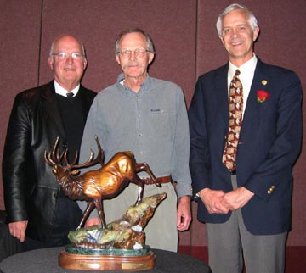
Richard Holthausen, retired USFS National Wildlife Ecologist, received the Lloyd Swift award at the 72nd North American Wildlife and Natural Resource Conference in Portland, Oregon (March 21, 2007). This award is presented periodically to a current or past Forest Service employee in the field of wildlife, fisheries and rare plants, who exemplifies the characteristics, accomplishments and qualities of Lloyd W. Swift Sr., a wildlife biologist for the Forest Service (1928-1963). Winners of this award must have demonstrated a lifetime of dedication, commitment, and leadership in management of the wildlife and fisheries resources of the United States.
L to R; Jim Hughes, Acting Director, BLM; Dick Holthausen; Joel Holtrop, USFS, Deputy Chief, NFS. Lloyd Swift Award.

Submitted By: David Pivorunas, USFS/WO/WFW

WIDOWSKI RECEIVES JACK ADAMS AWARD
Steve Widowski received the prestigious 2006 Jack Adams award at the 72nd North American Wildlife and Natural Resource Conference in Portland, Oregon (March 21, 2007). Steve is an Assistant District Ranger and Wildlife Biologist from the Mississippi Bluffs Ranger District of the Shawnee National Forest in Illinois. The Jack Adams Award is presented annually to a Forest Service wildlife biologist, fisheries biologist, or botanist exemplifying the characteristics and qualities of Jack Adams, wildlife biologist for the Forest Service (1961-1984). These characteristics include steady hard work and dedication to balanced resource management of the National Forests, and ensuring that wildlife, fisheries, and rare plants needs are fully reflected in all management decisions.

Submitted By: David Pivorunas, USFS/WO/WFW

WILEY & GARCIA RECEIVE JOINT AGENCY AWARD FOR CUTTHROAT PROJECT
Barry Wiley of the Forest Service and Melissa Garcia of the Bureau of Land Management received the joint Forest Service/BLM Project award. Wiley and Garcia worked on the Upper Rio Grande Cutthroat Conservation Project. Both are employees at the San Luis Valley Public Land Center and Monte Vista, Colorado in the Rocky Mountain region. Melissa Garcia (Wildlife Biologist) and Barry Wiley (Fisheries Biologist, Rio Grande National Forest) accepted the award at the annual North American Wildlife and Natural Resources Conference in Portland, OR. Garcia and Wiley served on a cooperative team that published the “Conservation Agreement for the Range-Wide Preservation and Management of the Rio Grande Cutthroat Trout” in June 2003, which resulted in the establishment of an aggressive cutthroat trout population restoration program in the Rio Grande Valley.

The project awards is presented annually to recognize development and implementation of a joint FS-BLM project with outstanding conservation accomplishments for fish, wildlife and/or native plants and their habitat on public lands, and/or facilitates their use, enjoyment or appreciation. The project can be at either a local, regional or national level.

Submitted By: David Pivorunas, USFS/WO/WFW; Amy Unthank, USFS/R3/WFRP; FSToday

BURTON RECEIVES JOINT AGENCY AWARD FOR ASPEN DELINEATION
David Burton accepted this year’s joint Forest Service/Bureau of Land Management Partner award at the annual North American Wildlife and Natural Resources Conference in Portland, OR. Burton is a volunteer working on the Aspen Delineation Project in California, helping agencies identify, map, treat, and monitor aspen habitats.

The partner award is presented annually to an organization or individual representing a conservation organization for their outstanding leadership in the development and implementation of conservation programs and activities that have directly benefited fish, wildlife and/or native plants on public lands or their use, enjoyment and appreciation.

Submitted By: David Pivorunas, USFS/WO/WFW

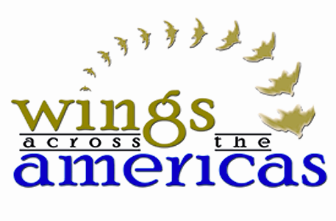
Wings Across the Americas - 2007

Joel Holtrop, Deputy Chief, National Forest Systems, and Linda Goodman, Regional Forester from Region 6, honored award recipients for outstanding achievements in bird conservation at the 72nd North American Wildlife and Natural Resources Conference. This annual international event brings partners together to recognize outstanding achievements in bird conservation across the Americas. Awards were given to Forest Service employees and partners from conservation organizations, universities, foundations, and private sector partners. Partnerships are the most effective way to conserve birds across different land ownerships, and across domestic and international boundaries.

Awards for 2007 were given in the following categories:

International Cooperation AwarD
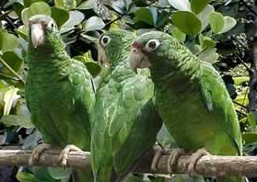Distribution, Ecology, and Life History of the Pearly-eyed Thrasher (Margarops fuscatus): Primary nest predator and competitor for nest sites of the critically endangered Puerto Rican Parrot (Amazona vittata)
Puerto Rican Parrot, photo courtesy of Caribbean National Forest
Awardees from the Forest Service included: Dr. Wayne J. Arendt, International Institute of Tropical Forestry, Mrs., Angela I. Arend field biologist volunteer, Dr. Jaime Collazo, U.S. Geological Survey, North Carolina State University, Dr. Steve Beissinger, University of California, Berkeley, Dr. Mark Cook, former University of California Berkeley Post-Doctoral candidate, and three awardees from the University of Puerto Rico include Gary A. Toranzos, and Ana Trujillo and William Beltrán, Río Piedras.

Research and Management Partnership Award
Birds and Burns Network: Fire Effects on Populations and Habitats of Sensitive Species of Wildlife in Ponderosa Pine Forests of the Interior West. Awardees from the Forest Service included: Dr. Vicki Saab, Rocky Mountain Research Station, Dave Thomas – Retired, Intermountain Region, Sam Hescock—Payette National Forest, Bruce Higgins—Kaibab National Forest, Bill Block – Rocky Mountain Research Station, Robin Russell – Rocky Mountain Research Station, Amy Markus -- Silver Lake RD Fremont/Winema National Forest, John Lehmkuhl, Pacific North West Research Station, and Craig Bienz--The Nature Conservancy, Scott Story – Montana Fish, Wildlife, and Parks, and Lisa Bate – Kalispell, MT

Habitat Conservation Awards
Two habitat conservation awards were handed out this year.

1) Cooper River Corridor awardees included: Emily Cope, Elizabeth Crane, and John Frampton of the South Carolina Department of Natural Resources; Chuck Myers, Region 8 Regional Forester, and Tom Darden, Cooperative Forestry from the Forest Service; and, Ken Babcock from Ducks Unlimited.

2) South Patrol Road Restoration Partnership awardees included: U.S. Forest Service Midewin National Tallgrass Prairie; The Wetlands Initiative, Chicago District; and the U.S. Army Corps of Engineers, CorLands.

For more information about Forest Service Program, Wings over the Americas, visit the Forest Service website: www.fs.fed.us/global/wings

USDI Fish & Wildlife Service (FWS Region 2)

UNTHANK RECEIVES FISHERIES & HABITAT CONSERVATION AWARD
On March 1, Amy Unthank, Southwestern Regional Fisheries Program Manager, received a Fisheries and Habitat Conservation award from Region 2 of the U.S. Fish and Wildlife Service. The award was for being a much appreciated partner, dedication to the southwestern aquatic systems both on and off National Forest lands, for help in achieving the downlisting of Gila trout, and for working with a range of partners and publics in southwestern New Mexico that present a diverse and challenging array of interests.

The award was presented at a luncheon in the Rayburn House Office building, attended by five members of Congress, USFWS staff from around the country, and winners from the other 7 regions of the U.S. Fish and Wildlife Service. It was the USFWS's "Species Survival Revival" week in Washington D.C. when various personnel from USFWS come into DC to attend partner events and visit congressional members and staffers. The award was presented by Dr. Mamie Parker and Director H Dale Hall of the U.S. Fish and Wildlife Service. The WO Assistant Director over Watershed and Fisheries, Ron Dunlap, attended the luncheon with Amy.

Submitted By: Ron Dunlap, USFS/WO/WFW

31st National Wild Turkey Federation National Convention

The USDA Forest Service received multiple awards during the National Wild Turkey Federation's 31st annual Convention and Sport Show in Nashville, TN, February 23 to 25, 2007. The NWTF, with the assistance of its many dedicated volunteers, and corporate and government partners, has helped improve more than 11 million acres of wildlife habitat on rights-of-way, private, corporate and public lands. For more information about the NWTF, or efforts to promote sound land stewardship, call (800) THE-NWTF.

Land Stewardship Award: Southern Region, Chuck Myers RF
Chuck Myers, Southern Region Regional Forester accepted Land Stewardship award for the Southern Region. The USDA Forest Service Southern Region earned the award for its land management efforts on behalf of wild turkeys and wildlife through their State and Private Forestry organization. The group provides technical and financial assistance to landowners and resource managers to help sustain the nation's forest and protect communities and the environment.

"The USDA Forest Service has been one of our partners from the earliest days of the NWTF," said Bryan Burhans, NWTF national director of land management programs. "They continue to be a major supporter of our organization as well as our national convention ... they very much deserve this award."

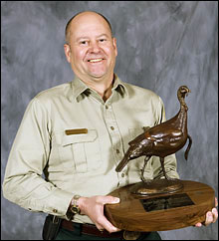
In an effort to promote its mission, the USDA Forest Service helped foster relationships between the NWTF and state forestry agencies, Southern Group of State Foresters and the National Association of State Foresters. These partnerships have led to significant partnerships projects with the NWTF.
USFS Regional Forester, Chuck Myers holding NWTF Award.

"Our relationships with these agencies have been key to managing nearly 10 million acres of land," said Dr. James Earl Kennamer, NWTF senior vice president for conservation programs. "The USDA Forest Service has shown great leadership by using sound land management practices to benefit wildlife. Their support of our conservation efforts and programs has helped us achieve our wild turkey conservation goals."

The NWTF has presented the Land Stewardship Award each year since 1994 to forestry and utility companies and organizations for excellence in land management, partnerships and NWTF project support. The award recognizes those that have done an outstanding job to benefit natural resources through land stewardship and partnerships.

"We are honored to be recognized with this prestigious award from a stellar organization such as the NWTF," USDA Forest Service Regional Forester Chuck Myers stated. "Our work through the State and Private Forestry organization and partners has reached more private landowners than any other program in the South. In order to accomplish even more, we must expand our relationships with our partners such as the NWTF and others in the conservation community." "The NFWF Land Stewardship award is sitting on my desk until we make a presentation to the Chief. It is very impressive!" commented Anne Zimmermann.

Wheelin’ Sportsmen NWTF Agency Achievement Award:
Forest Service
Anne Zimmerman, WO Director of Watershed, Fish, Wildlife, Air and Rare Plants, Chuck Myers, R8 Regional Forester, and Gary Peters, Wildlife Program Leader, Francis Marion and Sumter National Forests accepted the award. The Wheelin Sportsmen NWTF Agency Achievement award is presented to a natural resource agency in recognition of their support in providing outdoor activities for disabled participants.

"The USDA Forest Service has been one of our partners from the earliest days of the NWTF," said Kirk Thomas, NWTF national director of the Wheelin’ Sportsmen. "They continue to be a major supporter of our organization and many of our events ... they very much deserve this award."

In an effort to promote its mission, the USDA Forest Service helped foster relationships between the NWTF and to provide increased access to recreational opportunities and have supported many events for disabled hunters and recreationists. Wheelin' Sportsmen NWTF offers all outdoorsmen and women with disabilities the opportunity to enjoy the outdoors through events held in communities across the nation featuring hunting, fishing and shooting activities. The program also provides a full-color, quarterly magazine for its members.

Making Tracks Awards:

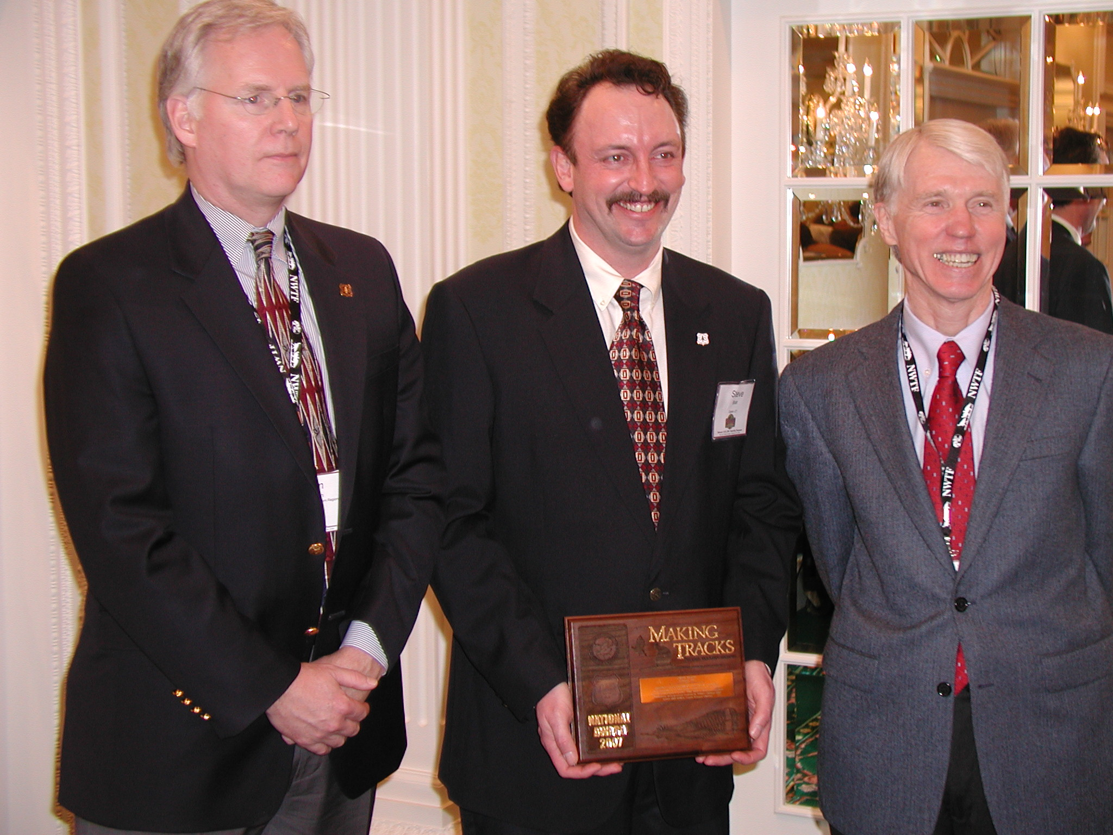
Habitat Project – Individual: Steve Blatt, Logan RD, Wasatch Cache NF
L to R: Tom Peterson, R8 DRF, Steve Blatt, and Fred Norbury.

Steve Blatt, Logan Ranger District of the Wasatch-Cache National Forest in Utah, received a National Making Tracks Habitat Management Projects award. Blatt received the award for his participation in the Willow Springs and Lower Mill Hollow Riparian Enhancement projects.

Habitat Project – Group: Tellico Ranger District, Cherokee NF and Partners
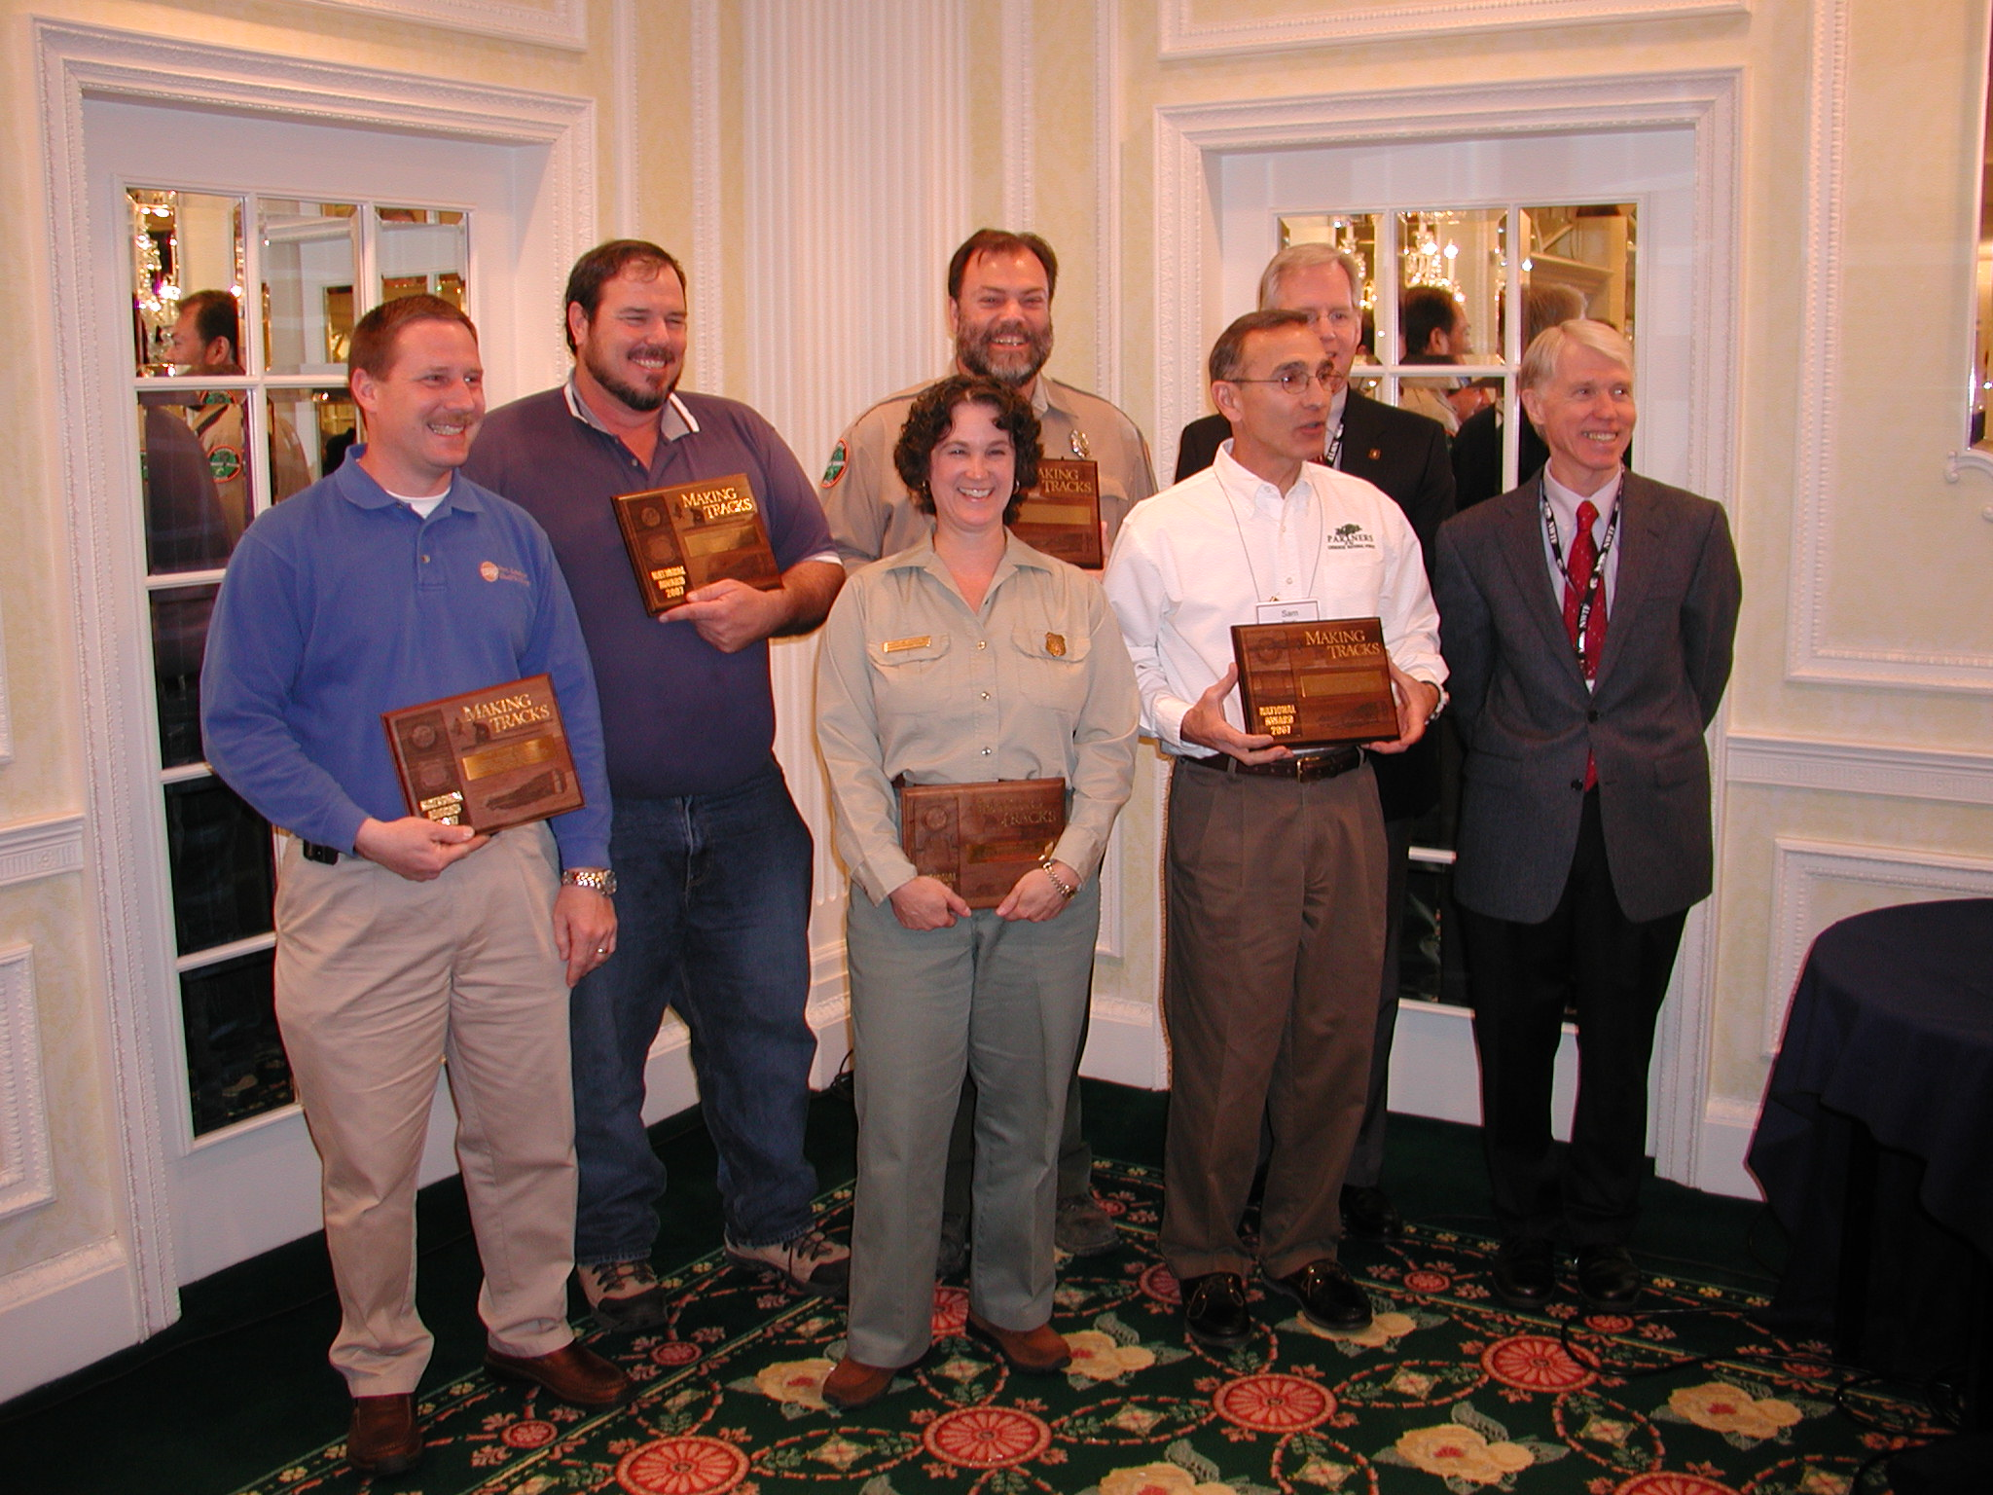
With thousands of miles of power lines streaming across state and federal forests, utility rights of way have great potential to provide food and cover to wildlife, especially wild turkeys. The Native Grass Establishment in Utility Corridors Partnership and the Cherokee National Forest received the National Making Tracks Habitat Management Projects award for enhancing habitat for wildlife on more than 18 miles of transmission lines.
L to R: Jerrod Brackett, Ft Louden Electric Cooperative, Greg Colvin, Southern Appalachin Chapter NWTF, Mary Dodson, Tellico RD WL biologist, David Whitehead, TN Wildlife Resource Agency, Sam Brocato, Friends of the Cherokee NF, Tom Peterson R8 DRF, Fred Norbury.

Conservation Program – Shawnee NF
For more than 20 years, the National Wild Turkey Federation has partnered with the U.S.D.A. Forest Service and the Illinois Department of Natural Resources to enhance wild turkey habitat in the Shawnee National Forest.

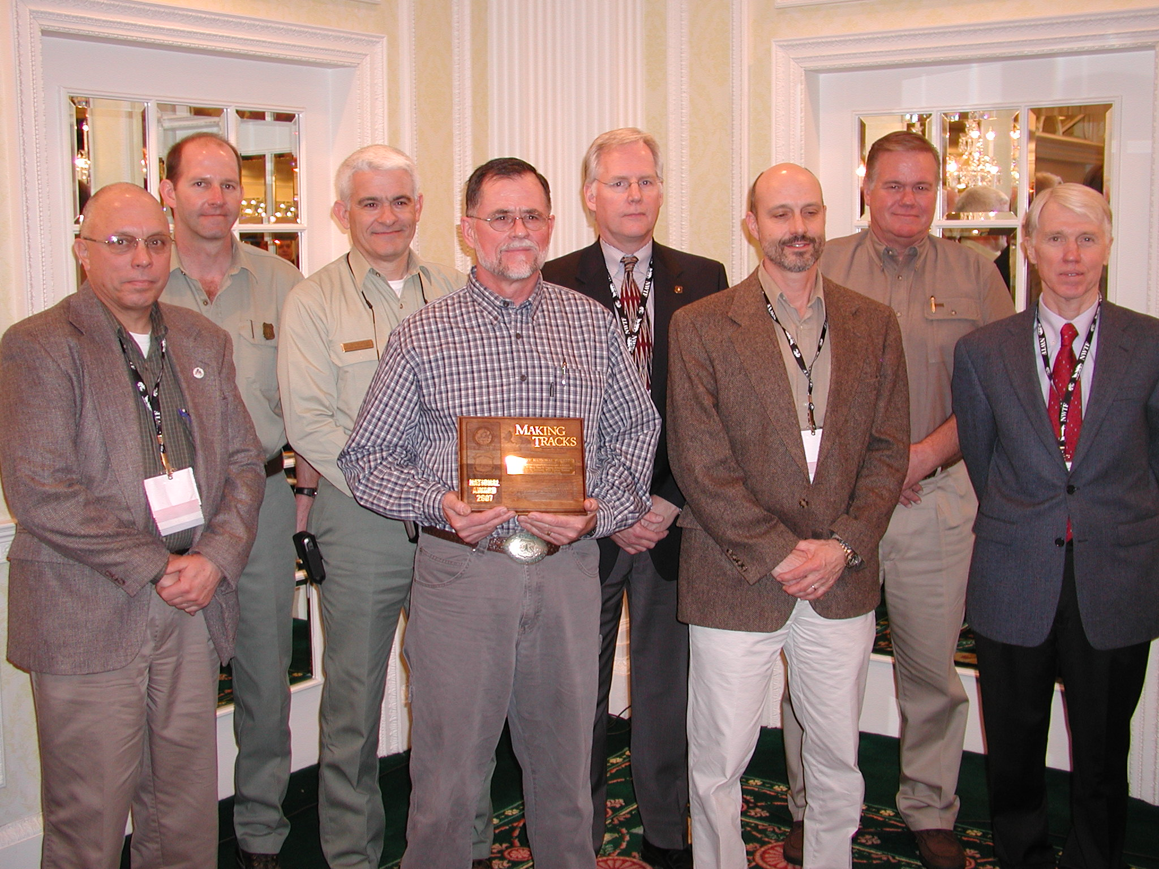
This partnership, which has enhanced thousands of acres of wildlife habitat on the largest block of public land in Illinois, earned the Shawnee National Forest the National Making Tracks Habitat Management Programs award. “The Shawnee National Forest is a popular hunting and recreation destination in Illinois,” said Dr. James Earl Kennamer, NWTF senior vice president for conservation programs. “The Forest Service has been dedicated to enhancing this area for the benefit of all.”
L to R. Steve Widowski Forest WL Biologist, Jeff Seefeldt, Vienna/Elizabethtown Districts Ranger, Allen Nicholas, Forest Supervisor, Rod McClanahan, East Side WL Biologist, Tom Peterson, R8DRF, Nick Giannettino, Resource Staff Officer, Dan Lentz, Jonesboro/Murphysboro Districts Ranger, Fred Norbury.

Submitted By: Ted Schenck, USFS/WO&R8/Making Tracks

7th Annual Mule Deer Foundation National Convention

THURMAN RECEIVES 2006 Mule Deer Conservation Award
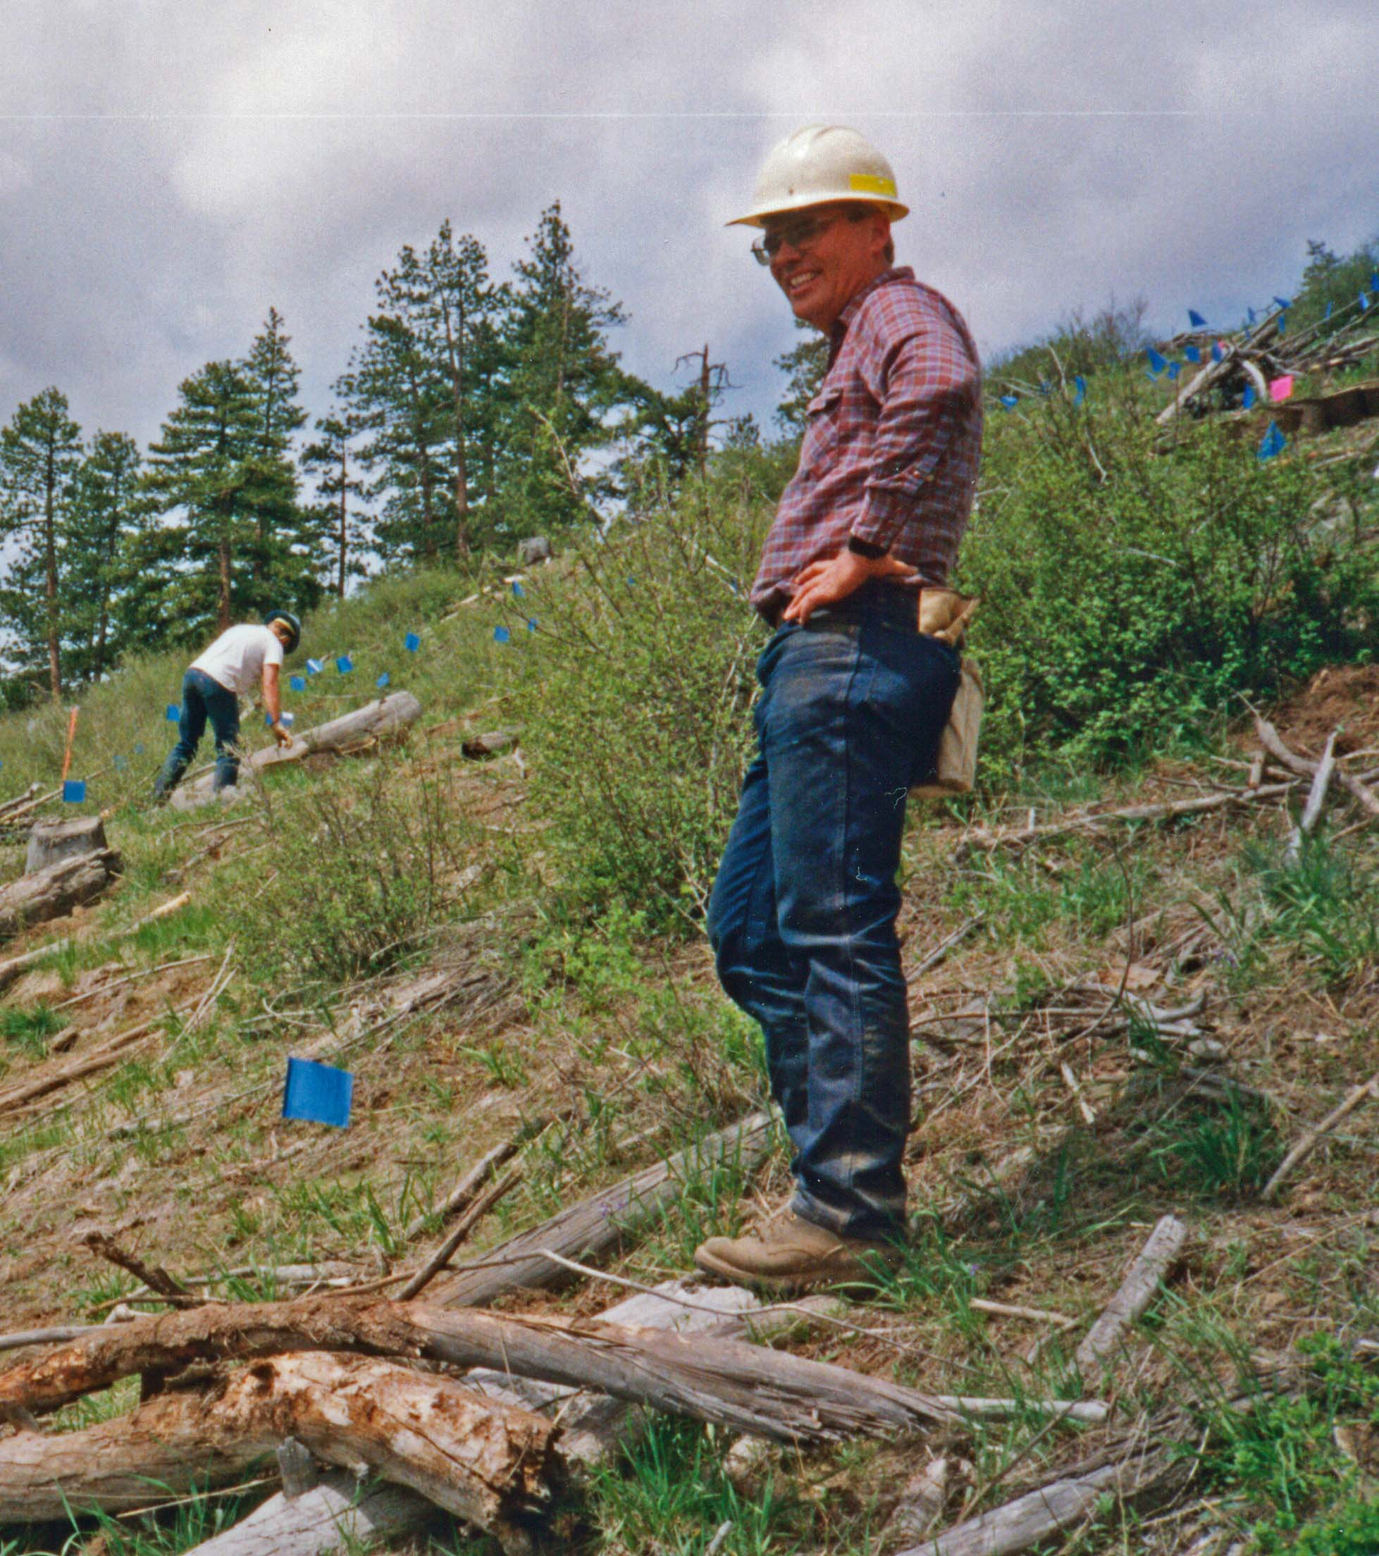
Mt. Hood National Forest wildlife biologist Rich Thurman was honored on January 20th, 2007, at the 7th Annual Mule Deer Foundation (MDF) National Convention in Reno, Nevada, for his leadership in restoring mule deer and black-tailed deer habitat on the Mt. Hood National Forest. This recognition stems from a national partnership, signed four years ago between the Forest Service and the MDF, for the conservation of mule deer and black-tailed deer. As part of the partnership, the MDF recognizes the Forest Service, unit or employees who best demonstrate leadership and excellence in mule deer conservation each year.
Rich Thurman on the job.

The award presented to Mr. Thurman reflects the great, long standing relationship and continued collaborative efforts he fostered with the Columbia Basin Chapter of the Mule Deer Foundation (MDF) that have contributed to mule deer conservation over the past 12 years. Mr. Thurman, recently retired in January 2007, served as the district wildlife biologist on the Barlow Ranger District of the Mt. Hood National Forest for the past 16 years. Since 1994, Mr. Thurman has worked to establish strong partnerships with volunteers from the MDF, and numerous other entities including - the Oregon Hunters’ Association, the Wild Turkey Federation, the City of The Dalles Watershed, the Rocky Mountain Elk Foundation, the Ruffed Grouse Society, Ducks Unlimited, and the Wasco Co. Soil & Water Conservation District. Through these relationships and with the help of partners, Mr. Thurman coordinated and implemented exceptional projects that will enhance the habitat for mule deer and black-tailed deer on the Mt. Hood National Forest for years to come.

The award was presented by Intermountain Deputy Regional Forester, Mary Wagner, Mule Deer Foundation Board Member Bill Burbridge, and Mule Deer Foundation CEO, Miles Moretti in Reno at the January event. Congratulations to Rich Thurman and the Pacific Northwest Region for their efforts and accomplishments in conservation of mule deer and black-tailed deer and their habitats.

23rd Rocky Mountain Elk Foundation Conference

The Rocky Mountain Elk Foundation (RMEF) presents four “Elk Country” awards given annually to individuals and agencies contributing to Conservation Education, Wildlife Habitat Improvement, Land Protection, and Individual Achievement nationwide. Focus is on long-term commitment to partnership and benefits to elk and elk Habitat. This year, elk country awards were presented in two of the four categories – Wildlife Habitat Achievement and Individual Achievement.

2007 ELK COUNTRY AWARD FOR WILDLIFE HABITAT ACHIEVEMENT
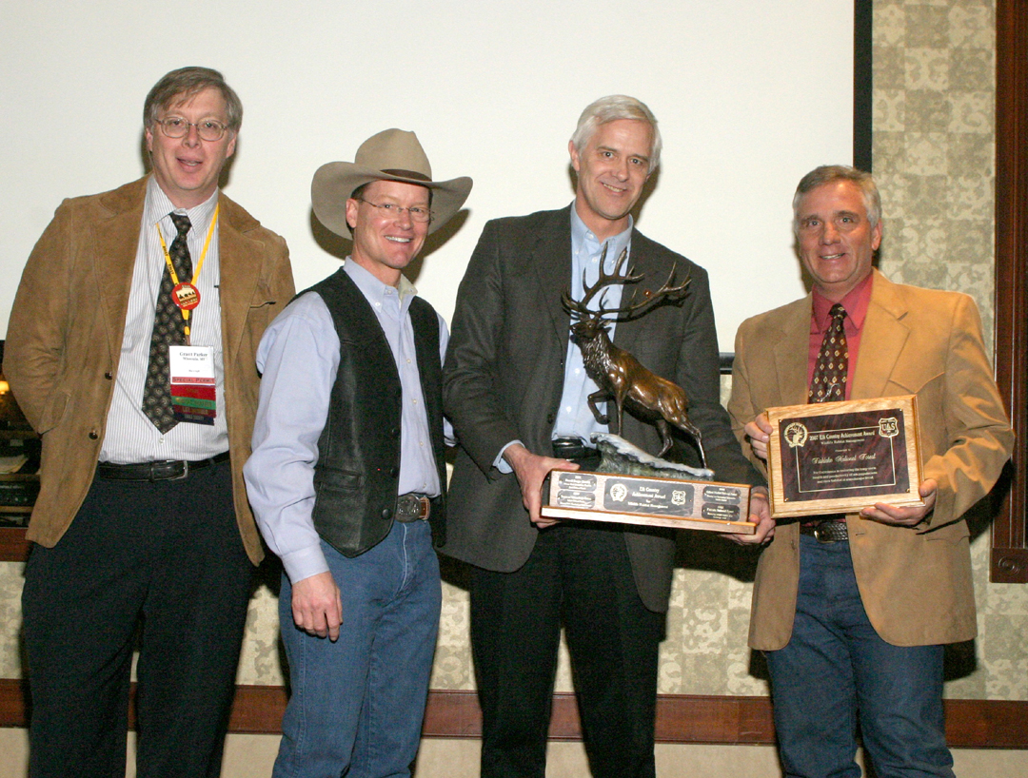The Rocky Mountain Elk Foundation (RMEF) presented a bronze elk statuette, February 22, at their 23rd national convention (Reno, Nevada) to Kreig Rasmussen, Wildlife Biologist for the Richfield/Loa Districts of the Fishlake National Forest. Kreig accepted the award on behalf of the Fishlake NF for excellence in restoring the long-term health and productivity of elk populations and their habitat at a landscape level. Coordination of ambitious partners including the Fishlake NF, Mule Deer Foundation, Utah Division of Wildlife Habitat Council, Sportsmen for Habitat, Dedicated Hunter Program (UDWR), BLM, local sportsmen and RMEF, resulted in treatment of approximately 30,000 acres of elk habitat on the National Forest as well as an estimated 30,000 acres of elk habitat on BLM.

Left to Right: Grant Parkter, VP of Lands and Conservation, RMEF; J. Dart, President/CEO, RMEF; Joel Holtrop, Deputy Chief, National Forest System and Kreig Rasmussen, Wildlife Biologist, Richfield/Loa Ranger Districts, Fishlake National Forest
2007 ELK COUNTRY AWARD FOR INDIVIDUAL ACHIEVEMENT
The Rocky Mountain Elk Foundation (RMEF) presented a bronze elk statuette, February 22, at their 23rd national convention (Reno, Nevada) to Craig Grother, Zone Wildlife Biologist for the Norwood and Ouray Ranger Districts of the Grand Mesa, Uncompahgre and Gunnison National Forest. Craig has worked on behalf of elk and elk habitat through planning and implementing a wide variety of habitat imprvement projects for over 18 years on the Forest. Craig’s tremendous efforts with dedicated partners including the Colorado Division of Wildlife (CDOW) and the Habitat Partnership Program (HPP) within the last 10 years, have resulted in over 10,000 acres of elk habitat enhancement.

Submitted By: Sandy Kratville, USFS/RMEF Liaison and Tom Toman, Conservation Director, RMEF.
Left to Right: Grant Parkter, VP of Lands and Conservation, RMEF; Craig Grother, Zone Wildlife Biologist, Norwood and Ouray Ranger Districts, GMUG National Forest, J. Dart, President/CEO, RMEF; Joel Holtrop, Deputy Chief, National Forest System.

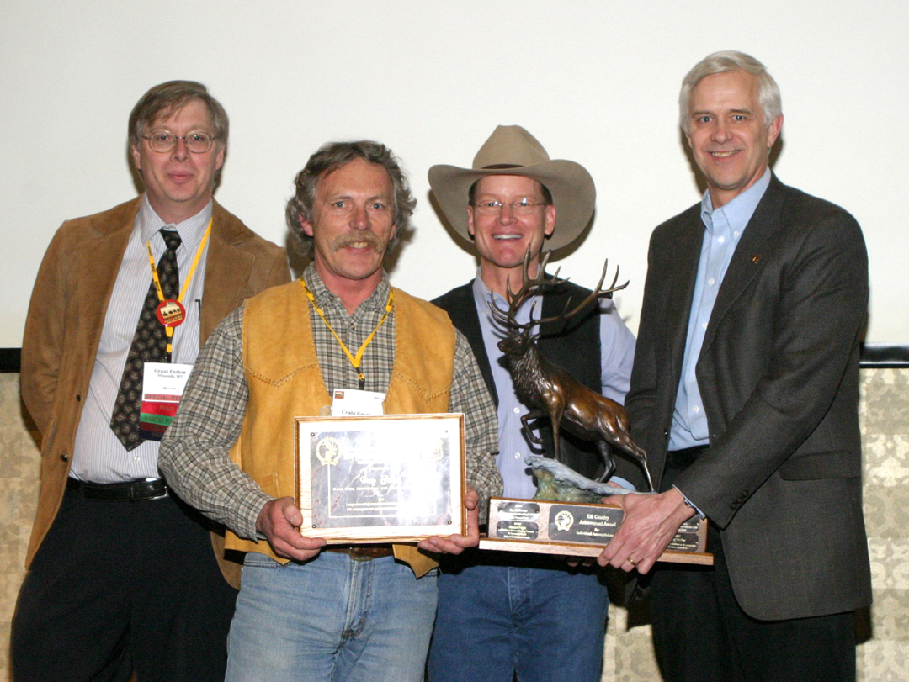
CONTENTS

Eastern Region Honors - USDA Region 9

HYDROLOGIST OF THE YEAR
Bonnie Ilhardt, USDA Forest Service, Region 9, Watershed & Riparian Program Manager
Congratulations to Bonnie Ilhardt for her recognition as 2006 Hydrologist of the Year at the Eastern Region Honors Awards on November 29, 2006. This award recognizes Bonnie’s years of contribution to hydrology during her long career and particularly during 2006. We’re glad to see Bonnie receiving the recognition she so richly deserves!

Written By: Paul Stockinger, Director, R9-Soil, Water, Air & Environment

WFW Newsletter Contact Information:
Disclaimer – Non Discrimination Statement
CONTENTS

WFW Newsletter is a monthly newsletter without a clever name and is provided by the National Forest System Watershed-Fish-Wildlife-Air-Rare Plants staff (including Soils and Meteorology) of the USDA Forest Service. Contributions are welcome and should be submitted to Netta Grant at agrant@fs.fed.us or your favorite Program Leader no later than the 20th of each month. We reserve the right to edit contributions for clarity and brevity. Emphasis on brevity. Links to detailed URLs or documents are great – include them in your information contribution. If photos are included in your submission please provide alternative text with each photo. Alternative text should not repeat captions but describe the scene shown in the photo.

If brevity and clarity are a struggle for you, we recommend the “Plain & Simple! Document Writing” workshop instructed by Dr. Jud Monroe.

Vacancy Positions listed are for outreach purposes only and are not full announcements. Interested individuals should contact the units referenced or consult the USAJOBS website.

"The U.S. Department of Agriculture (USDA), prohibits discrimination in all its programs and activities on the basis of race, color, national origin, age, disability, and where applicable, sex, marital status, familial status, parental status, religion, sexual orientation, genetic information, political beliefs, reprisal, or because all or a part of an individual's income is derived from any public assistance program. (Not all prohibited bases apply to all programs.) Persons with disabilities who require alternative means for communication of program information (Braille, large print, audiotape, etc.) should contact USDA's TARGET Center at (202) 720-2600 (voice and TDD).

To file a complaint of discrimination write to USDA, Director, Office of Civil Rights, 1400 Independence Avenue, S.W., Washington, D.C. 20250-9410 or call (800) 795-3272 (voice) or (202) 720-6382 (TDD). USDA is an equal opportunity provider and employer."

