
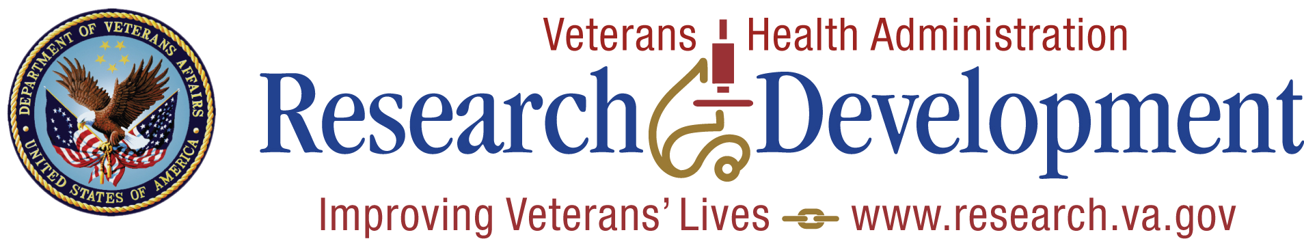

Research Administrative Review Report 1:
Findings and Recommendations

Submitted:
December 15, 2008

TABLE OF CONTENTS

I. Introduction 1
II. Methods 2
III. Findings and Recommendations 3
IV. Conclusion 12
APPENDIX A: Research Administrative Review Committee Members 13
APPENDIX B: Organization Chart 15
APPENDIX C: Lewin Report 16

- Introduction
Effective research programs require well-constructed and integrated operational plans that incorporate activities relating to human and animal protection, safety, information security, and other issues. The Office of Research and Development (ORD) initiated a Research Administrative Review to develop recommendations to respond to the challenge of effective management and to strengthen research activities occurring within VA field research centers. These efforts began early in 2008, progressed substantially during a June 2008 meeting convened by ORD, and have continued through conference calls and email exchanges from June through December. Committees consisting of VISN, Medical Center and research leadership were formed.

Participants in this process focused on potential improvements in two general areas:
- Issues related to governance, focusing on how changes in organizational structures, position descriptions, and handbook requirements can reduce inefficiencies while strengthening both the productivity and the accountability of research efforts occurring in VA medical centers; and
- Issues related to human capital, focusing on how key research leadership positions can be strengthened through enhanced recruitment and changes to minimize administrative burdens and maximize the ability to support productive research.

While discussions during the June meeting and in subsequent calls by the work groups have identified many possibilities for enhancing VA research efforts, this document focuses primarily on compliance-related issues and addresses opportunities in three high-priority areas:
- Medical Center Research Reporting relationships;
- Clarifications of position descriptions for research leadership positions; and
- Changes in the Research and Development Committee Handbook that are designed to enhance the ability of VA medical center research leadership to support productive research programs.

Early in the discussion the committee members identified that ORD should promulgate a declaration of research principles. ORD has begun this task and will continue interaction with the committee regarding this. Several priority issues not directly addressed in this report arose from the work of the subgroups and recommendations by their respective members. The committee will continue work in the following five areas:
- Protected time for research;
- Recruitment and retention;
- Mentoring and succession planning;
- Associate Chief of Staff for Research and Development (ACOS/R&D) and Administrative Officer for Research and Development (AO/R&D) responsibilities; and
- Affiliate relationships.

After providing an overview of the consensus-building process, this document will summarize key findings and recommendations emerging from the Research Administrative Review in each of the areas noted above. .
- Methods
This effort was led by a Steering Committee chaired by Dr. Joel Kupersmith (CRADO) and two task groups. The Governance task group was chaired by Dr. Randy Petzel (VISN 23 Network Director) while the Human Capital group was chaired by Jack Hetrick (VISN 15 Network Director). (See Appendix A for full Steering Committee member listing.) Activities designed to reach the consensus findings and recommendations reported in the next section proceeded through three stages.

- Initial Group Meeting
Steering Committee and task group members, along with other discussants familiar with the challenges of conducting research within VA, were convened for a two-day meeting in June 2008. After several plenary talks designed to clarify the challenges and issues facing the task groups, the Human Capital and Governance groups met separately to discuss key questions in their respective areas.

- For Human Capital, these included:
  - Mechanisms to recruit and mentor both research leaders and young scientists.

  - Defining the respective roles, responsibilities and reporting requirements within VA medical centers (e.g., ACOS/R&D, AO/R&D).

  - Practices to improve the management and protection of research time.

  - Performance expectations for medical center leaders.

- For Governance, key questions were:
  - Defining the roles of leadership positions within VA medical centers and at the VISN level.

  - Lines of reporting among local research offices, medical centers, and VISN.

  - The respective roles and responsibilities of the R&D Committee versus its subcommittees and the local research office.

By the end of the two-day meeting, both groups had reached consensus on a number of issues and had agreed on a process for focusing additional attention on key issues that were not fully resolved.

- Information-Gathering on Focused Topics
Task group members convened a series of conference calls to discuss their assigned topics. Subgroups focused on three key issues for which recommendations needed to be developed:

- Revisions of the Research and Development Committee Handbook.

- Defining the relative roles and responsibilities of individuals from the AO/R&D level to the VISN leadership (including clarifying position descriptions).

- Recruitment and retention of ACOS/R&D, AO/R&D, and RCO.

Additional information in the form of other VA documents, input from experts, and surveys of medical center leaders was compiled by each group. Each group’s work culminated in a series of conclusions and recommendations designed to guide VHA leadership in making changes to strengthen the research enterprise. Some of the groups have completed much of their work while others, such as the group focusing on protected time, are still in the information-gathering stage. Draft recommendations were circulated to all committee members for comment. Eight conference calls were held to discuss input and changes to recommendations. Revised recommendations were circulated to group members for final comment.

- Survey
A survey was conducted to gather data regarding recruitment and retention issues related to ACOS/R&D and AO/R&D. (Survey results are presented in Appendix B.)

The following section summarizes findings and recommendations that have emerged from this process.

- Findings/Recommendations
- Information Systems
- Support information tools which would allow for field offices to manage areas such as space, finances, and personnel.

- Defining Business Requirements: ORD has begun the process of defining business requirements for a common VA information system that will facilitate the following researcher and research office activities:
  - Management of Research Compliance and reporting requirements including animal programs, safety and environmental programs, human subject protection, and research performance. This will include but not be limited to:
  - Management of the R&D Committee.
  - Management of the Institutional Review Board.
  - Management of the Animal Care and Use Committee.
  - Management of Safety and Biosafety Committees.
  - Research protocol financial management, including Central Office reporting requirements.
  - Clinical trial management, including human-subject consenting and enrollment and, for multisite trials, central reporting requirements.
  - Drug and device warning management.
  - Adverse event analysis and reporting.
  - Other research-office management processes that are identified by field research offices.

- Business Requirement Elements: There are four elements to this requirements-development process:
- Analysis of current policies.
- Development of a “current state” document describing field research office business processes and IT support.
- Development of a unified business operations model for VA research offices.
- Development of a functional-requirements document for IT support that forms the basis for a development and implementation effort by the Office of Information Technology.

  - Development Process Status: Steps that have been taken to date include conference calls with ACOS/R&Ds and AO/R&Ds to develop consensus on the appropriateness of the development effort described above.

  - Next Steps in Development:
- Contracting with a facilitator who will devote an average of 25 hours a week to working with field offices and VHA staff to complete, in stepwise fashion, the tasks above.
- An introduction of the process with ACOS/R&Ds and AO/R&Ds at the ORD Local Accountability for Research in VA Facilities Meeting on Jan.13 and 14, 2009;
- Development of function task groups to develop processes and information;
- Regional meetings to facilitate buy-in to the process and develop information flow so that all 117 facilities currently engaged in research have an opportunity to participate at some level in the process;
- Telephone conference calls to move the process forward; and
- Document creation and review via a SharePoint site.

- Target Dates: Assuming that a facilitation contract is awarded by the end of January 2009, the analysis of current policies and development of a current-state document will be completed by July 2009, and that the unified business operations model and IT functional requirements document can be completed by January 2010.

Research and Development Committee Handbook Revisions
Much of the discussion in the Governance Task Group involved issues addressed in the Research and Development Committee Handbook. Because of this Handbook’s important role, group members carefully reviewed it, along with other VHA documents that impact its content. This review led to several conclusions, which guided a large number of proposed revisions to the General Conclusions:

- The role of the R&D Committee should be refocused on governance and oversight of the local research program, as opposed to oversight and reviewing of individual protocols. Oversight of individual protocols should be carried out solely by the appropriate subcommittees. Purely administrative functions have been re-assigned to the ACOS/R&D. The R&D Committee can thus be refocused on broader issues including:
- Ensuring the effective operation of the research program.

- Establishing the strategic direction of the research program.

- Establishing policy to ensure appropriate review for research involving human subjects, animals and biohazards.

- Reviewing the quality and performance of the local review process.

- Reviewing quality assurance activities, and programs designed to enhance the safety of personnel and the security of VA data and laboratories.

- Governance group members reached consensus on desirable changes to the Handbook. The most significant changes were:
- Approval of research will proceed through the most appropriate R&D Committee subcommittees; then the R&D committee will approve the minutes of the subcommittees, and finally the ACOS/R&D will inform the investigator, when all appropriate approvals have been met, that the research studies may be initiated.

- Continuing reviews of research studies will also be conducted by the appropriate R&D Committee subcommittees, as opposed to the full R&D Committee.

  - Responsibilities of the R&D committee (now in Handbook 1200.01) are:
- Planning and developing broad objectives for the R&D Program so that it supports VA’s mission.

- Determining the extent to which the R&D Program has met its objectives.

- Overseeing all R&D activities for each VA facility for which it serves as the R&D Committee of record.

- Reviewing all written agreements that establish:
- A committee from another VA or non-VA entity in lieu of a required committee or subcommittee for the R&D Committee.
- The R&D Committee, or one of its subcommittees, that functions as a committee or subcommittee of another VA facility.
- Reviewing and evaluating all subcommittees or committees both within the VA facility and at external entities that function in lieu of subcommittees, such as IRBs, IACUC, or biosafety committees. A summary of these reviews and evaluations must be sent to the Medical Center Director.

- In fulfilling its responsibilities to ensure effective oversight of the research program and in making appropriate recommendations to the Medical Center Director, including the suspension of a research study or disciplinary action against a Principal Investigator (PI), the Committee needs to rely on a variety of information sources, including:
- Quality assurance activities; reports to the committee by the ACOS/ R&D, AO/R&D, or other research staff members; subcommittee reports; facility reports or activities; and other appropriate sources.
- Review of subcommittee activities including:
- Annual reviews of the Research Safety and Security Program (including planned training, compliance, security issues, etc.).
- The Animal Care and Use Program (including inspection reports, IACUC composition, IACUC arrangements, budgets, space, support staff, training, quality improvement activities, compliance issues, and goals for next year).
- The Human Research Protection Program (including IRB composition or IRB arrangements, credentialing and training status report, budget, space, support staff, quality improvement activities, compliance issues, and goals for next year).

- Fulfilling such other functions as may be specified by the Medical Center Director and VHA procedures.

Implementation Steps: Implement revisions to 1200.01. The policy has been placed into the concurrence process.

  - R&D Committee responsibilities for the review of research:
- The R&D Committee is responsible for establishing policy to ensure that all research in which the facility is to be engaged has been reviewed and approved for the ethical use of human subjects, animals, and biohazards. This review should promote:
- Protection of human subjects (including privacy and confidentiality), and the implementation of adequate safety measures for research subjects and personnel.
- Welfare and appropriate use of animals in research.
- Safety of personnel engaged in research.
- Security of research laboratories where hazardous agents are stored or utilized and of all Biosafety Level 3 (BSL-3) research laboratories.
- Security of VA data, VAPI, and VA-sensitive information.

- Once approved by all appropriate R&D Committee subcommittees and the research office, the research becomes VA-approved research.

- If a research protocol requires review by a facility’s non-research committee(s) or subcommittee(s), such as the Radiation Safety Committee, this review may be conducted at any time, but the research may not be initiated until it has been approved by the non-research committee and all applicable R&D Committee subcommittees and the investigator has been notified by the research office. For protocols not meeting criteria for assignment to any subcommittee, the R&D Committee will be the review and approving committee of record.

Implementation Steps: Implement revisions to 1200.01. The policy has been placed into the concurrence process.

Respective Research Responsibilities
  - Emails were sent to Medical Center Directors, ACOS/R&Ds, and AO/R&Ds to provide sample position descriptions for the ACOS/R&D, AO/R&D, and RCO positions.

- Key findings based on this process included:
- There is substantial variability in required and desired qualifications, requirements, and responsibilities for each of these positions across VA medical centers, as indicated by the respondents. While the size of research activities accounts for some of this variability, it is clear that these positions differ considerably even across centers with similar research missions.
- While most respondents agreed on a core sets of qualifications, requirements, and responsibilities for these positions, there is much less agreement among respondents on which of these should be mandatory and which should be optional. However, there is strong agreement that at least some variability is needed based on the size of a center’s research program.

- Because the RCO position description has been developed by Office of Research Oversight (ORO) no discussion of that position description is included. General recommendations emerging from the review of these position descriptions include:
- There should be a core set of requirements for each position that applies across all VA medical centers.
- Additional optional requirements may be defined as appropriate for local research program needs. This will depend not only on the size of a program, but also on other factors such as whether there is an affiliate and whose IRB is used (for example, their own, another VA’s, or the affiliate’s). Office of Research Oversight is available to provide assistance in this regard.

- Workgroup members were asked to provide input on the research responsibilities of the MC Director and VISN Director positions for incorporation into the position descriptions for each position. In general, respondents indicated that while MC Directors are ultimately responsible for ensuring that listed activities are occurring at their facilities, these responsibilities are shared by a number of individuals, given the overwhelming number of responsibilities. Regarding the VISN Director position, respondents indicated that their primary responsibility is to perform compliance reviews of facility compliance programs and report findings to both the VISN and facility Director.

The recommendations offered by the committee members for research program responsibilities for the VISN Director, Medical Center Director, ACOS/R&D, VA investigators, and the R&D committee are identified below:

  - Research responsibilities of the VISN director include:
    - Fosters an institutional culture that supports the ethical conduct of research throughout the network.
    - Ensures adequate support for local research programs including, but not limited to, providing adequate resources, staff, equipment, and infrastructure.
    - Ensures local facilities’ compliance with all VA and other federal requirements for the conduct of research.

Implementation Steps: Discussion with 10N in Work Group on Research led by Ann Patterson

  - Responsibilities of the Medical Center Director include:
      - Fosters an institutional culture that supports the ethical conduct of research.
      - Fosters an institutional culture of high-quality research.
      - Ensures adequate support for local research programs including, but not limited to, providing adequate resources, staff, equipment, and infrastructure.
      - Serves as the Institutional Official responsible for all aspects of the research program, including but not limited to human subjects protection, animal welfare, privacy and security of VA data, and biosafety.
      - As the Institutional Official, is responsible for the facility’s compliance with all federal, VA, and VHA research requirements. This includes protection of human research subjects; care and use of laboratory animals; research laboratory safety; granting access to research facilities; and research information security.
      - Is responsible for all required reporting to and correspondence with federal oversight offices, agencies, and accreditation organizations.
      - Is responsible for providing sufficient resources and administrative support for research oversight programs. In addition,
      - Is responsible for certifying that all research personnel have appropriate credentials, privileges, and scope-of-practice requirements.
      - Ensures that research compliance program has sufficient resources and that Research Compliance Office reports directly to Medical Center Director.
      - Completes and fulfills Medical Center Director Certification of Research from the Office of Research Oversight as per instruction at the following website: http://www1.va.gov/oro/docs/Director_Cert_Rsch_Oversight-06-13-08.doc.
      - Complies with Medical Center Director responsibilities to R&D Committee as per Handbook 1200.01:
- Ensures that research in which the facility is engaged is approved by the appropriate R&D Committee subcommittees.
- Ensures adequate resources and administrative support, including personnel, space, and equipment and training, for the R&D Committee and its subcommittees so they can fulfill their responsibilities.
- Ensures appropriate education and training for members of the R&D Committee, the research administration staff, and other staff involved in research.
- Ensures that investigators meet the requirements of the section below: Responsibilities of the investigator:
- Serves as a non-voting, ex officio member of the R&D Committee.
- Retains institutional responsibility for the research program at the facility if the facility’s R&D Committee of record is that of another VA facility.

Implementation Steps: Discussion with 10N in Work Group on Research

  - General Roles and Responsibilities of the ACOS/R&D:
      - Foster an institutional culture that supports the ethical conduct of research.
      - Fosters an institutional culture of high-quality research.
      - Manages the ongoing operation of Research and Development program activities.
      - Promotes the growth and development of Research and Development opportunities for new and experienced investigators through training and assistance with the VA grant applications process.
      - Provides support to the Research and Development Committee; and
      - Functions as Executive Secretary of the R& D Committee.

Implementation Steps: The specific roles and responsibilities of the ACOS/R&D position will be further developed at the Local Accountability for Research in VA Facilities Meeting in January, 2009.

  - Responsibilities of VA Investigators include:
- Foster an institutional culture that supports the ethical conduct of research.
- Foster an institutional culture of high-quality research.
- Ensure that they have the required and appropriate expertise and training and have been awarded the credentials and privileges to conduct research at VA prior to initiating any research.
- Comply with all applicable personnel, training, and other VHA policies, whether the investigator holds a compensated, without-compensation, or Intergovernmental Personnel Agreement appointment.
- Obtain the appropriate Committee and Subcommittee approvals prior to initiating research activities.
- Develop research plans that are scientifically valid and that minimize risk to human subjects and animals used in research, and personnel.
- Develop plans for data use, storage, and security that are consistent with VA, VHA, and other federal statues, regulations, and policies and local policies and procedures.
- Appropriately use grant funds and VA resources in keeping with approved research plan(s).
- Comply with all appropriate policies, regulations, and reporting requirements regarding research.

- Resources for Research Compliance
  - Resources for research compliance and oversight should be addressed.

Ensure that VA research conducted within the system has adequate resources to meet compliance milestones and achieve scientific goals. Ensure that Medical Center Directors are addressing these issues and taking efforts to improve the VA research enterprise.

Dependent on the size and need of the research program, increase support staff such as deputy ACOS/R&D or associate AO/R&D to help manage compliance, training, audits, and certifications. Support should come from VERA dollars, but new methods of support should be explored.

Implementation Steps: Research Support Funding Workgroup is considering this.

- Reporting Relationships (see Appendix B)
  - The ACOS/R&D reports to the Medical Center Director through the Chief of Staff. All committee members also agreed that the ACOS/R&D should have a mechanism to regularly engage with the Executive Leadership Board. There was an opinion on the part of some on the committee that for certain issues there should be direct reporting to the Medical Center Director. It was also suggested that the ACOS/R&D should have a role in staff hires to help identify promising candidates and to identify potential research involvement (especially as research is a tool for recruiting physicians in Medical Centers).
Implementation Steps: Discussion with 10N in Work Group on Research

- Performance Measures
- Research performance measures should be in contracts for VISN and Medical Center leadership.

  - The measure for FY 2009 is that each Medical Center doing research must have a RCO.
  - In the future, other measures should be considered. One suggested option for research program improvement was to add research performance ratings for facility and VISN Directors.
Implementation Steps: The report and recommendations will be transmitted to the National Performance Measurement Workgroup; network directors might consider adding specific research performance measures for their facility
- Mentoring of Research Office Leadership
- Sponsor a periodic web conference that will allow leaders to share experiences relating to successfully recruitment and retention for ACOS/R&Ds, AO/R&Ds, and RCOs.

  - Support mentoring programs within medical centers to prepare persons to assume the roles of ACOS/R&D, AO/R&D, and RCO.

  - Develop cross-site mentoring programs that would allow new hires (<3 months) in these positions to spend time training in another facility.

  - Create forums where centers with formal or informal mechanisms to groom persons for these positions can share what they have learned with other centers.

Implementation Steps: ORD will identify potential mentors and provide a policy for shared travel support (with the hiring facility) for these trainees by the second quarter 2009. ORD will develop and support an annual ACOS/R&D and AO/R&D meeting, with the first meeting to take place in the first quarter of 2010.

H. Training Resources

Develop online “how to” manuals directed towards the responsibilities and procedures for ACOS/R&D and AO/R&D positions. These online manuals might also be valuable for medical center leadership and VISN directors.

Implementation Steps: ORD has begun a process to develop training materials for ACOS/R&Ds and AO/R&Ds. It is expected that these materials will be available in the first quarter of 2010.

- There is an existing requirement for each Medical Center Director to develop an ongoing local awareness/training program at his/her facility. ORD will provide an opportunity at the Local Accountability for Research in VA Facilities meeting, January 2009, for the local facilities to share ideas on developing and implementing such a program. One goal of these discussions is to identify approaches to incorporate research training into Medical Center Director orientation curriculum.

Implementation Steps: ORD is beginning an annual leadership training program which will involve training at Senior Management Meetings and half-day or full-day trainings at regional meetings in years when there is no Senior Management Meeting.

IV. Conclusion

- The Research Administrative review process began in Spring 2008 with the formation of three committees (steering, governance, and human capital) with a total of 39 members representing clinical and research leadership in the Veterans Health Administration. Consensus recommendations were derived from information gathered from the field and discussions among the committee members. Recommendations and implementation steps identified by the committees focused on:

- Research information systems.

- Focusing efforts of the Research and Development committee on the strategic direction of the research program and delegating review of research proposals to appropriate subcommittees.

- Identification of research responsibilities for VISN directors, Medical Center directors, Associate Chief of Staff R&D, and VA research investigators.

- Identification of reporting relationships for research centers and Associate Chief of Staff R&D.

- Mentoring for the research office.

- Resources for research compliance.

- Research performance measures.

  - Several other issues not directly addressed in this report arose from the work of the committees and recommendations by its members. The committees will continue work in the following five areas:

    - Protected time for research.

    - Recruitment and retention.

    - Mentoring and succession planning.

    - Associate Chief of Staff for Research and Development and Administrative Officer Research responsibilities.

    - Affiliate relationships.

Appendix A

Research Administrative Review Committee Members

Steering Committee
Chair: Joel Kupersmith (CRADO)
Ralph Gigliotti (Durham, Medical Center Director)
Betty Goolsby (Durham, Asst. Director, Office of the Director)
Jack Hetrick (VISN 10, Network Director)
Odette Levesque (VACO 10NC, Clinician/QA liaison)
Randy Petzel (VISN 23, Network Director)
Tom Puglisi (ORO, Chief Officer)
Jim Roseborough (VISN 12, Network Director)
John Stuart (Memphis, ACOS/R&D)

Governance
Chair: Randy Petzel (VISN 23, Network Director)
Anna Alt-White, RN (VACO, Office of Nursing Services)
Paul Bockelman (Director, Sioux Falls VA Medical Center)
Thomas Capello (North Florida/South Georgia Health Care System, Med. Center Dir.)
Lynn Cates (ORD, Director PRIDE)
Micheal Davey (ACOS/R&D Portland, OR VISN 20)
Joe Francis (Deputy Cheif Quality and Performance Officer)
John Hudson (Research Compliance Officer, VISN 12)
David Johnson (Baltimore, ACOS/R&D)
Marie Johnson (AO/R&D Gainsville, FL)
Odette Levesque (VACO 10NC, Clinician/QA liaison)
Skye McDougall (Chief Medical Officer, VISN 22)
Brian Mittman (Sepulveda, Health Services Research)
Lynn Pulliam (ACOS/R&D San Francisco, CA)
Jim Roseborough (VISN 12, Network Director)
Gordon A. Starkebaum (Seattle, COS)
John Stuart (Memphis, ACOS/R&D)

Human Capital
Chair: Jack Hetrick (VISN 10, Network Director)
- Organization of Research Subgroup
Lead: Peggy Hannon (AO/R&D, Indianapolis)
Jerry Beccia (CO, West Haven)
Patsy Cipolloni (ACOS/R&D, Boston)
Betty Goolsby (Durham Asst. to the Director)
Susan Harper (ORO)
Jeannette Post (VISN Director (retired), Boston)

- Protected Research Time Subgroup
Lead: Ali Sonel, MD (ACOS/R&D, Pittsburgh)
Ralph Gigliotti (Medical Center Director, Durham)
Martin Hayworth (COS)
Laurence Meyer (ACOS/R&D, Salt Lake City)
Dean Norman (COS, Los Angeles)
Bruce Sangeorzan, MD (Orthopedic Surgeon, Seattle)

- Recruitment and Retention Subgroup
Lead: John Vara (COS, Miami)
Phil Cook (AO/R&D, Milwaukee)
Lynette Roff (Medical Center Director, Eastern CO)
Gary Rosenthal, MD (ACOS/R&D, Iowa City)
Don Rubin (ACOS/R&D, Tennessee Valley)
Edgar Tucker (Medical Center Director, Houston)
Appendix B

VISN Director
Medical Center
Director
RCO

AO
Research Centers
CoEs
REAPs
Chief of Staff
R&D Committee
IACUC
IRB
Radiation Safety
Biosafety
Others, e.g.
Research Equipment
ACOS R&D
Director Clinical Science R&D, ORD
Cooperative Studies Research Centers
Appendix C



Research Administrative Review: Recruitment and Retention Group Survey Findings

Draft Report

Prepared for:
Veterans Health Administration

Submitted by:
The Lewin Group, Inc.

October 14, 2008

Research Administrative Review: Recruitment and Retention Group
Survey Findings

Draft Report

Prepared for:
Veterans Health Administration

Submitted by:
The Lewin Group, Inc.

October 14, 2008
Table of Contents

I. OVERVIEW 1
II. METHODS 1
III. MAJOR FINDINGS 2
IV. CONCLUSIONS 6
APPENDIX A: SPECIFIC SURVEY RESULTS A-1
APPENDIX B: OPEN ENDED QUESTION RESPONSES B-1
APPENDIX C: SURVEY INSTRUMENT C-1

Overview
As part of the Research Administrative Review (RAR) initiative, an effort being led by the Office of Research and Development (ORD) to strengthen research activities within the Veterans Health Administration (VHA), a subgroup of participating VA staff formed to focus on recruitment and retention issues was tasked with developing recommendations to strengthen the pool of qualified personnel for three key positions: Associate Chief of Staff for Research and Development (ACOS/R&D), Research Compliance Officer (RCO) and Administrative Officer (AO). To support the development of data-driven recommendations, the group developed a survey to gather information about key recruitment and retention challenges within VA Medical Centers. This document summarizes the methodology used to develop and implement this survey and reports on its key findings.

Methods
The survey was developed by the Recruitment and Retention Committee, led by John Vara, MD, Chief of Staff for the Miami VA Medical Center, and with the assistance of staff from The Lewin Group (Lewin) who have expertise in survey development and analysis. A request to complete the survey was sent to all members of three VHA list serves: COS, ACOS/R, and AO. Respondents were asked to access a secure website and complete the survey. The 24-question survey included both free response questions and multiple choice questions and required between 5-10 minutes to complete. While the responses were anonymous, the survey did request respondents to provide information on certain characteristics of the medical center so that the results could be examined based on factors such as center size. Responses were submitted online between August 15 and September 2, 2008. A copy of the survey questions is included in Appendix C.
In total, 268 responses were received, representing 92 uniquely identifiable medical centers. Twenty-two responses could not be linked to a particular center. In 94 cases, more than one person from a particular center responded; we pooled these responses so that analyses could treat the center as the unit of analysis. Multiple responses from a single medical center were combined as one, in instances where the open-ended responses were the same, and averaged in instances when the open-ended responses were different. Many of the multiple responses were unfinished surveys, in which case the most complete survey was used to represent that particular medical center’s response.
For the purposes of analyzing the results of the survey, VA medical centers were classified as large, medium or small centers based on the amount of funding they received from the VA. Centers receiving above $7 million in funding were classified as large facilities; centers receiving between $600,000 and $7 million in funding were classified as medium-sized; and any centers receiving less than $600,000 in VA funding were classified as small.
The analyses reported in the following section are based on responses from 26 large medical centers, 40 medium centers, and 26 small centers, as well as an additional 22 responses from centers that could not be identified by size. Response rates were relatively high at 84% (26/31) for large centers, 89% (40/45) for medium-sized centers, and 74% (26/35) for small centers.

Major Findings
The following section describes major findings from the survey regarding vacant positions; retention methods; usual sources of hire for the ACOS/R, RCO, and AO positions; hiring challenges; and recruitment efforts. Additional findings from the survey are included in Appendices A and B.
- Vacant Positions
Figure 1 reports current vacancy rates. Overall, 16% of RCO positions were unfilled, compared with 13% of ACOS/R positions and 4% of AO positions. Unfilled positions were slightly more common in large centers.
Figure 1. Current Vacancy Rates
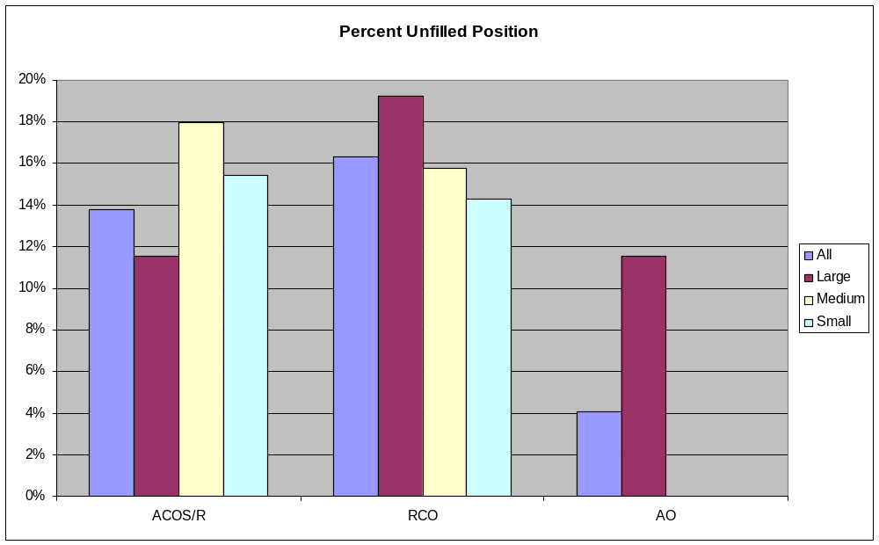
RCO vacant positions had been unfilled for a median of 12 months, compared to 6 months for the ACOS/R position and 2 months for the AO position. In large medical centers, the RCO position had been unfilled for a median of 18 months.
While the number of responses received to the question about reasons for departure was small, the survey findings indicated that as many or more ACOS/R and RCO vacancies were created by performance-related departures as by retirements or opportunities for professional advancement.
Respondents were asked to identify the factor that would most enhance the retention of persons in these three positions. Figure 2 identifies the most commonly identified themes in response to this question. Across facilities, adequate resources, competitive salaries, and enhanced training programs were the most frequently identified factors.
Figure 2. Most Commonly Cited Changes Made to Enhance Retention Efforts
Changes to Enhance Retention
0
5
10
15
20
25
30
35
Recognize/Reward Performance
Decrease
Regulatory/Oversight/Compliance
Burden
Education/Training Programs
Adequate/Competitive Salary
Adequate Resources (Staff,
Funding, IT, Facilities)
Top 5
# of Responses
- Recruitment for Positions
For positions currently unfilled, roughly 25% of the centers expected the positions to filled within the next two months and over half the centers believed the positions would be filled in six months or less.
Figures 3 through 5 reflect the backgrounds of persons holding these three positions in large, medium and small VA medical centers. While large majorities of ACOS/Rs and AOs were hired from within the medical centers, fewer RCOs were hired from within the medical center and substantially more RCOs were hired from outside the VA with no prior VA experience. This trend was more pronounced in medium and large medical centers.
Figure 3. Sources of Hire for ACO/R Position
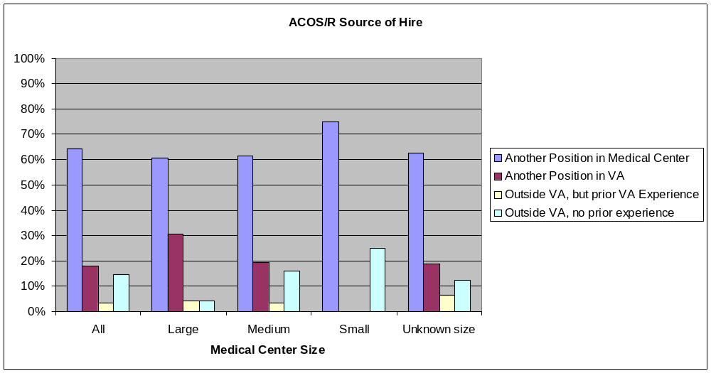

Figure 4. Sources of Hire for RCO Position
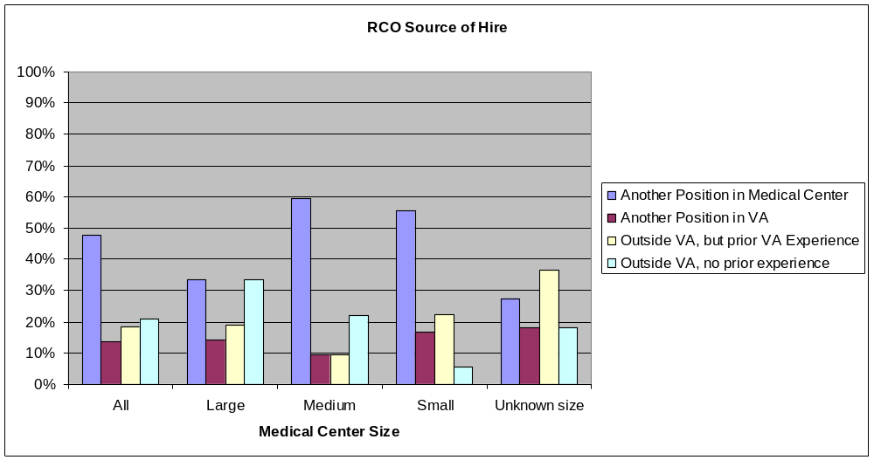

Figure 5. Sources of Hire for AO Position
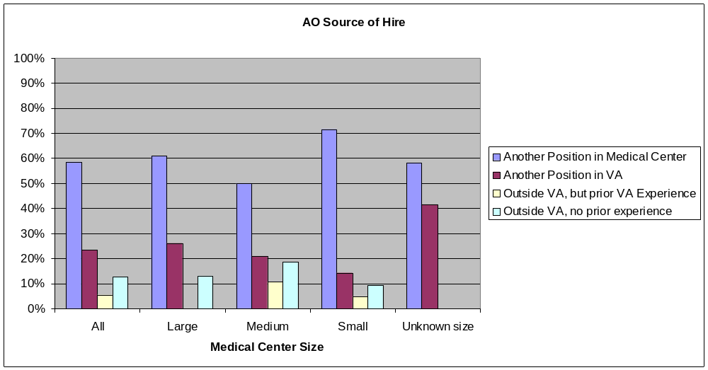
Respondents were also asked to identify the biggest challenge in filling each of the three positions. Tables 1 summarizes the most common responses received from across facilities.
Table 1. Top Hiring Challenges by Position
 | ACOS/R | RCO | AO
Appropriate Personality Set | 12 | -- | --
Ability to Balance Administrative & Research Tasks | 13 | -- | 9
Qualified (Background, Experience) | 31 | 49 | 50
Research Program Size/Location | 11 | -- | --
Salary | -- | 7 | 9
Regulatory/Oversight/Compliance Burden | -- | 3 | --
HR/Recruiting Process | -- | 3 | --
Workload/Lack of Resources | -- | -- | 14

Survey participants were also asked what changes to their systems have the potential to have the greatest impact on recruitment. Figure 6 identifies the most commonly identified themes in response to this question. Adequate resources, competitive salaries, and enhanced training programs were the most frequently identified factors.
Figure 6. Most Commonly Cited Changes Made to Enhance Recruitment Efforts
Changes to Enhance Recruitment
0
5
10
15
20
25
30
Develop Research
Program/Increase Research
Activities
Decrease
Regulatory/Oversight/Compliance
Burden
On-Going Education/Training
Programs
Adequate/Competitive Salary
Adequate Resources (Staff,
Funding, IT, Facilities)
Top 5
# of Responses

Conclusions
While the overall number of respondents was not large and the number of responses to some questions was considerably less due to skip patterns in the survey design, over 80% of all VA medical centers were included in the survey. The Recruitment and Retention Committee will provide additional interpretation of the data, but several general conclusions seem warranted.
- Both recruitment and retention represent significant challenges, particularly for the ACOS/R and RCO positions. About one is seven medical centers is seeking to fill the RCO position and one in eight is seeking an ACOS/R. The AO position appears to be the easiest position to fill and keep filled.
- The RCO position appears to be particularly challenging to fill with a qualified person. Performance failure was the most common reason for departure from this position, salary and a qualified pool of candidates are challenges in recruitment, and more RCOs are recruited from outside the VA, where they are unlikely to have knowledge of complex VA regulations.
- While some differences were observed across the three positions, changes designed to enhance recruitment and retention were reasonably consistent. These included the need to expand the pool of qualified persons, to address regulatory and administrative burdens in these positions, and the need for improved training, and the ability to pay salaries that can attract qualified applicants.
- Experiences across centers are quite variable, with some centers reporting little difficulty attracting and retaining qualified persons for these positions and others indicating that recruitment and retention were significant challenges. While all centers may benefit from changes that address these underlying challenges, the urgency of these improvements varies substantially.
- Backgrounds of persons recruited to fill the RCO position differ substantially. Moreover, a number of centers reported that they did not have an RCO or shared one with another institution. Recruiting well qualified RCOs and training existing RCOs may be critical to efforts to assure centers can foster research programs that are both productive and fully compliant. These efforts are also likely to enhance the attractiveness of the ACOS/R position.

Appendix A:

Specific Survey Results
Figure 1. Percent Unfilled Position
Percent Unfilled Position
0%
2%
4%
6%
8%
10%
12%
14%
16%
18%
20%
ACOS/R
RCO
AO
All
Large
Medium
Small
Figure 2. Status of Medical Center ACOS/R Positions
ACOS/R Position
0%
10%
20%
30%
40%
50%
60%
70%
80%
90%
100%
All
Large
Medium
Small
Unknown
size
Medical Center Size
Unfilled
Tenure 1 yr or less
tenure over 1 year
Figure 3. Status of Medical Center RCO Positions
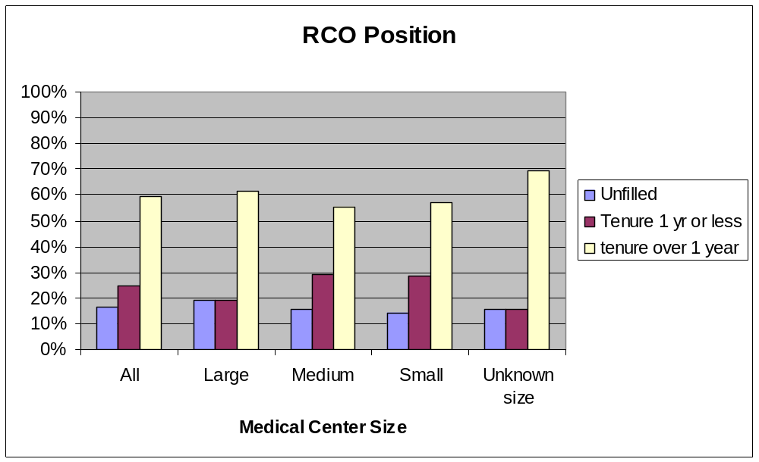

Figure 4. Status of Medical Center AO Positions
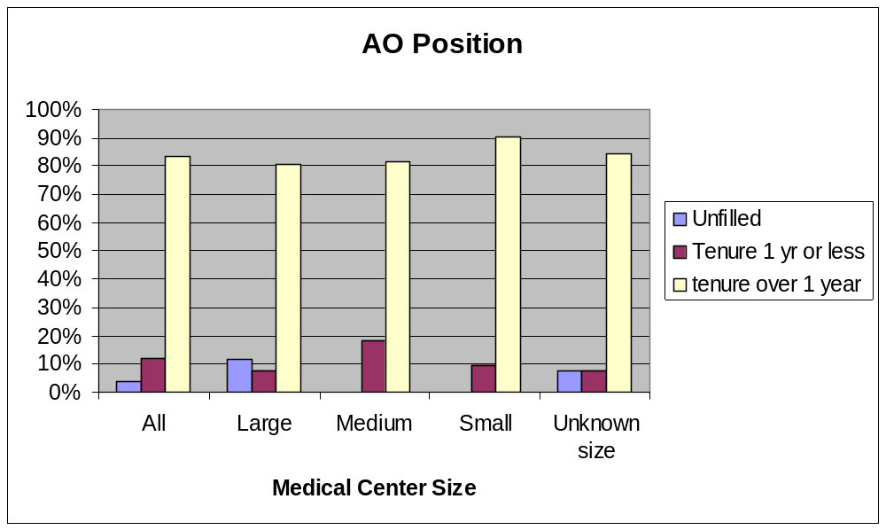

Figure 5. Mean Tenure for Positions
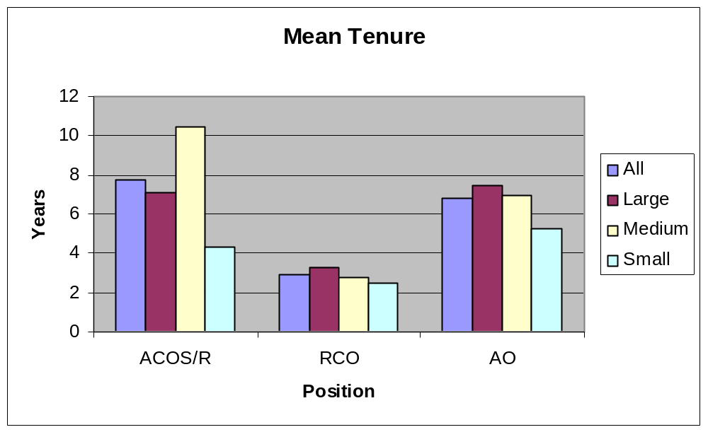

Figure 6. Source of Hires for ACOS/R position
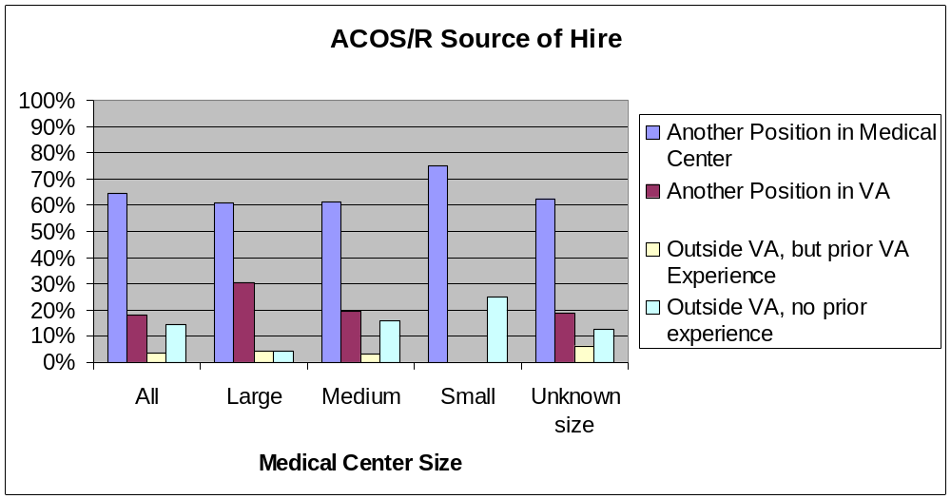

Figure 7. Source of Hires for RCO position
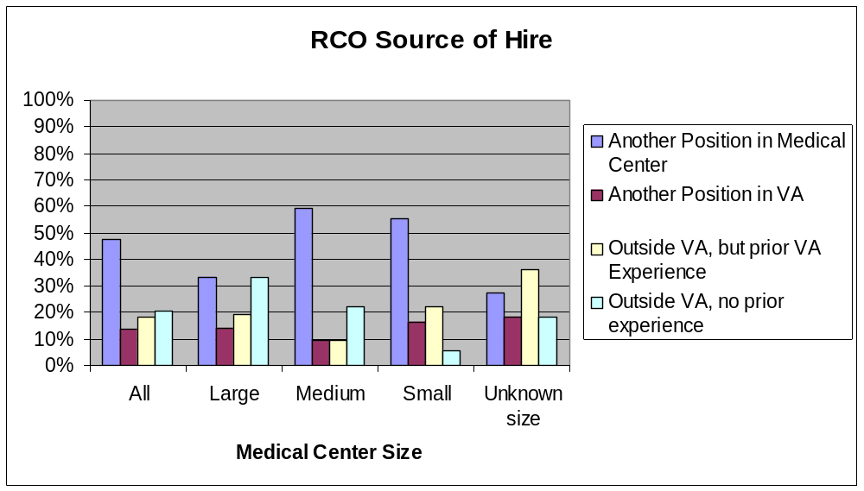

Figure 8. Source of Hires for AO position
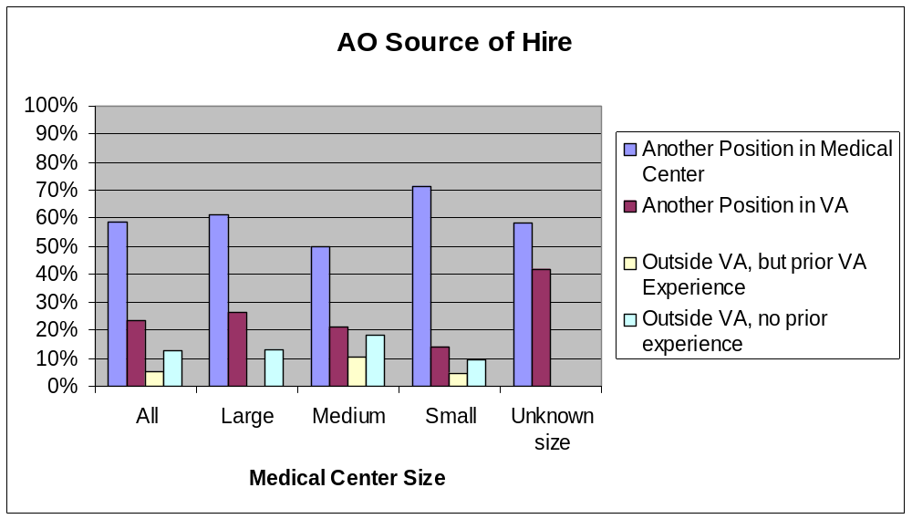

Figure 9. Expected Time to Fill Positions
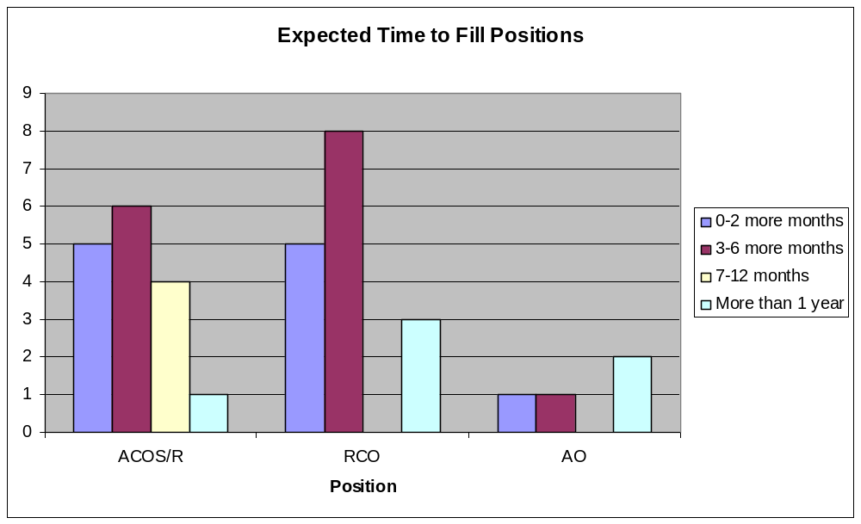

Figure 10. Reason for Departure

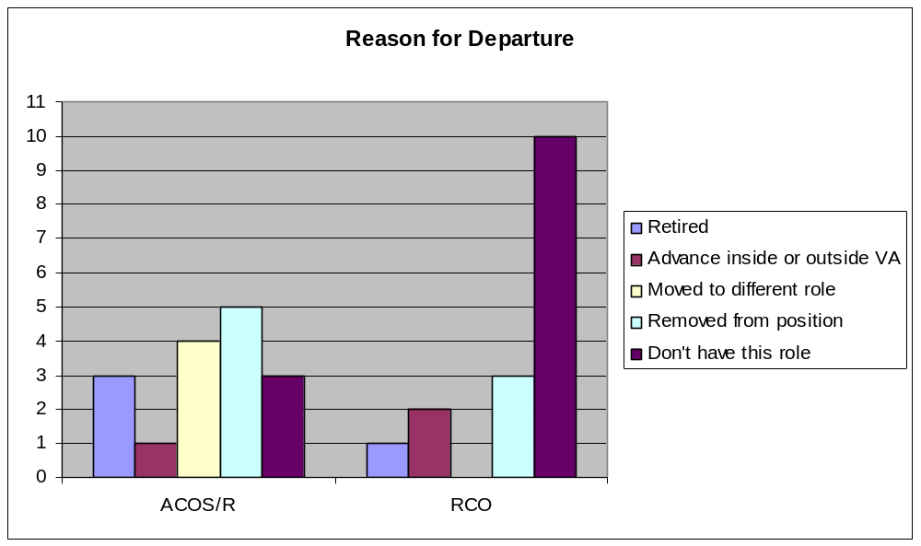

Appendix B:

Open Ended Question Responses

When your ACOS for Research position becomes vacant, what do you expect will be the biggest challenge in filling it with a qualified candidate?
- “Convincing someone to take the job. As the regulatory burden has increased logarithmically, the job has become much less attractive, and most of our investigators are aware of that. The ACOS now spends more time responding to outside regulatory/accrediting bodies than in actually overseeing the research program”
- “Finding someone who will have interest in managing the complexities of today's research environment while maintaining a laboratory. A solid foundation is critical to recruit into these types of positions”
- “Understanding the VA Research By Laws”
- “Educating a new individual on policies and procedures for Research and the VA”
- “Finding someone willing to deal with the increasingly byzantine regulations that VA is imposing”
- “Persuading someone to take responsibility for a large program, reporting both locally and centrally, governed by multiple regulations, and overseen by multiple agencies. The position increasingly is dominated by concerns with compliance, rather than on accomplishing research and developing investigators”
- “Lack of interest for MD's considering they are still required to do clinical work half time”
- “Workload”
- “A succession plan has been made by the current ACOS in an attempt to identify candidates who have institutional knowledge of this VA which has a ______. Granted, any open ACOS position will still need to go through a formal recruitment process by a search committee and open to all potential candidates. Any ACOS in Research needs to tread and balance many times conflicting demands from investigators, Medical Center needs, and ORD and outside agency requests, thus the candidate must be thoughtful and have a positive attitude no matter what situation arises. Essentially, the candidate should have a "no fear" attitude and "do the right thing" without worry of repercussions from other forces”
- “Finding a candidate who is either not aware of the current administrative hassles or one who is aware of the issues but still willing to take on the challenge”
- “Though we have many talented researchers, we have many fewer who have the personality to excel in administration and to be able to balance the rapid-fire dictums that are being handed down to the research office so frequently”
- “Increasing time required for compliance issues”
- “Succession planning has identified a candidate. Willingness to move to this location and to interact with affiliate may be problematic”
- “Experience with VA research”
- “Finding someone equally crazy to fill it”
- “We will need to make sure that whoever applies is an experienced researcher who is aware of the VA regulations as well as research regulations”
- “Biggest challenge will be finding the right fit. Someone that is good for Rsh. Administration in general and someone with a proven track record of getting things done and strongly relying on those in management positions to follow-through with their obligations”
- “It will be a challenge”
- “Finding a qualified candidate with first-hand experience in conducting and supporting clinical-applied research, something that all too many ACOS/R lack as a majority are involved primarily with basic research”
- It appears to be a thankless and miserable job because of the crisis-driven, resource poor situation in VA research now. Our ACOS is likely to be leaving soon, and I fear there will be no one who wants the job”
- “Need a scientist but scientists cannot handle the administrative time for compliance and space needs. Salary also a problem”
- “The large administrative burden with little time to be creative”
- “Finding a qualified candidate (our position was vacant for _____during which I went out _____ times to recruit; finally persuaded one of our physicians at _____ who had all the necessary skills to take the job)”
- “You need an experienced researcher but administrative burden has become substantial and probably not interest anyone who still had active ongoing research”
- “Finding someone with an appreciation for VA research, VA interests, and a legitimate grasp of the VA centric requirements associated with managing a diverse research program affiliated with a dynamic university focused on building their own research enterprise”
- ”Finding resources to build a research program”
- “Having just gone thru the process two years ago, the two major hurdles were getting thru the maze in HRM - then having qualified applicants apply, two excellent candidates withdrew after the interview process, very few Clinicians showed interest and the PhD's all seemed to want a sign on package similar to the academic setting they were coming from (start of money, etc). It was more than a two year process”
- “The lack of clear lines of authority within the research service is of primary concern for any ACOS. That is, many of the local research section leaders deal directly with the local, regional and national administration so that the ACOS frequently does not know of many of the issues discussed nor has a part in contributing to many of the decisions made concerning various aspects of research. This helter-skelter process seems to be actively fostered at all levels in the VA even though the current directive for the organization for research administration says that the ACOS is responsible for all research issues. This lack of a chain of authority makes for confusion and makes being a Research director's job very frustrating and makes the ACOS more ineffective than should be the case. Also, the barrage of administrative and "training" directives and questionnaires is overwhelming and, by my thinking, not necessary and really is counterproductive. Also, the local research administrative financial support is woefully inadequate for all the reports, oversight activities and reviews we are expected to do especially in the continuous "crisis mode" in which we operate. We do not have enough administrative support staff to do all that is expected of us without putting undue strain on the staff that we do have. Also, the Research service and its contributions to _____ are not very fully appreciated throughout _____. One of several ways of elevating the appreciation of the contributions of research to _____ would be to elevate the stature and pay of the ACOS. In order for an ACOS to be most effective, he/she needs to have the ability and interest to "think outside the box", formulate new initiatives and have the time and energy to pursue their ideas. Currently, that time and energy is being expended, necessarily so, in operating in a very frustrating organization. Thus in order to attract the best candidates for research leadership the job needs to be made more attractive by remedying these negatives. In my opinion, this is the biggest challenge in recruiting a qualified candidate for ACOS”
- “Finding anyone who will put up with the job and the gotcha agency mentality”
- “Finding someone who has not heard the truth about the job. The frequent nation-wide "emergency" requests for information that come from multiple sources that are often un-informed and create redundant and excessive workload. This work demand leaves little time for the ACOS to participate in research, their own or others”
- “Overall experience--fiscal, compliance, grants management. The most qualified candidate would be an ACOS from elsewhere”
- “Finding someone who has an active, funded research program who can tolerate all the negative aspects of the position, particularly those that exist nationally”
- “Finding someone that will be able to maintain an active individual research program while managing the day-to-day research operations, staying abreast of (changing) regulatory requirements, and working on improving the relationship with the academic affiliate in an environment that is becoming more difficult to do so”
- “There are very few individuals with the required expertise in the medical center and VISN”
- “Difficult for ACOS to do meaningful research”
- “Finding someone who has active research experience who wishes to assume this responsibility in _____”
- “The position is much less attractive than it used to be, hence the quality of ACOS applicants will be less and the number fewer”
- “Finding a knowledgeable person (knowledgeable about Research Compliance activities) with appropriate research background”
- “Knowledgeable candidate with a willingness to devote needed time to the actually operations of the service.
- I will defer to our ACOS to answer this question, but believe the biggest challenge will be finding people truly dedicated to fostering, stimulating and facilitating research who are willing to put up with the increasingly burdensome regulatory environment”
- “Research Background”
- “Time, rewards, all of the oversight stuff that seems to be getting worse by the day - unfunded mandates. Also, difficulty in keeping the Research Office running on a limited budget and getting good employees to do the multiple tasking jobs”
- “I do not know”
- “Research administrative experience”
- “Individuals with research background and an administrative flare are a minority on campus”
- “Finding a physician scientist who is willing to take on oversight of all the various regulatory issues”
- “Knowledge of the requirements for conducting research, specific to the VA”
- “Finding someone who is able to spend time dealing with administrative issues while juggling an academic and clinical career”
- “Top VISN/VAMC management will look for a manager who understands performance measures (these make up 60% of a Director's performance rating - this is what the Director really cares about because it translates to his paycheck). In addition, top VISN/VAMC management will want an individual who won't make significant demands for protected time to do research (protected time for MDs is a big constraint as management attitudes have drifted towards the idea that MDs should do their research after their 8 hour tour of duty seeing patients). If we can get research into the VISN/Director performance standards it will be a big step in getting more local support for Research”
- “Recruiting a person with both significant research experience with an active research program who is willing to devote the time necessary to the administrative responsibilities of the job. We attempted to recruit more than _____, as the current ACOS was offered another position _____. We were unsuccessful in identifying an acceptable candidate”
- “Finding someone with knowledge of VA regulations and willingness to deal with them”
- “Recruiting to our geographical area (_____), as well as making the position attractive for a qualified candidate”
- “Moving to a small town”
- “Small size of program; specialization of program (_____); no significant _____ affiliation”
- “The burden from a responsibility and liability standpoint”
- “We have a very old Research building (circa _____) and inadequate space for clinical research. This was a major factor when recruiting for our last ACOS. In addition, we are not co-located with _____ (_____). Finally, our Research Program is inadequately funded. If this situation continues, we would find it again very hard to recruit an "outside" ACOS if our current ACOS were to leave”
- “The positions are very hard to fill with interested and qualified candidates who actually have an interest in ADMINISTRATIVE issues”
- “Recruiting a qualified person to _____”
- “Obtaining protected time from patient care duties to actually spend doing Administrative work”
- “Funding”
- “Lack of qualified candidates”
- “Research interests that parallel our mission and research history”
- “Experience with research AND with VA regulations - along with an interest in administration”
- “Finding someone with VA Research Experience”
- “It's hard to recruit good people to a small place and a small program like _____. One of the potential challenges is how many other things the person will be encumbered with. This has been one of my biggest challenges....in addition to being the ACOS/RD I'm the ACOS for Education which means on any given day I might have to answer for the organization about resident complaints about the lack of food available on call, or deal with an affiliation agreement for training phlebotomists or orchestrate the facility roll-out of LMS (none of these are trivial issues.). In addition, I continue to see patients in clinics and teach residents. I've tried to get out of the latter but it's hard to do. In addition I'm often tasked with "special" projects in our facility: I currently co-Chair the COS search committee and sit on other special groups. So, what will my successor be expected to do? I don't know but I think this will be a battle ground. At a minimum, I think it will be very hard to find someone willing to do both ACOS for RD and ACOS for E tasks”
- “Lack of individuals in this community with knowledge and experience with research performance, administration and the research accreditation process”
- “Finding someone qualified - since our Research Program is quiescent and most hires are from within”
- “The biggest challenge(s) are administrative oversight and the compliance burden. It is extremely time-consuming, onerous and provides no job satisfaction”
- “Attracting a person to a 'fledgling' program - _____ is a new VAMC”
- “Small size of our program”
- “I expect to fill the Acting position with a permanent ACOS for Research from within our facility”
- “Finding a person who is willing to work on such a limited budget and staff. ACOS is also a clerk and secretary”
- “Getting the paperwork through HR. I am in the position now and asked to move to a clinical position in February 2008, and our HR dept has still not posted the position”
- “No internal candidates are qualified; will require hiring from outside. Doubtful that outside candidates will want such a small program because the job will be collateral with some other major duties”
- “We are a small facility and finding a candidate with the interest and time to dedicate to the position will be difficult”
- “Knowledge of federal mandates”
- “Achieving the right balance in someone with expertise and administrative skills as well as clinical leadership
- Finding someone with the right qualifications who wants to come to a smaller facility”
- “Finding one willing to do the job”
- “ACOS for Research is a collateral duty with COS position. _____ is a member of the multi-site IRB in VISN20”
- “Knowledge and competency”
- “Finding a person willing to deal with the bureaucracy from ORD”
- “Getting it processed thru Human Resources”
- “Time commitment and salary for a qualified person”
- “Negotiating the amount of administrative, clinical, and research time”
- “Finding someone willing to sacrifice hope of continuing to do hands-on research”

When your Compliance Officer position becomes vacant, what do you expect will be the biggest challenge in filling it with a qualified candidate?
- “We just filled this position. We looked for many months before identifying a single qualified applicant with relevant experience. There does not appear to be a pool of individuals with relevant experience and interest in doing this job, at least in the _____ area”
- “Finding personnel with broad based experience”
- “Understanding the VA By Laws”
- “Educating any new candidate on policy and procedure for Research and the VA”
- “Not sure”
- “Identifying a person who has or can acquire detailed knowledge of regulations, and is able to apply it an a collegial and educational way to achieve a culture of compliance rather than an atmosphere of criticism and failure”
- “Not enough pay for people who are truly qualified to do the job. GS11 currently”
- “Relatively few individuals have the detailed knowledge/interest in the practical application of the regulations”
- “Finding a knowledgeable candidate”
- “I do not know enough about it as the position is not in RS, but in the Director's Office”
- “Finding someone hopefully that has some research experience and understands both regulations and the needs of investigators and is able to be a good liaison with outside inspecting agencies”
- “This position should not be a major problem to fill as many of the research nurses might be interested in this type of position”
- “Expected expansion of the duties of the Compliance Officer to include human, animal and biosafety”
- “Identifying an appropriate candidate”
- “Impossible to fill with someone as qualified with current VA salaries and micromanagement”
- “Finding someone who has research experience”
- “It will be a challenge”
- “Finding someone who is competent and proficient with VA and federal-wide human subjects research protection policies and procedures, as well as credentialing requirements, other research compliance rules and regulations, and who is able to complete duties and responsibilities in a timely manner”
- “Not sure, but the recent hire came with no research or compliance experience”
- “Competition from private sector”
- “Finding someone with suitable knowledge and experience”
- “Finding a candidate with VA Research Compliance experience, since the compliance requirements have exploded over the past 2 years”
- “Finding a qualified candidate who will work for the VA salary. Parenthetically, with the new pending performance requirements re audits and reviews of research, a program of my size will need at least one additional, possibly 2, RCOs”
- “I prefer medical records technicians. They have a little difficulty with start up but we have been able to fill these positions fairly easily”
- “Finding someone with the required general research regulatory knowledge and expertise and a grasp of and an appreciation for the VA centric requirements”
- “Finding someone with sufficient scientific background to understand the programs being reviewed”
- “Finding someone with knowledge of VHA policies and procedures who understands the uniqueness of research and its myriad compliance issues”
- “Hiring an individual from within VA system, that has experience with both Research and Compliance”
- “I think that this will be the easiest research job to fill”
- “Our position is filled by a consultant/IPA as the VA does not support a salary sufficient to hire an appropriate candidate at a high enough level. The compliance officer workload approaches 70hrs/wk and the expertise is incredibly rare. The VA environment is more oppressively regulatory than our affiliate and the position is not competitive”
- “Knowledge of VA regulations and policy regarding privacy and confidentiality. In the private sector, the knowledge base (at most) would be human subjects, animal studies, conflict of interest, and misconduct”
- “Making a difficult and onerous job as attractive as possible. The job needs the strong support of the ACOS, AO, COS, and Med Center Director”
- “Finding a qualified individual that is knowledgeable about VA regulations and is willing to take on the job duties (audits, etc.) to keep the medical center in compliance with VA regulations”
- “Salary”
- “Foresee no challenges”
- “We share this position with _____ at present”
- “Uncertain, since the position is so new”
- “Finding someone with research background willing to stop doing research and solely do RCO activities”
- “I will defer to our RCO and ACOS also to answer this question, but I believe the biggest challenge will be finding people who have the necessary combination of scientific background AND knowledge of research compliance issues”
- “Research Compliance background, especially understanding VHA Regulations”
- “Finding a well trained and/or skilled person to do the job. Finding the needed funds at the proper level to hire someone good”
- “Research regulation(s) experience”
- “Knowledge of all the different regulations pertaining to human subject research, animal research, biosafety, HIPAA, and VA-specific requirements”
- “Knowledge of rules and experience with different relevant players”
- “Finding someone who can keep track of constantly changing and conflicting directives and regulations while preparing for endless site visits”
- “If we pay up and hire a nurse I think we will get qualified candidates because of the normal tour of duty advantage”
- “Identifying a person with the knowledge to do the job effectively from the "get go" our current compliance officer has been in training for almost a year”
- “Knowledge of VA regulations”
- “Again, recruitment of qualified candidates is difficult in _____ and relocation funding is not expected for the RCO, although the ACOS/R would have relocation expenses covered”
- “Finding an individual who had clinical, research and some compliance experience”
- “Finding someone qualified”
- “Current RCO has been a collateral duty of R&D AO. Currently recruiting a dedicated RCO to report to the Director”
- “Lack of applicants, lack of direction in this position, lack of clear and consistent direction from ORD, ORO, OI&T, DUSHOM!”
- “Lack of qualified and/or interested individuals. The search process for the last RCO took about a year. Recruitment for the RCO position is managed through the Chief of Staff's Office; so I, as Administrative Officer, am not conversant with all of the issues that caused this recruitment to take so long”
- “This is an on-the-job training sort of position; that makes it hard to get the right person and get them up to speed. I plan to look for someone who "gets the big picture" and is there to educate as well as oversee”
- “Finding a qualified person”
- “Understanding and knowledge of VA research regulations”
- “The individual being familiar with VA policies and regulations”
- “Filling with a comparably utilitarian employee -- he's leaving and has been wonderful”
- “Limited pool of qualified candidates”
- “Lack of qualified candidates”
- “Finding an experienced individual”
- “Finding someone knowledgeable about VA Regulations”
- “We contract with another VA for the use of their Contracting Officer. The biggest challenge should this fall through would be trying to recruit someone who knows about research who is willing to do such a job part time. We contracted with another facility because looking around we really didn't have anyone locally who had sufficient expertise and skill to do this job”
- “Finding an individual in the community with research experience and quality management/compliance experience and knowledge”
- “Experience with research compliance and the administrative oversight”
- “Attracting an experienced Compliance officer”
- “Lack of local candidates”
- “Finding candidates with appropriate experience”
- “Obtaining someone with knowledge of VA regulations and personality to obtain compliance”
- “This job has HUGE responsibilities and is only a GS9”
- “We have no one with experience here”
- “Have none at present. Heard of new mandated requirement that all facilities must have a compliance officer. Depending on management's decision to implement - whether we will hire new or fold the research program”
- “Knowledge of federal mandates”
- “Recruitment”
- “Do not expect a significant problem”
- “Currently a 0.25FTE position”
- “Finding a person who can balance compliance needs with need to support researchers and allow them to proceed with the business of doing research. It is very easy to pass on all of the work to the investigators and in the process we will drown them and handicap their productivity”
- “Same----getting it thru Human Resources”
- “Salary level”
- “Finding someone who has is both comfortable with interpreting regulations and making decisions. Further, the pressure of the job and the responsibility that is placed on the person requires someone who is able to separate themselves from the details at times’
- “Getting Personnel Service to act in a timely fashion”

When your Administrative Officer position becomes vacant, what do you expect will be the biggest challenge in filling it with a qualified candidate?
- “Finding a qualified candidate. The job requires in depth knowledge of budgeting, human resources and research administration. It is difficult to find someone with experience in all three areas. In addition, AOs are asked to manage a complex, high level organization with inadequate resources, making the job less attractive to highly qualified candidates”
- “Identifying someone with the broad skill sets required to meet the challenges. Salary”
- “Educating the candidate on policy and procedures of Research and the VA”
- “Research background”
- “Fortunately, we just got a new and superb person who has moved up the ranks here and i expect and hope she will be around as long as the previous AO (_____) who was also excellent. I think that the key issue is who the ACOS/R is”
- “Identifying a person with abilities in finance, personnel supervision, building maintenance, policy development and interpersonal communication”
- “Lack of understanding of research requirements, regulations and funding from administrators outside of the service”
- “Finding an individual with the right mix of skills (fiscal, compliance, management)”
- “Regulatory work load”
- “I was the AO for 4 years and was replaced by someone for 6 weeks. That person left the VA and now our center has decided to have a Deputy Director and no AO”
- “This is probably the biggest challenge as the AO position in research in the VA is the most complicated and demanding position of any AO position at any given Medical Center. Definitely, it is worthwhile to recruit someone with a scientific background and who has been involved in research, knows what factors make an investigator productive and competitive and who can navigate the needs of the Medical Center administration and the directives from ORD and other organizations, to cohesively help investigators through processes of budget, personnel, etc. There are many administrative types at a Medical Center, but the AO for Research must be flexible with that unique perspective of science and a view that one size does not fit all (needs some degree of creativity)”
- “Trying to identify someone with the required skills from among many administrative applicants, few of which will have any research experience”
- “This will be a very difficult position to fill. The work load is enormous and the attention to detail requires a very skilled individual. The hope is to have someone with administrative experience and with our last search we only had two somewhat qualified candidates from around the country”
- “Being able to offer the candidate a competitive salary”
- “Succession planning has identified a candidate. Suitable training will be important”
- “Experience with VA research”
- “Finding someone equally laid back and compulsive. Have a perfect person at present”
- “It will be difficult to find someone on station with knowledge of research. We would probably have to go outside this station to fill the position unless we took someone with little or no Research experience”
- “Same as with the ACOS. We must keep in mind that at least 14 Medical Centers have Admin. Officers of RR&D as well. As with both positions, workloads are huge. In some cases, there is only 1 admin. person (AO) performing all administrative tasks and some”
- “It will be a big challenge”
- “Finding a qualified candidate who can work effectively with all research program personnel, be an effective leader of the R&D Admin Support Staff, demand high-level customer service and accountability from his/her staff, and not buy into the controlling and adversarial behaviors that are otherwise prevalent”
- “The breadth of responsibilities for the AO is unbelievable (human research, animal research, chemical safety, fiscal management, personnel management, and the list goes on). It is difficult to find someone qualified and it is an extremely high stress job”
- “Getting someone with sufficient fiscal knowledge”
- “Finding a candidate with research administrative experience locally, and someone who is willing to work the extended hours required to accomplish all of the duties associated with this position”
- “Finding adequately qualified individuals as the playing field has and continues to change dramatically”
- “Finding a qualified candidate who will work for the VA salary”
- “Almost have to have someone with VA experience”
- “Finding someone who is familiar with local operational processes (engineering, environmental management, safety, radiation safety, occupational health, employee training, HR, financial, contracting) and can facilitate completion of the varied service management requirements and at the same time have a comprehensive knowledge of research management”
- “Finding someone who is familiar with VA policies and procedures and who is not burned out”
- “From what I have been witnessing over the past five or so years, the experienced A/O's are leaving because of the enormous amount of work/responsibilities being expected of them and no administrative help or support from the facilities. I have heard of the 12-14 hour days many of the A/O's put in on a daily basis and weekends to just to stay on top of things and that is getting almost impossible. So most of the qualified candidates are looking for positions elsewhere and those without experience are burned out before they start”
- “Experience within research, in addition to sufficient funding for the administrative staff”
- “Making the position more attractive by having enough research administrative staff to do all that needs to be done so the prospective AO would not fear that he/she would not be adequately supported’
- “The over regulated and very judgmental CO environment”
- “This position is not sufficiently supported at an adequate salary level. The salary aside, the antiquated computerized data collection systems such as financial systems make it difficult to effectively and efficiently manage operations (everything from inventory to finance to HR interaction). The constant requests for data and statistics that are not routinely collected and the sense of non-participation in decisions of operational change that seriously effect the field and the AO's job are challenges”
- “The AO job is completely different now then it was even 6-7 years ago. Over 90% of the AO duties are regarding compliance. The AO must be fluent in human subjects, animal studies, laboratory policy and regulation, COI, misconduct--as well as the traditional AO responsibilities (fiscal, personnel, operations, etc.). The biggest challenge is that there is no training program for AO's. In the past, there was a specific training program for AO's/R&D that focused on research administration. There is nothing like that now. Also in the past, the SRA had a large AO "caucus" that met annually to learn about "research administration." However, this venue has been completely given over to compliance issues and content. There is far more to being an AO then compliance oversight”
- “Similar issues as stated for RCO”
- “The responsibilities of the AO and the myriad areas of knowledge required are tremendous - this large burden of work placed on the AO in and of itself will likely make the position difficult to fill”
- “Administration”
- “Expertise and salary. These positions are classified at a low G/S level”
- “Foresee no challenges”
- “Finding a qualified candidate who wants this position in _____”
- “None”
- “It will be very hard because unless it can come from already active in this research program”
- “Someone with Research background willing to spend most of their time doing Research Office Administrative duties”
- “Salary”
- “Limited truly qualified candidate and also finding a person will to devote the time to manage the day-to-day operations and problems of the service”
- “Finding candidates who have at least a basic understanding of the scientific environment; who are willing to commit very long hours to their jobs and ask their staff to do the same due to resource constraints; and who are willing to be viewed by their scientific clientele as more obstructionist than facilitative to the performance of research”
- “Understanding the specific issues within the Research Domain as it pertains to Basic Research Science, Human Research Protection Program”
- “Again, skilled person willing to do the massive job and who can multi-task. These positions often need to be at the 13 or 14 level to get someone good and classification problems complicate the job search. Like the ACOS/R position, the AO slot is often not rewarding and it is hard with unfunded mandates and balancing the books with far too little 101 dollars to hire the staff needed with all of the unfunded mandates”
- “Research administrative experience - especially budget administation”
- “A/O Research duties are unlike any other clinical area. The multi-disciplinary structure of Research (Human, animal, safety, budget, grants admin., etc.) lends itself to overwhelming staff with a multitude of rules and regulations not learned overnight”
- “Finding someone with necessary administrative skill set with some understanding of research and ideally with knowledge of VA system’
- “Knowledge of VA-specific regulations pertaining to research and how those additional protections are above and beyond a university research setting”
- “Position is soon to be vacant, and expect that it will be very difficult to find someone with experience in all the relevant areas: research, VA Administration, Financial, management of employees and who has the drive to work as hard as is needed for this very demanding position that requires multiple skill sets. This position really needs a VA training program as in the past”
- “Finding someone who can juggle all the administrative duties plus collateral jobs, committee assignments (research and facility), and has the stomach to deal with crumbling infrastructure, lack of resources, and little support”
- “VA HR constraints - and these are magnified if you go outside your local VAMC”
- “Again, identifying a person with both administrative and leadership qualities, and who has the knows the area to be effective with a minimum of start up time”
- “Knowledge of VA research regulations”
- “Not as challenging as recruiting the ACOS/R, since the AO/R position is an advancement opportunity for the current HRPP Administrator or IACUC/R&D/SRS Administrator should they wish to be promoted within VA Research at our site”
- “Finding an Administrative Officer who has previous research experience”
- “Finding someone with the experience”
- “Finding a replacement with the requisite operations experience in research”
- “Too many portfolios, lack of sufficient funding and personnel to carry out directives, and requests which appear to be short-sighted and knee jerk reflexes rather than well thought-out remedial plans”
- “Speaking as the current AO, several challenges will be involved in finding a qualified candidate: 1) AO's within the Medical Center perceive the position as "mysterious" and too demanding 2) The demands (budgets, grant support to investigators, physical plant renovations/building, etc) exceed the GS-13 level compared with VA clinical AO's and AO's at NIH. 3) The lack of opportunity at the Med Ctr for upward mobility. 4) The dilapidated physical facilities”
- “KNOWLEDGE!!!!! RESEARCH ADMINISTRATION IS A VERY BROAD AND DEEP FIELD AND REQUIRES LOTS OF DIFFERENT SKILL SETS”
- “Do not expect it to be difficult”
- “Knowing the VA system and how it works along with its policies and regulations”
- “Compensation -- it is a 12”
- “Willingness to take on work load”
- “Lack of qualified candidates”
- “I don't foresee a challenge”
- “Prior research experience”
- “This is the most vital position to the HRPP. Needs to be a training program for this. I would suggest the VA set up an intern position in order to train quality persons into this field”
- “The same challenges as I mentioned for my ACOS position. Our AO has to divide her attention between research issues and education issues. This doesn't work well because regardless of how many or few protocols one has in place, you still need to master all the regulations and implement procedures...even it only applies to one or two investigators (as is the case for our investigators who use our ‘wet lab’”
- “Finding a candidate with experience/knowledge in research and health care administration, grants application and management process, budgeting, acquisitions, and research accreditation process”
- “Finding funding to support position - if a true AO”
- “Knowledge of research administrative regulations, training oversight, no administrative support”
- “Lack of local candidates”
- “Finding candidates who possess the required knowledge”
- “Finding someone who has the commitment and knowledge to replace our current one who is retirement eligible”
- “Huge responsibilities and is only a GS9. This person is also the AO”
- “No one with experience”
- “Don't have AO; however the Program Specialist serves in that role, along with performing several tasks associated with compliance officer duties. No other internal staff qualified for the position. Would have to hire from outside. Research Program may have to fold”
- “Finding someone willing to work part-time”
- “Knowledge of federal mandates”
- “Admin approval for position!”
- “A person with VA and research experience”
- “Probably will have a lot of difficulty finding someone with the knowledge and willingness to take the job”
- “Collateral duty”
- “Finding a person who is attentive to details, but also understands researchers' needs. It is very easy to pass on all the work to investigators but this will drown them, handicap their productivity, and ultimately kill the research program”
- “Human Resources tends to slow down the hiring process considerably”
- “Finding a candidate with experience and the right training”
- “Candidate showing the ability to work with multiple moving parts and keep everything organized”
- “Finding someone with sufficient experience”
- “Finding someone with real familiarity with VA research”

What one or two changes would most strengthen your ability to successfully recruit qualified individuals for these three positions?
- “Increased resources to the local research offices. Some relief from the regulatory burden”
- “Clear guidelines and clear and adequate resources”
- “Competitive salary”
- “Recruitment incentives and funding to hire additional qualified staff to support the program”
- “Hiring procedures are antiquated. The most qualified do not necessarily make the certificate”
- “For ACOS/R, greater flexibility. The regulations are increasingly constraining. I don't have any strong feelings about what would help the other positions except that retaining a good ACOS/R is critical. We are fortunate in that regard”
- “Eliminate the responsibilities of the R&D Committee for day to day operations and for secondary review of research projects. These are properly responsibilities of the ACOS and AO and of the IRB and IACUC. Implement effective provision of VERA Research Support funds to medical centers according to the size of their research programs. This will require measures to insure that Research Support allocations are actually delivered to medical centers, and that they are used to support the indirect costs of the research program”
- “More money allotted for salaries from Central office. New model for administrative funding for facilities. 2. Approval from central office fiscal department to use VERA dollars or medical care dollars to support research positions”
- “Provide adequate funding to allow division of responsibilities (e.g. Deputy ACOS), adequate staffing to deal with the frequent compliance actions (e.g. IRB accreditation, data security issues, etc.)”
- “Better pay, more support staff”
- “For our center to have Permanent, not term positions. Have salaries commensurate with outside world”
- “More than likely, recruitment would be from within the institution or locally in _____ due to the very high cost of living in the _____ area. Perhaps a good relocation package would be helpful. Additionally, providing infrastructure support to build a new research facility would be critical”
- “Relief from the most onerous of computer and data security issues, particularly for investigators working with non-sensitive data. Higher position classification, especially for AO and CRO. Not sure what would keep ACOS in position, but relief from some of the administrative hassles to allow more research time, and possibly monetary incentives like increased market pay. It seems ACOS position is undervalued since value is placed on certain clinical specialties by present pay system. It seems there is an assumption that ACOS/R is an easy job and not a necessity, hence not remunerated highly, however, nothing can get the hospital into more trouble than a badly administered research program. Directors need to realize this”
- “A reduction in the heavy handed requests for action from CO. A reduction in the paperwork associated with compliance. The documentation has gotten out of hand”
- “These are very different positions requiring very different backgrounds and experiences so it is difficult to lump them together. A common thread through the three positions is the increasing complexity of compliance. So a reduction in that complexity would make it easier to recruit for all three positions. Being able to offer a competitive salary would strengthen our ability for successfully recruit for both the AO and Compliance Officer positions”
- “More autonomy”
- “Not sure”
- “Micromanagement and compliance are killing the VA research position (ACOS). There is no time to do research and mentor- the two reasons for taking the job in the first place. There appears to be a knee jerk mentality in CO -- probably quite understandable in the current political environment. However, it does not make it any easier at the Medical Centers. There are also some major questions about VA research priorities, first promulgated by _____ that have not gone away. The VA should fund more of the HSR from the Director's Office”
- “We do not usually have problems recruiting for the ACOS and AO position. It would help if the RCO position was full time just for Research, rather than doing compliance for the entire facility and Research”
- “Offering a special salary rate for positions such as these that are comparable to the private sector”
- “Previous experience, dedication”
- “Involve key research program constituents-users-stakeholders in the recruitment-interviewing and hiring processes’
- “Provide adequate administrative support for the R&D Office to function effectively and proactively, rather than only having the capacity to respond to crises (ORD, ORO directives, audits) which lead to stress and job dissatisfaction. Elevate the status of research in the eyes of the Medical Center leadership (so that they are more supportive), perhaps by increasing the rate of VERA allocation”
- “Higher salaries and more money to run Research program”
- “Funding for additional staff to support IRB, R&D committee, and other administrative functions. Approval from Med Center Director to hire AO at GS-14 level”
- “Training, training, training for both the Administrative Officer and RCO positions. It would be very helpful to have a formal training or internship program for both of these positions. Additionally, it is unknown if the medical center will pay relocation costs when these positions become vacant. We are currently in the process of recruiting for the ACOS position and have received over a dozen candidates, at least 1/2 of them appear to be qualified candidates. The medical center is offering full relocation for candidates outside of the _____ area”
- “Reduce the administrative burden on the ACOS. Remuneration commensurate with the AO position that is more competitive to what is available at other institutions in the town”
- “Additional support staff and better salaries. Re the ACOS' job, this position was previously one that allowed the incumbent to actively participate in research. The job today in a large program such as ours requires either full time commitment to administration of the program, or the support of an assistant ACOS who can contribute to the tasks of administration that require an MD or PhD to do well. RCOs should also have done research, hence should be PhDs, at the least. Today's AO should probably have a Masters in Administration or equivalent degree (again, this is for large programs)”
- “Research budget should allow for several more junior positions to transition into the leadership positions”
- “1. Creation of a formal training/mentoring program. 2. Funding to cover costs of adding some mid-level positions in each of these areas”
- “Create hard money positions for researchers. Streamline oversight of research programs’
- “Giving the clinicians protected time for their duties as ACOS/R, a complete training guide and one on one time with another ACOSR to learn their administrative role, training designed especially for the RCO outlining their expected duties - so many seem to do different things, a full week or two of specialty training with an experienced A/O for the new A/O's”
- “Having defined Position Descriptions out of Central Office. Sufficient funding to maintain R&D administrative staff”
- “Successfully implement the recommendations for improvement given in answer to previous questions”
- “Make them better jobs. Quit using them as scapegoats”
- “1) Increase in salary support 2) A centralized recognition of and support for the number of people it takes to do the mandated work so that a new hire doesn't walk into a multi-person job 3) A single chain of command for all requests of information that recognizes the limited manpower available to respond the constant-"urgent" requests inundating the office”
- “First and foremost, a balanced return in emphasis between compliance and research administration is vital not only for this purpose, but for the health and survival of research at the VA. Everyone is being crushed by compliance matters. New people recruited into the system learn that compliance is the center of everything. VA Research can not survive with this mind set”
- “The basic impediments involve the system nationally. The problems are the understaffing and autocratic attitude of ORD, the obsession in VA with inundating mandates and regulations. The ability to conduct research, interact with others, help investigators, etc do not count”
- “ACOS - for new ACOS hires, a "training trip" in which the newly hired ACOS (and his/her AO) spend a few days at another VA with an existing ACOS in a "buddy" system type visit. This would assure an incoming new ACOS that there is some mechanism by which they will learn at least some details of the position. Compliance Officer - access to training specific to the position (such as local accountability), uniformity of regulatory requirements, and access to VACO or other resources. Administrative Officer - based on the workload and number of areas touched by the AO it appears that consideration for a Deputy AO position might be the best strategy to not only assist the AO position but perhaps to establish training for future AOs”
- “Cooperation from HR”
- “Funds, performance awards”
- “Improve support for staff”
- “Higher Grades, and more salary dollars. Additionally the VA should have training programs to develop people for these positions”
- “For ACOS- Both MD and/or PhD should be able to apply. For RCO- Research Office must be provided with adequate funds to hire one specifically for Research”
- “The decrease in what appears to be an unnecessary and unrewarding amount of "training" and continually new directives making our investigators looking outside the VA”
- “Flexibility in having the RCO still be able to do some Research”
- “For ACOS, the goal is to grow research program. Our MC has very little resources to invest in growth. For the AO, managing both a HRPP + all the HR, finance, and grant submission is a very complex job. In a metro area, GS13 won't get you the best person. This really is not a position anymore where ‘on the job training’ cuts it”
- “More specialized training and expectation of ongoing training regarding the unique and ever-changing duties and requirements”
- “Grade/Series and Salary”
- “More money and less unfunded mandates and less excessive oversight issues. We are continuously overwhelmed with mandates from various sectors within VA that are clearly developed by those who have no appreciation for what is required or needed to conduct research, especially with strong academic affiliations”
- “VA-paid relocation expenses”
- “1) Human resources was not helpful in recruiting AO; process for posting job broadly was slow. 2) Information on local website about VA benefits to employees was not comprehensive and candidates looking at the position were not impressed”
- “More training on VA-specific regulations pertaining to research”
- “The competitive market for people who are qualified to assume positions in VA research administration is the academic community, especially medical schools, and to a lesser extent industry and research foundations. For the VA to keep pace with these other institutions, qualified potential applicants have to have the perception that the VA is at least equal not only as measured by financial compensation, but also in regard to the extent to which there is a culture of support and facilitation of those who are seeking new medical knowledge. In our local VA/academic community, researchers who once viewed the VA Research Office as more facilitative than regulatory of their research efforts now complain that the VA is more obstructionist and regulatory than facilitative, and increasingly, more so than the university. Their complaints about the VA find their way to university research administrative staff, among the ranks of whom qualified candidates are most likely to be found, and dampen their enthusiasm for coming to the VA. Unfortunately, the VA tends to be at a recruiting disadvantage to begin with. Highly qualified people in a field that is essentially academic do not generally come to _____ to work at the VA. Proposed changes: Although the VA's often-stated goals of "leading the nation" in various aspects of health care delivery is admirable and should not be abandoned, VA research compliance cannot be so far in the lead that our physician clientele decides that the ability to do research at the VA is no longer one of their incentives for being at the VA. There needs to be far more "harmonization" of the regulatory environments in the VA and in medical schools. In general, VA requirements should be in synch with NIH requirements. For example, in regard to research-specific compliance issues, the content and frequency of VA training should be similar to NIH's, and attainable without duplication of effort. The same argument for the importance of harmonization could be made for non-research compliance areas. We have many complaints from researchers--and again, word gets back to the medical school, our most likely source of qualified candidates--about the difficulty and resource consumptiveness of purchasing, hiring, and even equipment inventories in the VA. I recognize that these issues are probably beyond the ability of ORD to address and are fraught with political considerations, but I believe they do affect the VA's attractiveness to our primary qualified applicant pool significantly. The alternative to hiring already qualified research administrators for outside the VA is to mentor and train existing eager and talented VA research employees. Unfortunately, none of them I know express any interest in my job, and numerous among them who know what I do have told me they would never want my job. This has not always been the case”
- “Training programs to prepare people for these jobs. Appropriate salary compensation greater support to higher more competent people in the office to provide greater support for these positions. More use of deputies (ACOS or associate AOs) to both assist in the job but also to provide training for these people to fill in behind departing people. More sharing of SOPs, information between sites, so each site does not spend so much time reinventing the wheel”
- “1. If research was focused more on scientific productivity rather than compliance the job would be more desirable and more rewarding and fun. Obviously funding more Merit Reviews would be desirable but that requires more money. 2. Get VA to pay up for compliance activities rather than draining the research appropriation and thrusting research into a scenario where we have to change a tire while we are driving 60mph - we can hardly keep up with ever increasing compliance requirements. 3. The higher the pay grade the better person you get and the more respect that they get within the VAMC”
- “Increased resources in the area of office personnel, HR, IT support”
- “Decreasing regulatory burden”
- “Reducing the administrative burden (checklists, SOPs, site visits) and focusing on growing research”
- “Recruit RCO's with medical backgrounds, i.e., RNs and or clinical research coordinating experience, for the RCO position. Maintain title 38 appointment for RNs who serve as the RCO. Establish a formal training program for Administrative Officers for Research. ACOS for Research should have a strong administrative background with research and regulatory experience”
- “More dedicated research resources”
- “Enhance medical school affiliation; expand full-time MD, PhD research staff; diversify research portfolio”
- “Change in leadership at the highest levels with clear thinking and proper direction rather than reactionary ‘go with the flow’ processes’
- “It would be most advantageous to ‘grow’ individuals from within. Due to budget constraints”
- “1. Better pay scale. 2. On-going education. 3. Better systems - computer software, web-based products that are useful to the field. 4. More staff”
- “ACOS for R is in Pay Table One. The VA is able to come close to the market for most specialties, but not for qualified physician executives”
- “Increased salary”
- “To have a 1 year training program like the one they had in the past”
- “1. Organized VA development of these employee positions -- designed succession 2. Enhanced funding to attract private sector competition to provide external benchmarking for VA employees to attain (i.e., skill sets and private sector expectations)”
- “Fewer reports to submit”
- “Significant increase in salary”
- “More user-friendly VA research system (i.e. greater access to research funding)”
- “Having good support for research activities at the Medical Center (protected time and research nurses) and good support staff for the Research Program”
- “Pay. The pay range for A/O's in VISN 23 ranges from GS9- GS13. There is no consistency. Our A/O is leaving Research Service due to the GS9 rating which is the lowest in the VISN”
- “1. Separate Research and Education duties into two offices at this facility...so research staff could focus on research issues and education staff could focus on education issues. 2. Provide an intensive orientation for all new people to these positions....it was really hard for me starting in this role to even begin to understand issues related to research finances, awareness of where to get help, knowledge of all the Handbooks, and even more basic things like the structure of ORD. The old regulations (M-2 I think) mention that new ACOS are supposed to be oriented by ORD, and I asked about this early on. The only people who have been more than willing to help have been those in COACH and PRIDE. The financial people are not responsive and I don't find their reports helpful or readily understandable”
- “Create training programs for ACOS for Research & Development, Research Compliance Officer and Research Administrative Officer positions. This would create a larger pool of individuals trained in research administration”
- “Secure funding and commitment from Central Office and facility to these positions”
- Less training requirements.
- “1. Development of Lab space to attract university/VA joint appointees 2. Development of a modest research portfolio
- “Growth of the research program; stable support for these positions”
- “Relocation and recruitment incentives”
- “Case managers for Research”
- “Make the AO and RCO separate positions”
- “I don't know”
- “Avoid attaching collateral duties to the positions. The oversight of the Research Program is compromised when other clinical and non-clinical assignments are given more priority’
- “Funding, space”
- “Additional support personnel: an AO and a Research Compliance officer”
- “Better research opportunities in the area”
- “Change in the atmosphere in the VA to be supportive of field staff”
- “Increase research activities”
- “Administrative support from ORD such as a centrally supported administrative data base to allow the field offices to manage space, finances, personnel, etc. Also ORD needs to better understand how their requests impact the field. Some require a great deal of work and do not actually achieve ORD's goals - for example the requirement to credential through VetPro FMGs who do not work with patients and who are not eligible for US medical license. A consistent opportunity to share experiences between field offices”
- “I'm part of the _____ Program at _____, so I'm not involved in recruiting for these positions”
- “Improve compensation”
- “Improve the ability to do planning and long range goals vs the sometimes overwhelming level of information security and privacy regulations that require modifications”
- “Reduce compliance burden on Research Administration. Shift ancillary tasks like equipment management, appointments and perhaps ordering to other departments better suited”
- “1. Making the VA salaries competitive and strengthening the role of the Affiliate in recruitment of ALL physicians at the VA. 2. The Administration impressing the Personnel Service of the importance of acting expeditiously when openings occur in the Research Service”

What one or two changes would most strengthen your ability to successfully retain qualified persons for these three positions?
- “Increased resources to the local research offices. Some relief from the regulatory burden”
- “Ensuring that that ACOS position has enough time to do the work. NO collateral duties. VA re-initiate a training program for AOs and ACOS and start a new one for RCOs”
- “Competitive salary”
- “A separate incentive award funding account to reward outstanding performance and the appropriate electronic software needed in order to keep up with audits of grants”
- “Promotion potential; adequate compensation”
- “Improved overall environment for research in VA”
- “Provide appropriate facilities for research and research administration. Permit research programs to acquire needed IT equipment and software promptly when the need arises”
- “Ability to pay at a higher level. Agreement between ORD, ORO, EES, OIT, etc on all requirements to do research within the VA”
- “Better pay and more support staff”
- “Have a Research Service who was co-operative with the Center”
- “A "moratorium" on continued new requirements and quick response requests would be helpful. It would be good for a research program to be able to consolidate any changes that it has made to adhere to new requirements so that there can be stability for a period of time. The apparent punitive environment that can sometimes pervade the running of a research organization or a medical center is not healthful for any program which drives out folks from positions of responsibility”
- “Grades (AO, RCO), Pay, Respect for positions and value of excellence in job performance by management (AO, RCO, ACOS)”
- “A reduction in the heavy handed requests for action from CO. A reduction in the paperwork associated with compliance. The documentation has gotten out of hand’
- “Competitive salary for AO and Compliance Officer and decrease in complexity of the compliance program”
- “Relieve burden of paperwork. Fewer short turnaround requests”
- “Not sure”
- “1. Provide a most about of research funds to ACOS - much like a University Chair position that could be used for the support of the ACOS laboratory effort. This would make these positions quite attractive. 2. Simplify the lines of command. The Chief's of Staff have been marginally engaged in research and add a layer of incompetency. It would be better to deal with the Director without a filter. One incompetent is about all one should have to deal with at a time? Of course, I am not writing about my current leadership team, just teams I have known. 3. Provide sufficient 101 funds to adequately support the administrative office without begging for funds from the front office. Be better for the AO and ACOS. 4. Have the ACOS understand the role of the AO --- probably reinstitute training for these positions that cover the nuts and bolts. Might be easier to hire a good AO. 5. Have a set of SOPS that have been approved by AAHRP that they can understand. RE-inventing the wheel at every location is not cost effective. Easier for compliance officer. 6. Empower the IACUC at each location. Micromanagement of these decisions for centers that have good working animal care may pick up occasional protocols that got through, but it is not worth the squeeze. Do a study to see how much it costs in lost time to have each of these re-reviewed. 7. Do away with R&D review of IRB protocols. It slows down the system to a crawl- if VA has ownership of the IRB. It would make compliance easier for the compliance officer”
- “Having a dedicated compliance officer for Research would help”
- “Offering a retention incentive or special salary rate for position such as these”
- “No changes required”
- “Performance-based pay incentives that ensure these individuals are accountable and rewarded for superior performance based upon such considerations as supervisor ratings of performance appraisals and including feedback from key constituents-users-stakeholders”
- “Increased administrative support dollars (revising the ORD administrative funding formula to match the level of complexity of research management in 2008). Provide for more middle management positions to offset some of the ACOS and AO responsibilities”
- “Same as previous questions and support from Leadership”
- “The overwhelming number of unfunded mandates in Research are not supported in the Research budget. While our VAMC and NPC have provided some funding support for the RCO and one GS-7 Program Support Assistant who serves as our training manager and SRS coordinator, the amount of comp time and overtime needed to meet the oversight requirements is substantial. Last week, we requested VAMC support for one GS-6 Supply Technician to manage Research equipment, since this facility mandates that all equipment, regardless of value, be inventoried annually. In short, additional funding for Research Administration is needed to alleviate "burn out" by the A/O, ACOS, and RCO”
- “Additional staff, funding for research administration”
- “Reduce the administrative burden on the ACOS. Remuneration commensurate with the AO position that is more competitive to what is available at other institutions in the town”
- “Having access to an IT person to manage data security and facilitate investigators access to it. This has been a real drain on the ACOS. We have added a deputy ACOS to help manage compliance, training, audits, and certifications. This was a critically needed position”
- “I think specific things could be done for each position, but generally creation of an environment where constant change is not the perceived norm. Change is inevitable, but to force the change on the field without central support systems is a sure contributor to burn out, frustration, and job dissatisfaction”
- “To give, in writing, the facilities the authority to administratively support research. Having an office that is staffed according to the many needs of Research vs. one putting out the hot fires and always fighting to stay a little a head of the curve (when its possible)”
- “Support from Central Office and knowing there is only so much a few individuals can do before they are overloaded”
- “Successfully implement the recommendations for improvement given in answer to previous questions”
- “Make them better jobs. Quit using them as scapegoats”
- “1) Centralized updating of resources for salaries commensurate with the constant addition of new duties 2) When new initiatives, responsibilities and regulations are imposed funds to hire the staff to do the work is imperative. Otherwise they fall to individuals in these positions who are already overextended”
- “First and foremost, a balanced return in emphasis between compliance and research administration is vital not only for this purpose, but for the health and survival of research at the VA. Everyone is being crushed by compliance matters. New people recruited into the system learn that compliance is the center of everything. VA Research can not survive with this mind set”
- “Free them from some of the above constraints. Make sure they are adequately trained. For the ACOS, make sure he/she has enough time to do research”
- “ACOS - adequate resources and adequate cooperation among all medical center entities to advance the research mission of the VA. A recognition that the ACOS's personal research program must be given a priority and that the day-to-day regulatory features of the job should not prevent him/her from pursuing that goal. Compliance Officer - recognition that this is a highly visible and important position at the medical center and a recognition that the duties performed by the CO are vital to the success of the research program. A continued recognition that training and support for this position are important. Administrative Officer - some mechanism (e.g. Deputy AO) to help off-load some of the work that this position is responsible for or some other mechanism to allow the AO to better manage day-to-day operations”
- “Adequate support staff”
- “Funds, performance awards”
- “Have sufficient support staff”
- “Higher Grades and more salary dollars. Additionally the VA should have training programs to develop people for these positions”
- “For ACOS and AO with PhD- they should not be competing for the eligibility to submit grants Research office budget to be adjusted to increase resources to hire Research Compliance Officer and an additional support staff to comply with all compliance related activities which are increasing every year”
- “Movement away from the ‘Gotcha’ mentality regarding Research”
- “If there is no element of growth in the research program, the ACOS responsibilities become repetitive and unfulfilling. The job has become overly preoccupied with compliance and regulation. Make sure that there is a research opportunity for the ACOS”
- “Additional VACO funding for a full-time (not shared with other duties). Compliance Officer and ongoing national training”
- “See previous essay, with emphasis on: 1. harmonization of as many VA research compliance requirements as possible with the (mostly NIH-driven) ones our clienteles are subjected to at their universities. 2. Effort at the highest level of the VA to gain some relief in the areas of hiring and purchasing. I know this is pie-in-the-sky, but the frustration of telling a PI that his lab manager and co-author has to COMPETITIVELY reapply for employment at the end of his/her 4-year term appointment--while HR blithely suggests that we could avoid this problem by hiring grant personnel on permanent appointments--does not contribute to an AO's job satisfaction. Nor does having contracting staff repeatedly tell us that an ORD approved and funded grant, the performance of which requires the purchase of specific state-of-the-art technology or highly specialized consultative expertise, does not have any bearing whatever on why the VA "needs" to make the purchase. And while I'm ranting, although this is relatively minor, who decided that in this time of appropriate strong emphasis on real issues such as patient access and seamless transition from active duty medical care that 1005 accurate equipment inventories should be an inflexible performance measure for VA Hospital Directors?! 3. If 1 & 2 are insurmountable problems, then provision of adequate resources to do all that we are required to WITHOUT cutting into the Merit Review funding line is essential. Otherwise, VA Research's problems go beyond hiring and retaining key administrative people. The demands now placed on us have now reached the point where no one who is hired or convinced to stay will be able to meet them without additional resources”
- “Grade/Series, Salary, Educational Training”
- “Training opportunities/handbooks/mentoring, especially when first entering position”
- Orientation processes to VA systems that are targeted to research and don't require people to go off station for a week at a time (i.e. the boot camp strategy for managers in general was not idea)”
- “Ability to provide continued professional development and training on VA-specific regulations”
- “Appropriate salary compensation and advancement greater support to higher more competent people in the office and supporting compliance to provide greater support for these positions. More use of deputies (ACOS or associate AOs) to both assist in the job but also to provide training for these people to fill in behind departing people. This also allows ACOS/R position to be more "big picture" oriented (planning, development, working on collaborations) rather than spending time with all the crisis and regulatory issues. More sharing of SOPs, information between sites, so each site does not spend so much time reinventing the wheel”
- “1. Get research productivity into the Director/VISN performance ratings - if those guys get paid more because of research they will do more for research and they won't look at us as potential time bombs that will get their names on the front page - academic playboys who could get them into big trouble if we make a compliance mistake. 2. Make VERA funding real and transparent......we in _____ have never seen a penny of it and our VA non-profit pays for the HRPP, ACUP and RISP. ”
- “Decreasing regulatory burden”
- “Reducing the administrative burden (checklists, SOPs, site visits) and focusing on growing research”
- “RCOs need empowerment and autonomy to ensure compliance with VA regulations. Collaborative efforts between Research Administration, Compliance and IRB to establish programs that assure compliance. Salaries for all three positions should be commensurate with the duties. Local research infrastructure must be available to provide ancillary support for all three positions. This means that the administrative budgets need to include sufficient funds to pay needed personnel”
- “Dedicated research time”
- “Enhance medical school affiliation; expand full-time MD, PhD research staff; diversify research portfolio’
- “Change in leadership at the highest levels with clear thinking and proper direction rather than reactionary "go with the flow" processes”
- “With the unusual demands that are placed on the _____ including frequency of high level visits, inspections, reports and audits, and from my biased viewpoint, I think consideration should be given to raising the AO for Research to a GS 14 level. Awards and retention bonuses should also be offered. Since there is no option for upward mobility here at the Med Ctr, those seeking more responsibility and higher grades leave to take positions at Central Office”
- “1. Better pay scale. 2. On-going education. 3. Better systems - computer software, web-based products that are useful to the field. 4. More staff”
- “Allow greater flexibility on compensation for ACOSR”
- “Again a training program so they know the basics of the job”
- “1. Visibility and appreciation for the incredible amount of work administrative positions take to do well 2. Networking among these people to improve the sense of connection and peer support”
- “More support staff”
- “Significant increase in salary”
- “More user-friendly VA research system (i.e. greater access to research funding)”
- “Having good support for research activities at the Medical Center (protected time and research nurses) and good support staff for the Research Program”
- “Create standardized position descriptions for each position with set grades. If someone acts as both A/O and Compliance Officer pay them for it”
- “1. Separate Research and Education duties into two offices at this facility...so research staff could focus on research issues and education staff could focus on education issues. 2. Provide an intensive orientation for all new people to these positions....it was really hard for me starting in this role to even begin to understand issues related to research finances, awareness of where to get help, knowledge of all the Handbooks, and even more basic things like the structure of ORD. The old regulations (M-2 I think) mention that new ACOS are supposed to be oriented by ORD, and I asked about this early on. The only people who have been more than willing to help have been those in COACH and PRIDE. The financial people are not responsive and I don't find their reports helpful or readily understandable”
- “Increase pay level for these three positions (higher grades for AO and RCOs or offer special pay rate above the general schedule). Create an environment that recognizes and rewards good performance and innovation rather than a reactive environment that manages isolated error and unfavorable media headlines with blanket punitive responses such as short turnaround time and new oversight requirements. The default response seems to always be adding more oversight burdens to those working in the field”
- “Secure funding and commitment from Central Office and facility to these positions. Appropriate work load - in other words, do not overburden”
- “Clearer guidance”
- “A critical mass of researchers”
- “Re-establish research (and education) as an important component of the mission of VHA (nationally and locally)”
- “More training directed at new incumbents. There is a great deal of training available, but none for people that are new to the position”
- “Ability to provide staff with protected time”
- “Financial support for research”
- “Less paperwork. Less political reactivity by Central Office leading to more paperwork”
- “Avoid attaching collateral duties to the positions. The oversight of the Research Program is compromised when other clinical and non-clinical assignments are given more priority”
- “Additional support personnel: an AO and a Research Compliance officer”
- “More support and education in understanding research processes”
- “Change in the atmosphere in the VA to be supportive of field staff”
- “Improve the ‘research culture’ atmosphere”
- “Administrative support from ORD such as a centrally supported administrative data base to allow the field offices to manage space, finances, personnel, etc. Also ORD needs to better understand how their requests impact the field. Some require a great deal of work and do not actually achieve ORD's goals - for example the requirement to credential through VetPro FMGs who do not work with patients and who are not eligible for US medical license. A consistent opportunity to share experiences between field offices”
- “I'm part of the _____ Program at _____, so I'm not involved in recruiting for these positions”
- “To pay competitive salaries”
- “Streamlining of regulations, more specific guidance from CO on how directives should be implemented not requiring the wheel to be reinvented by each VA. Improve HR process with research hires (not office staff by study staff)”
- “Strong support for their decisions, salary, resources to meet the requirements of offices”
- “1. Making salaries competitive. 2. Drastically reducing the number of Medical Center Committees that the individuals in these positions are required to attend”

Appendix C:

Survey Instrument
1) Which Medical Center are you affiliated with?
2) How long has your ACOS for Research been in their position?
O Position is currently unfilled
O 1 year or less
O If more than 1 year, provide the number of years:
3) Was your current (or most recent) ACOS for Research:
O Hired from another position in your medical center
O Hired from another position within the VA
O Hired from outside the VA, but with prior VA experience
O Hired from outside the VA, but with no prior VA experience
4) When your ACOS for Research position becomes vacant, what do you expect will be the biggest challenge in filling it with a qualified candidate?
5) How long has the position been unfilled? (round to the nearest number of months)
6) How long had the prior ACOS for Research been in the position (round to the nearest number of years)
7) The ACOS for Research position will probably be filled in:
O 0-2 months
O 3-6 months
O 7-12 months
O More than 1 year
8) What would you identify as the most important factor in the departure of your former ACOS for Research?
O Retirement
O Opportunity for advancement in the VA
O Opportunity for advancement outside the VA
O Geographic relocation
O Other:
9) How long has your compliance Officer been in place?
O Position is currently unfilled
O 1 year or less
O If more than 1 year, provide the number of years:
10) Was your current (or most recent) Compliance Officer:
O Hired from another position in your medical center
O Hired from another position within the VA
O Hired from outside the VA, but with prior VA experience
O Hired from outside the VA, but with no prior VA experience
11) When your Compliance Officer position becomes vacant, what do you expect will be the biggest challenge in filling it with a qualified candidate?
12) How long has the position been unfilled? (round to the nearest number of months)
13) How long had the prior Compliance Officer been in the position (round to the nearest number of years)
14) The Compliance Officer position will probably be filled in:
O 0-2 months
O 3-6 months
O 7-12 months
O More than 1 year
15) What would you identify as the most important factor in the departure of your former Compliance Officer?
O Retirement
O Opportunity for advancement in the VA
O Opportunity for advancement outside the VA
O Geographic relocation
O Other:
16) How long has your Administrative Officer been in place?
O Position is currently unfilled
O 1 year or less
O If more than 1 year, provide the number of years:
17) Was your current (or most recent) Administrative Officer:
O Hired from another position in your medical center
O Hired from another position within the VA
O Hired from outside the VA, but with prior VA experience
O Hired from outside the VA, but with no prior VA experience
18) When your Administrative Officer position becomes vacant, what do you expect will be the biggest challenge in filling it with a qualified candidate?
19) How long has the position been unfilled? (round to the nearest number of months)
20) How long had the prior Administrative Officer been in the position (round to the nearest number of years)
21) The Administrative Officer position will probably be filled in:
O 0-2 months
O 3-6 months
O 7-12 months
O More than 1 year
22) What would you identify as the most important factor in the departure of your former Administrative Officer?
O Retirement
O Opportunity for advancement in the VA
O Opportunity for advancement outside the VA
O Geographic relocation
O Other:
23) What one or two changes would most strengthen your ability to successfully recruit qualified individuals for these three positions?
24) What one or two changes would most strengthen your ability to successfully retain qualified persons for these three positions?

