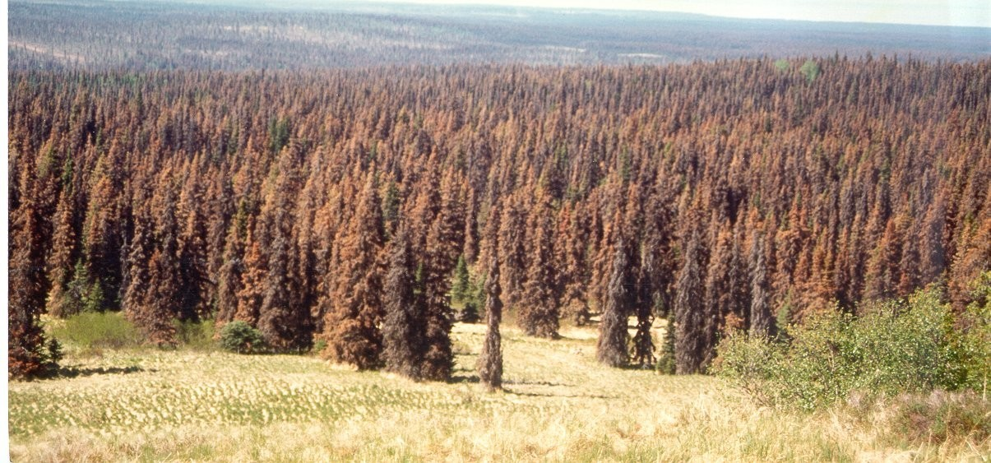

Key Message
During the 1990s, over four million acres of our forests in Alaska were heavily infested by the spruce bark beetle (Dendroctonus rufipennis). This was the largest bark beetle outbreak ever documented. Only when the beetle ran out of larger trees to feed on did the outbreak subside.

Issue
Aesthetics, wildlife habitat, watershed functions, recreation opportunities, timber resources and many other ecosystem services over vast areas of Alaskan forests were impacted by the spruce bark beetle outbreak. Forest fuels and hazardous trees increased with the concomitant threats of severe wildfires and human injury or dead. The economies of several local communities were significantly impacted.

Background
Spruce bark beetle populations increased to unprecedented levels during the 1990s. Over four million acres of spruce forests, primarily in south central Alaska, were impacted. Outbreaks near Hope, Girdwood, Dillingham and other locations still continue in residual stands. Although newly infested acreage has dropped considerably, the spruce beetle is still the most significant insect caused mortality agent in the state.
All infested areas have not had the same degree of impacts. Stands of pure spruce, such as those that occur in the southwestern Kenai Peninsula and the Copper River Basin, lost 80-90% of their trees. Forests elsewhere containing a mixture of hardwood trees still have those trees remaining.
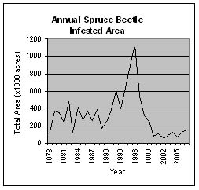
Lack of spruce and birch regeneration following this infestation is creating the need for reforestation treatments. With a lack of regeneration, forest dependent wildlife species may be affected, and watershed functions, aesthetics, and public safety may be compromised.

Current Situation
Beetle-killed trees dramatically increase the risk of wildfire, especially in wildland urban interface areas. They are a hazard to life and property as they break and fall after five to ten years; they will take 75 years or more to decompose. These ghost forests present a major management challenge. Forest Health Protection of Alaska Region has initiated and/or funded several cooperative ventures to deal with the beetle killed landscapes:

The Kenai Spruce Beetle Task Force—Through U.S. Forest Service State & Private Forestry programs, over $13 million dollars has been provided to the Kenai Peninsula Borough to implement immediate actions on state and private lands. The Chugach National Forest received nearly $1,500,000 to implement actions on national forest lands. More than 50,000 acres of beetle impacted wildland urban interface landscape has been treated to date, but much work still remains. www.borough.kenai.ak.us/beetle.htm.

The Forest Health Monitoring Data Clearinghouse—The U.S. Forest Service State & Private Forestry, in cooperation with the U.S. Geological Survey Mapping Division, established an internet-based Forest Health Monitoring Data Clearinghouse to provide pertinent forest health information across all ownerships. http://agdc.usgs.gov/data/projects/fhm.

Local Governments—Over $18 million dollars of federal assistance has been provided to address these fire risk concerns in Anchorage, the Mat-Su Borough, Fairbanks, and around Nenana. http://www.muni.org/fire1/wildfire.cfm.

Forest Restoration—Cooperative reforestation efforts have taken place on Native and private ownerships after fuels have been removed, however, vast dead areas remain in need of restoration treatments. Cooperative restoration actions amount to $470,000 in 2004 and $373,000 in 2005 through the Forest Health Protection Program.

Summary

During 1990s, Alaska experienced a spruce bark beetle epidemic that impacted 4 million acres of forest. This spruce bark beetle epidemic has been and continues to be a pervasive forest health issue in Alaska. The long-term effects of the dramatic forest change will require the attention of land managers and public administrators for years.

More Information:

John E. Lundquist, Entomologist, Forest Health Protection, State & Private Forestry, Alaska Region, (907) 743-9453.

