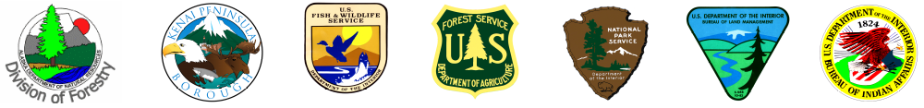

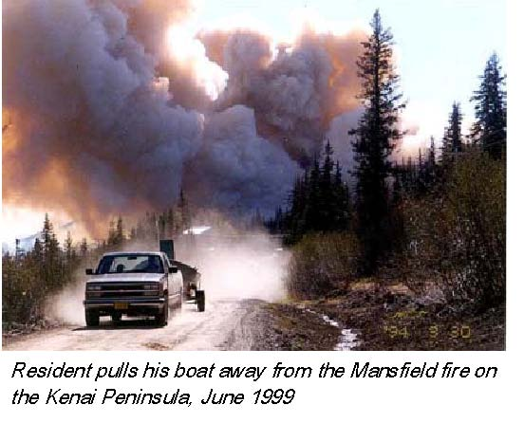
Key Message
The 10.25 million acres of the Kenai Peninsula Borough in Southcentral Alaska is at risk for catastrophic wildfire due to hazardous fuel accumulations created by the spruce bark beetle epidemic.

Issue
Alaska’s Kenai Peninsula Borough is continuing to experience a regional spruce bark-beetle epidemic that has caused greater than 90% mortality in many spruce stands in Southcentral Alaska. Approximately one million acres of spruce forest have been affected, resulting in hazardous fuel accumulations throughout the 10.25 million acre borough. This puts much of the borough at risk for large, intense fires.
The risk of catastrophic wildfire is at an historic high on the Kenai Peninsula, where most of the borough population of 51,200 residents is located, which has a tax-assessed value of $1.7 billion. With industrial and commercial structures added to residential values, the cumulative tax assessed value in the borough is $2.7 billion. Eighty-nine percent of the borough private property valuation is located in 15 community census areas with either an extreme or high wildfire risk rating.

Current Situation

In recognition of the wildland fire risk in the Kenai Peninsula Borough, an interagency committee called the Kenai Forest, Wildfire, and Fuels Management Coordinating Committee was formed in 2003. The committee is comprised of the following agencies: Alaska State Division of Forestry, Kenai Peninsula Borough, Kenai National Wildlife Refuge, Forest Service-Alaska Region, Bureau of Land Management-Anchorage Field Office, Kenai Fjords National Park, and the Bureau of Indian Affairs. The agencies signed a memorandum of understanding to work together to address the problem.

The Kenai interagency committee collaboratively developed the All Lands/All Hands Action Plan for FY 2005-2009 under the National Fire Plan and Healthy Forest Restoration Act (HFRA) for:
• Fire protection and prevention
• Hazardous fuels reduction from the "back porch out" (concept of homeowners on the wildland/urban interface to take steps to protect their own property)
• Insect and disease suppression
• Forest health restoration and rehabilitation treatments
• Community assistance

All Lands/All Hands Five Year Plan Implementation Projects include:
- • Collaborative development of community wildfire protection plans (CWPPs) for all “at risk” communities (ongoing; planned accomplishment in 2007)
• Increased interagency capabilities for fire prevention and protection
- • Defensible space fuel reduction on 17,550 private land parcels containing structures
• Fuel reduction on 97,000 Wildland Urban Interface (WUI) and non-WUI acres
• Mechanical fuel reduction adjacent to 641 miles of power lines & 222 miles of highway/road evacuation routes
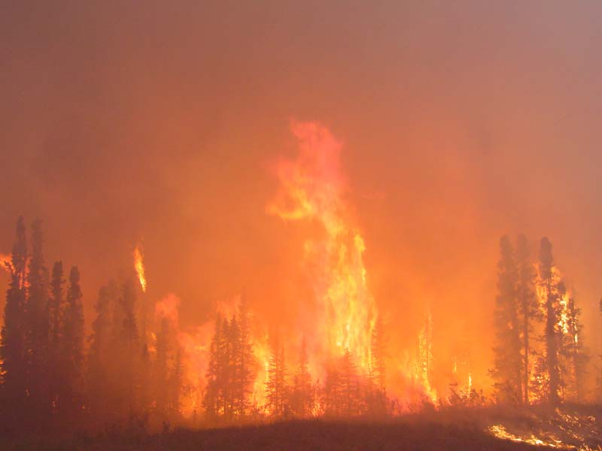
• Restoration of forest cover on 199,000 acres
• Construction of two strategic fuel breaks on the west side of the Kenai Peninsula

The FY 2006 Interagency mitigation accomplishments, as identified in the All Lands/All Hands Action Plan and funded under the National Fire Plan and Healthy Forest Restoration Act include the following projects:

1. Completion of 10 Community Wildfire Protection Plans (CWPPs) that cover 25 communities on the Kenai Peninsula. The Kenai Peninsula Borough completed eight CWPPs. The Chugach National Forest completed two additional CWPPs for communities in the vicinity of the National Forest. Communities scheduled for CWPPs include:

Communities with Extreme Wildfire Risk Rating
- • Anchor Point/Happy Valley/Nikolaevsk • Kenai
• Diamond Ridge/Fritz Creek/Fox River • Moose Pass/Crown Point/Primrose
• Homer/Kachemak • Ninilchick/Ninilchik Forties
• Kalifornsky/Kasilof/Cohoe/ClamGulch • Nikiski/Salamatof/Grey Cliff

High/Moderate Wildfire Risk Rating
• Hope/Sunrise/Summit • Cooper Landing

2. Reduction of hazardous fuels reduction on all lands managed/owned by cooperators:
  - • Mechanical—1,384 acres
• Slash Pile Disposal—908 acres

3. Timber sale offerings that continue to be uncut & available from previous years: 9,323 acres

FY07

In 2007, Kenai Peninsula Borough is planning the accomplishment of seven additional CWPPs, covering the communities of Soldotna, Sterling, Seldovia, Seldovia Village, Halibut Cove, Tyonek & Port Graham. While all Kenai Peninsula communities at “Extreme Risk” of stand-replacing wildfire are currently operating under completed CWPPs, this next set of plans will cover remaining communities in the high or moderate risk categories.
In addition, interagency, All Lands All Hands accomplishments planned for 2007 on the Kenai Peninsula include 1,836 acres of hazardous fuels removal, 2,662 acres planned for prescribed fire, and 500 acres of fuel break; for a total of 5,000 acres of treatment.

MORE INFORMATION

n

Debora Cooper  National Fire Plan Coordinator  DOI / USFS / State Div of Forestry  Phone: (907) 714.2439  e-mail: debora_cooper@dnr.state.ak.us | Roberta Wilfong  Program Manager, Spruce Bark Beetle  Kenai Peninsula Borough  Phone: (907) 260.6202  e-mail: rwilfong@borough.kenai.ak.us  www.borough.kenai.ak.us/sprucebeetle | Ric Plate  Area Forester  State Division of Forestry  Phone: (907) 260-4210  e-mail: ric.plate@alaska.gov

