This briefing book provides short descriptions of the some of the issues facing the Forest Service in Alaska in 2008.
The Forest Service in Alaska is a leader in protecting the land's bounty, while providing a place for people to work and play. In looking to the future, we understand that forests are valued in different ways. The forests are seen as:
- Global open space
- Living classrooms or laboratories
- A national sense of place
- A place for recreation
- A source of wood products
- A resource for traditional subsistence uses
- A rich heritage where generations have lived.
We manage the forestlands for all these purposes, while protecting the resources for the long term.
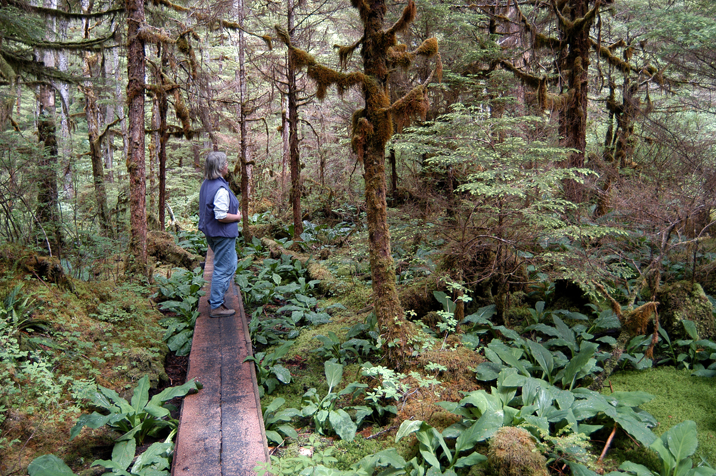
Forest Service employees of the Alaska Region work with the public to manage more than 22 million acres in Southcentral and Southeast Alaska. Vast watersheds filled with rivers, lakes, wetlands, salmon streams and glaciers make up the extensive Tongass and Chugach national forests, the two largest in the United States.
The Tongass National Forest stretches the 500-mile length of the Alaska Panhandle and covers more than 80 percent of the land. Juneau, Sitka, Ketchikan, Petersburg and more than 25 other communities are closely tied to this vast temperate rainforest. The Chugach National Forest makes a 210-mile arch around Prince William Sound and is a vital part of the towns of Anchorage, Seward, Cordova, Valdez and others.
The communities depend on the timber, minerals, salmon, and wildlife available in the forests, while many rural residents use the forests for the fish, blueberries, deer and other items needed in a subsistence lifestyle. Each year, the Forest Service develops projects to protect, use and enhance the resources.
National and international visitors join local residents in exploring the rivers and trails that stretch from sea level up to an icy alpine environment. Commercial tours and cruises provide a front-row seat to the wildlife and scenery, while independent travelers make their own way to excellent fishing, kayaking and camping.
The 127-mile Seward Highway, which links Anchorage with Seward, was designated an All-American Road in 2000. Travelers along this highway enjoy the spectacular scenery of Turnagain Arm.
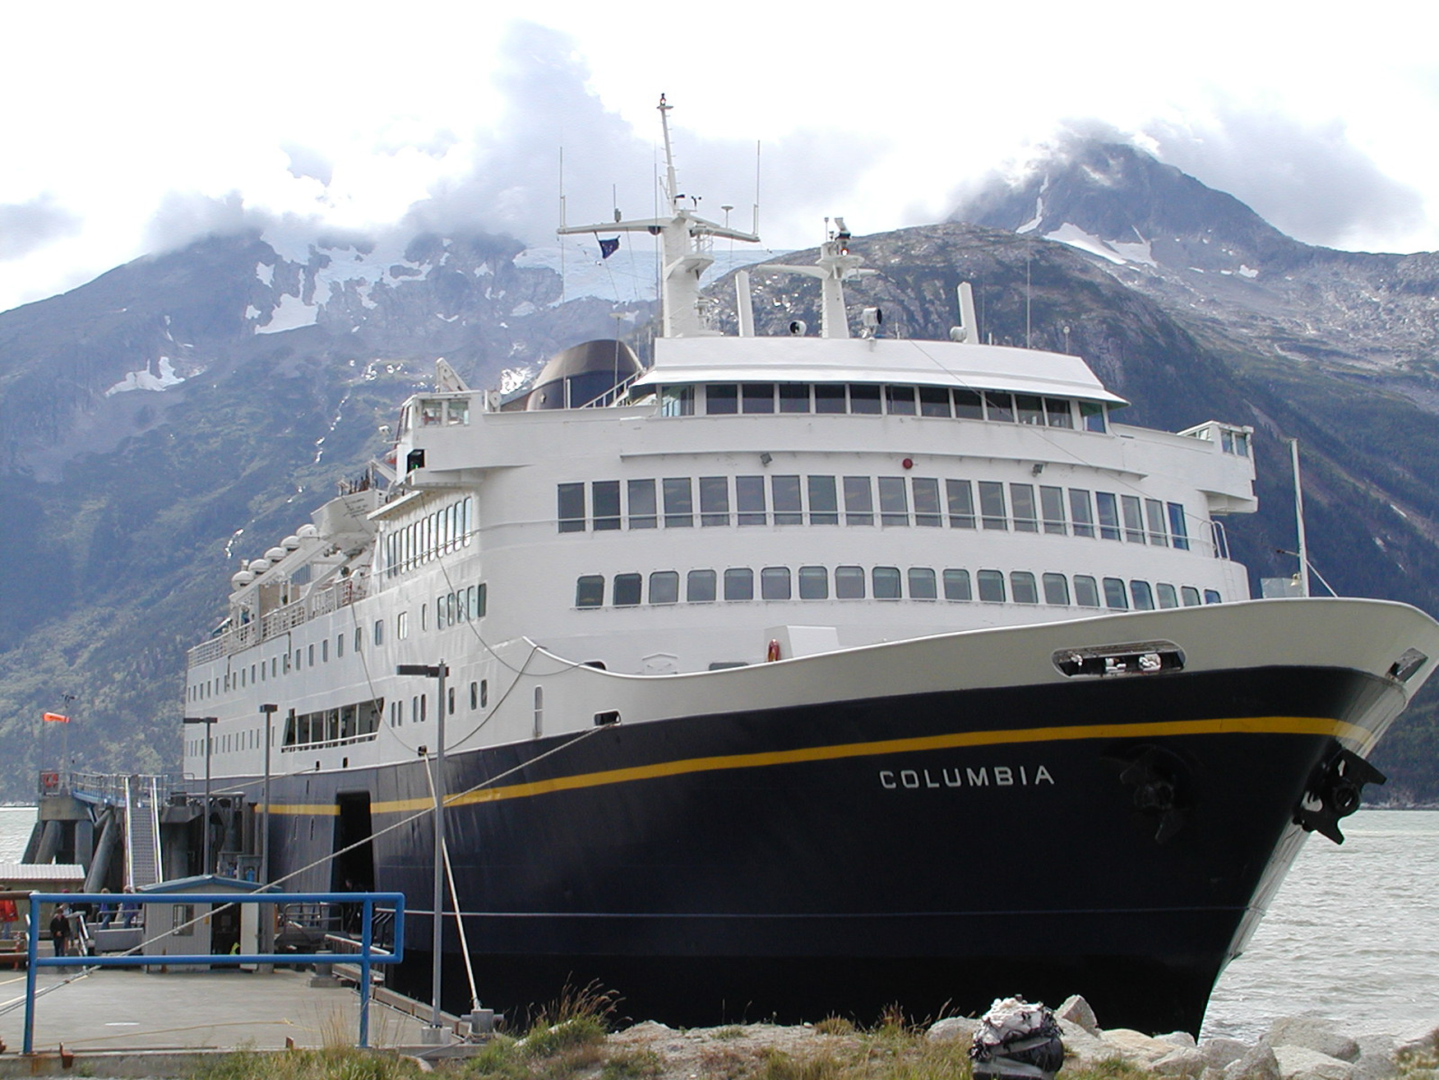
The Alaska Marine Highway—which consists of 8,000 miles of water routes from Bellingham, Wash., to the east end of the Aleutian chain—is 45 years old. The highway has been named a National Scenic Byway. The benefits of this designation include increased economic opportunities for the 34 coastal communities along the route, grants for improvements and maintenance projects, recognition of the exceptional scenic, historic, natural, cultural, and archaeological features of the highway, appreciation by visitors for the natural resources upon which Alaskans depend, and international marketing provided by the Byways program.
M/V Columbia
The Forest Service has been a partner with the Alaska Marine Highway System in providing seasonal shipboard interpreters. These trained interpreters ride the ferries, sharing their knowledge of Alaskan culture and natural history.
The vast expanse of the two national forests creates challenges both for the public and for the Forest Service. While roads are slowly improving, in some areas they are virtually nonexistent in vast areas of the landscape. That means people often must travel by boat or aircraft.
Land management planning provides the backbone for protecting the resources, while providing services to the public. The Tongass completed an amendment to its forest plan this year which includes protection for streams, wetlands, caves and wildlife in Southeast Alaska, while providing sustainable resources for communities.
The Chugach, with much public collaboration, completed its own plan revision in 2002. A variety of options were developed to address such issues as ecosystem management, fish and wildlife needs, subsistence needs, resource development, recreation/tourism, and special land designations.
This book contains more information about these ongoing programs as well as updates on current issues facing us now and in the immediate future.
Updated April 2008.

