Spencer Glacier: Mining and Recreation
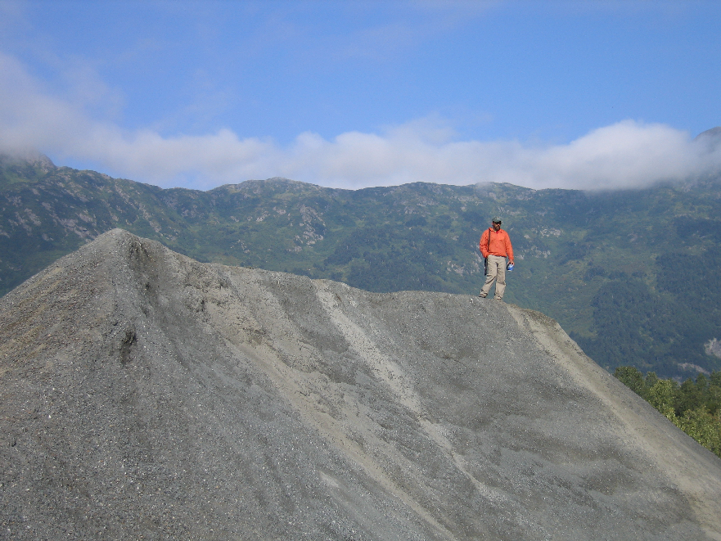The Spencer Glacier area of the Chugach National Forest contains a significant mineral materials deposit and high recreational values each within the same geographic area. Mineral material mining has occurred on this site since 1907. The vast sand and gravel deposit at Spencer is high quality. Its stone is exceptional hard and durable, and its property of breaking into large, competent pieces when blasted supplies excellent “armor stone” for harbors, break waters and other marine projects. There is a demonstrated demand for sand, gravel and stone from this site which is only accessible by the Alaska Railroad.

The recreational values of Spencer are now more accessible to the public through the Whistle Stop project, a partnership with the Alaska Railroad. Rail passengers will access spectacular ice-capped mountains, glaciers, and wild rivers, facilitated by backcountry campsites, cabins, trails, and guide services. Popular guided raft float trips from the lake down the Placer River have been occurring over the last four years. The site was designated a developed recreation complex in the revised forest plan. The revised forest plan establishes direction to manage this area in a manner that facilitates both recreational development and mining activities.

The Chugach National Forest is considering offering an extensive mineral materials sale, greater than 10 million cubic yards. The forest has an excellent track record of meshing gravel mining, fisheries enhancement, and recreation in nearby Portage Valley, which is a showcase area where both new and old mineral material pits have been reclaimed by designing them to function as rearing habitat for fish and campgrounds for visitors. There is every reason to believe that similar multiple use management is achievable at Spencer Glacier.

Actions on Track
The Forest Service is scheduled to release the draft environmental impact statement for the Spencer Glacier Mineral Materials Project in spring 2008. The proposed action for mineral materials extraction facilitates recreational development and will not materially interfere with existing placer mining claims.

Potential Reinvestment Strategies
The forest is interested in exploring a means for investing receipts from mineral material sales within in the Chugach Whistle Stop Project area. Some ideas of how this could be accomplished include:
- Establish authority to retain receipts for reinvestment into the Whistle Stop project corridor for resource restoration and enhancement, recreation facilities and infrastructure.
- Establish a Whistle Stop Working Capital Fund in order to advance provision of infrastructure investments such as cabins, trails, Whistle Stop facilities and associated rolling stock; to be paid back through generation of receipts from mineral materials sales.

This could be sought as a pilot authority to establish examples where site and facility investments are made through capitalization from the approved use of natural resources where the public benefit is maximized by on-site investments where such investments otherwise could not be capitalized. Pilot authority such as this would demonstrate a “pay-go” approach to provide public facilities and services through a working capital fund, and address the value of providing associated investments in advance with payback generated through receipt retention.

More Information
Joe Meade, Forest Supervisor, (907) 743-9525; Jim Fincher, Girdwood District Ranger (907) 743-9541; John Kato, Regional Minerals Program Manager, (907) 586-7869

