Issue
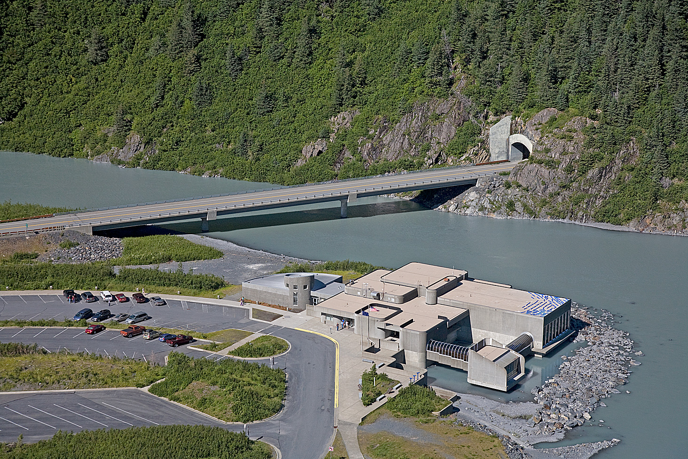
Begich, Boggs Visitor Center is a large, multi-use Forest Service visitor center in the heart of Southcentral Alaska. Visited by hundreds of thousands of tourists and residents, the center provides an introduction to the natural and cultural aspects of Portage Valley and Prince William Sound within the Chugach National Forest.
Operating this multi-million dollar facility is an important responsibility. The Forest Service is committed to offering visitors a high quality experience with interactive exhibits, skilled naturalists, an award-winning movie, and education materials from the Alaska Geographic Interpretive Association.
Currently, the Chugach National Forest devotes half its recreation operations and maintenance budget to operating and maintaining the visitor center. However, with flat to declining budgets, funding is not presently adequate to open the center all year.

Background
The Forest Service began conducting public meetings last November to explore options to increase cost recovery for center operations and maintenance. Responses were received from the general public and tour operators.
The majority of responders recommended that movie fee increases should not occur until Summer 2009. By postponing this change to the Recreation Fee Program, tour guide operators may market and advertise the new rate prior to the 2009 visitor season. This delayed fee change will also allow the Forest Service to educate the general public about the change prior to their arriving at the Center for visits. Most people recommended that the increase begin with a $3 fee and increase it to no more than $5 per adult, over time.

Future of the Fee Program
For Summer 2008, the Forest Service will maintain its existing, adult only, $1 fee for the movie. Beginning with Summer 2009, the fee will change to cover the movie and the exhibits. This standard amenity fee will be $3 per adult in 2009, $4 per adult in 2010 and $5 per adult in 2011. Season passes will be sold to individuals, two adults or family groups. In all cases, children 15 and under will be admitted to the movie and exhibits free of charge, as will people who own an America the Beautiful Pass, Senior Pass, Access Pass, Golden Age Pass or Golden Access Pass. Beginning in 2009, permitted tour guide companies will be able to receive a 10% discount in the standard amenity fee for their guests by paying in advance.

Benefits of Amended Fee Program
Additional funds will assist, over time, with:
- Reopening the visitor center during off-season weekends and for special events
- Reinstating the annual “Nature Spooktacular”
- Enhancing conservation education and interpretive program offerings
- Offering new exhibits and special events
- Creating a new film
- Paying operation and maintenance costs
- Advertising and marketing the center
- Updating and improving its web page.

Additional Opportunities
Greater use of this facility could occur by charging fees for appropriate special activities such as film festivals, concerts, and special events. The facilities and staff could also be made available to the private sector for meetings, small conferences or workshops, trainings, and receptions during the off-season or when the center is closed to the public.

For More Information

- Joe Meade, Forest Supervisor (907) 743-9525
- Lezlie Murray, Visitor Center Director (907) 754-2316
- Ruth Monahan, Regional Director, Recreation, Lands, and Minerals (907) 586-8877

