Frequency Analysis

Table: | SP_GSA_EMP

Filter: | None

Question: | Name of Cabinet within which your agency resides or Other if your agency does not fall within a Cabinet.

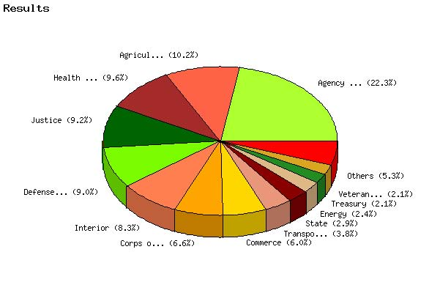

   | Count | % Sample  Answered | % Sample  Asked | % Sample  Total
  Agriculture | 100 | 10.2% | 10.2% | 10.2%
  Commerce | 59 | 6.0% | 6.0% | 6.0%
  Defense (Except Corps of Engineers) | 89 | 9.0% | 9.0% | 9.0%
  Corps of Engineers | 65 | 6.6% | 6.6% | 6.6%
  Education | 7 | 0.7% | 0.7% | 0.7%
  Energy | 24 | 2.4% | 2.4% | 2.4%
  Health & Human Services | 94 | 9.6% | 9.6% | 9.6%
  Homeland Security | 11 | 1.1% | 1.1% | 1.1%
  Housing & Urban Development | 7 | 0.7% | 0.7% | 0.7%
  Interior | 82 | 8.3% | 8.3% | 8.3%
  Justice | 91 | 9.2% | 9.2% | 9.2%
  Labor | 19 | 1.9% | 1.9% | 1.9%
  State | 29 | 2.9% | 2.9% | 2.9%
  Transportation | 37 | 3.8% | 3.8% | 3.8%
  Treasury | 21 | 2.1% | 2.1% | 2.1%
  Veterans Affairs | 21 | 2.1% | 2.1% | 2.1%
  Agency not within Cabinet | 219 | 22.3% | 22.3% | 22.3%
  Government Corporations | 9 | 0.9% | 0.9% | 0.9%
  Not Answered | 0 | N/A | 0.0% | 0.0%
  Not Asked | 0 | N/A | N/A | 0.0%
  Total | 984 | 100% | 100% | 100%
  Statistics
  Minimum Value | 1.00
  Maximum Value | 18.00
  Average | 9.36
  Sum | 9213
  Standard Deviation | 5.82
  Median | 10
  Mode | 17

Question: | Please select the appropriate Defense Agency.

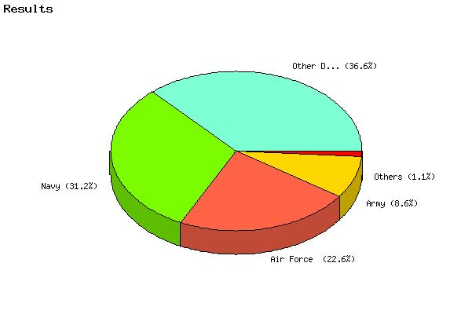

   | Count | % Sample  Answered | % Sample  Asked | % Sample  Total
  Air Force | 21 | 22.6% | 22.6% | 2.1%
  Army | 8 | 8.6% | 8.6% | 0.8%
  Navy | 29 | 31.2% | 31.2% | 2.9%
  Marine Corps | 1 | 1.1% | 1.1% | 0.1%
  Other DoD organization (Please specify) | 34 | 36.6% | 36.6% | 3.5%
  Not Answered | 0 | N/A | 0.0% | 0.0%
  Not Asked | 891 | N/A | N/A | 90.5%
  Total | 984 | 100% | 100% | 100%
  Statistics
  Minimum Value | 1.00
  Maximum Value | 5.00
  Average | 3.20
  Sum | 298
  Standard Deviation | 1.56
  Median | 3
  Mode | 5

Question: | Are you?

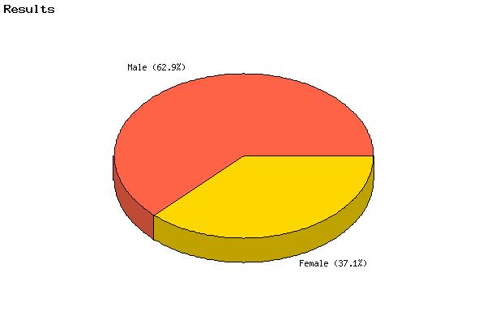

   | Count | % Sample  Answered | % Sample  Asked | % Sample  Total
  Male | 612 | 62.9% | 62.2% | 62.2%
  Female | 361 | 37.1% | 36.7% | 36.7%
  Not Answered | 11 | N/A | 1.1% | 1.1%
  Not Asked | 0 | N/A | N/A | 0.0%
  Total | 984 | 100% | 100% | 100%
  Statistics
  Minimum Value | 1.00
  Maximum Value | 2.00
  Average | 1.37
  Sum | 1334
  Standard Deviation | 0.48
  Median | 1
  Mode | 1

Question: | What is your pay category/grade?

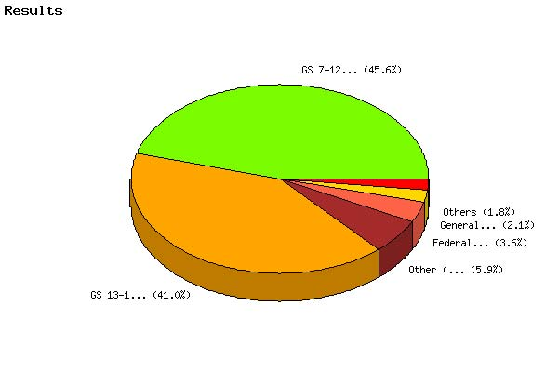

   | Count | % Sample  Answered | % Sample  Asked | % Sample  Total
  Federal Wage System (e.g., WG, WL, WS) | 35 | 3.6% | 3.6% | 3.6%
  General Schedule (GS))1-6 or equivalent | 21 | 2.1% | 2.1% | 2.1%
  GS 7-12 or equivalent | 446 | 45.6% | 45.3% | 45.3%
  GS 13-15 or equivalent | 401 | 41.0% | 40.8% | 40.8%
  Senior Executive Service or equivalent | 18 | 1.8% | 1.8% | 1.8%
  Senior Level (SL) or Scientific or Professional (ST) | 0 | 0.0% | 0.0% | 0.0%
  Other (Please specify) | 58 | 5.9% | 5.9% | 5.9%
  Not Answered | 5 | N/A | 0.5% | 0.5%
  Not Asked | 0 | N/A | N/A | 0.0%
  Total | 984 | 100% | 100% | 100%
  Statistics
  Minimum Value | 1.00
  Maximum Value | 7.00
  Average | 3.59
  Sum | 3515
  Standard Deviation | 1.12
  Median | 3
  Mode | 3

Question: | During your tenure with the Federal Government how many times have you moved at the government's expense?

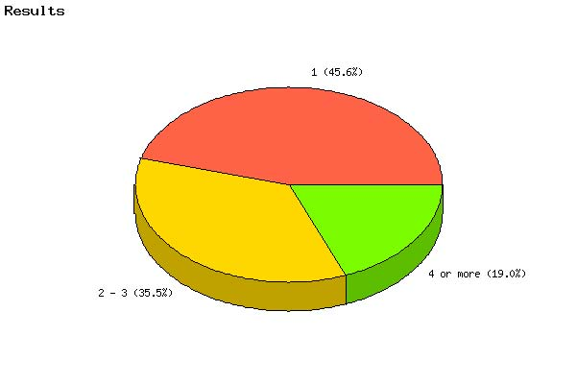

   | Count | % Sample  Answered | % Sample  Asked | % Sample  Total
  1 | 445 | 45.6% | 45.2% | 45.2%
  2 - 3 | 346 | 35.5% | 35.2% | 35.2%
  4 or more | 185 | 19.0% | 18.8% | 18.8%
  Not Answered | 8 | N/A | 0.8% | 0.8%
  Not Asked | 0 | N/A | N/A | 0.0%
  Total | 984 | 100% | 100% | 100%
  Statistics
  Minimum Value | 1.00
  Maximum Value | 3.00
  Average | 1.73
  Sum | 1692
  Standard Deviation | 0.76
  Median | 2
  Mode | 1

Question: | Which describes how your relocation was handled? (check all that apply)

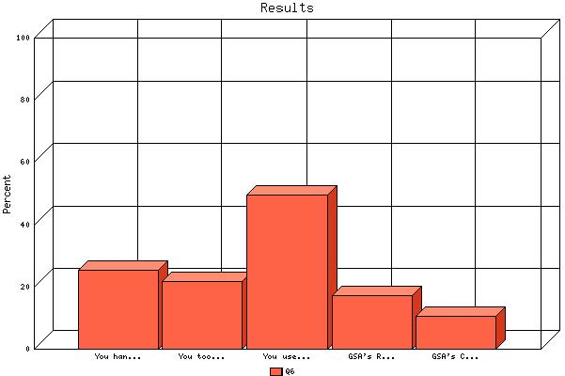

 | Count | % Sample  Answered
You handled the relocation on your own with reimbursement for actual expenses. | 250 | 25.4%
You took a lump-sum payment for expense categories without a requirement to document your actual expenses. | 215 | 21.8%
You used third-party assistance as allowed by your agency's policies. | 486 | 49.4%
GSA's Relocation Schedules | 168 | 17.1%
GSA's Centralized Household Goods Traffic Management Program (CHAMP) | 104 | 10.6%

Question: | Did your agency provide a single point of contact or a set of coordinated contacts so that you felt that you always knew whom to go to for help?

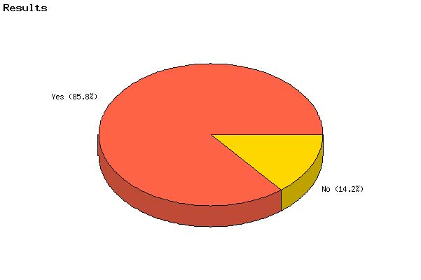

   | Count | % Sample  Answered | % Sample  Asked | % Sample  Total
  Yes | 833 | 85.8% | 84.7% | 84.7%
  No | 138 | 14.2% | 14.0% | 14.0%
  Not Answered | 13 | N/A | 1.3% | 1.3%
  Not Asked | 0 | N/A | N/A | 0.0%
  Total | 984 | 100% | 100% | 100%
  Statistics
  Minimum Value | 1.00
  Maximum Value | 2.00
  Average | 1.14
  Sum | 1109
  Standard Deviation | 0.35
  Median | 1
  Mode | 1

Question: | How satisfied were you with Government relocation?

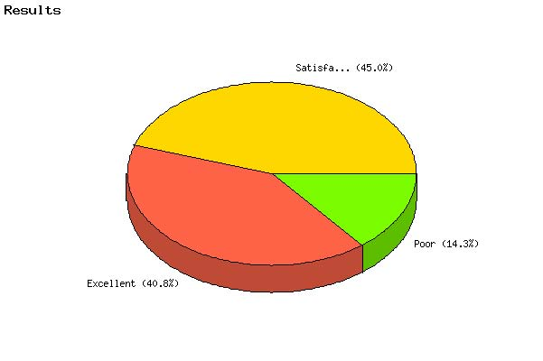

   | Count | % Sample  Answered | % Sample  Asked | % Sample  Total
  Excellent | 397 | 40.8% | 40.3% | 40.3%
  Satisfactory | 438 | 45.0% | 44.5% | 44.5%
  Poor | 139 | 14.3% | 14.1% | 14.1%
  Not Answered | 10 | N/A | 1.0% | 1.0%
  Not Asked | 0 | N/A | N/A | 0.0%
  Total | 984 | 100% | 100% | 100%
  Statistics
  Minimum Value | 1.00
  Maximum Value | 3.00
  Average | 1.74
  Sum | 1690
  Standard Deviation | 0.69
  Median | 2
  Mode | 2

Question: | If you consulted GSA's Federal Travel Regulation for specific allowances and benefits, how do you rate its usefulness?

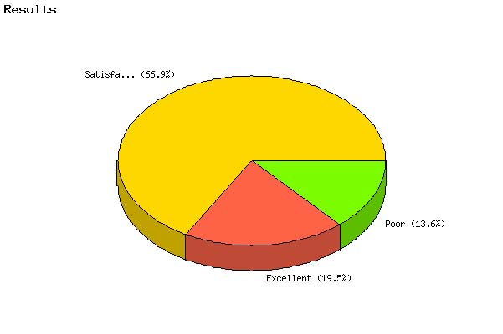

   | Count | % Sample  Answered | % Sample  Asked | % Sample  Total
  Excellent | 139 | 19.5% | 14.1% | 14.1%
  Satisfactory | 475 | 66.8% | 48.3% | 48.3%
  Poor | 97 | 13.6% | 9.9% | 9.9%
  Not Answered | 273 | N/A | 27.7% | 27.7%
  Not Asked | 0 | N/A | N/A | 0.0%
  Total | 984 | 100% | 100% | 100%
  Statistics
  Minimum Value | 1.00
  Maximum Value | 3.00
  Average | 1.94
  Sum | 1380
  Standard Deviation | 0.57
  Median | 2
  Mode | 2

Question: | Did the Government's relocation program provide reasonable coverage of your relocation expenses?

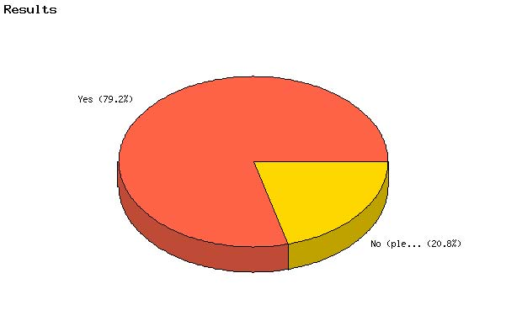

   | Count | % Sample  Answered | % Sample  Asked | % Sample  Total
  Yes | 770 | 79.2% | 78.3% | 78.3%
  No (please explain) | 202 | 20.8% | 20.5% | 20.5%
  Not Answered | 12 | N/A | 1.2% | 1.2%
  Not Asked | 0 | N/A | N/A | 0.0%
  Total | 984 | 100% | 100% | 100%
  Statistics
  Minimum Value | 1.00
  Maximum Value | 2.00
  Average | 1.21
  Sum | 1174
  Standard Deviation | 0.41
  Median | 1
  Mode | 1

Question: | What were your three best sources of information about your relocation allowance entitlements? Please choose exactly 3.

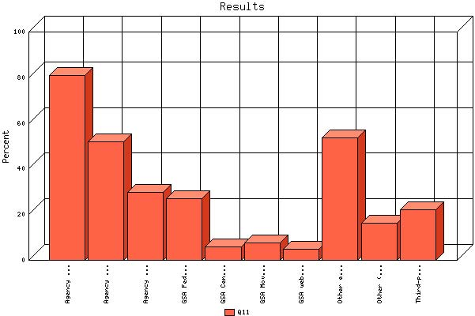

 | Count | % Sample  Answered
Agency relocation specialists | 797 | 81.0%
Agency or third-party written guidance | 510 | 51.8%
Agency web site | 292 | 29.7%
GSA Federal Travel Regulation (FTR) | 267 | 27.1%
GSA Centralized Household Goods Traffic Management Program (CHAMP) | 58 | 5.9%
GSA Move Management Services | 74 | 7.5%
GSA web site | 49 | 5.0%
Other employee at your agency | 527 | 53.6%
Other (please specify) | 160 | 16.3%
Third-party counseling services (vendors) | 217 | 22.1%

Question: | Please rate the following relocation allowance entitlements in rank order 1-3, with 1 being the best.
Topic: | Agency relocation specialists

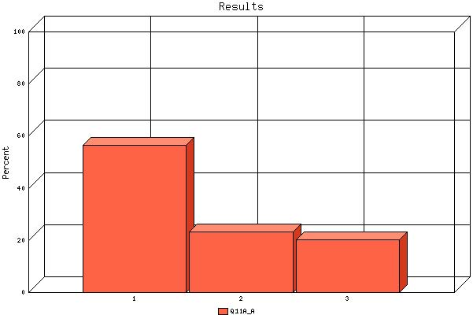

   | Count | % Sample  Answered | % Sample  Asked | % Sample  Total
  1 | 442 | 56.4% | 44.9% | 44.9%
  2 | 183 | 23.4% | 18.6% | 18.6%
  3 | 158 | 20.2% | 16.1% | 16.1%
  Not Answered | 201 | N/A | 20.4% | 20.4%
  Not Asked | 0 | N/A | N/A | 0.0%
  Total | 984 | 100% | 100% | 100%
  Statistics
  Minimum Value | 1.00
  Maximum Value | 3.00
  Average | 1.64
  Sum | 1282
  Standard Deviation | 0.80
  Median | 1
  Mode | 1

Question: | Please rate the following relocation allowance entitlements in rank order 1-3, with 1 being the best.
Topic: | Agency or third-party written guidance

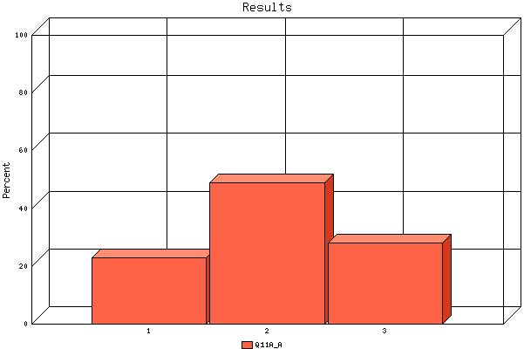

   | Count | % Sample  Answered | % Sample  Asked | % Sample  Total
  1 | 115 | 23.0% | 11.7% | 11.7%
  2 | 244 | 48.9% | 24.8% | 24.8%
  3 | 140 | 28.1% | 14.2% | 14.2%
  Not Answered | 485 | N/A | 49.3% | 49.3%
  Not Asked | 0 | N/A | N/A | 0.0%
  Total | 984 | 100% | 100% | 100%
  Statistics
  Minimum Value | 1.00
  Maximum Value | 3.00
  Average | 2.05
  Sum | 1023
  Standard Deviation | 0.71
  Median | 2
  Mode | 2

Question: | Please rate the following relocation allowance entitlements in rank order 1-3, with 1 being the best.
Topic: | Agency web site

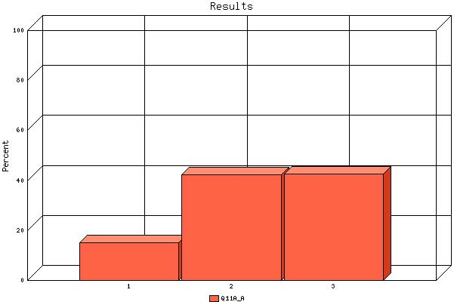

   | Count | % Sample  Answered | % Sample  Asked | % Sample  Total
  1 | 43 | 15.1% | 4.4% | 4.4%
  2 | 120 | 42.3% | 12.2% | 12.2%
  3 | 121 | 42.6% | 12.3% | 12.3%
  Not Answered | 700 | N/A | 71.1% | 71.1%
  Not Asked | 0 | N/A | N/A | 0.0%
  Total | 984 | 100% | 100% | 100%
  Statistics
  Minimum Value | 1.00
  Maximum Value | 3.00
  Average | 2.27
  Sum | 646
  Standard Deviation | 0.71
  Median | 2
  Mode | 3

Question: | Please rate the following relocation allowance entitlements in rank order 1-3, with 1 being the best.
Topic: | GSA Federal Travel Regulation (FTR)

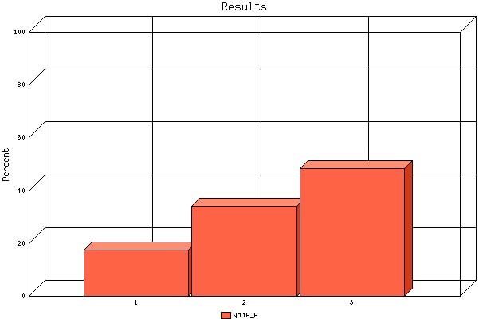

   | Count | % Sample  Answered | % Sample  Asked | % Sample  Total
  1 | 45 | 17.6% | 4.6% | 4.6%
  2 | 87 | 34.0% | 8.8% | 8.8%
  3 | 124 | 48.4% | 12.6% | 12.6%
  Not Answered | 728 | N/A | 74.0% | 74.0%
  Not Asked | 0 | N/A | N/A | 0.0%
  Total | 984 | 100% | 100% | 100%
  Statistics
  Minimum Value | 1.00
  Maximum Value | 3.00
  Average | 2.31
  Sum | 591
  Standard Deviation | 0.75
  Median | 2
  Mode | 3

Question: | Please rate the following relocation allowance entitlements in rank order 1-3, with 1 being the best.
Topic: | GSA Centralized Household Goods Traffic Management Program (CHAMP)

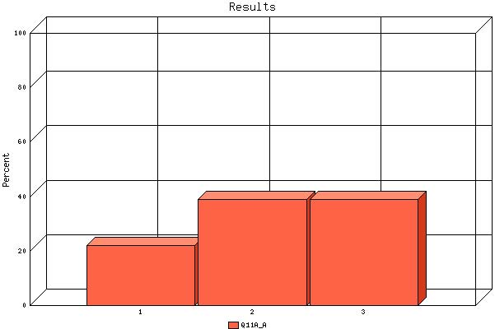

   | Count | % Sample  Answered | % Sample  Asked | % Sample  Total
  1 | 13 | 22.0% | 1.3% | 1.3%
  2 | 23 | 39.0% | 2.3% | 2.3%
  3 | 23 | 39.0% | 2.3% | 2.3%
  Not Answered | 925 | N/A | 94.0% | 94.0%
  Not Asked | 0 | N/A | N/A | 0.0%
  Total | 984 | 100% | 100% | 100%
  Statistics
  Minimum Value | 1.00
  Maximum Value | 3.00
  Average | 2.17
  Sum | 128
  Standard Deviation | 0.77
  Median | 2
  Mode | Multi-Modal

Question: | Please rate the following relocation allowance entitlements in rank order 1-3, with 1 being the best.
Topic: | GSA Move Management Services

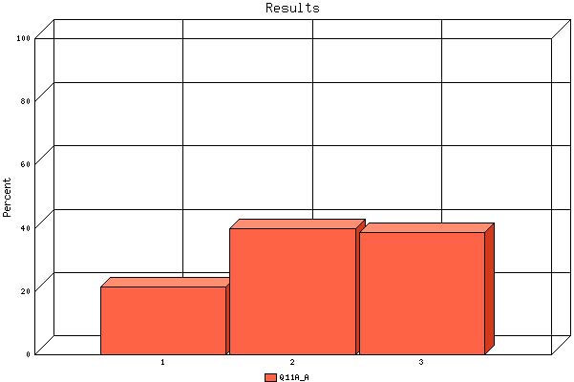

   | Count | % Sample  Answered | % Sample  Asked | % Sample  Total
  1 | 16 | 21.3% | 1.6% | 1.6%
  2 | 30 | 40.0% | 3.0% | 3.0%
  3 | 29 | 38.7% | 2.9% | 2.9%
  Not Answered | 909 | N/A | 92.4% | 92.4%
  Not Asked | 0 | N/A | N/A | 0.0%
  Total | 984 | 100% | 100% | 100%
  Statistics
  Minimum Value | 1.00
  Maximum Value | 3.00
  Average | 2.17
  Sum | 163
  Standard Deviation | 0.76
  Median | 2
  Mode | 2

Question: | Please rate the following relocation allowance entitlements in rank order 1-3, with 1 being the best.
Topic: | GSA web site

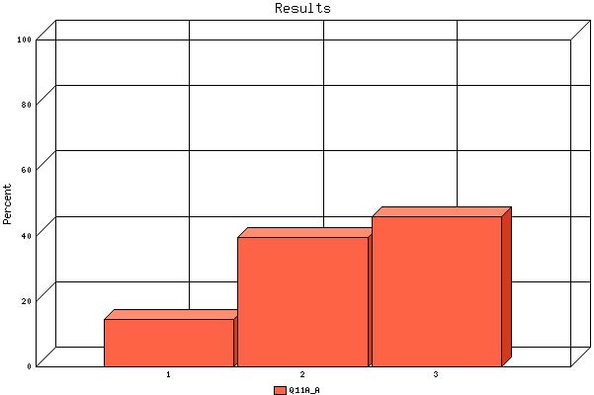

   | Count | % Sample  Answered | % Sample  Asked | % Sample  Total
  1 | 7 | 14.6% | 0.7% | 0.7%
  2 | 19 | 39.6% | 1.9% | 1.9%
  3 | 22 | 45.8% | 2.2% | 2.2%
  Not Answered | 936 | N/A | 95.1% | 95.1%
  Not Asked | 0 | N/A | N/A | 0.0%
  Total | 984 | 100% | 100% | 100%
  Statistics
  Minimum Value | 1.00
  Maximum Value | 3.00
  Average | 2.31
  Sum | 111
  Standard Deviation | 0.72
  Median | 2
  Mode | 3

Question: | Please rate the following relocation allowance entitlements in rank order 1-3, with 1 being the best.
Topic: | Other employee at your agency

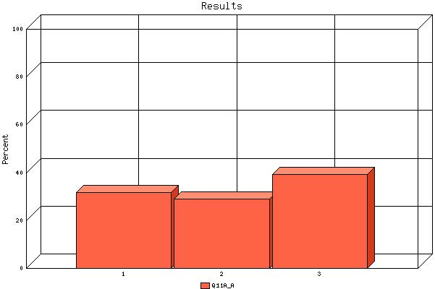

   | Count | % Sample  Answered | % Sample  Asked | % Sample  Total
  1 | 164 | 31.8% | 16.7% | 16.7%
  2 | 149 | 28.9% | 15.1% | 15.1%
  3 | 203 | 39.3% | 20.6% | 20.6%
  Not Answered | 468 | N/A | 47.6% | 47.6%
  Not Asked | 0 | N/A | N/A | 0.0%
  Total | 984 | 100% | 100% | 100%
  Statistics
  Minimum Value | 1.00
  Maximum Value | 3.00
  Average | 2.08
  Sum | 1071
  Standard Deviation | 0.84
  Median | 2
  Mode | 3

Question: | Please rate the following relocation allowance entitlements in rank order 1-3, with 1 being the best.
Topic: | %Q11Specified_9%

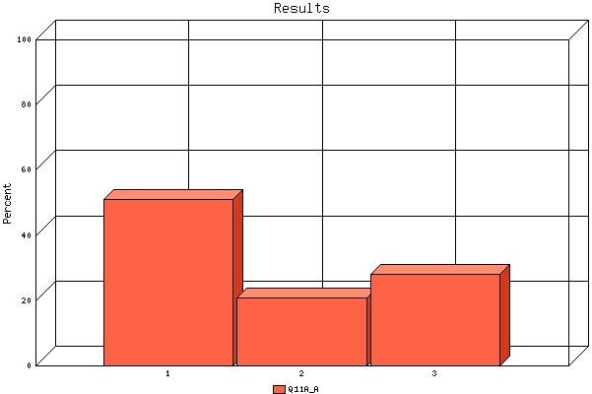

   | Count | % Sample  Answered | % Sample  Asked | % Sample  Total
  1 | 78 | 51.0% | 7.9% | 7.9%
  2 | 32 | 20.9% | 3.3% | 3.3%
  3 | 43 | 28.1% | 4.4% | 4.4%
  Not Answered | 831 | N/A | 84.5% | 84.5%
  Not Asked | 0 | N/A | N/A | 0.0%
  Total | 984 | 100% | 100% | 100%
  Statistics
  Minimum Value | 1.00
  Maximum Value | 3.00
  Average | 1.77
  Sum | 271
  Standard Deviation | 0.86
  Median | 1
  Mode | 1

Question: | Please rate the following relocation allowance entitlements in rank order 1-3, with 1 being the best.
Topic: | Third-party counseling services (vendors)

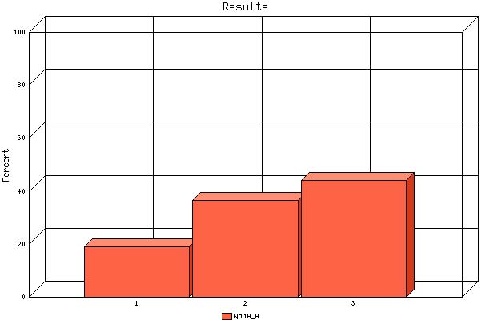

   | Count | % Sample  Answered | % Sample  Asked | % Sample  Total
  1 | 41 | 19.1% | 4.2% | 4.2%
  2 | 79 | 36.7% | 8.0% | 8.0%
  3 | 95 | 44.2% | 9.7% | 9.7%
  Not Answered | 769 | N/A | 78.2% | 78.2%
  Not Asked | 0 | N/A | N/A | 0.0%
  Total | 984 | 100% | 100% | 100%
  Statistics
  Minimum Value | 1.00
  Maximum Value | 3.00
  Average | 2.25
  Sum | 484
  Standard Deviation | 0.76
  Median | 2
  Mode | 3

Question: | In your most recent move why did you relocate? (Select all that apply)

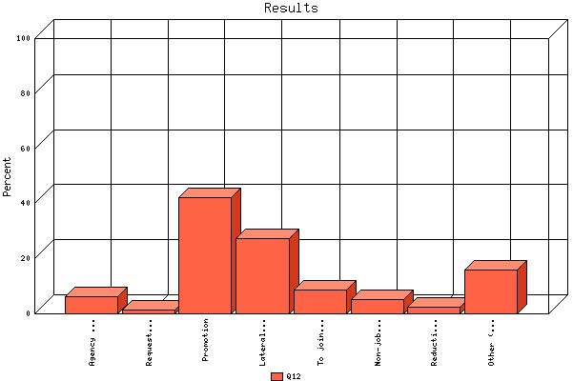

 | Count | % Sample  Answered
Agency supervisor/manager request | 61 | 6.2%
Request of Human Resources Office | 14 | 1.4%
Promotion | 416 | 42.3%
Lateral move | 269 | 27.3%
To join another agency | 86 | 8.7%
Non-job related personal goal | 50 | 5.1%
Reduction-in-force | 25 | 2.5%
Other (please specify) | 157 | 16.0%

Question: | How many months did it take (from travel authorization to move into permanent residence) to complete your relocation?

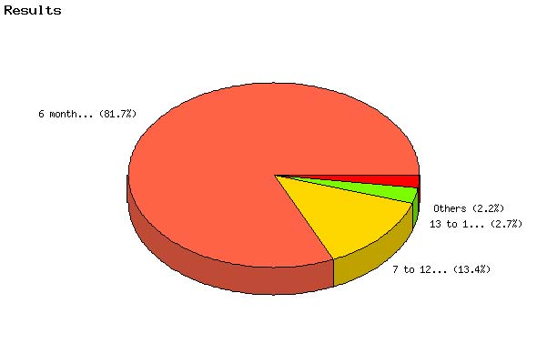

   | Count | % Sample  Answered | % Sample  Asked | % Sample  Total
  6 months or less | 793 | 81.7% | 80.6% | 80.6%
  7 to 12 months | 130 | 13.4% | 13.2% | 13.2%
  13 to 18 months | 26 | 2.7% | 2.6% | 2.6%
  19 to 24 months | 12 | 1.2% | 1.2% | 1.2%
  25 or more months | 10 | 1.0% | 1.0% | 1.0%
  Not Answered | 13 | N/A | 1.3% | 1.3%
  Not Asked | 0 | N/A | N/A | 0.0%
  Total | 984 | 100% | 100% | 100%
  Statistics
  Minimum Value | 1.00
  Maximum Value | 5.00
  Average | 1.27
  Sum | 1229
  Standard Deviation | 0.67
  Median | 1
  Mode | 1

Question: | Did your agency require you to sign a service agreement in exchange for relocation reimbursements

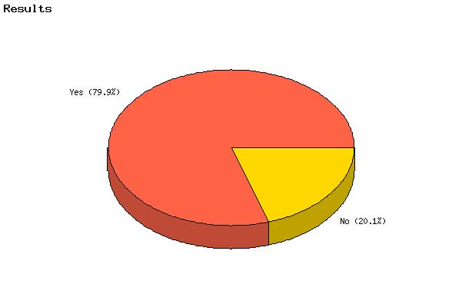

   | Count | % Sample  Answered | % Sample  Asked | % Sample  Total
  Yes | 767 | 79.9% | 77.9% | 77.9%
  No | 193 | 20.1% | 19.6% | 19.6%
  Not Answered | 24 | N/A | 2.4% | 2.4%
  Not Asked | 0 | N/A | N/A | 0.0%
  Total | 984 | 100% | 100% | 100%
  Statistics
  Minimum Value | 1.00
  Maximum Value | 2.00
  Average | 1.20
  Sum | 1153
  Standard Deviation | 0.40
  Median | 1
  Mode | 1

Question: | In addition to covering your relocation costs, did your agency pay you a separate relocation bonus as an incentive to relocate?

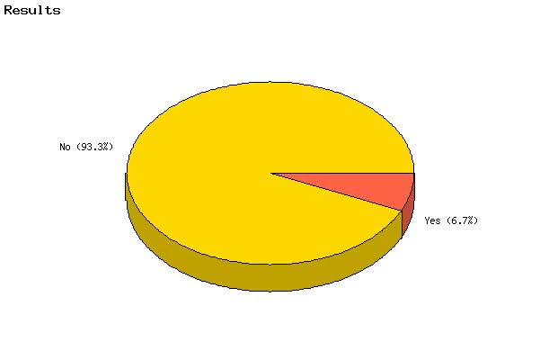

   | Count | % Sample  Answered | % Sample  Asked | % Sample  Total
  Yes | 65 | 6.7% | 6.6% | 6.6%
  No | 909 | 93.3% | 92.4% | 92.4%
  Not Answered | 10 | N/A | 1.0% | 1.0%
  Not Asked | 0 | N/A | N/A | 0.0%
  Total | 984 | 100% | 100% | 100%
  Statistics
  Minimum Value | 1.00
  Maximum Value | 2.00
  Average | 1.93
  Sum | 1883
  Standard Deviation | 0.25
  Median | 2
  Mode | 2

Question: | Satisfaction with relocation services received (for each of the following elements, please rate your satisfaction level):
Topic: | Shipment of Household Goods (overall satisfaction)

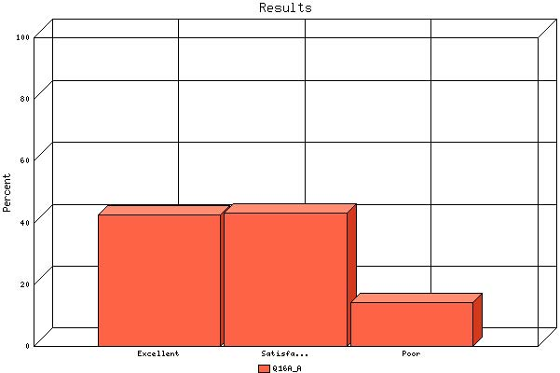

   | Count | % Sample  Answered | % Sample  Asked | % Sample  Total
  Excellent | 362 | 42.5% | 36.8% | 36.8%
  Satisfactory | 368 | 43.2% | 37.4% | 37.4%
  Poor | 122 | 14.3% | 12.4% | 12.4%
  Not Answered | 132 | N/A | 13.4% | 13.4%
  Not Asked | 0 | N/A | N/A | 0.0%
  Total | 984 | 100% | 100% | 100%
  Statistics
  Minimum Value | 1.00
  Maximum Value | 3.00
  Average | 1.72
  Sum | 1464
  Standard Deviation | 0.70
  Median | 2
  Mode | 2

Question: | Satisfaction with relocation services received (for each of the following elements, please rate your satisfaction level):
Topic: | Household Goods Counselor

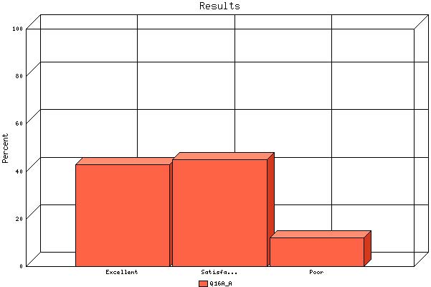

   | Count | % Sample  Answered | % Sample  Asked | % Sample  Total
  Excellent | 385 | 42.9% | 39.1% | 39.1%
  Satisfactory | 403 | 44.9% | 41.0% | 41.0%
  Poor | 109 | 12.2% | 11.1% | 11.1%
  Not Answered | 87 | N/A | 8.8% | 8.8%
  Not Asked | 0 | N/A | N/A | 0.0%
  Total | 984 | 100% | 100% | 100%
  Statistics
  Minimum Value | 1.00
  Maximum Value | 3.00
  Average | 1.69
  Sum | 1518
  Standard Deviation | 0.68
  Median | 2
  Mode | 2

Question: | Satisfaction with relocation services received (for each of the following elements, please rate your satisfaction level):
Topic: | Packing Crew

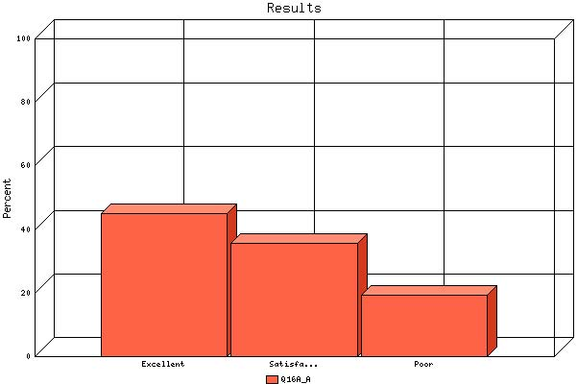

   | Count | % Sample  Answered | % Sample  Asked | % Sample  Total
  Excellent | 412 | 45.1% | 41.9% | 41.9%
  Satisfactory | 326 | 35.7% | 33.1% | 33.1%
  Poor | 176 | 19.3% | 17.9% | 17.9%
  Not Answered | 70 | N/A | 7.1% | 7.1%
  Not Asked | 0 | N/A | N/A | 0.0%
  Total | 984 | 100% | 100% | 100%
  Statistics
  Minimum Value | 1.00
  Maximum Value | 3.00
  Average | 1.74
  Sum | 1592
  Standard Deviation | 0.76
  Median | 2
  Mode | 1

Question: | Satisfaction with relocation services received (for each of the following elements, please rate your satisfaction level):
Topic: | Driver

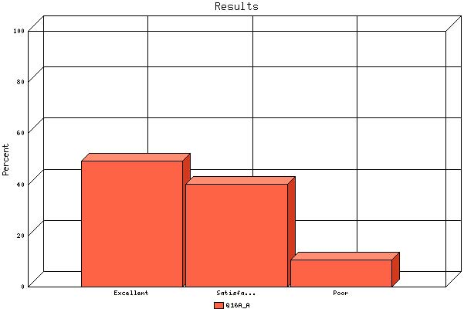

   | Count | % Sample  Answered | % Sample  Asked | % Sample  Total
  Excellent | 437 | 49.2% | 44.4% | 44.4%
  Satisfactory | 358 | 40.3% | 36.4% | 36.4%
  Poor | 93 | 10.5% | 9.5% | 9.5%
  Not Answered | 96 | N/A | 9.8% | 9.8%
  Not Asked | 0 | N/A | N/A | 0.0%
  Total | 984 | 100% | 100% | 100%
  Statistics
  Minimum Value | 1.00
  Maximum Value | 3.00
  Average | 1.61
  Sum | 1432
  Standard Deviation | 0.67
  Median | 2
  Mode | 1

Question: | Satisfaction with relocation services received (for each of the following elements, please rate your satisfaction level):
Topic: | Storage of Household Goods

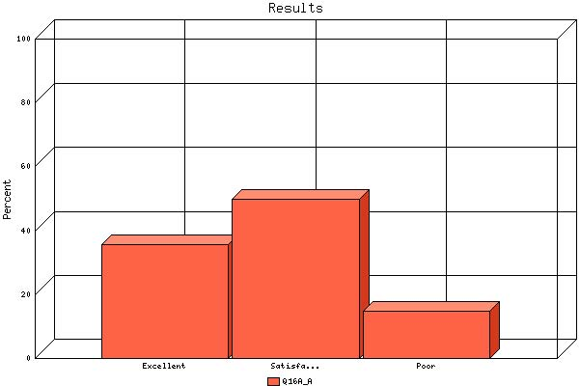

   | Count | % Sample  Answered | % Sample  Asked | % Sample  Total
  Excellent | 263 | 35.5% | 26.7% | 26.7%
  Satisfactory | 369 | 49.8% | 37.5% | 37.5%
  Poor | 109 | 14.7% | 11.1% | 11.1%
  Not Answered | 243 | N/A | 24.7% | 24.7%
  Not Asked | 0 | N/A | N/A | 0.0%
  Total | 984 | 100% | 100% | 100%
  Statistics
  Minimum Value | 1.00
  Maximum Value | 3.00
  Average | 1.79
  Sum | 1328
  Standard Deviation | 0.68
  Median | 2
  Mode | 2

Question: | Satisfaction with relocation services received (for each of the following elements, please rate your satisfaction level):
Topic: | Shipment of Vehicle(s)

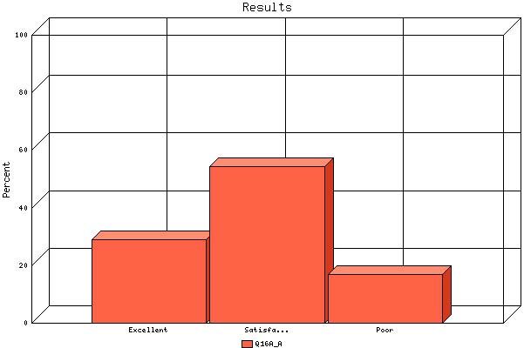

   | Count | % Sample  Answered | % Sample  Asked | % Sample  Total
  Excellent | 112 | 28.9% | 11.4% | 11.4%
  Satisfactory | 211 | 54.4% | 21.4% | 21.4%
  Poor | 65 | 16.8% | 6.6% | 6.6%
  Not Answered | 596 | N/A | 60.6% | 60.6%
  Not Asked | 0 | N/A | N/A | 0.0%
  Total | 984 | 100% | 100% | 100%
  Statistics
  Minimum Value | 1.00
  Maximum Value | 3.00
  Average | 1.88
  Sum | 729
  Standard Deviation | 0.67
  Median | 2
  Mode | 2

Question: | Satisfaction with relocation services received (for each of the following elements, please rate your satisfaction level):
Topic: | Home Transactions-Selling

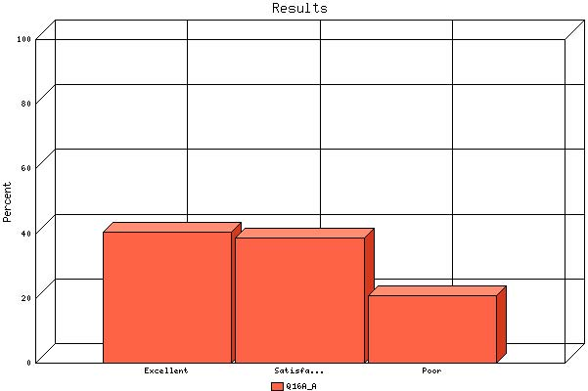

   | Count | % Sample  Answered | % Sample  Asked | % Sample  Total
  Excellent | 243 | 40.6% | 24.7% | 24.7%
  Satisfactory | 231 | 38.6% | 23.5% | 23.5%
  Poor | 124 | 20.7% | 12.6% | 12.6%
  Not Answered | 386 | N/A | 39.2% | 39.2%
  Not Asked | 0 | N/A | N/A | 0.0%
  Total | 984 | 100% | 100% | 100%
  Statistics
  Minimum Value | 1.00
  Maximum Value | 3.00
  Average | 1.80
  Sum | 1077
  Standard Deviation | 0.76
  Median | 2
  Mode | 1

Question: | Satisfaction with relocation services received (for each of the following elements, please rate your satisfaction level):
Topic: | Home Transactions- Buying

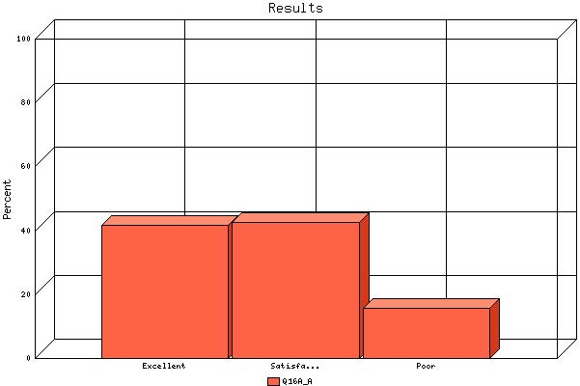

   | Count | % Sample  Answered | % Sample  Asked | % Sample  Total
  Excellent | 260 | 41.8% | 26.4% | 26.4%
  Satisfactory | 265 | 42.6% | 26.9% | 26.9%
  Poor | 97 | 15.6% | 9.9% | 9.9%
  Not Answered | 362 | N/A | 36.8% | 36.8%
  Not Asked | 0 | N/A | N/A | 0.0%
  Total | 984 | 100% | 100% | 100%
  Statistics
  Minimum Value | 1.00
  Maximum Value | 3.00
  Average | 1.74
  Sum | 1081
  Standard Deviation | 0.71
  Median | 2
  Mode | 2

Question: | Satisfaction with relocation services received (for each of the following elements, please rate your satisfaction level):
Topic: | Home Transactions-Renting

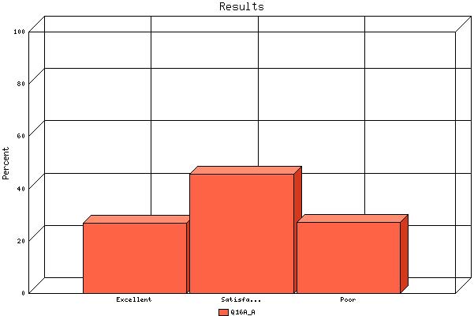

   | Count | % Sample  Answered | % Sample  Asked | % Sample  Total
  Excellent | 94 | 27.0% | 9.6% | 9.6%
  Satisfactory | 159 | 45.7% | 16.2% | 16.2%
  Poor | 95 | 27.3% | 9.7% | 9.7%
  Not Answered | 636 | N/A | 64.6% | 64.6%
  Not Asked | 0 | N/A | N/A | 0.0%
  Total | 984 | 100% | 100% | 100%
  Statistics
  Minimum Value | 1.00
  Maximum Value | 3.00
  Average | 2.00
  Sum | 697
  Standard Deviation | 0.74
  Median | 2
  Mode | 2

Question: | Satisfaction with relocation services received (for each of the following elements, please rate your satisfaction level):
Topic: | Home Transactions - Property management

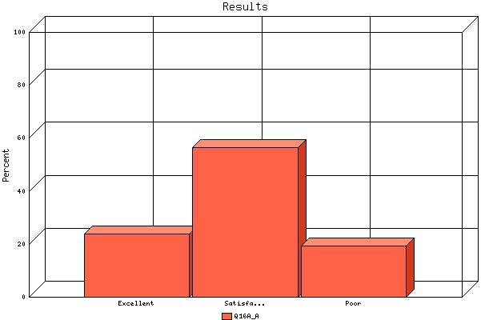

   | Count | % Sample  Answered | % Sample  Asked | % Sample  Total
  Excellent | 68 | 24.0% | 6.9% | 6.9%
  Satisfactory | 160 | 56.5% | 16.3% | 16.3%
  Poor | 55 | 19.4% | 5.6% | 5.6%
  Not Answered | 701 | N/A | 71.2% | 71.2%
  Not Asked | 0 | N/A | N/A | 0.0%
  Total | 984 | 100% | 100% | 100%
  Statistics
  Minimum Value | 1.00
  Maximum Value | 3.00
  Average | 1.95
  Sum | 553
  Standard Deviation | 0.66
  Median | 2
  Mode | 2

Question: | Satisfaction with relocation services received (for each of the following elements, please rate your satisfaction level):
Topic: | Destination Services (finding a new home)

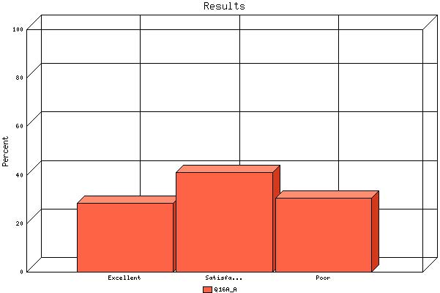

   | Count | % Sample  Answered | % Sample  Asked | % Sample  Total
  Excellent | 168 | 28.5% | 17.1% | 17.1%
  Satisfactory | 242 | 41.0% | 24.6% | 24.6%
  Poor | 180 | 30.5% | 18.3% | 18.3%
  Not Answered | 394 | N/A | 40.0% | 40.0%
  Not Asked | 0 | N/A | N/A | 0.0%
  Total | 984 | 100% | 100% | 100%
  Statistics
  Minimum Value | 1.00
  Maximum Value | 3.00
  Average | 2.02
  Sum | 1192
  Standard Deviation | 0.77
  Median | 2
  Mode | 2

Question: | Satisfaction with relocation services received (for each of the following elements, please rate your satisfaction level):
Topic: | Expense Management (Processing of Relocation expenses)

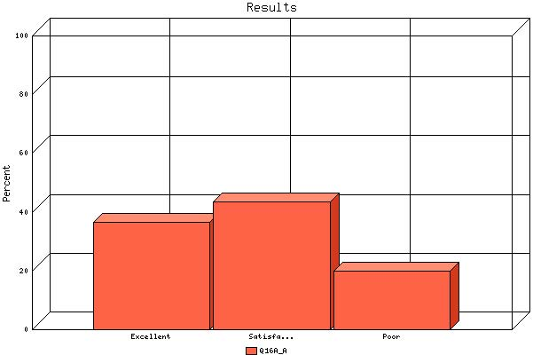

   | Count | % Sample  Answered | % Sample  Asked | % Sample  Total
  Excellent | 314 | 36.6% | 31.9% | 31.9%
  Satisfactory | 373 | 43.5% | 37.9% | 37.9%
  Poor | 171 | 19.9% | 17.4% | 17.4%
  Not Answered | 126 | N/A | 12.8% | 12.8%
  Not Asked | 0 | N/A | N/A | 0.0%
  Total | 984 | 100% | 100% | 100%
  Statistics
  Minimum Value | 1.00
  Maximum Value | 3.00
  Average | 1.83
  Sum | 1573
  Standard Deviation | 0.73
  Median | 2
  Mode | 2

Question: | Satisfaction with relocation services received (for each of the following elements, please rate your satisfaction level):
Topic: | Spousal Services

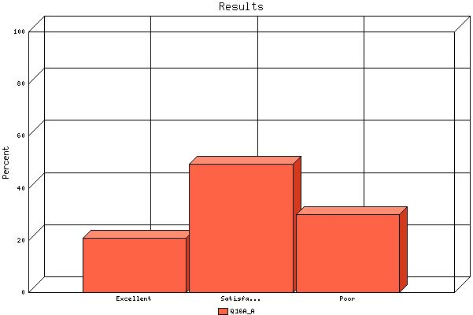

   | Count | % Sample  Answered | % Sample  Asked | % Sample  Total
  Excellent | 87 | 20.8% | 8.8% | 8.8%
  Satisfactory | 206 | 49.3% | 20.9% | 20.9%
  Poor | 125 | 29.9% | 12.7% | 12.7%
  Not Answered | 566 | N/A | 57.5% | 57.5%
  Not Asked | 0 | N/A | N/A | 0.0%
  Total | 984 | 100% | 100% | 100%
  Statistics
  Minimum Value | 1.00
  Maximum Value | 3.00
  Average | 2.09
  Sum | 874
  Standard Deviation | 0.71
  Median | 2
  Mode | 2

Question: | Satisfaction with relocation services received (for each of the following elements, please rate your satisfaction level):
Topic: | Entitlement Counseling Services

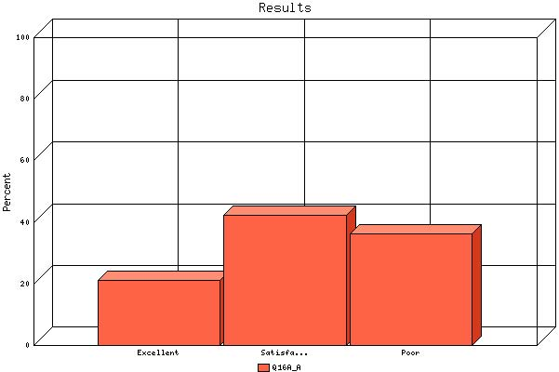

   | Count | % Sample  Answered | % Sample  Asked | % Sample  Total
  Excellent | 109 | 21.2% | 11.1% | 11.1%
  Satisfactory | 218 | 42.4% | 22.2% | 22.2%
  Poor | 187 | 36.4% | 19.0% | 19.0%
  Not Answered | 470 | N/A | 47.8% | 47.8%
  Not Asked | 0 | N/A | N/A | 0.0%
  Total | 984 | 100% | 100% | 100%
  Statistics
  Minimum Value | 1.00
  Maximum Value | 3.00
  Average | 2.15
  Sum | 1106
  Standard Deviation | 0.74
  Median | 2
  Mode | 2

Question: | Satisfaction with Agency Relocation Specialists (for each of the following elements, please rate your satisfaction level):
Topic: | Communicated information clearly

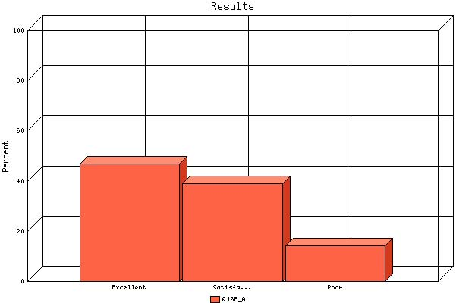

   | Count | % Sample  Answered | % Sample  Asked | % Sample  Total
  Excellent | 449 | 46.9% | 45.6% | 45.6%
  Satisfactory | 373 | 38.9% | 37.9% | 37.9%
  Poor | 136 | 14.2% | 13.8% | 13.8%
  Not Answered | 26 | N/A | 2.6% | 2.6%
  Not Asked | 0 | N/A | N/A | 0.0%
  Total | 984 | 100% | 100% | 100%
  Statistics
  Minimum Value | 1.00
  Maximum Value | 3.00
  Average | 1.67
  Sum | 1603
  Standard Deviation | 0.71
  Median | 2
  Mode | 1

Question: | Satisfaction with Agency Relocation Specialists (for each of the following elements, please rate your satisfaction level):
Topic: | Responded in a timely manner

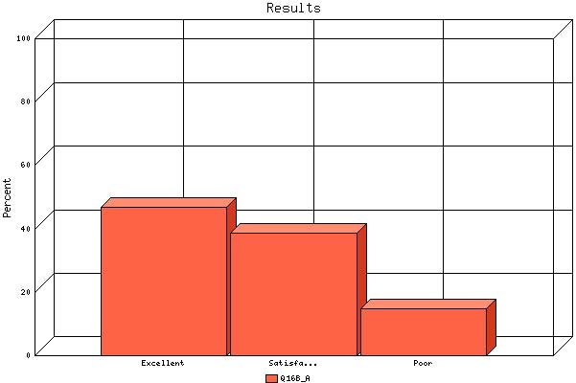

   | Count | % Sample  Answered | % Sample  Asked | % Sample  Total
  Excellent | 448 | 46.7% | 45.5% | 45.5%
  Satisfactory | 371 | 38.6% | 37.7% | 37.7%
  Poor | 141 | 14.7% | 14.3% | 14.3%
  Not Answered | 24 | N/A | 2.4% | 2.4%
  Not Asked | 0 | N/A | N/A | 0.0%
  Total | 984 | 100% | 100% | 100%
  Statistics
  Minimum Value | 1.00
  Maximum Value | 3.00
  Average | 1.68
  Sum | 1613
  Standard Deviation | 0.72
  Median | 2
  Mode | 1

Question: | Satisfaction with Agency Relocation Specialists (for each of the following elements, please rate your satisfaction level):
Topic: | Provided accurate information

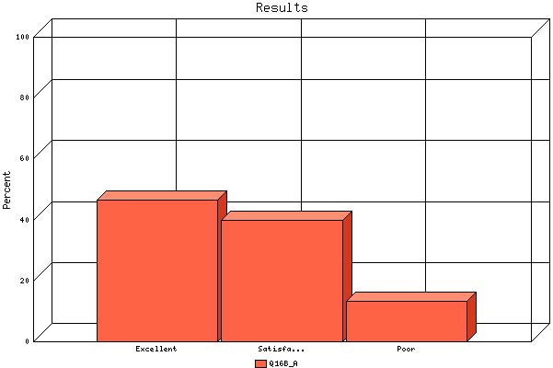

   | Count | % Sample  Answered | % Sample  Asked | % Sample  Total
  Excellent | 447 | 46.6% | 45.4% | 45.4%
  Satisfactory | 384 | 40.0% | 39.0% | 39.0%
  Poor | 129 | 13.4% | 13.1% | 13.1%
  Not Answered | 24 | N/A | 2.4% | 2.4%
  Not Asked | 0 | N/A | N/A | 0.0%
  Total | 984 | 100% | 100% | 100%
  Statistics
  Minimum Value | 1.00
  Maximum Value | 3.00
  Average | 1.67
  Sum | 1602
  Standard Deviation | 0.70
  Median | 2
  Mode | 1

Question: | Satisfaction with Agency Relocation Specialists (for each of the following elements, please rate your satisfaction level):
Topic: | Were able to resolve inquiries

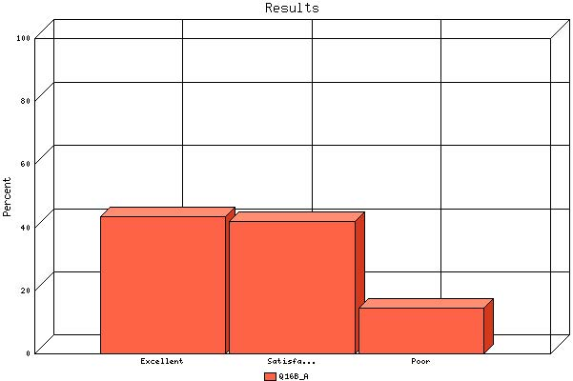

   | Count | % Sample  Answered | % Sample  Asked | % Sample  Total
  Excellent | 415 | 43.5% | 42.2% | 42.2%
  Satisfactory | 401 | 42.0% | 40.8% | 40.8%
  Poor | 138 | 14.5% | 14.0% | 14.0%
  Not Answered | 30 | N/A | 3.0% | 3.0%
  Not Asked | 0 | N/A | N/A | 0.0%
  Total | 984 | 100% | 100% | 100%
  Statistics
  Minimum Value | 1.00
  Maximum Value | 3.00
  Average | 1.71
  Sum | 1631
  Standard Deviation | 0.70
  Median | 2
  Mode | 1

