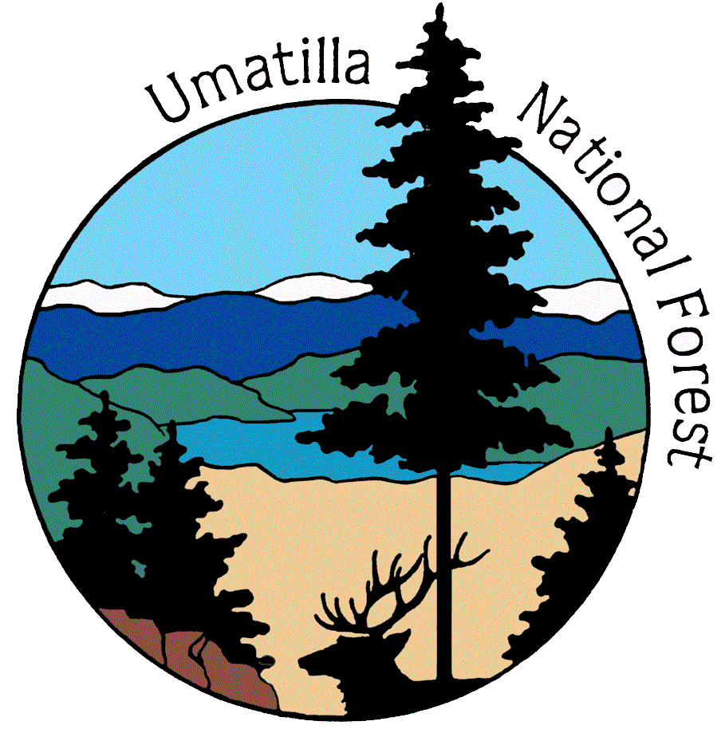
MEETING NOTES
Tollgate Working Group Meeting
November 19, 2008 Tollgate, OR

Meeting Facilitator: Joani Bosworth
Meeting Recorder: Shawnita Lennox

Participants: Kimpton Cooper, Mark Johnson, Brett Thomas, Mike Rassbach, Amber Mahoney, Joani Bosworth, Kevin Martin, Norm Kasionan, Ray Denny, David King, Julia Lauch, Tom Insko, Bernard and Mary Louise Chapman, Rod and Marcella Morrow

Summary:

Agenda Topic: Introductions

Discussion: The group went around the table and introduced them selves as well as stated what their interest was in the project. Mike Rassbach also explained why we are looking at the Tollgate community and the stand health issues in the surrounding areas.

Agenda Topic: Healthy Forest Restoration Act (HFRA) PowerPoint
Handouts: PowerPoint print out of the Slideshow

Discussion: Mike Rassbach and Kimpton Cooper went through a PowerPoint that explained the legislation and history behind HFRA and how it would apply and be implemented within the Tollgate Area. The PowerPoint also included the additional guidance provided by Umatilla County CWPP.

Agenda Topic: Interest in Project and Tollgate Area

Discussion: Mike Rassbach opened with the question: What we should and need to be looking at in this area? Each of the group members stated their interest and association with the project:
- Bernard Chapman
  - Bernard felt that the main problem is the Spruce budworm that occurred about 18 years ago that killed a large amount of bigger trees, trees that are 2 ft or larger in diameter. Bernard also gave some specific examples in the area; Baldy area has a lot of dead and down timber that is getting punky and on the 6403 Rd there are numerous trees that are dead and ready to fall and when they do they will fall onto the road.
  - The wind event that came through and blew so much of that timber down around Baldy and the Lookingglass area was also mentioned. The timber that is on the ground from that event has been there for a long time and the ground is so covered that one can not walk through that area.
  - Bernard also mentioned the fire break that was created during the Columbia Complex on the 64 Rd from Tiger Canyon towards Bluewood. He thought that this should also be done along the 64 rd towards Jubilee Lake to help with snow melt off and stand management.

- Rod Morrow
  - Agreed with all of the comments that Bernard made but added that there needs to be something done with the personal use firewood cutters in the area. They are cutting down trees that are over the limit and damaging the smaller trees in the area to get to those larger ones. They are also having campfires and parties during the time when public use restrictions are in effect restricting campfires.
- Tom Insko
  - Concerned with the fire hazards, forest health and the general poor condition that the forest stands are in. Frustrated that as a tax payer we have let our public lands become this much of a liability but thinks that with the proper management and involvement of the right people, the timber industry, the lands can be returned to the state in which they need to be in. He believes that this whole area can be treated and returned to the state that it needs to be in and that there is no reason that some money can be made at the same time. He has high aspirations for the project.
- Norm Kralman
  - Norm missed the first meeting and asked what the scope of the project was. He was at a land owner meeting last year that was more aimed at telling the land owners what they needed to do and he felt that this was dictatorial and the wrong approach to the problem. He feels that the public lands are in sad shape and feels that the problem is huge and asked where we would start the process in fixing such a large problem.
    - Mike Rassbach answered his question of the size of land that this project would be addressing. The section of land that is being looked at for this project is 55,000 acres; this includes wilderness and Wild land Urban Interface (WUI) areas. No action will be taken in the wilderness areas that would go against the wilderness laws.
  - Norm stated that the only logical way to manage the forest is to log and that we need to not let environmentalist tell us how to manage our own forests. Are there going to be these people that can stop this specific project?

Agenda Topic: Forest Service Led vs Group Led Paths
Handouts: part of the HFRA PowerPoint Handout

Discussion: Mike Rassbach explained the difference between the two different paths that could be used to reach the same decision on how to proceed with the Tollgate area. There is the public tract and the group led tract. Both of these paths will end at the same goal, but there are difference that were pointed out. On the Forest Service led path, that is currently being utilized, input must be given as individuals and the process is open to the public. If this project was to utilize the group led path the group would meet independently of the Forest Service and bring their suggestions for a proposed action to the agency for consideration. Mike explained that since there is not currently an organized group this project will stay on the Forest Service led path unless an interest is expressed in the other.

The group expressed that they would like to stay on the forest service led path in this specific circumstance because of the localized aspect of the project and the background that Forest Service can bring to the table as well as subject matter expertise. Members of the group also expressed some concern with the possibility of the blocking of the project by other members of the public. Mike and Kevin explained the process that would be used in the case of a dispute and the history that the Umatilla National Forest has had with other projects and disputes.

Agenda Topic: Roles and Operating Procedures
Handouts: Tollgate Sideboards and Objectives

Discussion: Mike went through the hand out and explained the roles and guidelines that would be operated under for the duration of this project. It was asked why one of the objectives wasn’t to move the whole area into a different condition class, Mike and Kimpton explained that this would limit the scope of the decision that could be made at the end of this process. The flexibility needs to be there so that parts of the area could possibly be moved in different degrees while some may need to stay where they are and if one of the objectives is that the entire area needs to be changed this would inhibit the decision makers.

Agenda Topic: Public Involvement and Group Membership
Handouts: none
Discussion: Joani Bosworth presented information on the public process that the group will be working under. She explained we want this to be an open process that includes all that would like to be included. The meeting notes, handouts and maps will be available on the Umatilla National Forest’s webpage. Joani checked that everyone at the table would be comfortable with possibly having their picture also included on the website. Part of the transparency includes flexible participation of many members of the public, for this reason announcements will be posted on the website, published in local newspapers and included in mailing lists of those who have requested to be included.

Agenda Topic: Timeline and NEPA Process Overview
Handouts: none
Discussion: Kimpton Cooper presented a PowerPoint giving an overview of the National Environmental Policy Act (NEPA) and Healthy Forest Restoration Act (HFRA). Kimpton also gave a timeline for which the group will work to submit all suggestions and comments for a draft proposed action by June 1, 2009. A finalized version will be completed by the Forest Service in July 2009 and then submitted for public comment through the scoping process.

Agenda Topic: Tollgate Progress Report
Handouts: Maps
Discussion: Mark Johnson gave an update on what had occurred on the ground since the first meeting and gave a quick summary of what had happened before. An analysis was done to predict where an uncharacteristic fire would come from and where it would go. The data used for these models was from an older data set, a new set of data collected this summer. The models will be re-run this winter and should be available at the next meeting. Mark had analysis area maps for the people that would like to take them home and look them over for the next meeting. He took some time to explain the map keys and what the boundaries represented on each map. Mike reminded the participants to keep in mind that this is a large area and need to focus on the bigger picture for right now and resist the urge to focus on individual stands in specific areas.

Agenda Topic: Scheduling
Handouts: none
Discussion: Mike asked the group to get out their calendars and chose a date for the next meeting.

Decision: Next meeting will be January 22, 2009 at 6 pm, again at the Tollgate Trail finders Club House and that Marcella Morrow would make sure that the facility would be available at this time.

AGENDA
Tollgate Working Group Meeting
Wednesday November 19th
6:00- 7:30 PM
Tollgate Trail Finders Clubhouse
Facilitator: Joani Bosworth

- Opening Mike Rassbach
Joani Bosworth
- Introductions Group Members
- Tollgate Working Group
  - Interest in Project and Tollgate Area Group Members
  - Roles and Operating Procedures Mike Rassbach
  - Public Involvement and Group Membership Joani Bosworth
- Timelines and Scheduling Kimpton Cooper
- Overview of Forest Plan, HFRA and NEPA Kimpton Cooper
- Tollgate Progress Report Mark Johnson
- Questions and Comments
- Closing Statement Mike Rassbach
- Adjourn

Tollgate Collaborative Group
Objectives and Sideboards

Our objectives in pursuing this project are as follow:
- Reduce hazardous fuels that pose a risk to communities and ecosystem values.
- Improve forest health.

We also wish to present our (FS) expectations and some elements that you must be aware of before you begin this effort.

- This collaborative process must meet the objectives of the Healthy Forests Restoration Act and/or the Healthy Forests Initiative.

- Proposals must move portions of the area towards a change in condition class appropriate to that fire regime

- These collaborative efforts are open to all whom wish to attend. We may need to set up some operational procedures to ensure that forward progress is not derailed when new players enter the picture

- The Forest Service will function in a number of capacities throughout this process. However, the two most critical are:
1) Serve as technical advisors/subject matter experts on affected resources
2) To identify areas where the legality of the action may be questionable in terms of federal laws, regulations and policy.

- Participants need to spend time making sure their information requests to the Forest Service are clear.

- We want this to be a successful endeavor, which can and will set the stage on the forest for future collaborative planning efforts.

- Participating individuals/groups may offer their individual advice to FS personnel, but have no right or claim to the decision-making process. That is reserved for the Line Officer.

- We (FS) are not seeking any form of consensus from the participants in the group. Your input (comments, suggestions, questions, etc.) will be viewed individually and given no more or less weight than that of any one else participating or the rest of the public at large.

- Discussion and suggestion from individuals will be taken and reviewed by FS personnel, but only those actions/suggestions that fit within the operating framework (law, regulation, policy, etc.) will be given detailed consideration.

- All meeting notes and discussions are part of the public record.

- Participant’s ability to discuss various aspects of the project is not limited to the confines of a meeting. A contact list for relevant FS personnel will be supplied.

- FS will upon review of public comments/suggestions evaluate whether each fulfills the stated objectives, fits within the governing procedures (Forest Plan direction and other relevant laws/regulations), is operationally feasible and will then develop a proposed action for public review through the scoping process as outlined in NEPA.

- Participation in Working Group meetings does not confer legal standing to object. An individual wishing to have standing to participate in the objection process, must submit written comment during the publicly advertised scoping process.

Forest Service Contacts

Mike Rassbach | District Ranger, Walla Walla RD | 509-522-6293 | mrassbach@fs.fed.us
Kimpton Cooper | Environmental Coordinator/ Project Lead | 509-522-6009 | kmcooper@fs.fed.us
Joani Bosworth | Forest Public Affairs Officer | 541-278-3722 | jbosworth@fs.fed.us
Mark Johnson | Assistant Fire Management Officer, Fuels | 509-522-6283 | markjohnson@fs.fed.us
Su Meredith | District Silviculturist/TMA | 509-522-6059 | smeredith@fs.fed.us
Brett Thomas | Fire Management Officer | 509-522-6284 | bthomas@fs.fed.us

