SNOW AND ICE CONTROL PLAN

Table of Contents

Section 1 – Definitions
Section 2 – Administrative
Section 3 - Snow Removal Operations
Section 4 – Snow Clearing Principles
Section 5 - Runway Incursion/Surface Incident Mitigation Procedures
Section 6 - Runway Surface Assessment Reporting
Section 7 – Post Season Activities
Section 8 – Appendices

Section 1 – Definitions

a) Contaminant. Any substance on a runway or taxiway, for the purpose of this SICP contaminant is snow, slush, ice or standing water.

b) Dry Snow. Snow that insufficient free water to cause cohesion between individual particles. If when making a snowball, it falls apart, the snow is considered dry.

c) Wet Snow. Snow that has grains coated with liquid water, which bonds the mass together, but that has no excess water in the pore spaces. A well-compacted, solid snowball can be made, but water will not squeeze out.

d) Compacted Snow. Snow that has been compressed into a solid mass that resists further compression and will hold together or break up into lumps if picked up.

e) Slush. Snow that has water content exceeding its freely drained condition, such that it take a fluid properties (.e.g. flowing and splashing). Water will drain from slush when a handful is picked up.
f) Patchy Conditions. Areas of bare pavement showing through snow and/or ice covered pavements.

- Approved Chemicals. A chemical, either solid or liquid, that meet a generic SAE or MIL specification.

- Fluid Deicer/Anti-Icers. The approved specification is SAE AMS 1435, Fluid, Generic Deicing/Anti-icing, Runways and Taxiways.

- Generic Solids. The approved specification is SAE AMS 1431, Compound, Solid Runway and Taxiway Deicing/Anti-Icing.

- Airside Urea. (Otherwise known as “Carbamide”) The approved specifications are SAE AMS 1431, Compound, Solid Runway and Taxiway Deicing/Anti-Icing, and MIL SPEC DOD-U-10866, Technical Urea. Agricultural grade urea that meets any of these specifications, called airside urea, is acceptable.

Section 2 - Administrative

a) Airport Management Pre-season Meeting. The meeting should determine if the post season objectives were met, and effective. The (titles) will typically initiate a meeting, (month- August/September) to discuss equipment and material inventory, repair needs, staffing, budget, training, previous years issue’s, and any other topics associate with snow and ice control and its plan.

b) Snow and Ice Control Committee (SICC) Meetings. The Airport has developed a Snow and Ice Control Committee (SICC) to provide feedback and make recommendations to snow and ice removal operations and Snow and Ice Control Plan (SICP) updates at (Airport Name). The SICC is chaired by (title) and includes (list departments or titles from the airport), Federal Aviation Administration (Air Traffic and/or Technical Operations), and (list tenants, i.e. air carriers, FBO, flight school).

If applicable:
Tenants and airport users not able to participate in the SICC are provided minutes and keep apprised of all changes.

During the month of (state when) the Airport will begin notifying tenants and airport users of to review and provide comments to be discussed this season kick-off meeting (state when).

The following topics will be discussed in the SICC:

- Airport Clearing Operations Discussion Topics
  - Areas Designated as Priority I area, any new airfield infrastructure
  - Clearing operations and follow-up airfield assessments
  - Potentials for pilot or vehicular runway incursions or incidents
  - Staff requirements and qualifications (training)
  - Update training program
  - Streamline decision making process
  - Response time to keep runways, taxiways and ramp areas operational
  - Communication, terminology, frequencies, and procedures
  - Monitoring and updating of runway surface conditions
  - Issuance of NOTAMS/FCR’s and dissemination to ensure timely notification
  - Equipment inventory
  - Status of procurement contracts, including storage of materials
  - Validation of deicer certification letters from vendors (if applicable)
  - Procedures for storm water runoff mitigation
  - Snow hauling/disposing, snow dumps
  - New runoff requirements for containment or collection
  - Changes to contract service for clearing ramps

- Air Carrier Ground Deicing/anti-icing programs
  - Assessing all air carriers deicing programs by reviewing airport surface flow strategies; reviewing ground time and takeoff clearances after deicing; analyzing and adjusting airplane deicing plans
  - Maximize efficiency of operations during icing conditions by identifying locations for airplane deicing; planning taxi routes to minimize ground times; developing rates for deiced departures; allocating departure slots; determination airport deicing crew needs; verifying communications.

- Any requirements for containment/collection of deicing/anti-icing.

c) Personnel Training. All (titles) personnel receive annual, recurrent snow removal training. All training for airport personnel is conducted by (state whom). Training records are maintained by (title). (State what training is provided).

    - (Title i.e. Management and describe training received)
    - (Title i.e. Operations and describe training received)
    - (Title i.e. Communications specialist and describe training received)
    - (Title i.e. Maintenance and describe training received)

- Pre-event Meetings. Before each snow event if possible, airport management (or designated employee – please state who and title) should host a meeting and invite (Air Traffic) to discuss any issues that have arisen from last event, and that are outstanding issues items that have been resolved. In addition, management shall ensure that sufficient and qualified staffing, materials, and equipment are available for a snow or ice event.

- Post Event Meetings. After each snow event, airport management will host a meeting and invite (Air Traffic) to discuss any issues that have arisen from the event.

All members of the SICC are encouraged to provide feedback to airport management before, during or following each snow event. After a significant event or a challenging operation, or if as special circumstances dictate, a separate SICC meeting will be held.

If applicable:

During the snow season winter operations is an agenda item at (tenant meetings, station manager meeting, etc.) which is held (state frequency, i.e. monthly).

f) Equipment Preparation. The airports (type of friction tester) will be calibrated, updated and certified (timeframe recommended by manufacturer i.e. annually) (when i.e. during summer).

(Timeline i.e. 30 or 60 days) prior to snow season (title or company) Inspect and prepare each piece of snow removal equipment. Required fluids, replacement parts, and snow removal equipment components will be inventoried and stockpiled.

Section 3 – Snow Removal Operations

a) Authority. Describe overall staffing and procedures you have in place, and the authority of management or delegated authority of personnel. If your airport has several departments (Management, ARFF, Operations, Maintenance, etc.) with responsibilities during snow removal operations provide an explanation of authority and the responsibilities for each department (or individual).

- Who is responsible to monitor the airfield, when and how often?
- Is the airfield physically inspected? By whom?
- Who is responsible or delegated to initiate a Snow Alert Callout?
- Specify Procedures for Callout and Notification of Personnel
- Hold over or call in of personnel?

  - Snow Control Center (SCC). Describe the complexity of the Snow Control Center that is in use at your airport. What functions does the SCC perform at your airport? How is the SCC equipped to communicate or disseminate movement-area assessment information?

If applicable, describe where, when and who operates the SSC (i.e. snow desk or command vehicle).

What functions does the SCC perform at your airport? Is the SCC at your airport mobile? If so, describe the method of employment.

c) Weather Forecasting.
- Who is responsible to monitor the current and/or forecast weather conditions?
- Is this person delegated the authority to call-in personnel/snow-team?
- How often are conditions monitored?
- What sources are used for weather forecasts? (News, Papers, Websites, etc.)
- Does your airport have in-pavement surface sensors? If not, does your airport use other technology? If so, state here. If the airport does not employ pavement sensors to obtain temperature of pavements, state as well.

- Shift coverage. Are sufficient and qualified personnel assigned to work shifts, in a manner acceptable to the administrator, to provide the necessary level of snow removal capabilities so as to ensure runways and taxiways are cleared and maintained in an acceptable manner? See Table 1-1 or 1-2.

e) Airfield Clearance Times. Discuss your airfield clearance times. This should not be limited to runways it needs to include required associate taxiways.

State which table below you comply with and delete the other table.

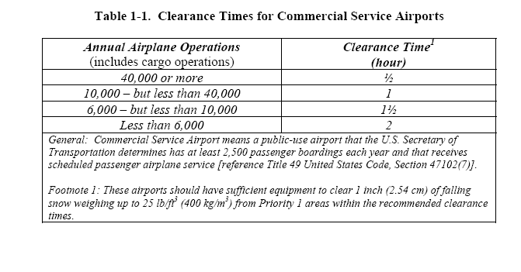
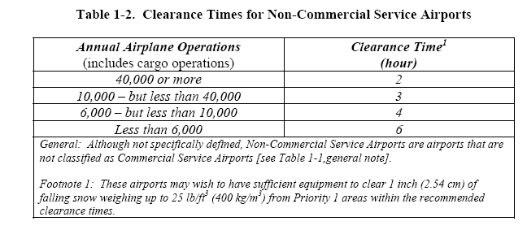
f) Airfield Clearing Priorities. Describe how the priorities are determined. A color coded map may be included but should not substitute text.

Priority 1

List areas to be cleared which are the most critical portions of the aircraft movement area and supporting facilities. This would normally include primary runways with associated turnoffs, access taxiways leading to terminal, terminal, terminal and cargo ramps, ARFF stations and designated emergency response roads, NAVAIDs. The entire airport would not be a Priority 1.

Priority 2

List areas to be cleared in Priority 2, which are areas of less importance than Priority 1. These areas would include crosswind/secondary runways and associated taxiways, remaining aircraft movement areas, commercial ramp areas.

Priority 3

At some airports areas not essential to flight operations or not used on a daily basis would be Priority 3. Some airports might only have Priority 1 and 2 and not Priority 3.

- Snow Removal Operations Triggers. When will snow removal operations commenced:

Example: Runway 2-20 will be closed when friction, falls below a ‘Mu’ of 25. The runway shall remain closed until the airport operator has determined that Runway 2-20 has been deemed safe for takeoff and landing operations of aircraft.

Precipitation | Depth in Inches
Slush | ?
Wet Snow | ?
Dry Snow | ?
Ice or Freezing Rain | ?

How were these triggers determined? What is the most critical aircraft/airline serving your airport? Specify.

- Snow Equipment List. Can be referenced as an exhibit – if so, reference here. Some airports may use primary and secondary equipment – if so, please specify.

List Equipment, Year, Make, Model, Ability/Role (ie: 25-foot plow blade)

i) Storage of Snow and Ice Control Equipment.

Describe where equipment is stored and maintained, inside, inside heated or outside.

j) FAA-Approved Chemicals. Provide an inventory description of the types of chemicals, both solid and/or liquid used on your airport. Provide specification and have available from manufacturer/distributor.

Section 4 – Snow Clearing Principles

- Runway and Taxiways

Describe equipment and procedures used at your airport. Local factors that contribute to these decisions. Minimum acceptable clearing for runway at your airport (is it full width?). Typical technique use at your airport.

Types of formation of snow equipment (V-formation, close wing formation)

High Speed Turn Offs

Snow Bank Height Profiles – See Figure 4-1

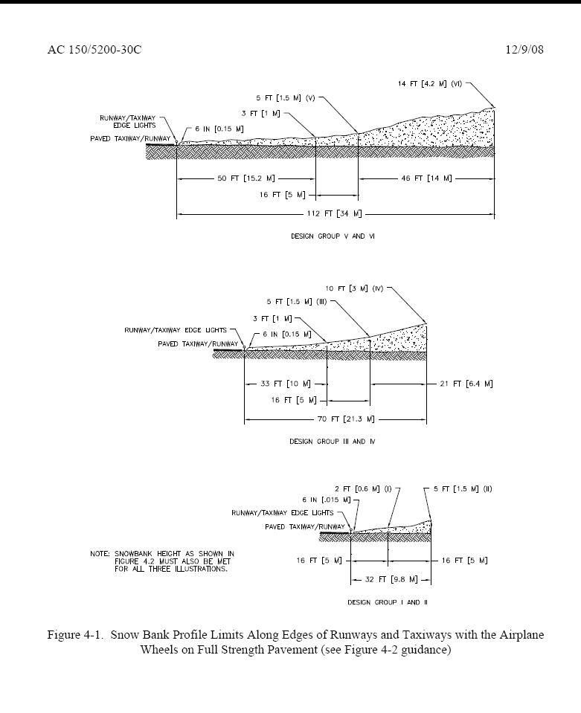
  - Terminal Ramps, Taxi-lanes, other Ramps. Describe snow clearing objective for the ramp and terminal and who is responsible? (Does your airport contract this area out? If so, has the appropriate training been conducted, and documented?)

Address procedures to:
- Ensure signs are clear of snow

Stockpiles of snow issues should address:
- Height Limitations-Clearance
- Obstruct View of Pilots
- Heavy Snow-Hauling/Melting?

c) NAVAIDs/Weather Observation Equipment

Address triggers to clear glide slope critical areas, PAPI/VASIs, weather equipment and who is responsible. Maps describing critical areas.

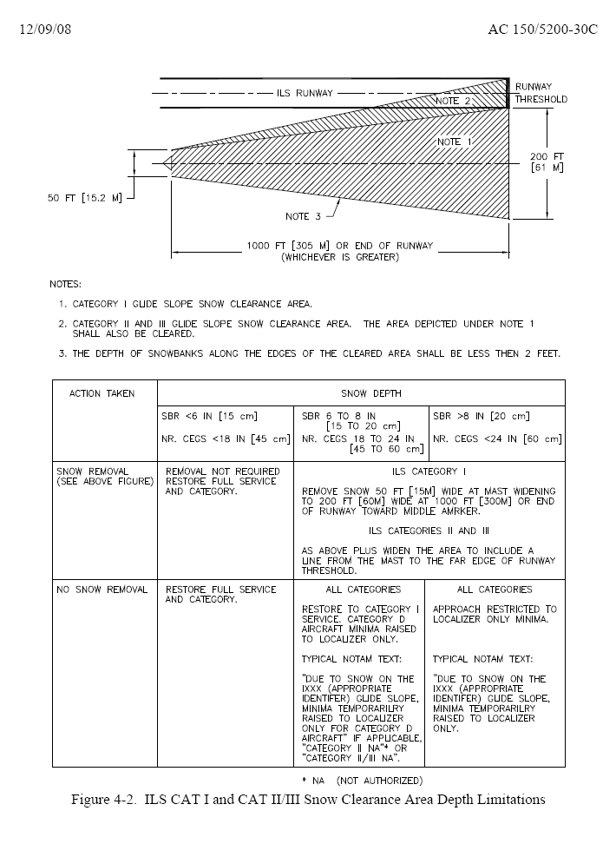

- Controlling/Mitigating Snow Drifts.

Describe methods used at your airport (i.e. snow fences, snow trenches).

- Safety areas, Blast Pads, De-icing Pads, Special Circumstance Surfaces or Areas.

Describe any areas that affect the landing and taking off of aircraft in this section, and how these areas will be addressed, in terms of mitigating hazards in close proximity to either the runway environment or areas listed.

- Methods for Ice Control and Removal-Chemicals.

Describe if anti-icer or de-icer products are used and which ones and how they are applied.

- Sand.

Describe if sand is used, how and when it is applied and if it is chemically treated or heated. State if your sand meets FAA gradient standards and which table below.

m) Stockpiling. Are areas designated if required, for the placement of snow removed from the movement areas, or other surfaces? If so, where? If a dump is created, is it negatively impacting any other NAVAIDs, safety areas or access roads used by emergency equipment?

Section 5 - Runway Incursion/Surface Incident Mitigation Procedures

Do you review past surface incidents at your airport that have occurred during snow removal operations? Do you discuss how additional vehicles and time on the airfield might lead to a surface incident? What preventative measures have you put in place at your airport to prevent such an occurrence during winter operations.

Vehicles will be marked and lighted in accordance with AC 150/2510-5, Painting, Marking and Lighting of Vehicles Used on an Airport.

- Radio Communications. What radio communications procedures are in place at your airport during Snow Operations? Provide description of your operation, i.e. ground and tower control frequencies, scanner for approach and ground control, CTAF, or be in the direct control of vehicles equipment). Does one person monitor all communication and take the lead on communicating? Are equipment operators provided headsets?

- Failed Radio Communication. What procedures do you have in place if radio communication fails between the snow team and or the Air Traffic Control Tower (if applicable)?

Low Visibility and Whiteout Conditions. Describe what specific procedures you have put in place to follow if visibility suddenly drops or a whiteout conditions exist.

- Driver Fatigue. Do you have limits on time on equipment or shift? What do you to do for operator fatigue?

Section 6 - Runway Surface Assessment Reporting

a) Runway Condition Reporting.

A runway (and taxiway) condition report is provided whenever the pavement condition is worse than bare and wet.

Describe procedures for reporting:
- Runway surface conditions by contaminants types and depths.
- When the cleared runway width is less than full width, and if you have uncleared runway edges with a different condition from cleared width on runway.

Describe procedures for determining when to update runway conditions. What triggers a runway condition report to be updated or changed (time/changing weather conditions)? Any time a change to the runway surface conditions occurs which could be any of the following:
- active snow event
- plowing/brooming/deicing/sanding
- rapidly rising or falling temperatures
- rapidly changing conditions

State what the minimum timeline acceptable at your airport when contaminants exist on the runway and runway condition report is updated.

Describe how your airport assesses runway conditions to ensure that they are accurate and timely?

- How often and who is responsible?

- How this information is communicated to the user of your airport and who is responsible to communicate this information?

- What forms are used to convey this information (should be included in you SICP).

If applicable, for small airports:
Issuance of a NOTAM “airfield surface conditions unmonitored between the hours of _____ and ____ local time.” Describe the dates this would be in effect for and who would be responsible to issue this NOTAM for your airport.

- Runway Friction Surveys and Equipment. State what type of equipment (decelerometer or continuous friction measuring equipment) you airport operates. If no friction equipment exists at your airport, state and skip to Paragraph 5.3.

- Conditions. Describe what pavement contaminants conditions are acceptable to use decelerometer or continuous friction measuring equipment.

d) When to Conduct. Friction assessments should be conducted if any of the following occurs:

When the central portion of the runway, centered longitudinally along the runway centerline, is contaminated 500 feet or more.

After any type of snow removal operations or chemical application (including sanding)

Immediately following any aircraft incident or accident on the runway.

Describe any additional triggers you have locally.

- Friction Measuring Procedures - How to Conduct. Describe procedures in how you conduct a friction test and address:

- lateral location from centerline (provide distance based on narrow or wide body aircraft)

- direction (same direction as arrival aircraft)

- friction tests is completed in one pass

- Runway zones: Touchdown, midpoint and rollout zones.

- Friction Assessment Reporting. Describe procedures at your airport for friction assessment reporting and the format used to report. (Provide a sample report if not provided as an exhibit in the ACM).

Friction values will be reported when:
- Compacted snow and/or ice are present on the center portion of the runway, and friction values are 40 or below on any zone of the runway.
- Rise above 40 on all zones of any active runway that previously have a friction value below 40.
- Go below 40 for any zone (touchdown, midpoint, rollout) of any active runway that previously had Mu’s above 40.

g) Out of Service Equipment. A NOTAM will be issued whenever (specify type of equipment) is out-of-service. This NOTAM will remain until (specify type of equipment) is available for service.

h) Requirements for Runway Closures. Runways receiving a NIL braking (either a PIREP or by a braking action assessment by the airport operator) are unsafe for aircraft operations. Describe what procedures and Letters of Agreement (include LOA’s) that you have in place to immediately cease all aircraft operations on any runway when a NIL braking action is received.

We recommend some airports develop additional triggers for runway closures (i.e. maximum slush, wet, dry snow depths, ice or freezing rain and minimum MU level).

If you have several triggers requiring runway closures, the format of a table might be beneficial – such as in Section 3(i) of this plan.

- Continuous Monitoring. Describe when continuous monitoring procedures are put in place and what deteriorating braking action, weather and surface conditions triggers continuous monitoring. What constitutes continuously monitoring a runway at your airport (details)?

Section 7 – Post Season Activities

- Post Season SICC Meeting. After each snow season, a SICC meeting will be held, typically in (state month) to review the snow season issues and recommendations for changes. The same topics as pre-season should be reviewed.

Provide actions for each of your department or sections post season, i.e. Maintenance- inspect and repair equipment, replace sweeper heads, Operations – calibrate friction tester, Airport management – update SICP.

- Airport Management Post Season Meeting. Typically in (state month) Review SICC Minutes, and recommendations, and make necessary procedural changes to either the Snow and Ice Control Program, and if applicable update SICP.

- Calibration.

Describe how often your friction equipment is calibrated and who is responsible to ensure that it is.

Section 8 – Appendices

Insert your own.

