Master Sergeant Kirk M. Koehler
Fleet Manager of the Year (Large Fleets)

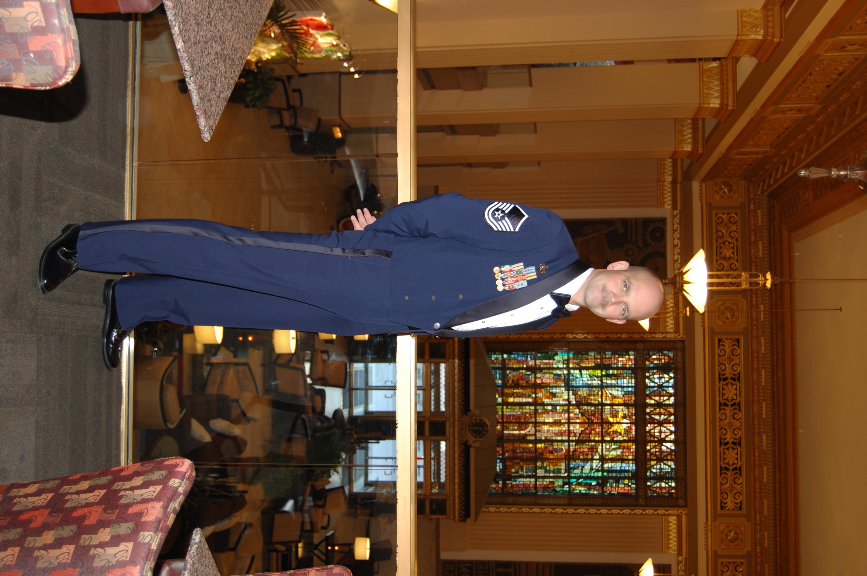
Master Sergeant Kirk Koehler was the Command Vehicle Fleet Manager for Air Education and Training Command (AETC), Randolph Air Force Base, Texas. He was also charged with procurement and authorization oversight of the Air Force Recruiting Service (AFRS) vehicles. His overall responsibility spanned 12,325 vehicles valued at over $600 Mil, dispersed throughout 863 locations. His combined responsibilities put him in charge of one of the largest fleets in the Air Force, and his flawless asset management ensured 23 AETC organizations have safe and reliable ground transportation that meet mission requirements. His foresight and vision were responsible for the most efficient and effective fleet in AETC and AFRS history.

Sergeant Koehler managed to ingeniously modify, modernize, and reduce fleet dynamics through such variables as alternative fueled vehicles, low speed vehicles, special fuels technology and mandatory use of specific fuel-efficient tire tread design. His strict adherence to vehicle classification has enabled the AETC to reduce vehicle fossil fuel consumption by 32%, while simultaneously ensuring precious resources and equipment are available to train Air Force war fighters.

Sergeant Koehler was responsible for 13 vehicle accounts located throughout southeast Iraq. He initiated and managed the $51K Basra Air Base vehicle lease program. His quick action and coordination with 10 multi-national, multi-service agencies provided time sensitive tailored transportation for incoming transition teams. His tireless efforts played a key role in rebuilding Iraq’s armed forces and infrastructure. After enduring
numerous mortar and rocket attacks, Sergeant Koehler devised a new vehicle yard access and dispersion plan that expedited personnel accountability by 10 minutes, and is credited with a Security Forces lauded, zero security breach record. He also engineered a tracking program for Tactical Air Control Party vehicles throughout the area of responsibility. His program template was quickly adopted Central Air Force Command for all ground based Low-Density, High-Demand assets. He was personally recognized by the Air Force Office of Special Investigations for his contributions, and successful execution of classified counter insurgency operations around Ali Air Base, Iraq.

Master Sergeant Koehler is the sole architect for the new Air Force manpower standard for the recently Vehicle Management & Analysis (VM&A) career field. His meticulous audit of duties and responsibilities captured and quantified all task aspects required of a VM&A technician. He later developed a curriculum and led a 16-hour training session for those affected by the merger, ensuring a seamless transition. He researched and coordinated use of the first ever crane-truck for the Department of Defense air drop training at Kirtland Air Force Base, New Mexico. This simple, yet brilliant vehicle replacement eliminated need for three of the four air drop reconstitution vehicles and replaced them with one all terrain multi-functional asset, saving over $120 million dollars in vehicle, transportation and maintenance costs over the next ten years.

Dave Rice
Fleet Manager of the Year (Small Fleets)

As the Base Support Vehicle & Equipment (BSVE) Branch Manager, Dave Rice superbly led 62 personnel working in management, operational services, and maintenance functions at the Naval Station in Sigonella, Italy. Transportation equipment under his effective management includes Civil Engineer Support Equipment (CESE). Material Handling Equipment (MHE), tactical equipment, special purpose equipment, category I through IV Weight Handling Equipment (WHE) and plant and minor property. Financial resources under his expert purview include $10.9 MIL (CESE fleet capital cost), $2.5 MIL (civilian and military annual labor cost), and $1.6 Mil (annual material, parts, fuel, and vehicle lease costs).
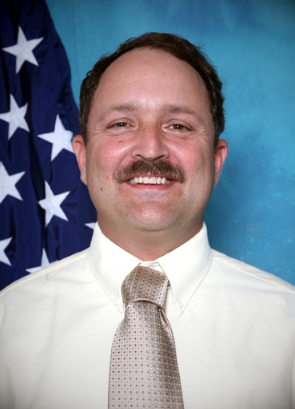
Dave Rice was a dedicated and knowledgeable (BSVE) Branch Manager, led by personnel example, aggressively met goals and freely shared his expertise with others. He encouraged subordinate ownership through empowerment and positive recognition reflected in the sustained 90 percent equipment availability, client satisfaction, and numerous personal awards for his subordinates. He communicated clearly and intelligently with customers at all levels, putting them at ease with their concerns. He was a team member and worked collaboratively with other European Theatre Transportation professionals exchanging relevant information to management of transportation.

Mr. Rice’s leadership responsibilities included effectively supervising two local national supervisors, one local national licenser and operations assistant and three military supervisory positions. As the BSVE Branch Manager he was responsible for a total of 29 local nationals and 33 military personnel. He was a dynamic key player in developing the department’s strategic plan, he effectively communicated the division’s strategic vision to the deck plates to ensure employee understanding and support for the department’s long term goals.

Mr. Rice’s managerial responsibilities included formulating operating budgets, determining staffing levels to meet production requirements within financial constraints. He managed the GSA Lease Program, executing certifying official responsibilities for the station’s WHE and Explosive Ordnance Material Handling Certification Program, the government VISA card program and the acquisition program for repair parts. He ensured that Crash Fire and Rescue equipment, aircraft refuelers, and runway maintenance equipment were effectively serviced to maintain operational airfield category and that Weapon’s Department’s vehicles and the station’s cranes were maintained at a level that afforded immediate response to support all weapons movement evolutions. He ensured that Public Works was able to provide requisite services to transient commands/personnel including US Air Force and other Tenant Commands with a combined population of over 2,600 military personnel.

