C E R T A L E R T

ADVISORY CAUTIONARY NON-DIRECTIVE

FOR INFORMATION, CONTACT Ken Gilliam, AAS-310 (407) 812.6331 Ext.134, ken.gilliam@faa.gov
DATE: | 10/28/2004 | No. 04-13
TO: | Airport Operators, FAA Airport Certification Safety Inspectors
TOPIC: | Rocket-Deployed Emergency Parachute Systems

This CERTALERT is to provide ARFF personnel with the information required to safely deal with the discovery of an unfired rocket-deployed emergency parachute system (sometimes called a ballistic parachute) at the scene of an aircraft accident. While these devices are intended to save lives, they have the potential to cause injuries or even death to rescue workers.

While there are several manufacturers of ballistic parachute systems on the market, the BRS Inc. is a prevalent system found in the industry. In addition to BRS ballistic parachute, there are several other brands called Pioneer, Second Chantz, Advanced Ballistic Systems, Galaxy, or GQ Security.

The BRS whole aircraft recovery system is intended as an option for pilots that have concluded that a safe landing may be difficult if not impossible. However, in certain instances, there may have been no opportunity to deploy the system prior to impact. In those cases where the impact was notably violent, it is quite likely the system will have fired as a result of airframe breakup or distortion. This leaves the final scenario, one in which the parachute system has not been activated due to crash forces, and the system’s rocket is still very much alive and capable of being fired.

A keen eye and training can help the first responder to first identify the presence of a BRS system and then carefully render it completely harmless. We have attached a BRS document that is intended to provide information to emergency personnel, which may be referenced at the scene of an aviation incident. The company has also provided a power point presentation that provides an overview of how best to accomplish these tasks. This power point presentation can be found on the web at www.faa.gov/arp. Then click on Safety and Operations. It is also located on the Aircraft Rescue and Fire Fighting Working Group web site at www.arffwg.org."

Attachment

_____________OSB____________________ 10/28/2004
Benedict D. Castellano, Manager Date
Airport Safety and Operations Division, AAS-300


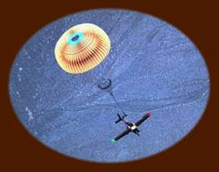

BRS Ballistic Parachutes:
Information for Emergency Personnel

Airplane crashes are rather rare events, thankfully. This helps illustrate that aircraft, whether commercial airliners, general aviation aircraft or recreational sport planes, are generally quite safe when flown by competent pilots.
However, the rare nature of these crashes also means that those who arrive first at the scene of an accident (rescue workers, investigating officers, fire fighters, and other safety personnel) may be overwhelmed or not recognize the parts of the aircraft particularly well.
One potential hazard rescue workers may encounter is an unfired rocket-deployed emergency parachute system (sometimes called a ballistic parachute). While these devices are intended to save lives, they have the potential to cause injuries or even death to rescue workers.

An emergency call takes you to the scene of an aircraft accident. Victims inside may be injured. You want to act quickly but people at the scene warn you about a rocket-deployed parachute installed on this airplane. The pilot did not activate the safety device and now you may find yourself working on or near the airplane with its ballistic device still ready to fire. You want to help the victims, but you don't want to harm yourself or others around you.
Perhaps the occupants escaped without serious injury and may be out of the plane. But the wreckage must be dealt with and a damaged aircraft with a ballistically-deployed parachute can be lethal. What do you do?
In the hope of preventing a secondary tragedy, this article attempts to answer the questions facing emergency personnel.
SUMMARY... But Please Read the Entire Article
The following summary provides the minimum steps to disarm a BRS rocket motor:
- Locate the BRS parachute system by finding the parachute pack (see photo of container types). NOTE: Keep in mind that a badly broken apart airplane may have already put the activating housing into a stretched state that may be close to firing.
- Identify the rocket motor launch tube (photos inside). Note where the activating housing attaches to the base of the launch tube.
- Cut the activating housing at the base of the launch tube using a Felco-brand cutter (identified within) or equivalent.
- Remove the still-live rocket motor to a secure place and contact BRS for further directions about permanently disabling the rocket motor.

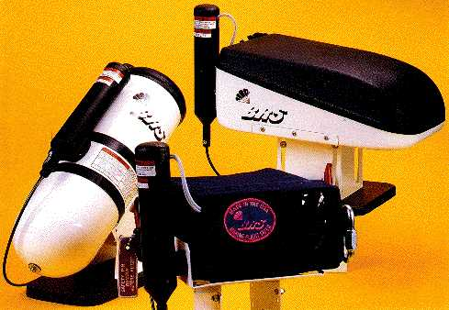
What Does "Ballistic" Mean?
The term ballistic in this context has nothing to do with guns or ammunition. Instead it refers to a means of extracting a parachute. For Ballistic Recovery Systems (BRS) today, this means a rocket-deployed emergency parachute system.
Used as intended, these BRS-brand emergency parachute systems have saved over 165 lives. More correctly stated - they save lives if used. However, the pilot must elect to deploy the system, completely different than, say, an airbag which deploys automatically when certain conditions develop. Because the pilot (or his passenger) must pull the activating handle, sometimes the units are not used.

The pilot may have felt he could rescue the plane from its predicament. Or he may have been unable to deploy for physical or other reasons, such as being at very low altitude. Regardless of why a ballistic parachute was not used, the fact remains for safety personnel that when handling an accident where a BRS unit was not deployed, a potentially dangerous device now confronts them.

How Dangerous Are They?
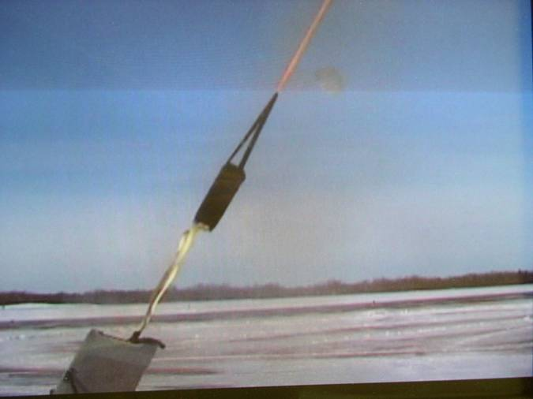
The rocket motors are ignited by pulling an activation handle in the cockpit. They then accelerate to over 100 mph in the first tenth of a second after ignition. While the total firing period is only one second, someone in the path of an escaping rocket could be seriously injured or killed. These are powerful rockets (about 1½-2 inches diameter and 8-10 inches long) that work very efficiently. At left is a test of a Cirrus system showing the 55 pound parachute pack being pulled by the rocket motor. This is a fraction of a second after ignition.
The danger to safety personnel may now be more obvious. A rescue worker who disregards the position of the ballistic parachute system, or who moves the aircraft without determining the existence of a ballistic parachute system may put him or herself in considerable jeopardy. BRS has worked with NTSB and FAA personnel, as well as rescue personnel throughout the country and around the world. We have assembled this information for safety personnel to disarm these systems, but caution is required.
COMPONENT DESCRIPTION/INSTALLATION DIAGRAMS

A BRS unit is comprised of four major elements: Activation Handle, Activation Cable or Housing, Rocket Motor Assembly and Parachute Container.

The first thing emergency people will see may be a red firing handle. This will usually be located near the seats, as it must be close to the pilot. The red firing handle will connect to the activation housing, the flexible cable that links the firing handle to the igniter.

In the picture below, see that each handle is secured with a safety pin. This is to remain with the handle until the aircraft departs for flight. The pilot should then remove the pin. A first step for first responders is to place some type of 3/16 inch pin or rod into the handle holder. This provides some measure of security as you proceed to further disarm the system.

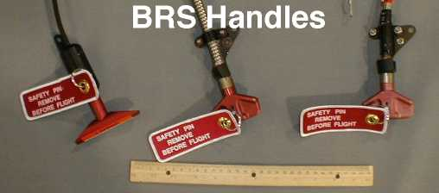

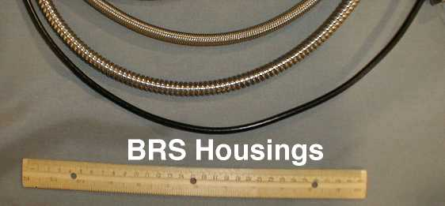
PARACHUTE CONTAINERS

The parachute may be housed in a fabric covering called a softpack, in a fiberglass box called a VLS (vertical launch system), or a white aluminum canister. Each of the various container types may be mounted in a variety of locations, according to aircraft design.
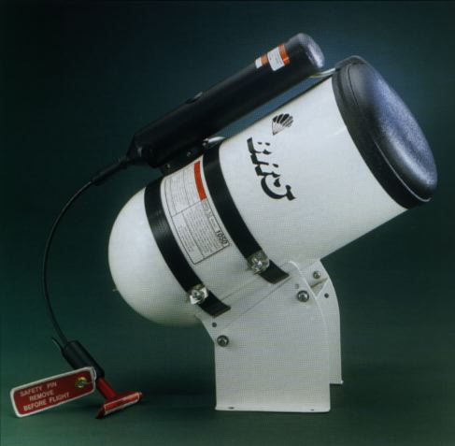
At right is the BRS Canister system, very commonly used in a wide variety of ultralight, experimental and sport aircraft. They come in sizes for aircraft ranging from 500 to 1200 pounds GTW. Below are the softpack and VLS systems.
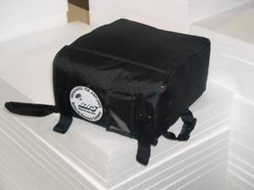

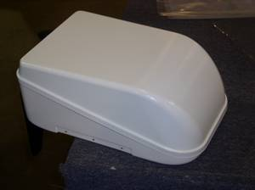

CIRRUS

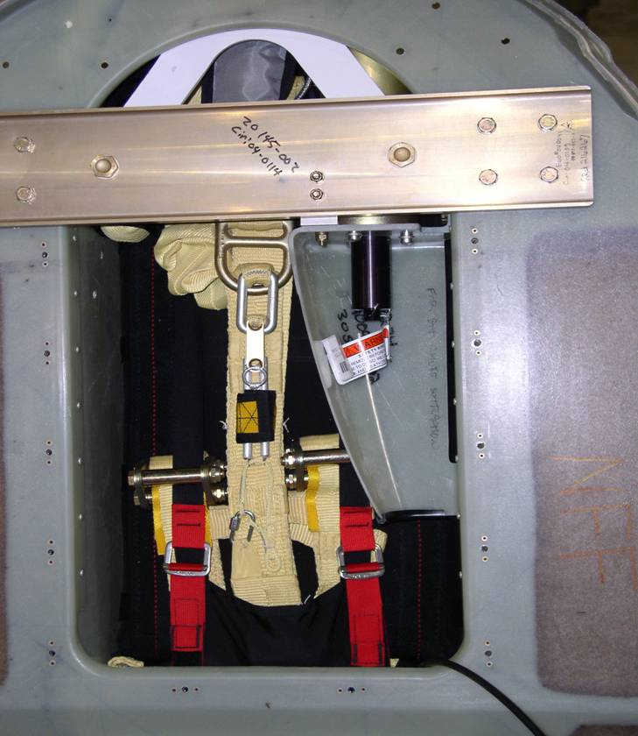

The photo at left shows the Cirrus parachute installed into its stowage area, located just behind the baggage compartment. It is normally covered by a sheet metal panel and interior trim. The rocket motor is mostly hidden behind the aluminum beam; the igniter is visible in the upper right center as a black cylinder. The Cirrus parachute is contained within a heavy nylon bag, so it is a softpack by definition.

CIRRUS
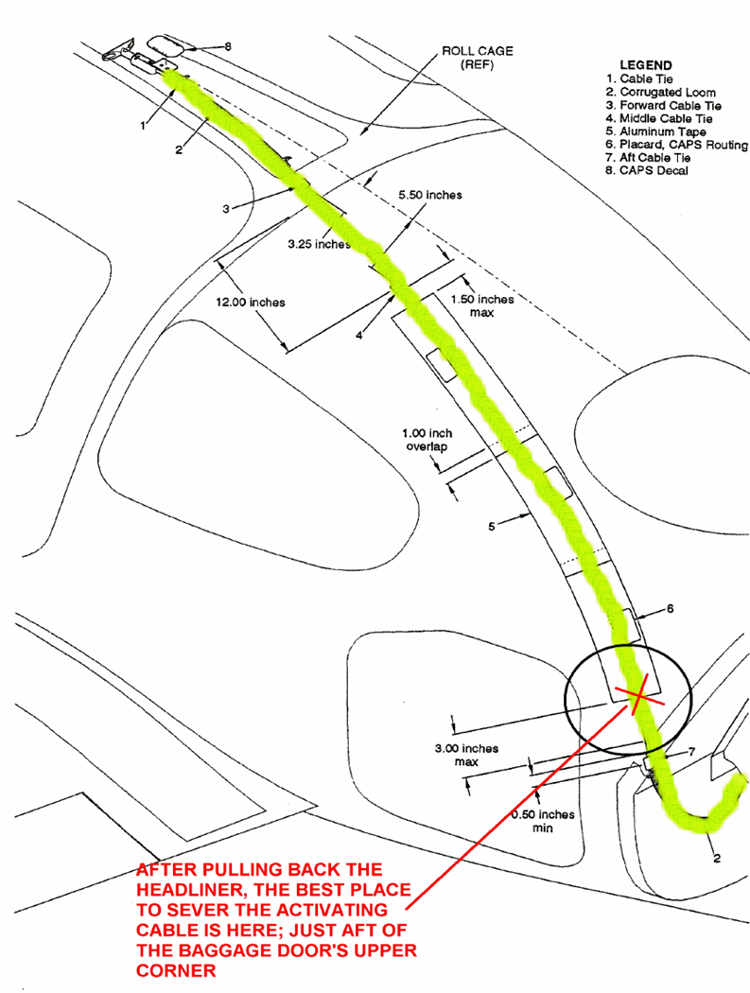
This illustration shows the routing of the activation cable in a Cirrus SR20 or SR22 aircraft. Unfortunately, it is covered entirely by headliner panels. The best place to expose the cable is just aft of the baggage door, near the upper right corner.

Cessna 172

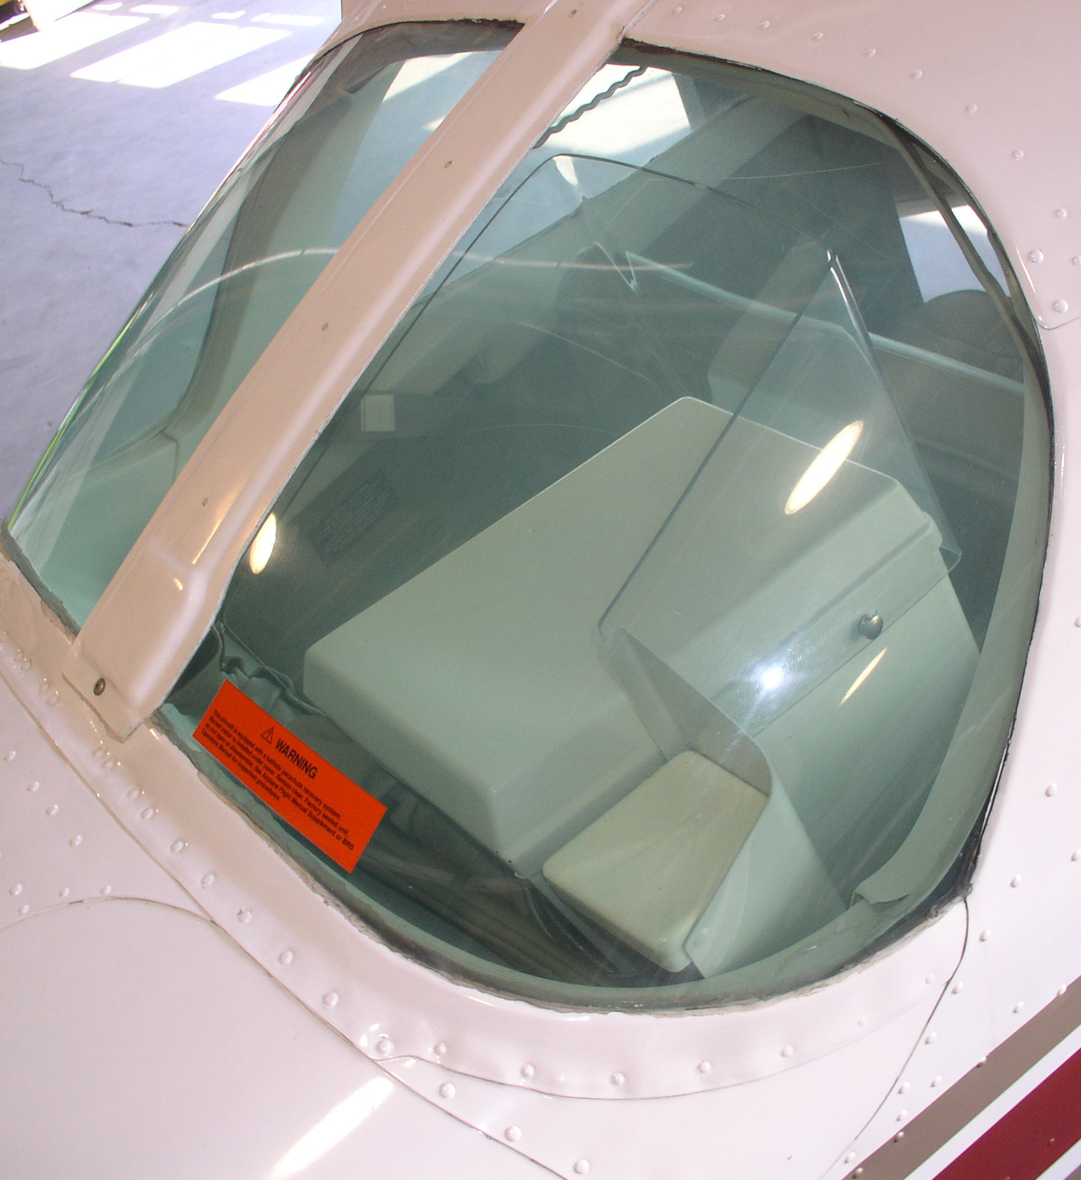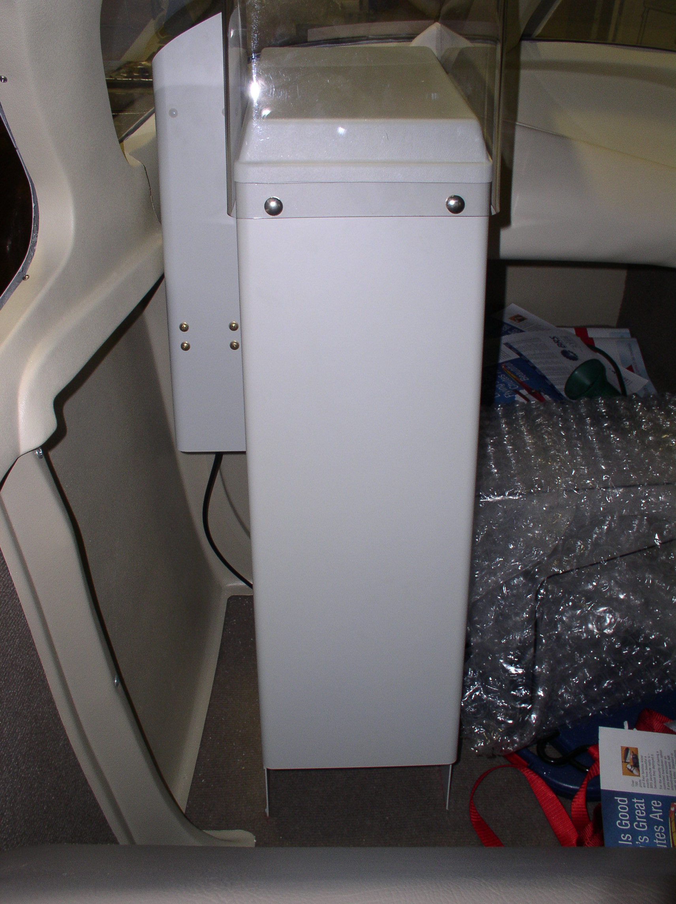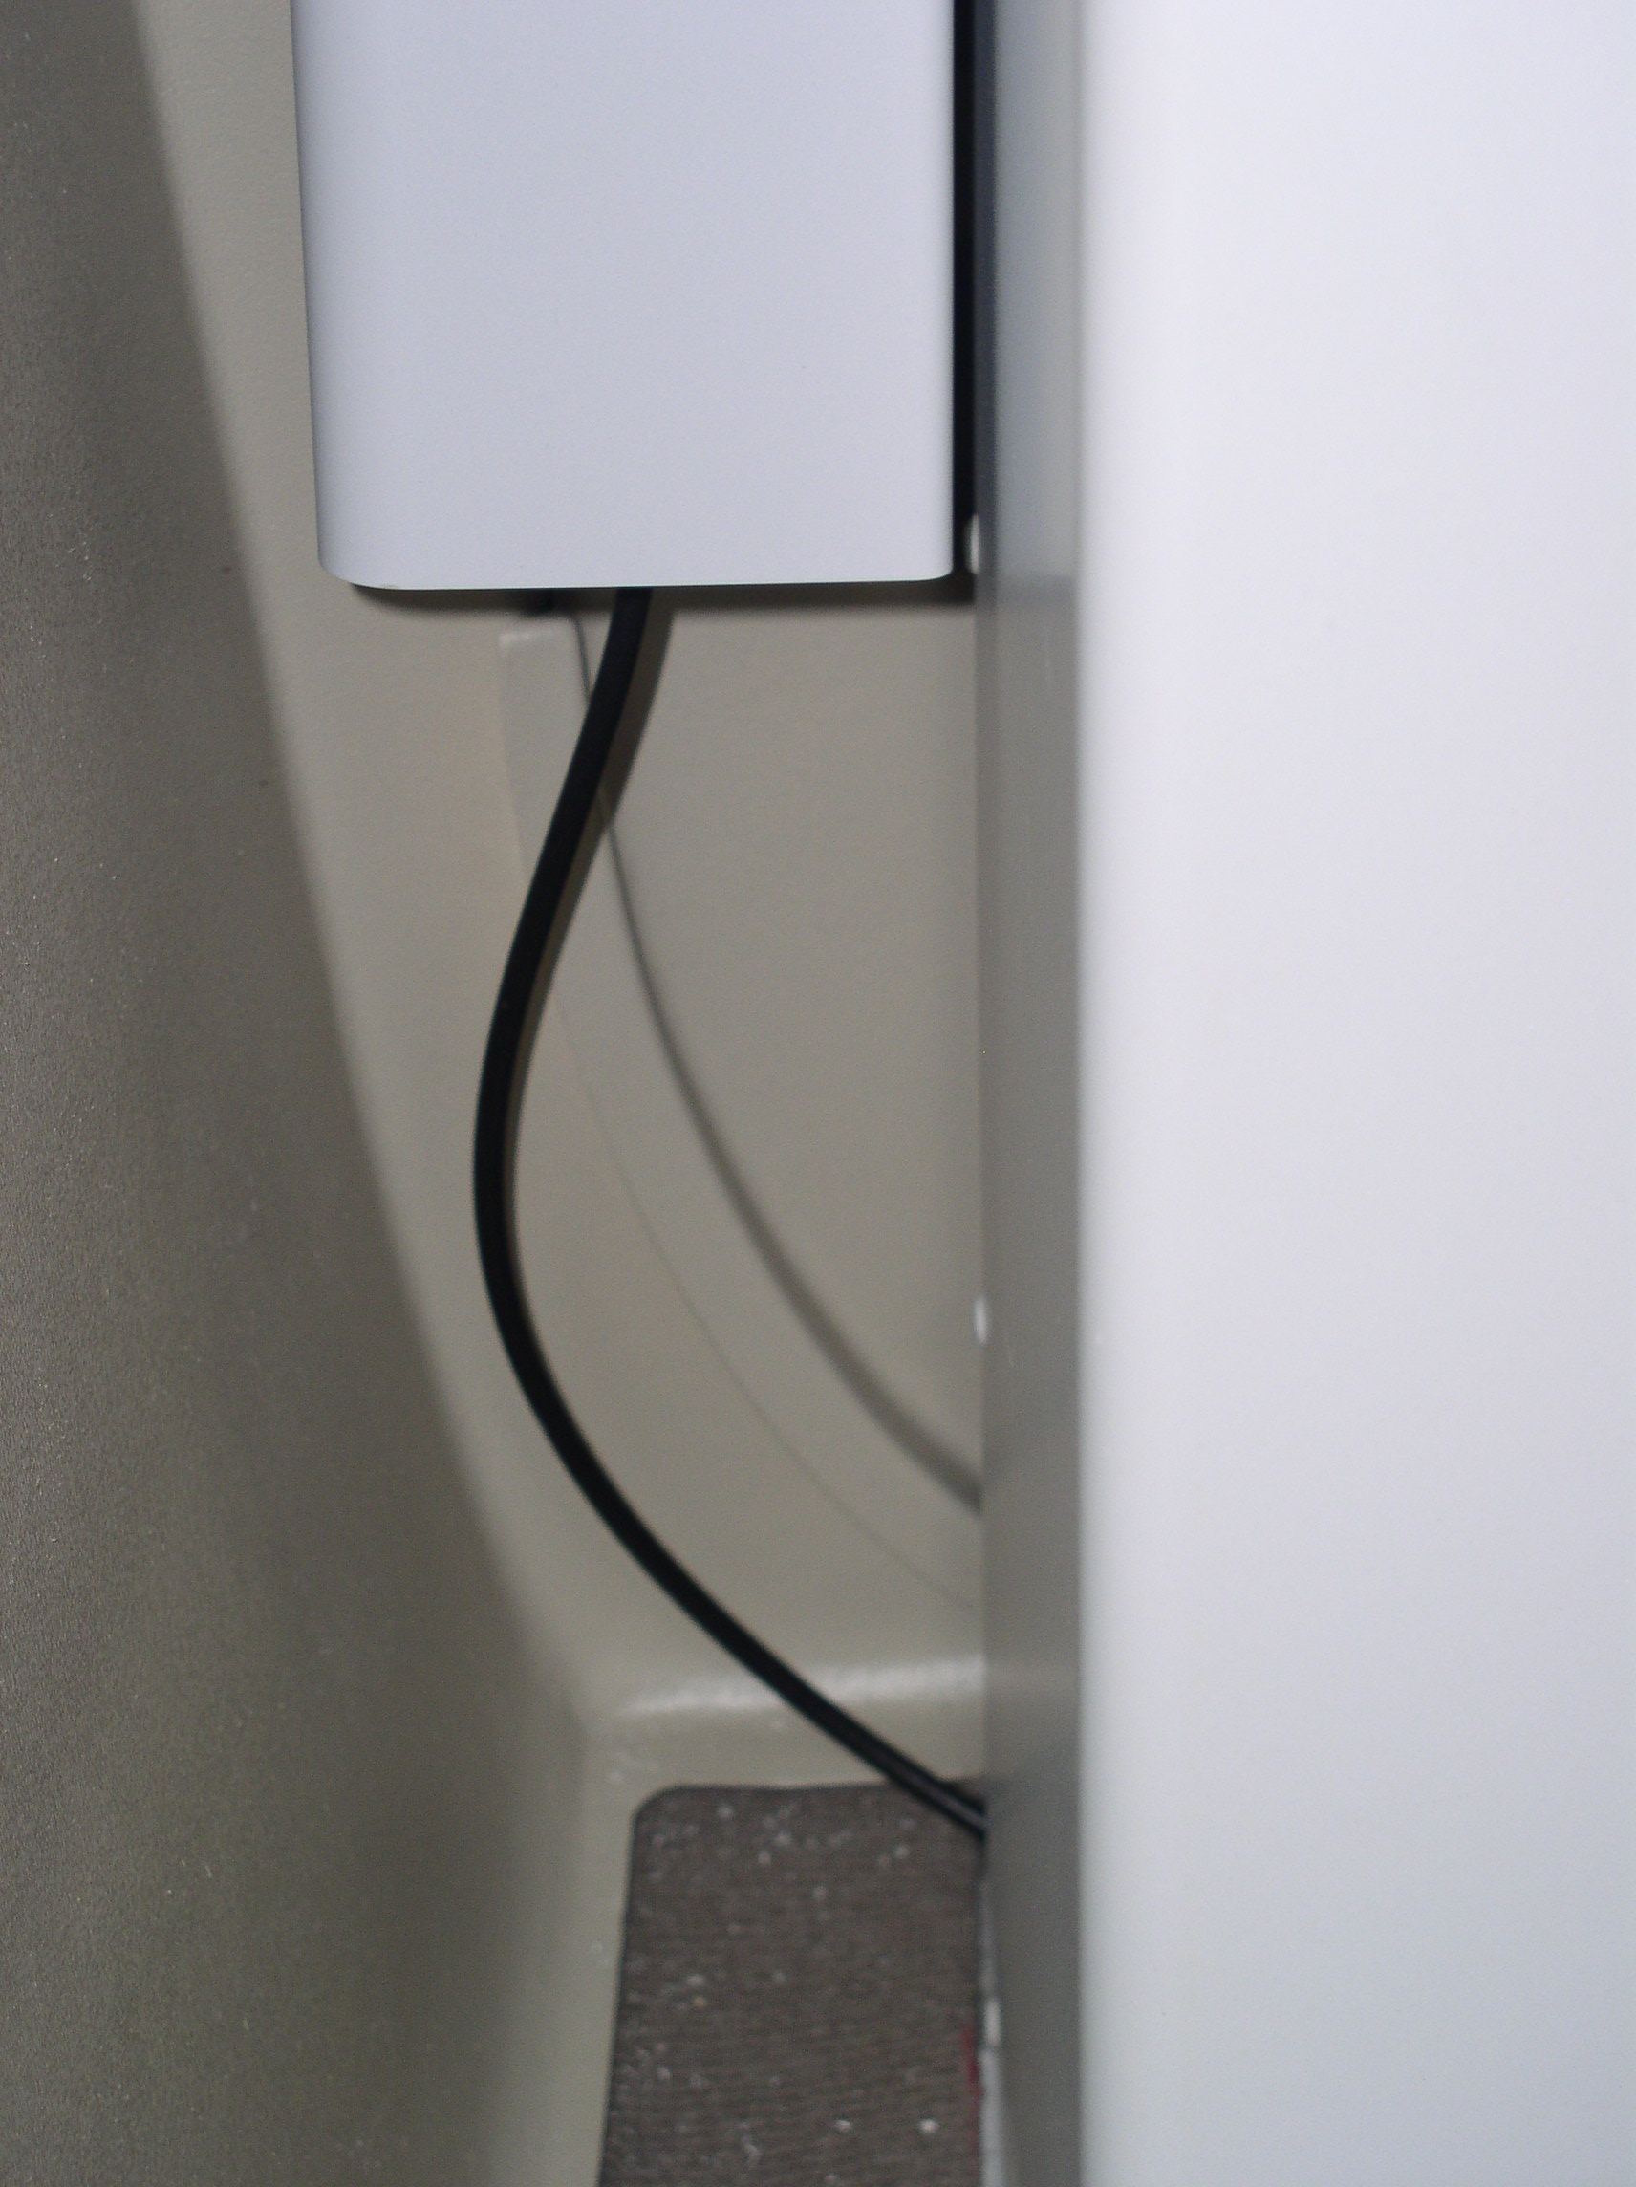
Top View Interior View Activating Cable

The above three photos show the location of the parachute canister and rocket in the Cessna 172. The aluminum parachute canister (large box) is in the left rear of the baggage area, as viewed from the front seats. The rocket is on the left of the parachute canister; the activation cable runs down to the floorboard, under a cover, then forward to the activation handle, located near the fuel selector.
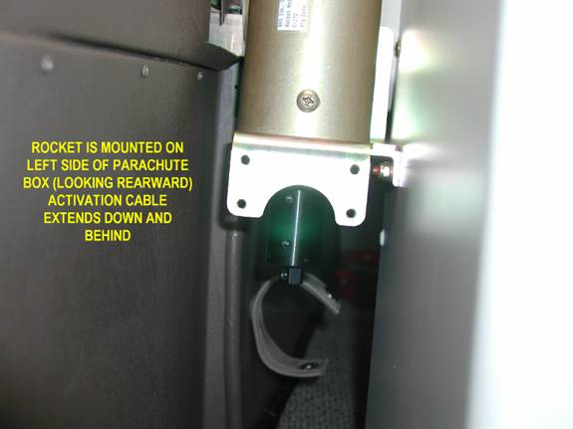
At left, the C172 rocket and igniter with the plastic cover having been removed. Inside the launch tube resides the rocket motor, shown below. The rocket motor is secured to the igniter base by three 10-32 nylon screws which fracture at firing.

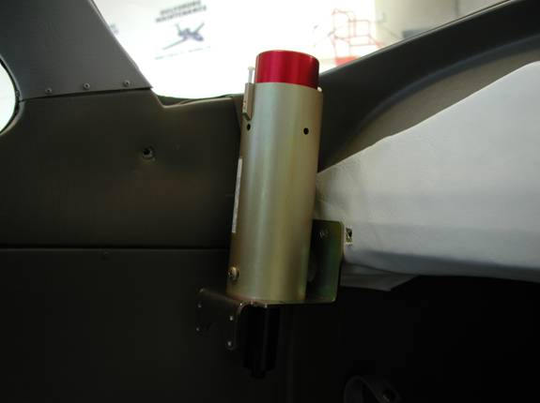

Here is another perspective of the C172 rocket with cover removed. It is just a few inches below the rear window, which it will readily break through when fired.

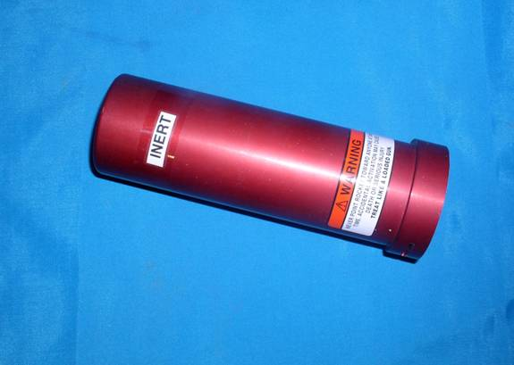

This is a close up of the BRS 900 rocket motor, common to both Cessna and Cirrus installations. It produces roughly 225 pounds of thrust over a 1.2 second burn time and must be respected. It burns solid propellant derived from military formulations and is very resistant to accidental initiation.

Cessna 182
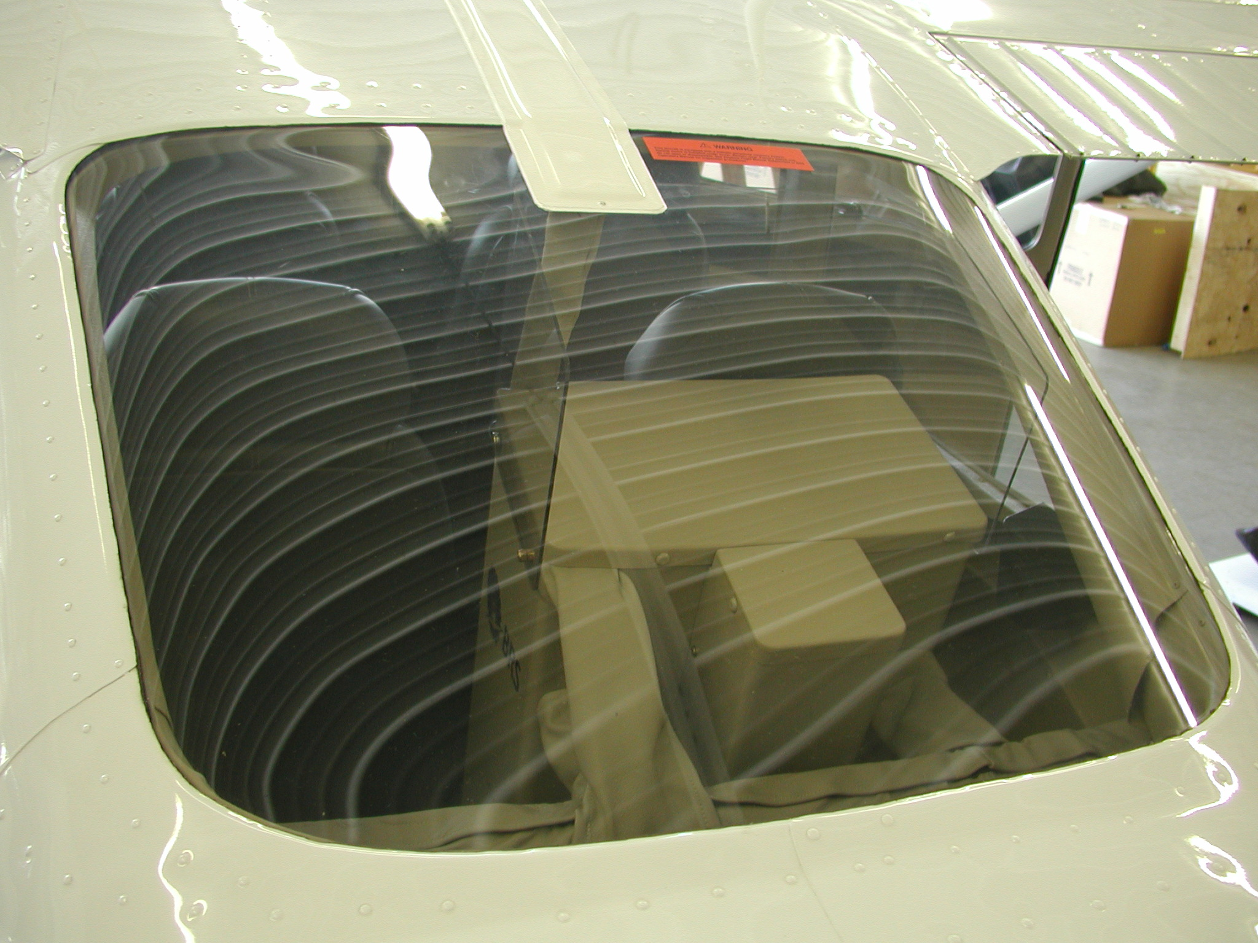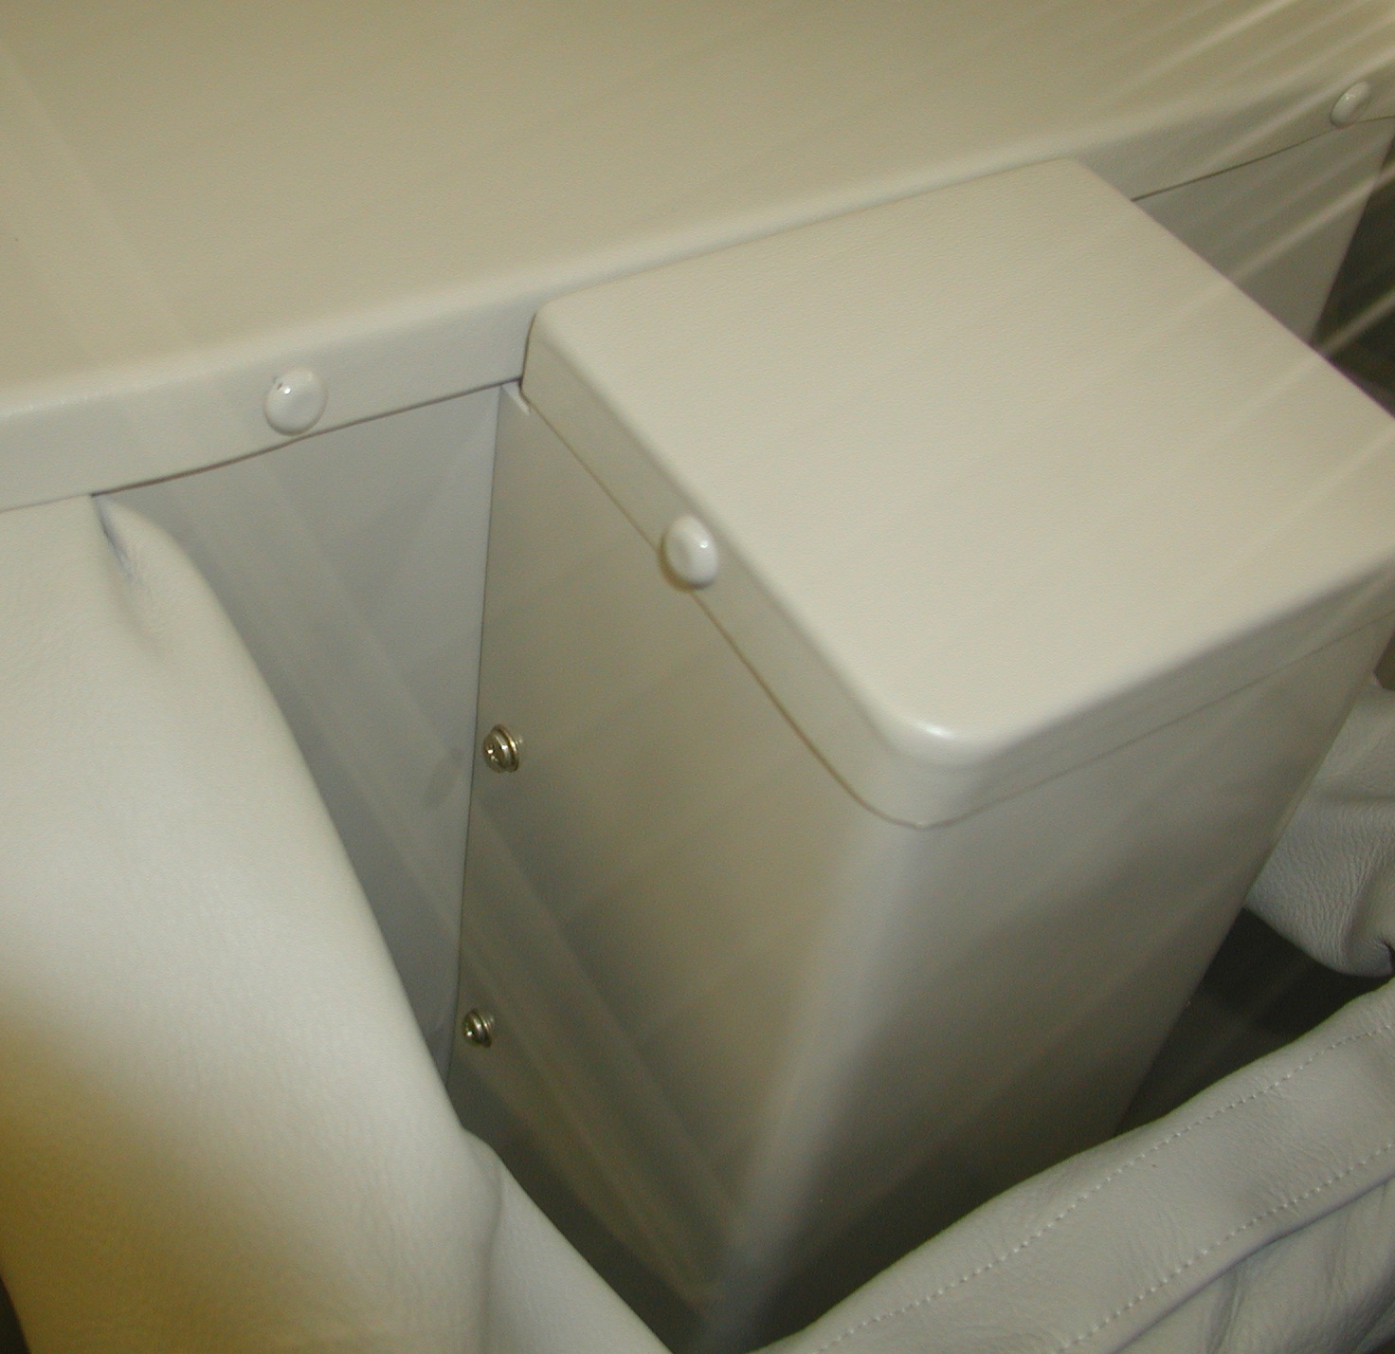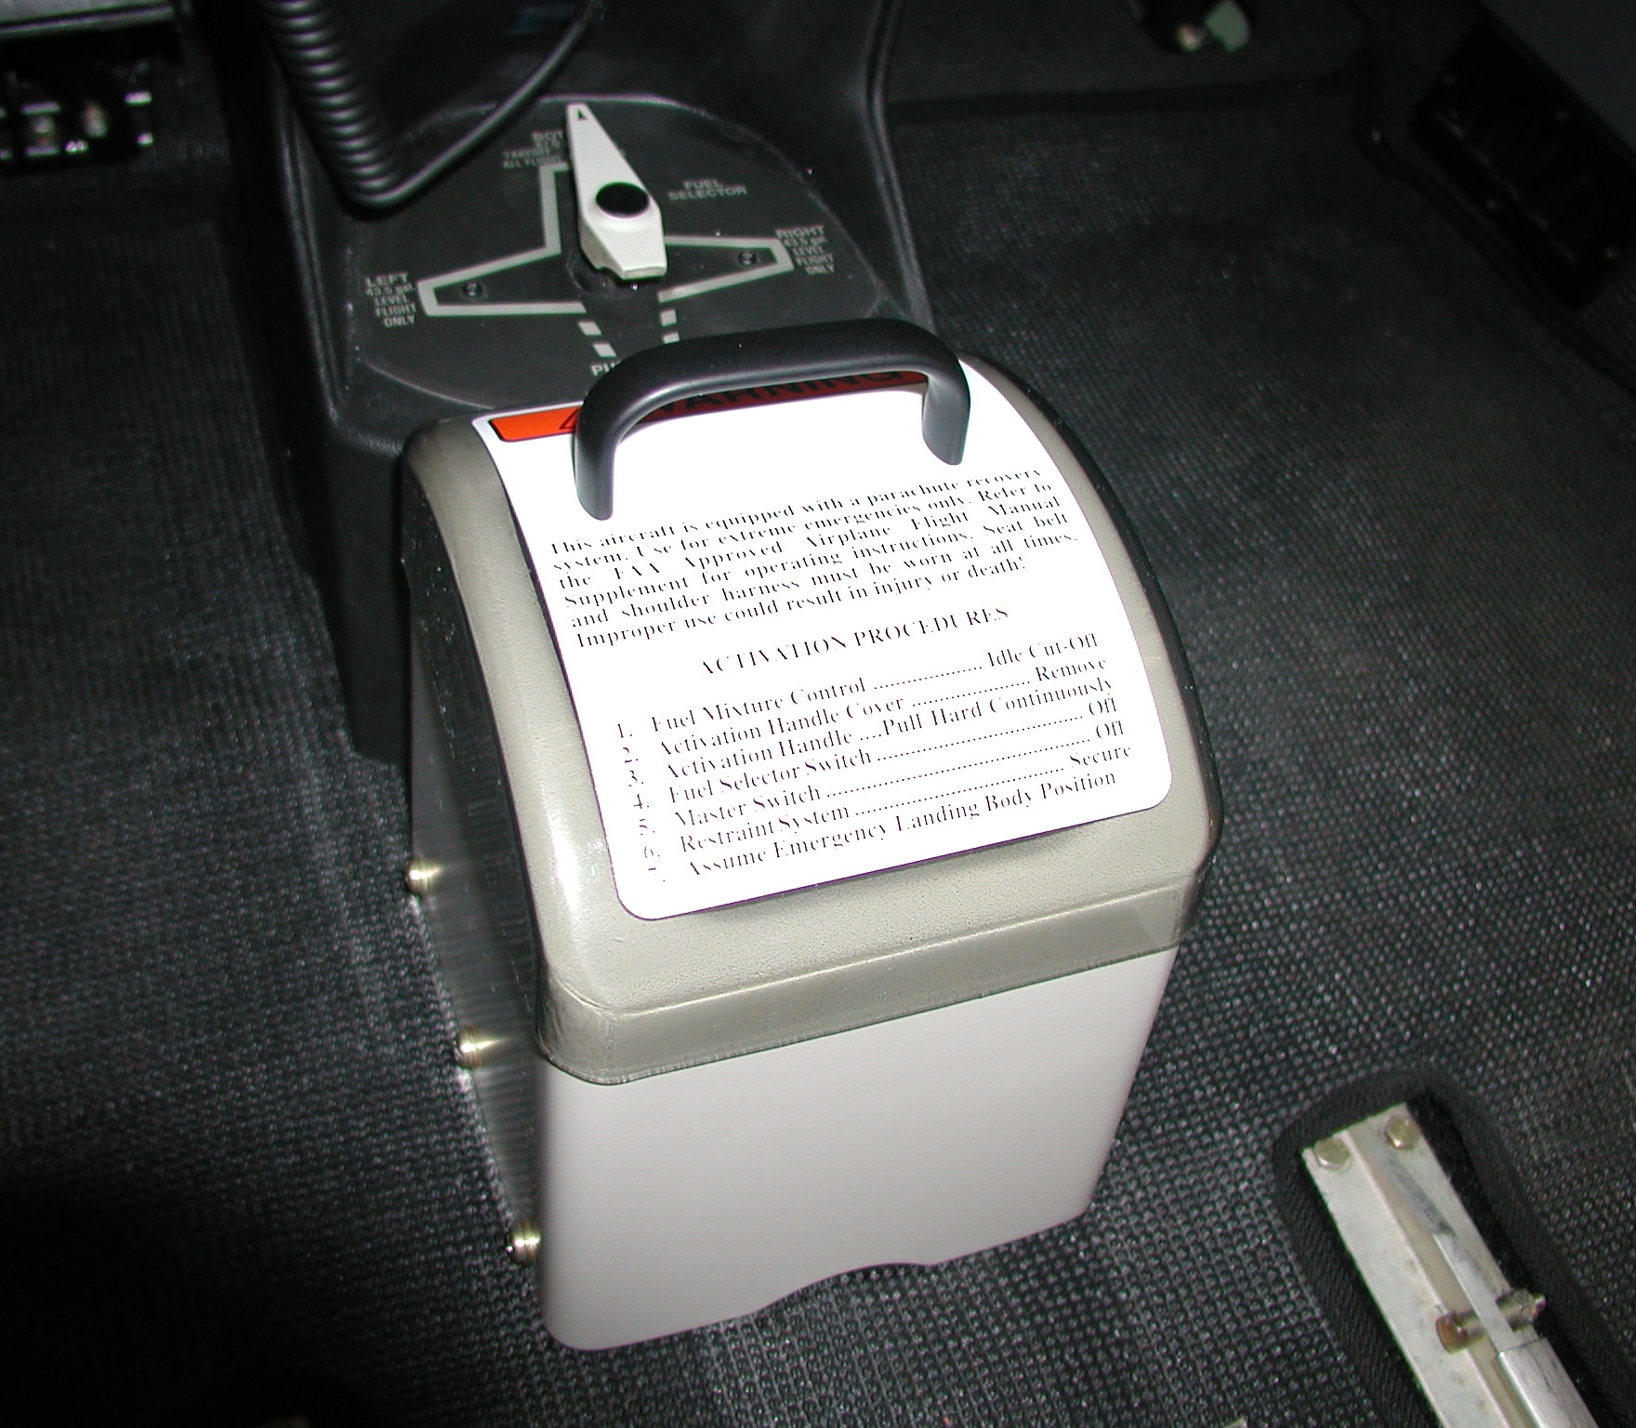

Top View, thru window Top View, inside Handle Box

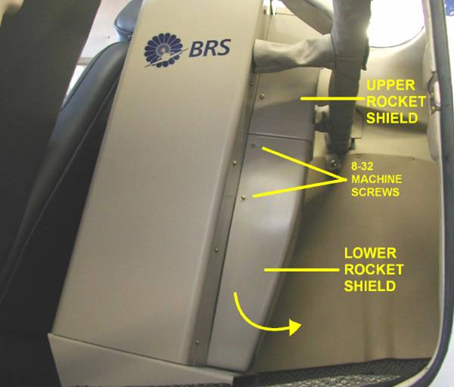
Many of the design elements of the newer, C182 ballistic parachute system are very similar to its predecessor, the C172. The canister is rotated 90 degrees and the rocket is located aft of the canister, however, the activation cable is still relatively accessible prior to being covered on the floorboard. The best way to reach the cable would be through the left side baggage door, if possible. As shown here, the rocket motor and igniter are covered by the upper and lower rocket shields, which are intended to protect the components from bumping. To gain access to the cable, perform the following steps:

- Using a Phillips screwdriver, remove the two 8-32 screws securing the left side of the lower rocket shield
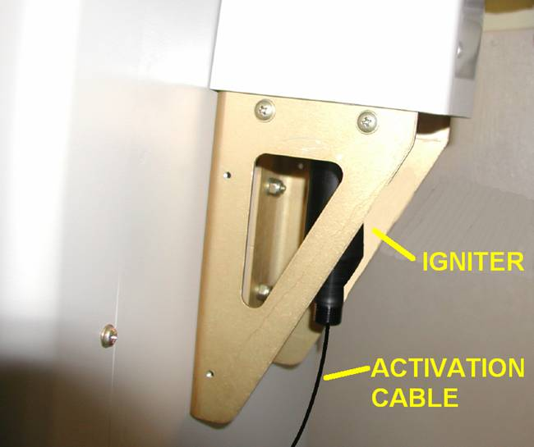
- Place force on the shield in an effort to move it away from the parachute canister. Even though there are two more screws on the right side, it should fracture and may then be pushed out of the way.
- You will then see the igniter and the activation cable, as at left.
- Using the Felco cutter, or equivalent, proceed to cut the cable 1” – 2” from the end.
- The rocket has now been rendered safe, and it may be removed for disposal or safe storage.

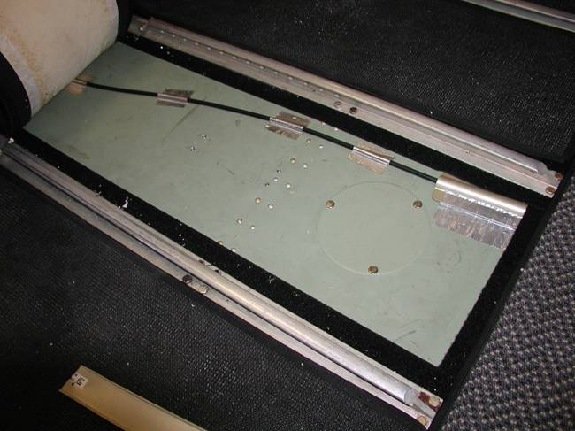
Note: This photo shows the routing of the activation cable between the front seats in either C172 or C182 installs. It is partially protected by aluminum channel, as you see in the right of the photo. Aluminum tape is also used to secure the cable to the floor. For any reason, should you be unable to access the cable near the igniter, this is a secondary point of access.

HISTORICAL NOTES:

ROCKET OR DROGUE GUN?

In 1987, a determination was made that a solid propellant rocket motor was the best choice to extract the parachute. It is, therefore, increasingly unlikely that emergency personnel will encounter the older systems which employed a device called a drogue gun. The drogue gun is basically a small cannon which fires a heavy weight using a propellant charge. Both systems, however, will be located very near the parachute; and both are disarmed using these techniques.

CHANGES TO THE ACTIVATION HOUSING (CABLE)
The activation housing on BRS units has changed over the years. The material formerly was a flexible, spiral-wound, bright silver stainless tube of about a half inch diameter. Later this became a braided material similar in appearance and size. The newest models use a black plastic exterior that resembles a bicycle brake cable.

AT THE SCENE
Rescue personnel should first determine the existence of a BRS-brand unit. You can scan for a company logo, often placed on the outside of the aircraft. Or you can look for the unit itself. The containers, which hold the parachute canopy, will always have a company logo on them. A few other brands exist, but overwhelmingly, you will encounter the BRS product. Locate the parachute container, rocket, activation cable (housing) assembly and activation handle.

The activation housing, again, joins the firing handle on one end to the rocket motor on the other. Pulling either end away from one another can fire the unit. Normally the handle and the parachute unit will be mounted securely, but as stated above, in an accident, positions may change. Rescue workers, police officers, and fire fighters should initially exercise extreme care when working around these systems, especially if the airplane is severely broken up or the activation cable appears to be tightly stretched.

Examine the parachute container. Alongside the parachute container will be a 2-inch diameter black, silver or white tube about 10 inches in length. This is called the launch tube and it contains the rocket motor. In Cessna installations, the rocket is further covered by a rectangular plastic or fiberglass cover.
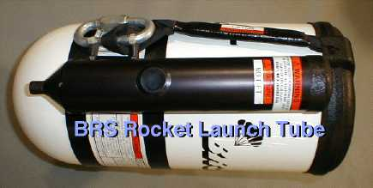
A rocket motor assembly consists of two principle parts: The launch body, which will leave the launch tube when fired; and the igniter, which remains in the launch tube after ignition. The launch tube on newer units is covered with a plastic cap while on certain older models it remained open.

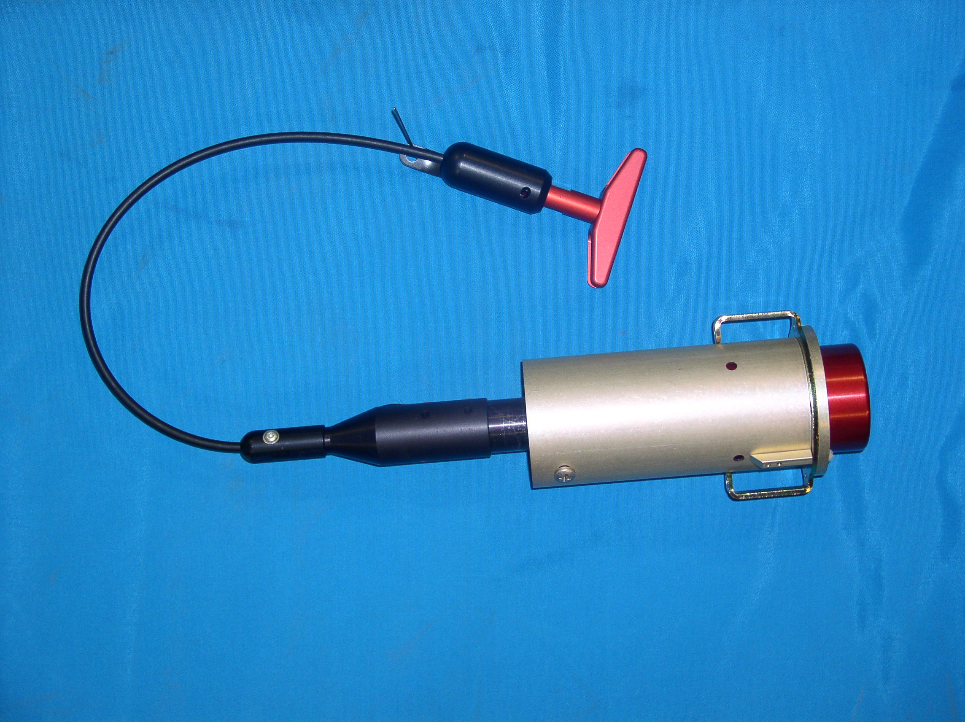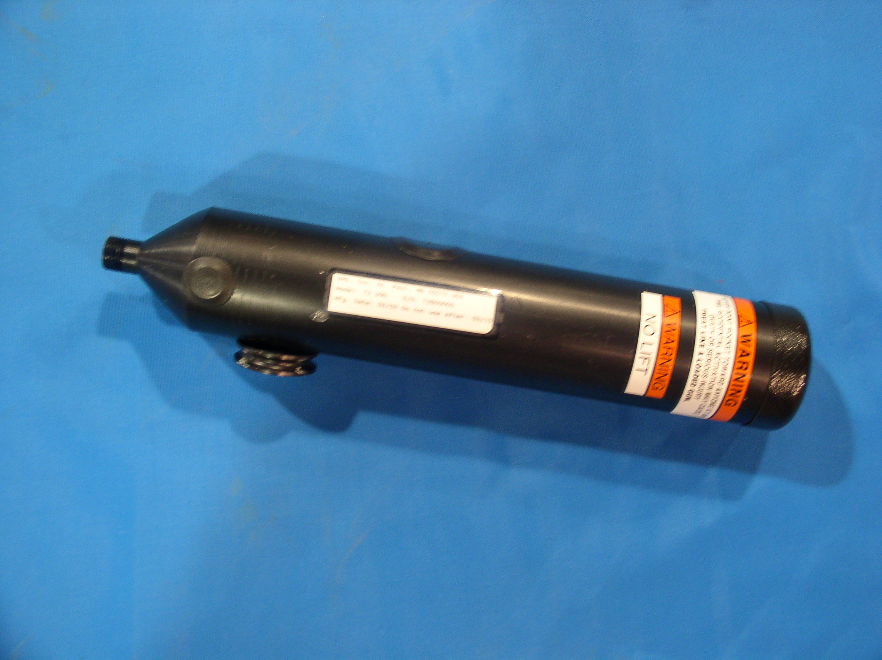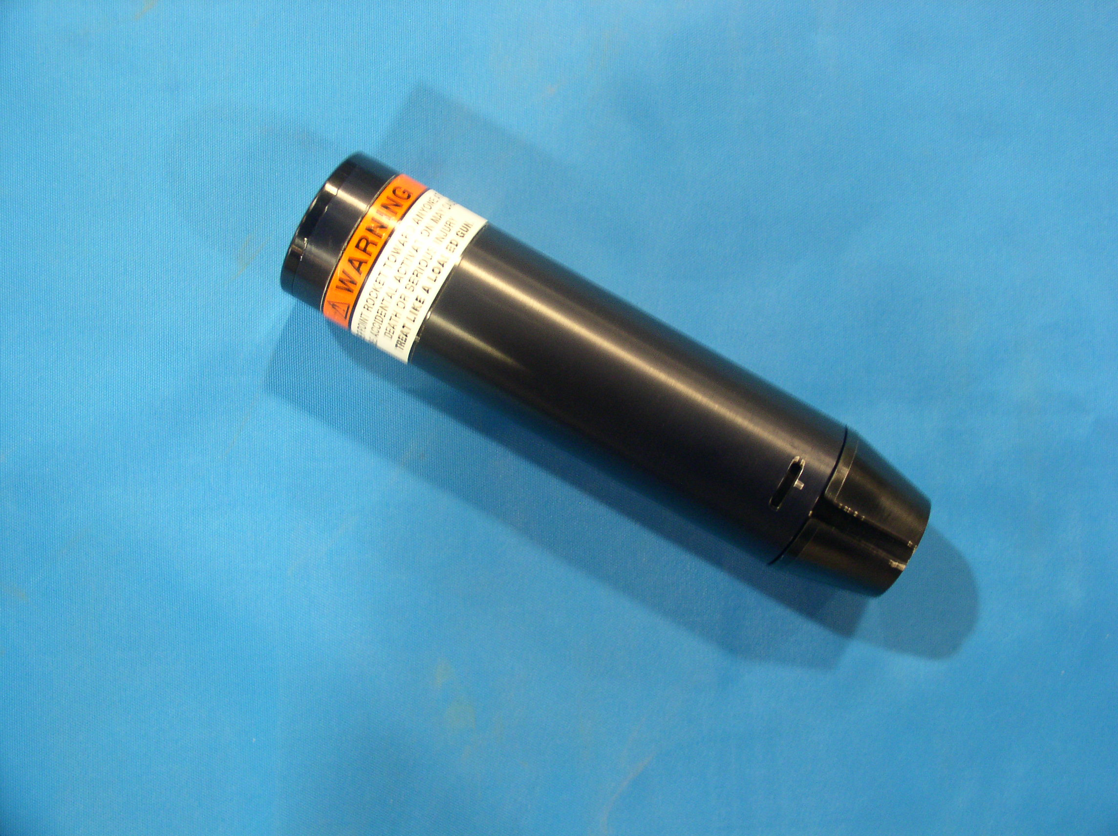
Cirrus/Cessna Rocket Sport Launch Tube Sport Launch Body

HAS THE ROCKET FIRED?

If the airframe has experienced significant breakup, there is a very good chance that the rocket motor has been initiated. Telltale signs of this would be the parachute canopy extracted from it’s container, the rocket motor no longer in the launch tube, a burned appearance on the lanyards joining the rocket motor to the parachute or being unable to locate the rocket motor at all. A rocket motor that has separated from the igniter poses no significant hazard, unless it is exposed to fire. Experience has shown that a rocket motor subjected to high temperatures will not ignite in a normal manner and launch. Rather, they have been observed to burst in a relatively non-threatening display.

After a determination is made that the rocket is live, under no circumstances should rescue personnel place any part of their person in front of the launch tube. Clear a 90 degree area in front of the rocket motor, extending 100 feet out, if possible.

THE IGNITER ASSEMBLY

The rocket motor igniter is NOT an armed, hair-trigger device. It requires a deliberate pull of about 30-40 pounds to cock and fire the system. Both cocking and firing are accomplished by one pull of the handle. Because of the design, the handle will come free of the handle holder and travel roughly two inches unimpeded. Then, the compressing of the spring commences. At that point, the system needs only about one-half inch of additional movement to ignite.

Under certain circumstances, crash forces may physically separate the rocket from the igniter. This separation alone greatly reduces risks. The igniter contains two shotgun primers and a small amount of black powder/magnesium mix and the output is a loud report and a flash of flame. This could cause minor injury, but it is not particularly dangerous. Should one encounter this scenario, cutting the activating cable is still desirable.

SEVERING THE ACTIVATION CABLE

BRS STRONGLY RECOMMENDS using a Felco-brand C.16 cutter (part number 39601-63-00). This can be obtained from various sources, including Sanlo Manufacturing Co. (219-879-0241). Greenlee Company, Div. of Textron, manufactures similar products made specifically for cutting cables, which can be viewed on line at:
http://www.greenlee.textron.com. Greenlee offers several catalog numbers that would work well, including 704,705,706,718 or 727.

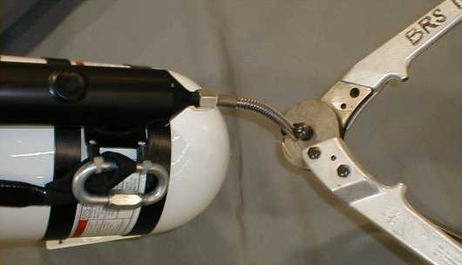
This photo shows the Felco cutter being used to sever one of the older style stainless steel cable assemblies.

NOTE: DO NOT ATTEMPT TO CUT THE ACTIVATION HOUSING WITH AN ORDINARLY BOLT CUTTER! A bolt cutter is NOT effective at cutting the cable housing. The Felco or Greenlee brand cutters gather the cable and work with surprising ease. Care must be taken, however, not to twist the housing while cutting it. This cutter makes a worthy addition to any rescue organization's standard tool box. It has also proven useful for cutting fences, steel cables, and other obstacles which may prevent workers from reaching the scene of an accident or freeing occupants.
Using the diagrams and information presented here, locate a point in the activation cable located near the igniter, then cut it using the Felco or Greenlee cutter. Once the housing is severed, the system is rendered relatively harmless and rescue workers should face no further danger handling the accident victims or aircraft wreckage.

ATTACHMENT TO THE AIRFRAME

Worth mentioning are the mounting hardware components and attachment bridles which connect parachute to aircraft. Made from nylon or Kevlar, the bridles connect the canopy to designated points on the fuselage. Conceivably, it may be necessary to remove the bridles to gain access to components or injured parties. A sharp knife, or your Felco cutter, may be used to sever them if required.

DISPOSTION OF ROCKET MOTOR
Later, after immediate concerns have been addressed, emergency workers are advised to remove the rocket motor and to completely disarm it by removing the rocket fuel, and firing the igniter. BRS will provide assistance for this effort, which can be obtained by calling 651-457-7491 during business hours, CST. Alone, separated from the igniter, the rocket poses very little danger, but it should be stored in a secure location.

ALTERNATIVES

Some agencies that BRS have communicated with take a very conservative position regarding how best to handle an unfired rocket. They feel that this is work best left to the local bomb squad. We leave such decisions entirely up to the individuals in charge at the scene. However, if the above steps are followed and normal precautions observed, we feel that disarming the system can be safely accomplished by emergency personnel without undue risk.

A CAUTION AND DISCLAIMER

While the advice above should prevent problems for safety personnel in most situations, the instructions given apply to BRS brand products only. BRS dominates the U.S. market, so encountering other systems is unlikely. However other brands called Pioneer, Second Chantz, Advanced Ballistic Systems, Galaxy, or GQ Security have been sold in the past. While these systems are similar, they are not identical. BRS can provide no information on how to disarm these systems.

