If you experience any difficulty, please contact the EBC at 1-866-217-9197 (toll-free) or ebc@uspto.gov.

Steps to enable the SSL 3.0 and TLS 1.0 options for IE 6.browser:
  - Select Tools → Internet Options from browser Menu.
  - In the Internet Options screen, select Advanced option.
  - check Use SSL 3.0 and Use TLS 1.0 check boxes.
  - Click Apply.

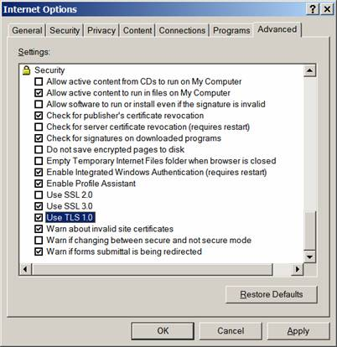

The following page is displayed if SSL 3.0 and TLS 1.0 is not selected in IE 6.0
browser:
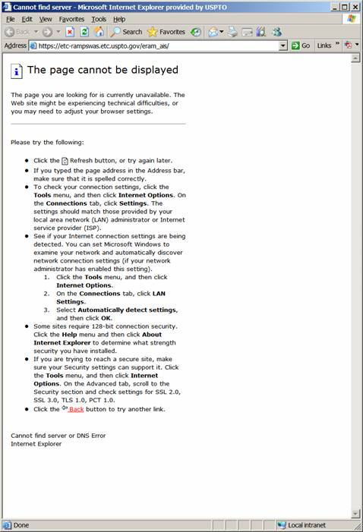

Steps to enable the SSL 3.0 and TLS 1.0 options for Firefox browser:
  - Select Tools → Options from browser Menu.
  - In the Options screen, select Advanced option.
  - Select Encryption tab.
  - Under the Encryption table check Use SSL 3.0 and Use TLS 1.0 check boxes.
  - Click OK.

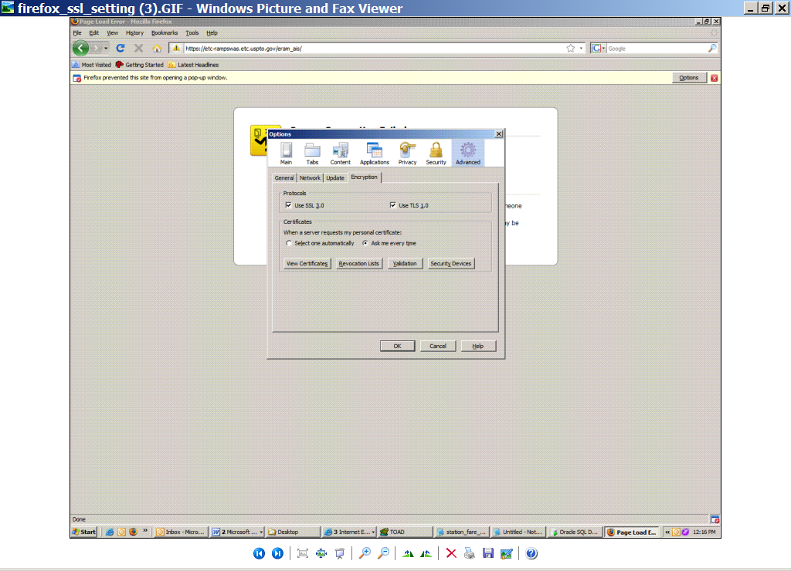

The following page is displayed if SSL 3.0 and TLS 1.0 is not selected in Firefox browser
