USGS Science: Facing Tomorrow’s Challenges
Georgia Water Conference
March 28, 2007

Dr. Mark Myers
Director,

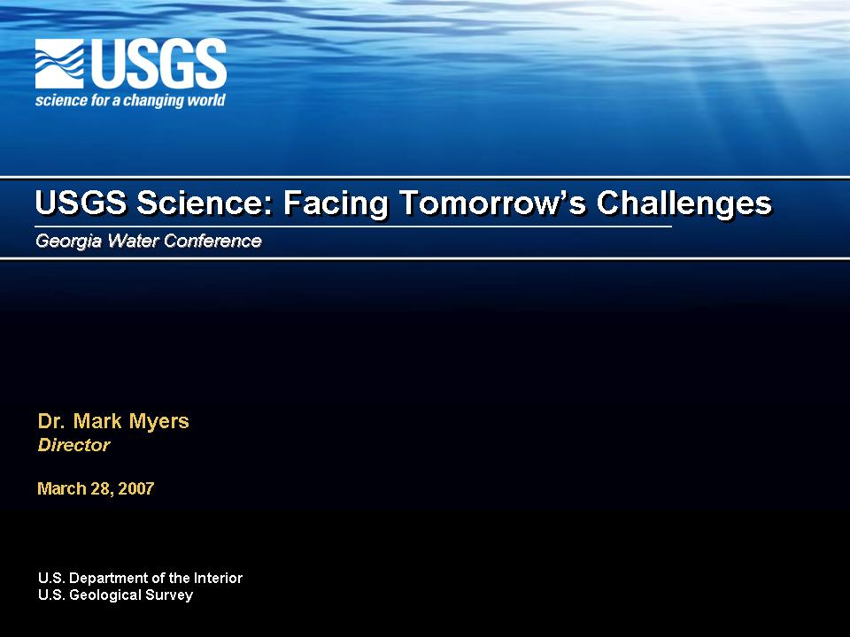
Slide One – USGS Science: Facing Tomorrow’s Challenges
Introduction
- Thank you for the opportunity to speak this afternoon…
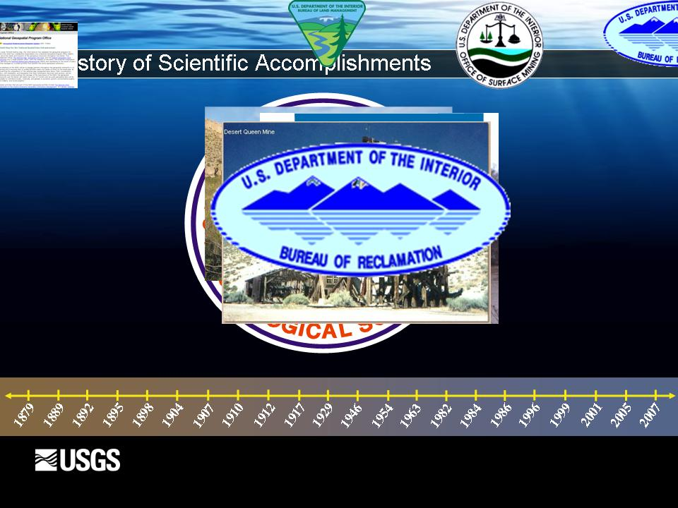
Slide Two – A History of Scientific Accomplishments
- Our future science direction is based on a long history of scientific accomplishments. The foundation that was created more than 128 years ago, continues to grow and serve the nation’s need for natural resource science data and information.
- Since the establishment of the USGS in 1879, our scientists have made significant advances in:
  - Hydrology, developing and advancing a national real-time network of reliable surface water and ground water data.
  - Exploring and mapping both the geologic framework and makeup and geographic contours of the nation.
  - Supporting NASA’s mission we have helped explore the geology and mapping of distant planets and partnering with NOAA we have provided valuable seismic data to warn against tsunamis, and streamgage data to warn against flooding.
  - Over the past two decades our science has expanded to include biology and most recently geospatial information. Both capabilities have strengthened the USGS and created a unique niche in our national science institutional framework.

- Today, those advances allow us to take a multidisciplinary, holistic look at many of the complex natural science issues that our Nation’s Land and Resource Managers and Policy Decision-makers are facing and will face in the future.

- But these advances would not have been possible without the help, cooperation and support from our partners and cooperators at the State, Local and Tribal levels.
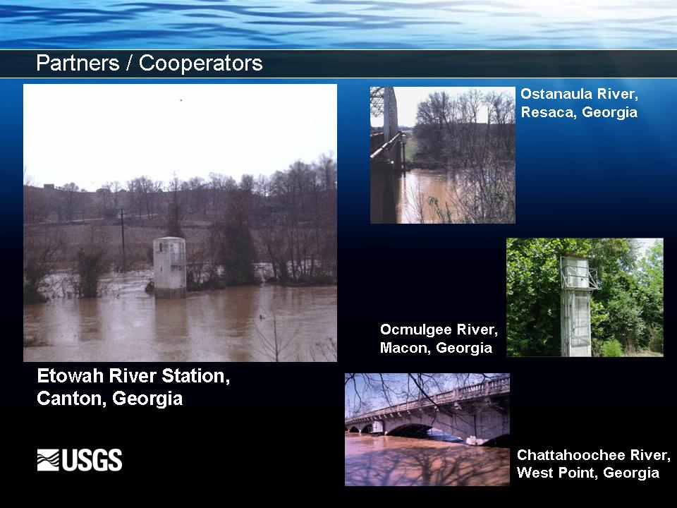
Slide Three – Partners / Cooperators
- Partners like the State of Georgia, who nearly 115 years ago recognized the value that natural science, research and data collection brings to the table, when the first streamgaging Station in Georgia was established on the Etowah River at Canton, Georgia in 1892.
- By 1896, three more stations had been started:
  - Ostanaula River at Resaca
  - Ocmulgee River at Macon
  - Chattahoochee River at West Point
- Today, those same stations are still providing valuable information to State of Georgia and to the Nation, and we expect to see the stations continue providing that data for at least another 100 years.
- While the number of streamgaging data stations, and other water, biological, geological, geographical and geospatial science has continued to grow in the state and throughout our nation, so has our list of Partners and Cooperators.
- In Georgia, the USGS Cooperative Water Resources Program included 3 state agencies, 5 regional agencies, 22 counties, and 21 cities. In 2006, USGS and Georgia Water Cooperators, operated 223 of the more than 7400 streamgages nationwide.
- Georgia cooperators are a critical component of the more than 1400 State, local and tribal governments that support the USGS in our mission. We at the USGS very much appreciate and value the contributions of each of these cooperators.
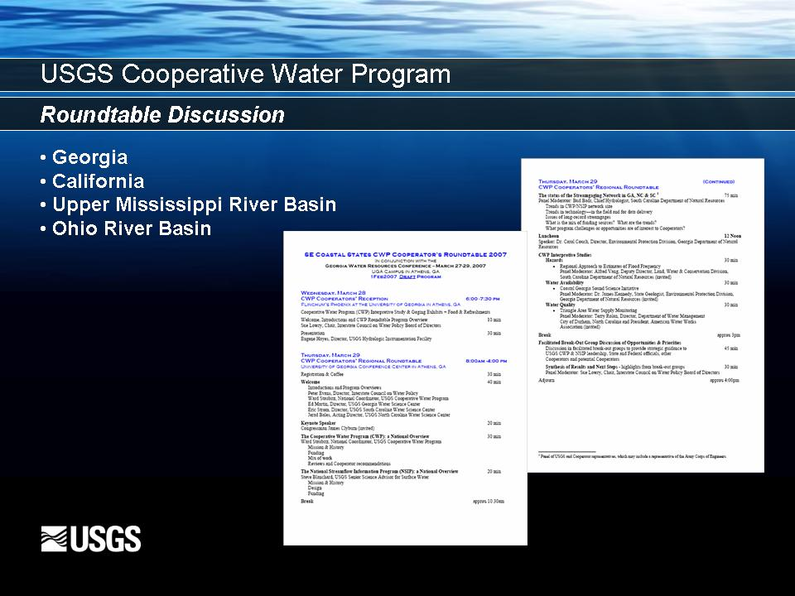
Slide Four – USGS Cooperative Water Program – Roundtable Discussion
- Tomorrow, here at the Georgia Water Conference, the USGS Cooperative Water Program is holding the first in a series of regional Stakeholder meetings to engage our cooperators and other stakeholders who rely on USGS hydrologic information.
- Tomorrow’s meeting will focus on the cooperative water program here in Georgia and in South and North Carolina.
- In May we will move on into California and expect to have stakeholder meeting in the Upper Mississippi and Ohio River Basins before the end of the year.
- In these meetings, we hope to discuss with our stakeholders both the strengths and the weaknesses of the Cooperative Water Program and identify what we can do to jointly strengthen this important program and improve our ability to meet the ever increasing need for high quality hydrologic information.
- I hope that you will join me tomorrow with other USGS national and local Water Science Center Staff and our important Stakeholders to participate in this discussion.
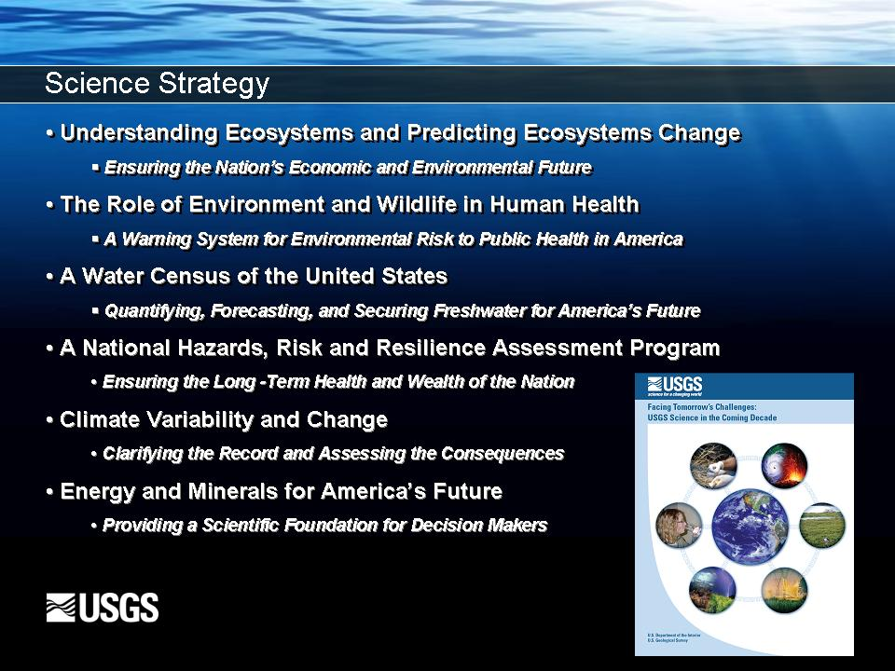
Slide Five – Science Strategy
USGS Science Strategy – Facing Tomorrow’s Challenges
- Define a vision, focus (reason/driving factors behind the development of the Strategic Science Plan Initiative) “Eco-centric or Ecosystem based Approach”
  - 1996 Strategic Plan –intended to be a 10 year plan, with 2007 approaching - need to review that document under the changing drivers and challenges since 1996, indicated the need for a new Strategic Plan:
- Goal – “to develop a comprehensive vision, with science goals and priorities that unite all bureau capabilities towards challenges for the future…”
- Intent of the Strategic Science Plan is to outline areas where natural science capabilities can make significant contributions to the well being of the Nation and the world by defining a science direction that will guide USGS program planning, technology investment, partnership development and workforce and human capital strategies
- Define six fundamental focus areas-
  - Understanding Ecosystems and Predicting Ecosystem Change
    - Ensuring the Nation’s Economic and Environmental Future
  - The Role of Environment and Wildlife in Human Health
    - A Warning System for Environmental Risk To Public Health in America
  - A Water Census of the United States
    - Quantifying, Forecasting, and Securing Freshwater for America’s Future
  - A National Hazards, Risk and Resilience Assessment Program
    - Ensuring the Long-Term Health and Wealth of the Nation
  - Climate Variability and Change
    - Clarifying the Record and Assessing the Consequences
  - Energy and Minerals for America’s Future
    - Providing a Scientific Foundation for Decision Makers
- For the purpose of today’s discussion I will concentrate on three of those areas, but it is important to note that every discipline plays a role in each of the focus areas and that each focus area has links to the other focus areas. Research that feeds into one will inevitably feed or contribute valuable information to the others
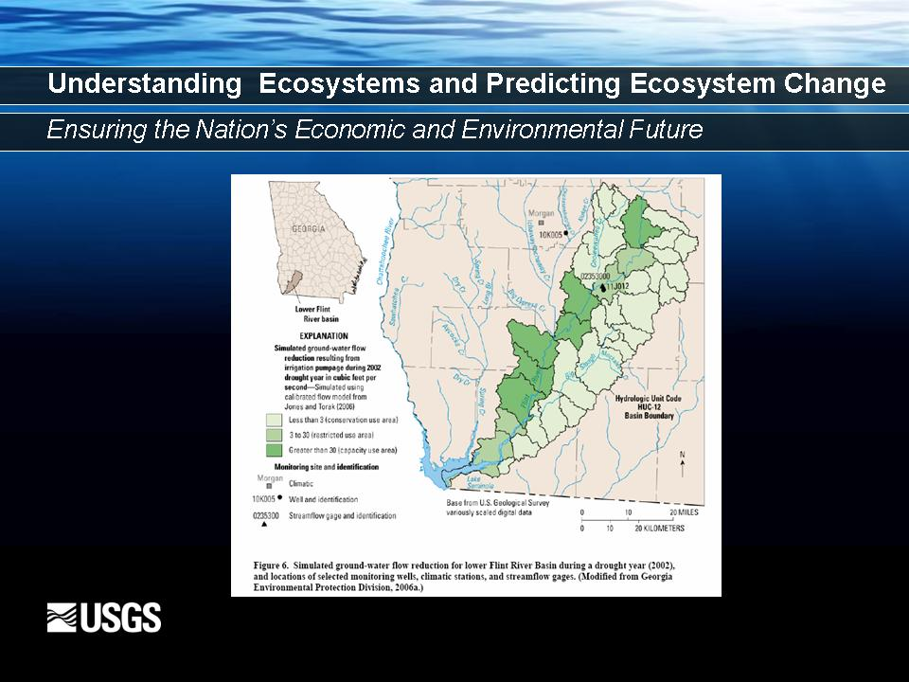
Slide Six – Understanding Ecosystems and Predicting Ecosystem Change
Ensuring the Nation’s Economic and Environmental Future

- Ecosystems are inherently multidisciplinary – requiring robust scientific assessments and modeling.
- Effective management of those ecosystem requires being able to accurately define, explore and record the data then communicate that data in an understandable context and format that they can be useful for policy and decision-makers.
- Our ecosystems provide a wealth of resources and services. Ensuring there sustainability and health is critical to ensuring that wealth.
- We are now asking questions like “Whether there is enough freshwater in quantity and quality to meet the needs for various uses, (environment, human, agricultural, industrial …) both today and in the future.”
  - Instream Flow – Determining of instream flow needs for aquatic habitats (Paradigm Shift: formally, to determine how much water we can take from the river, now how much water we need to leave in the river for aquatic habitat.
    - Very much a part of the Georgia State Water Plan.
    - Flint River Studies in Georgia
  - Identifying the critical indicators of an ecosystem condition can give advance warning of changes occurring that may affect human health and resource availability and sustainability.
  - USGS ecosystem science strategy is developed around several key themes.
    - Research in how ecosystems work, and how and why they change.
    - Monitoring of ecosystem status and trends through use of objective based science indicators.
    - Mapping of the Nation’s ecosystems
    - Development of techniques for managers to use in management, protecting, restoring, and evaluating ecosystems and the services they provide.
    - Assessment tools that will enable the Nation to incorporate understanding of ecosystem properties and processes into decisions that affect the health and welfare of human societies and the environment.
  - USGS Science Actions
    - Quantify the consequences of ecosystem change to water quality and quantity.
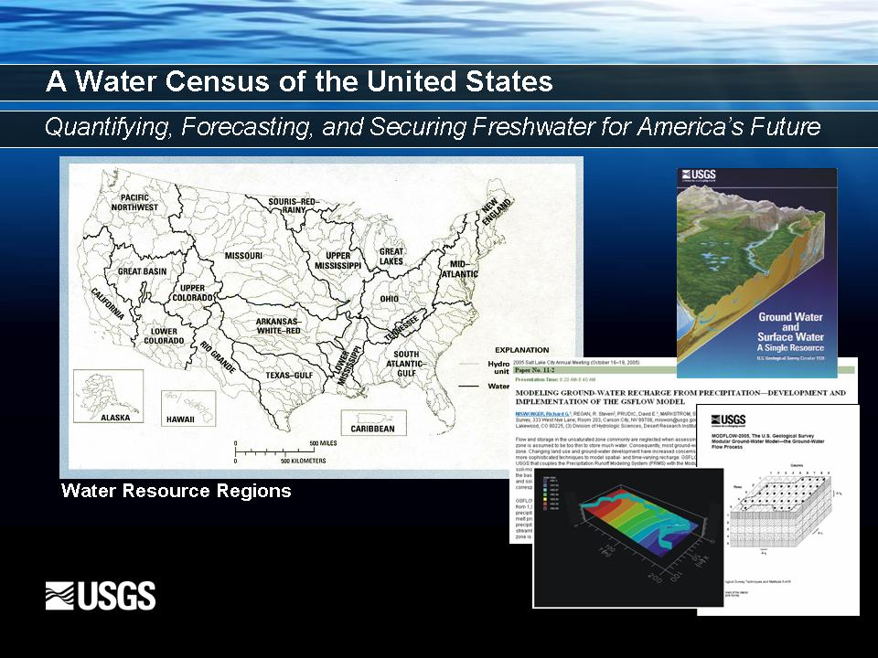
Slide Seven – A Water Census of the United States
Quantifying, Forecasting, and Securing Freshwater for America’s Future

- USGS is the primary Federal agency for scientific evaluation of the Nation’s natural resources including its water resources. The water Census will focus on the 21 water resources regions of the Nation, including their watersheds and associated aquifers as well as offshore extents.
  - Goal – systematic, periodic determination of
    - Freshwater quantity and quality present in surface waters, ground waters, snow and ice and water infrastructure
      - Salt Water Encroachment on Coastal Georgia/ Southeast South Carolina fresh water supplies. (MODFLOW (groundwater) & SUTRA model - USGS developed these models)
      - Surface-Water – Ground-Water Interaction (Paradigm Shift: formally scene as two separate resources, now scene as a single resource)
      - High Demand for Circular 1139 “Ground-water and surface-water: A single resource”
      - Modeling - GS FLOW the new modeling software in beta testing (Bill Cunningham), Carol Wakley

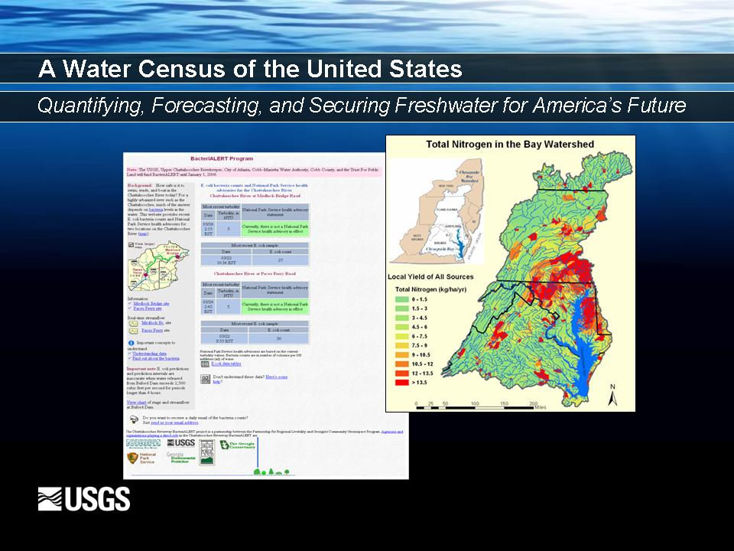
Slide Eight – A Water Census of the United States
Quantifying, Forecasting, and Securing Freshwater for America’s Future

    - Freshwater quantity and quality needs for human and environmental uses
    - Changes over time in freshwater quantity and quality
      - Landuse/land cover
      - Human
      - Environmental
    - Water Quality –
      - Clean Water Act - drive
        - Paradigm Shift: Formally focused on the need to regulate point sources, now needs to address non-point sources
      - NAWQA- Contribution understanding and predicting SPARROW model result pollution of the headwater great impact on downstream.
      - Toxics program – endocrine disruptors (Chattahoochee River Data Points)

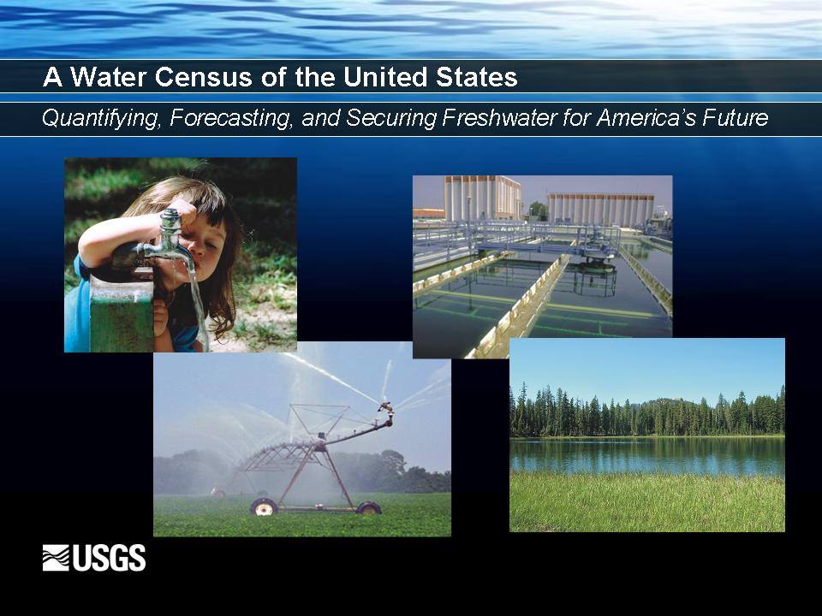
Slide Nine – A Water Census of the United States
Quantifying, Forecasting, and Securing Freshwater for America’s Future

  - Results of a Water Census will provide stakeholders
    - Information on how much freshwater is available
    - Whether the supply of and demand for freshwater is increasing or decreasing
    - Forecast how the availability of freshwater might change in response to decisions or environmental change.
  - Requirements –
    - improvements in the mapping characterization of the geologic, geochemical and geomorphic frameworks of the nation’s aquifers and watersheds (particularly in areas and regions of fractured rock (Eastern Georgia) and karst settings (Southwest Georgia))
    - improvements in our understanding of water movement from the land surface to the water table and a better understanding of the factors that influence the rate of movement.
    - continued improvements in modeling and the development of a water budget
    - National monitoring network

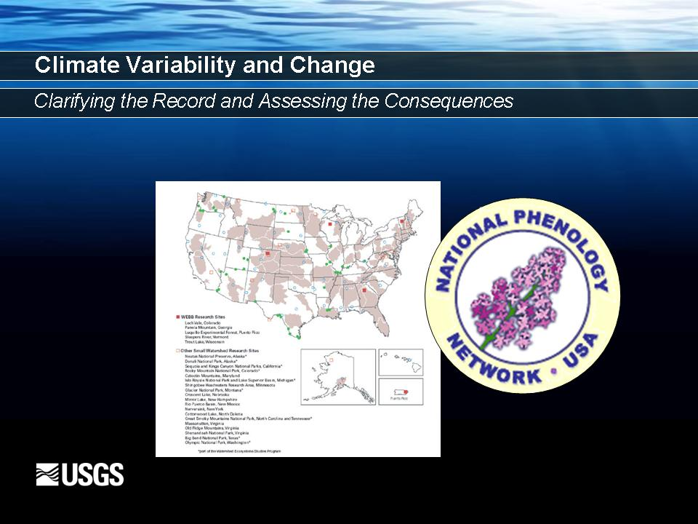
Slide Ten – Climate Variability and Change
Clarifying the Record and Assessing the Consequences

  - Exploring and monitoring our past to effectively predict our future.
  - Recent increase and attention to Climate Change,
    - no longer if it will occur
    - but how, when and what affect it will have
  - Questions: Land and Resource Managers want to know
    - How can regions and resources be managed to increase their resilience to climate variability and change?
    - How will climate change, in concert with land-use and land-cover change, affect ecosystems, soil and sediment systems, and the hydrologic temporal and spatial characteristics of water resources?
    - What places and resources in the United States are the most vulnerable to climate-influenced changes, and what are the characteristics increase the risk of adverse change?
  - Paradigm Shift: Hydrologic processes were formally scene as stationary, now scene as non-stationary
  - A Few Examples of USGS Hydro-Climatology Research Contributions
    - Changes in carbon export to air and water in the Yukon Basin
    - Formation of the National Phenology Network (paleo-record studies in the Colorado River Basin) Study of Periodic Plant and Animal cycle events influenced by Environmental Changes, seasonal variations in temperature and precipitation driven by weather and climate.
      - Phenology Data and Models used in
        - agriculture production
        - integrated pest and invasive species management
        - drought monitoring
        - wildfire risk management and
        - treatment of potential allergies
    - Geochemical issues in geologic sequestration of carbon dioxide
    - Changes in precipitation and runoff in the west and implications for water-resource management …
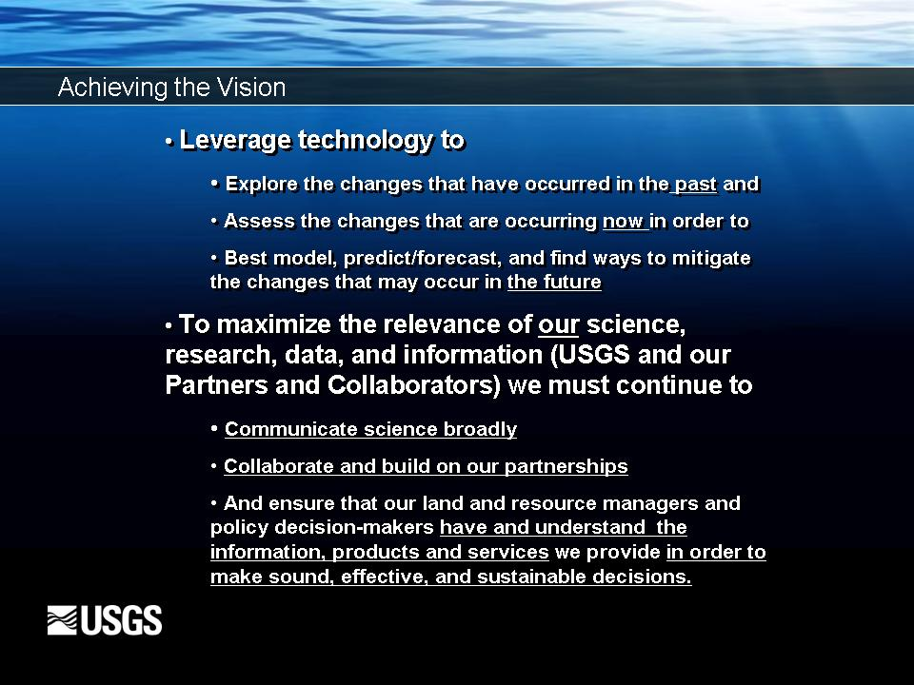
Slide Eleven – Achieving the Vision
- We are engaging in a whole new level of enlightened science focused on some pretty significant changes that are and will be occurring on our planet.
- We must continue to leverage technology to explore the changes that have occurred in the past and assess the changes that are occurring now in order to best model, predict/forecast, and find ways to mitigate the changes that may occur in the future.
- To maximize the relevance of our science, research, data and information (USGS and our Partner’s and Collaborators) we must continue to
  - communicate science broadly,
  - collaborate and build on our partnerships
  - and ensure that our land and resource managers and policy decision-makers have and understanding the information, products and services we provide in order to make sound, effective and sustainable decisions.
- The USGS is well positioned and well structured to focus on these science issues.
- With the right vision, partnerships and resources we will help society address the many natural hazard, resource management and resource utilization issues that effect our Economic and Ecological stability our Nation faces today and in the future.

