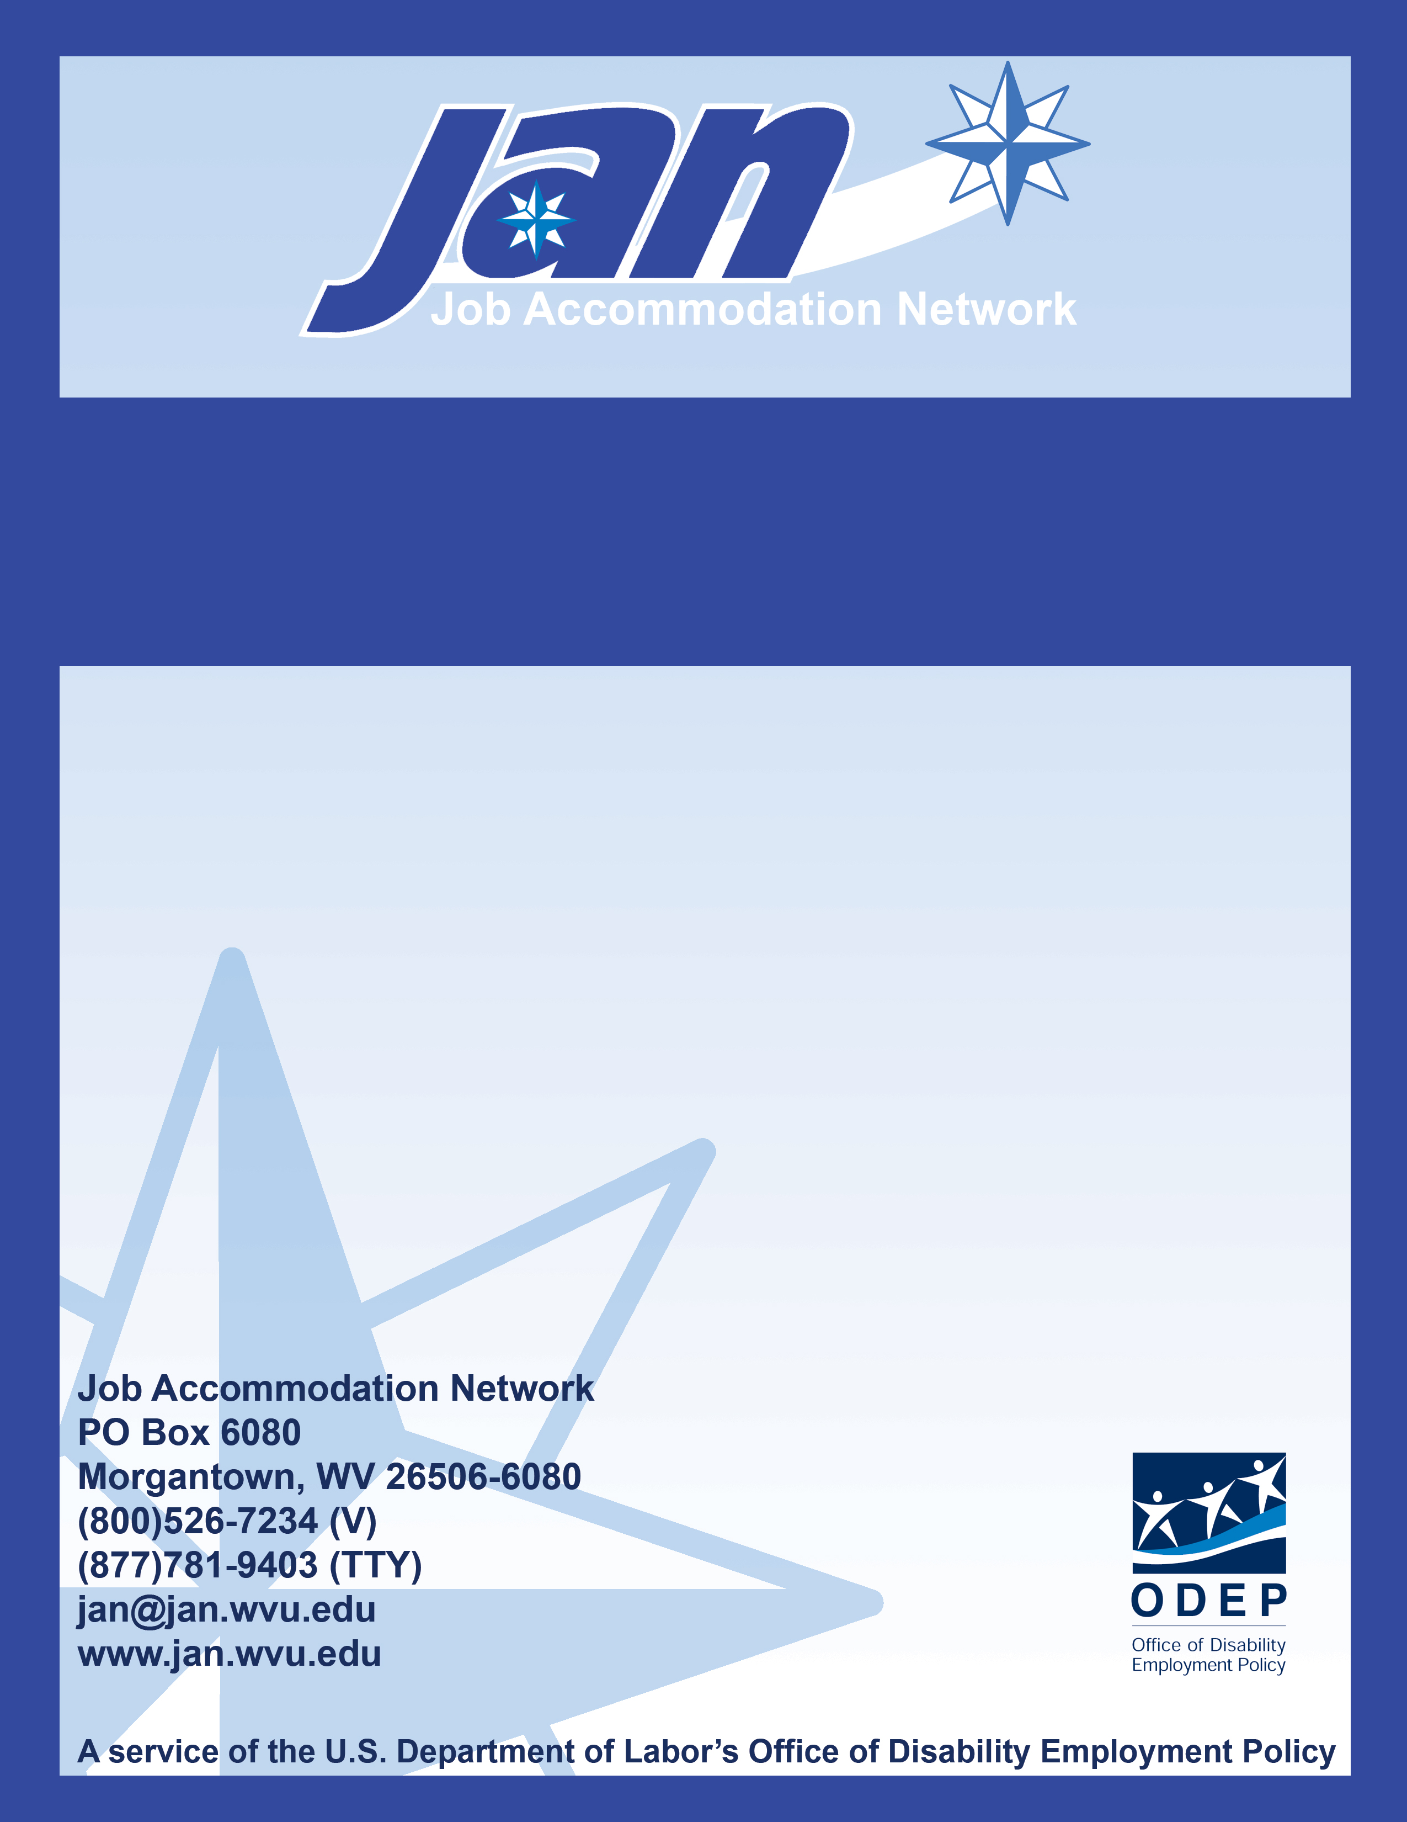
Fact Sheet Series

Considering the Needs of Employees with Disabilities During a Pandemic Flu Outbreak

JAN’S ACCOMMODATION FACT SHEET SERIES

Considering the Needs of Employees with Disabilities During a Pandemic Flu Outbreak

General Considerations

To ensure that all pandemic-related planning considers the needs of employees with disabilities, it is prudent to involve individuals with disabilities in the planning stage. It is also important not to exclude any individuals with disabilities from employment or employment-related activities because of fears about workplace emergencies. Only when the agency can demonstrate that a person with a disability will pose a “direct threat” can it lawfully exclude the individual from employment or other employment-related activities. For more resources on emergency planning, please go to: www.jan.wvu.edu/topics/emevac.htm

For all employees, the Center for Disease Control (CDC) has suggested washing your hands often with soap and water, especially after coughing or sneezing in order to prevent infection. Ensure that facilities are readily accessible and pathways are clear for individuals with disabilities.

Telework

Telework is a voluntary work arrangement in which an employee regularly performs officially assigned duties at home or at another worksite geographically convenient to his or her residence.
- If telework is to be used by your office, discuss any additional needs with employees who use workplace accommodations to complete their tasks (e.g., hardware software).
- In the case of a pandemic outbreak some employees with disabilities may have difficulty getting to the workplace due to the illness of personal assistants, problems with transportation to work, or lack of child care due to school closures. Consider the use of telework or flexible scheduling as a means of addressing these issues.
- If an employee is caring for a family member or individual with pandemic flu, the U.S. Office of Personnel Management (OPM) encourages the supervisor to allow that person to make use of telework.
Critical Questions

- Has the disability coordinator or affinity groups been used to address the specific needs of employees with disabilities during a possible pandemic incident?
- Have notification systems been made accessible to all employees so that individuals with disabilities can receive the same pertinent information at the same time as other employees?

RESOURCES

Employment Laws: Medical and Disability-Related Leave - ODEP
http://www.dol.gov/odep/pubs/fact/employ.htm

Key Facts on H1N1 Flu Outbreak - CDC
http://www.cdc.gov/swineflu/

Pandemic Influenza - OSHA
This Website provides guidance for employees whose responsibilities may bring them into close contact with infected persons. http://www.osha.gov/dsg/topics/pandemicflu/

PandemicFlu.gov
This Website provides one-stop access to U.S. Government swine, avian, and pandemic flu information. http://www.pandemicflu.gov/

Memorandum for Heads of Executive Departments and Agencies - OPM
Advice to Federal Employees and Agencies on Preventing the Spread of the Current Flu and Maintaining Readiness to Use HR Flexibilities if Necessary (April 29, 2009)
http://www.chcoc.gov/Transmittals/TransmittalDetails.aspx?TransmittalId=2227

Memorandum for Heads of Executive Departments and Agencies - OPM
HR Flexibilities Available to Assist Federal Employees Affected by
Severe Weather Conditions or Other Emergency Situations (June 17, 2009)
http://www.opm.gov/oca/compmemo/2008/2008-09.asp

Pandemic Influenza - OPM
This Website provides guidance on pandemic influenza, including OPM’s Implementation Plan for the National Strategy for Pandemic Influenza
http://www.opm.gov/pandemic/

This document is available in Spanish at: http://www.jan.wvu.edu/espanol/fichapandemiadeinfluenza.doc

Updated 4/29/09. This document was developed by the U.S. Department of Labor, Office of Disability Employment Policy.

Effective Emergency Preparedness Planning: Addressing the Needs of Employees with Disabilities. U.S. Department of Labor. August 2005.
Preparing the Workplace for Everyone: Accounting for the Needs of People with Disabilities A Framework of Emergency Preparedness Guidelines for Federal Agencies. Interagency Coordinating Council on Emergency Preparedness and Individuals with Disabilities Subcommittee on Emergency Preparedness in the Workplace. July 2005.
PUBLIC SERVICE ANNOUNCEMENT Hygiene Habits to Help Fight Swine Flu April 28, 2009 6:45 PM ET. http://www.cdc.gov/swineflu/psa/hygiene.htm
Telework and Emergency Preparedness. U.S. Office of Personnel Management Fact Sheet OPM-II-B-1 August 3, 2006. http://www.opm.gov/pandemic/agency2b-factsheet.pdf
What a Supervisor Should Do if an Employee Appears Ill During a Declared Pandemic Influenza or Has Been Exposed to Pandemic Influenza. U.S. Office of Personnel Management. April 29, 2009. http://www.opm.gov/pandemic/agency/decisionchart.asp
Getting Out Alive: Improving the Participation of Federal Employees with Disabilities in Emergency Preparedness. Job Accommodation Network. April 2009, page 19.

