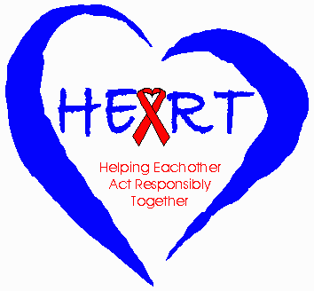

Carol Underwood
Holo Hachonda
Elizabeth Serlemitsos
Uttara Bharath
November 2001

Acknowledgements

The Zambia Integrated Health Programme (ZIHP) and the Youth Advisory Group (YAG) for the HEART Campaign, with the invaluable support of the Central Board of Health, conducted the survey research upon which this study is based.

We would like to thank the many individuals and organisations that provided support to this study. The Design Team developed the HEART Campaign, the impact of which is the focus of this report. Design Team members, past and present, include Clement Bwalya, (Youth Activists Organisation (YAO)), Jabulani Chiwaula (Society for Family Health (SFH)), Susan Gilbert (Consultant), Holo Hachonda, (ZIHPCOMM (Communication and Community Partnerships)), Lute Kazembe (ZIHPCOMM), Brad Lucas (SFH), Regina Lungu (ZIHPCOMM), Victor Mawere (Africa Directions), Crispin Melele (Central Board of Health (CBoH)), Matthews Miti (Network of Zambian People Living with HIV/AIDS (NZP+)), Chris Mukkuli, (Consultant),Chilufya Mwaba (SFH), Mary Phiri (Youth Media), Elizabeth Serlemitsos (ZIHPCOMM), Maimbolwa Shula (ZIHPCOMM), Karen Sichinga (Christian Medical Association of Zambia (CMAZ)), , Cecilia Wright (NZP+) and Paul Zietz (USAID), Robert Zulu (Africa Alive!)

The baseline questionnaire was designed by Boniface Sikateyo (CBoH), Catherine Mukwakwa (ZIHPSERVE), Cosmas Musumali (ZIHPSYS), Elizabeth Serlemitsos (ZIHPCOMM), Ellie Burleigh (ARCH), Juan Shoemaker (JHU/CCP), Mubiana Macwan'gi (ARCH), Thabo Mubonda (CBoH) and Uttara Bharath (ZIHPCOMM). The baseline survey instrument was revised and updated for use in the impact survey by Chris Mukkuli, Elizabeth Serlemitsos, Holo Hachonda, Maria Banda-Nkolola, MiAngel Cody and Uttara Bharath from ZIHP together with staff at Johns Hopkins Center for Communication Programs (JHU/CCP) headquarters.

Augustin Kapungwe (Professor at the University of Zambia), Chibwe Lwamba (Central Statistics Office (CSO)), and Carol Underwood (JHU/CCP), conducted the training sessions for the enumerators and supervisors.

We extend our special thanks to the District Health Management Teams in Kitwe, Ndola, Kabwe, Chibombo, Kalomo, Livingstone, Mwense, Samfya, Kasama, Chipata, Lundazi and Chama without whose assistance we would not have been able to field the survey.

Chibwe Lwamba (Demographer/Statistician, CSO) and Stanley Kamocha (Senior Statistician, CSO) supervised data entry and cleaning. Wilson Chizebuka (CSO) provided programming support and supervised data entry, which was carried out by Aswel Phiri, Belinda Mainza, Joseph Mukandawire, and Shambulo Kabongo.

In the ZIHP office, Elizabeth Halubili and Hope Sibanda oversaw financial administration and logistics. Computer backstopping was provided by Adam Ng'uni and Nick Venter Shamilimo.

Young people, who are actively involved in programmes for young people, were trained to serve as supervisors and enumerators. The supervisors were Angela Mulenga, Arthur Mazimba, Chipego Changulu, Rikki Mumba, Robert Mtonga, and Wilbroad Mutale. The enumerators were: Aaron M. Tembo, Beck Banda, Brenda Nyirenda, Chisenga Lupenga, Drosin Mwanamuchende, Edford Mutumwa, Elvis Lobe, Fred Mwila, Gertrude Moola, Jocelyn Zyongwe, Kasonde Zimba, Layson Mwanamuchende, Malunga Syacumpi, Mapenzi M. Milimo, Martha Ng'uni, Matanga Mallory Muchangwe, Matauka Muliokela, Mofya Cheela, Moses Chitimwango, Moses Sikanyika, Mukwati Akufuna, Mumba Shapi, Munyongo Munkanta, Mwamba Besa, Mwangala Manyando, Nancy Zyongwe, Nchimunya P. Nkwengele, Robert Zulu, Soka Chirwa, Tenix Machona, Thabo Kwawna, and Victor Mawere.

We wish to acknowledge the contributions of all the aforementioned organisations and individuals and the generous support of the US Agency for International Development (USAID) Mission to Zambia, with particular appreciation extended to Robert Clay, Director, Office of Population, Health and Nutrition, and Karen Shelley, Technical Advisor on HIV/AIDS.

Elizabeth Serlemitsos, Uttara Bharath, Holo Hochando, and Maria Banda-Nkolola of ZIHPCOMM and JHU/CCP staff members Susan Krenn, Chief, Africa Division, and Peter Roberts, Senior Program Officer, reviewed the manuscript and contributed significantly to the report.

Finally, we would like to thank all the young people who participated in the study for their co-operation in the survey, as well as all those who provided any assistance or contributed in any way towards the completion of this study.

The analysis, interpretation and recommendations are based on the authors’ interpretation of the survey findings. Yoonjoung Choi assisted with data analysis under the direction of Carol Underwood, Senior Research Officer, JHU/CCP, the lead author of this report.

__________________________________________

Dr. Ben U. Chirwa
Director, Health Services Planning
Central Board of Health
Zambia
Table of Contents

Acknowledgements i
Table of Contents iii
List of Figures iv
List of Charts iv
List of Tables iv
Executive Summary v

Introduction 1

Intervention 3

Evaluation Approach 4

Methodology 5
The Baseline Survey: Methodology 5
Impact Survey 5
Theoretical Framework 7

Findings 9
Background Characteristics of Survey Respondents 9

Evaluation of the Campaign 10
Awareness/Knowledge of the Campaign 10
Media Habits 11
Comprehension of Messages 12
Self-report of Actions Taken as a Result of Viewing the Campaign 13
Attitudes towards Abstinence and Campaign Exposure 14
Correlation between Campaign Exposure and Knowledge, Attitudes
and Self-efficacy Regarding Condom Use 16
Campaign Exposure and HIV/AIDS Knowledge, Attitudes and Risk
Perceptions 17
Discussions Regarding Safer Sex 18
Risk of HIV/AIDS 19
Voluntary Counselling and Testing 19
Social Norms Regarding Sexual Behaviour 20
Campaign Viewership and Behaviour Change 21

Conclusions and Recommendations 23

List of Figures

Figure 1 TV viewership and viewership of specific health communication
spots by residence 10
Figure 2 Reasons for abstinence among young men 14
Figure 3 Reasons for abstinence among young women 14
Figure 4 Mean number of people with whom respondents discussed
abstinence 15
Figure 5 HIV/AIDS Knowledge: Ways to prevent HIV transmission 17
Figure 6 HIV/AIDS knowledge among women: "Risk decreases after
you know someone for a while 17
Figure 7 Percent of impact survey respondents who have heard of VCT 19
Figure 8 Social norms & sexual experience among men: How many of
your male friends have had sex? 20
Figure 9 Social norms & sexual experience among women: How many
of your female friends have had sex? 20

List of Charts

Chart 10 Odds of primary or secondary abstinence by viewership 21
Chart 11 Odds of condom use by viewership 22
Chart 12 Odds of condom use during last sex by viewership 22
Chart 13 Cumulative effect of ideational factors on condom use among
male adolescents 24
Chart 14 Cumulative effect of ideational factors on condom use among
female adolescents 25
Chart 15 Odds of condom use by ideation and exposure 25

List of Tables

Table 1 Percent distribution of respondents by demographic
characteristics 9
Table 2 Percent distribution of respondents by background
characteristics 11
Table 3 Media access and media habits 12
Table 4 Self-reported actions taken as a result of viewing the HEART
campaign 13
Table 5 Self-efficacy score regarding condom use by background
characteristics 16
Table 6 Perceived risk of contracting HIV by background characteristics 18
Executive Summary

The Helping Each other Act Responsibly Together (HEART) Campaign, designed specifically for youth and by youth, informs young people about HIV/AIDS, discusses ways to protect oneself from HIV/AIDS and promotes abstinence and condom use. The Campaign was designed to provide a social context in which prevailing social norms are discussed, questioned and reassessed. By creating an atmosphere conducive to changes in social norms as well as in individual sexual behaviour the campaign was intended to contribute to the nation-wide effort to enhance the likelihood that young people would reduce their risk of HIV infection through either abstinence or consistent condom use and, thereby, reduce the incidence of HIV/AIDS and other sexually transmitted infections (STIs). Young people ages 13-19 were the intended audience for the campaign. The purpose of this report is to evaluate the impact of phase one of the campaign on young people in Zambia.

To evaluate the campaign, a quasi-experimental, separate sample pre and post-test design was used. The pre-test survey was conducted from July to November 1999 and the post-test was fielded in August 2000.

The campaign goals were largely met. Among the salient findings were the following:

- Television is an effective way to reach young people. The HEART Campaign reached over fifty percent of the intended audience. 71 percent of urban and 37 percent of rural youth saw one or more of the health communication spots. Young women—both urban and rural—were as likely as were young men to have seen some or all of the spots.
- Comprehension of the messages was good. Between 60 and 90 percent of viewers spontaneously identified the correct message with any given advert.
- Approximately 74 percent of male viewers and 68 percent of female viewers said that the health communication spots prompted them to talk with others about the spot, decide to abstain from sex until more mature, or use a condom.
- On average, male as well as female viewers discussed abstinence or safer sex with a significantly wider range of people than did their counterparts.
- Among women who are sexually experienced, 82 percent of campaign viewers contrasted with 69 percent of baseline and 64 percent of impact survey nonviewers reported they feel confident that they have “the ability to say no to unwanted sex.”
- Among both men and women, the perceived efficacy to use condoms was positively and significantly correlated with viewership.
- Overall, viewers were more knowledgeable about HIV/AIDS than were nonviewers. Nearly 86 percent of viewers of Mutale & Ing’utu compared with 72 percent of nonviewers recognised that a person who looks healthy can still be HIV+.
- Using logistic regression and holding the independent variables age, educational attainment, urban/rural residence, and sex constant, data show that viewers are 1.68 times more likely to report primary or secondary abstinence then were non-viewers.

- There was a dose effect: the more health communication spots recalled, the greater the likelihood that the respondent is abstinent.
- Logistic regression analysis found that viewers were 1.91 times more likely to have ever used a condom and 1.63 times more likely to report condom use during last sex when contrasted with nonviewers (holding sex, age, residence and education constant). Older, better-educated respondents were more likely than others were to use condoms. Interestingly, women were more likely to report condom use than were men when background characteristics were held constant.

While impressive, the findings indicate that, in designing the next phase of the Campaign, the Design Team should consider the following recommendations:

- Continue to support and encourage abstinence or a “return to abstinence” as a viable alternative;
- Convey the idea that abstinence is a social norm among young people;
- Portray the use of consistent condom use as a social norm;
- Address HIV/AIDS misconceptions directly and in multiple adverts;
- Continue to encourage young people to discuss safer sex and/or abstinence with their partners, close friends and family members;
- Continue to encourage consistent condom use;
- Design a health communication spot to help convince all sexually active young people that, while they are at risk, they can practice safer sex. While some element of “fear” may be needed to convey this message in a compelling manner, research shows that it will only be effective if accompanied by information regarding specific ways to protect oneself from the risk. In short, even as it heightens the viewer’s awareness that he or she is at risk, it should seek to enhance his or her self-efficacy by suggestion options.

The HEART Campaign is one among a range of programs designed to enable young people to protect their reproductive health. Community mobilisation efforts, faith-based projects, school curricula and several media programs have addressed many of the issues central to the HEART Campaign. While the independent correlation between exposure to the HEART Campaign and positive reproductive health choices has been demonstrated, positive secular changes also occurred over the same time frame that could not be attributed to the campaign, which one could argue reflects the synergistic effect of multiple campaigns and interventions. The data show that, while important progress has been made, there is still much to be done. The HEART Campaign should continue to expand the depth and breadth of its reach. Future research should be designed to capture the synergistic effects of reproductive health programs for young people by asking respondents about their involvement in community-based programs and exposure to the whole gamut of HIV-related mediated messages.

INTRODUCTION

Background

Youth constitute an important segment of the Zambian population. Approximately 15 percent of all Zambians are between the ages of 13 and 19, inclusive. Fully 25 percent of women of reproductive age are 19 years of age or younger. The reproductive health knowledge and practices of Zambia’s youth will influence demographic and health trends for decades to come. Moreover, the social norms embraced by Zambian youth today may well presage society-wide acceptance in the years ahead, particularly given the dire and ever-present consequences of Zambia’s full-blown HIV/AIDS epidemic.

The following data describe the context of HIV/AIDS and sexual behaviour among youth in Zambia:

- Approximately one in six urban youth aged 15 to 19 is HIV positive (Zambian Sentinel Surveillance, 1999)

- By the age of 15, 37 percent of boys and 27 percent of girls have had sex (Zambia Sexual Behaviour Survey, 1998)

- Among 15-19 year olds, 62 percent of the boys and 59 percent of the girls say they had had sex (Zambia Sexual Behaviour Survey, 1998)

- Of those who have had sex, 84 percent DID NOT use a condom the last time they had sex (Zambia Sexual Behaviour Survey, 1998)

- By the age of 19, only 16 percent of Zambian youth report that they have never had sex. (Zambia Sexual Behaviour Survey, 1998)

- 64 percent of girls and 70 percent of boys think they are at no risk of contracting HIV (Zambia Demographic and Health Survey, 1996)

- Among sexually active, never-married youth, 24 percent of boys and 13 percent of girls reported that they had more than one partner in the past year (Zambia Sexual Behaviour Survey, 1998)

In light of this situation, the Government of the Republic of Zambia (GRZ) asked USAID and its implementing partner, the Zambia Integrated Health Programme (ZIHP), to work with the Central Board of Health, the AIDS Council and Secretariat, NGOs and young people themselves, to implement a mass media campaign to address youth and HIV/AIDS. The primary objectives of the media campaign are to bring about behaviour change or influence behaviour formation that will prevent further transmission of HIV.

The Helping Each other Act Responsibly Together (HEART) Campaign, designed by youth specifically for youth, informs young people about HIV/AIDS, discusses ways to protect oneself from HIV/AIDS and promotes abstinence and condom use. The overall campaign goal is to provide a social context in which prevailing social norms are discussed, questioned and reassessed. By creating an atmosphere conducive to changes in social norms as well as in individual sexual behaviour the campaign will contribute to the nation-wide effort to reduce the incidence of HIV/AIDS and other STIs. The purpose of this report is to evaluate the impact of that campaign on young people in Zambia. To that end, findings from pre-test and post-test surveys are compared and contrasted herein.

INTERVENTION

To develop the campaign, a Design Team of communication and adolescent reproductive health specialists, including seven young people, was created. The Design Team is responsible for strategic planning, campaign development and implementation. The young people on the Design Team, who were drawn from a variety of backgrounds—including print, radio, peer education, video and drama, are the key decision-makers for critical aspects of the campaign. One of these youth is HIV+, which has been critical to ensure the voice of the HIV+ youth in the design and implementation of the campaign.

To achieve broader youth involvement a Youth Advisory Group (YAG) constituted by 35 young people from 11 youth organisations was formed. The YAG serves as an advisory body to the Design Team. The YAG developed the communication objectives and messages for each of the four audiences namely; abstinent males, abstinent females, inconsistent male condom-users and inconsistent female condom-users, all in the age range of 15 to 19 years. Finally, message concepts (commercial scripts) were tested for appeal and comprehension through focus group discussions and in-depth interviews; post-broadcast spot surveys were conducted to test reach and recall. This fieldwork has involved over 1200 young people (ages13-19) in rural and urban settings as well as in and out of school.

The Design Team assessed available data and segmented the audience as follows:

- girls, 15-19, who have never had sex;
- girls, 15-19, who are sexually active and sometimes use condoms;
- boys, 15-19, who have never had sex;
- boys, 15-19, who are sexually active and sometimes use condoms.

As a result of the above audience segmentation and message development, five television health communication spots were developed for Phase One. The spots include:

- Ice Garden Braii, with the message to boys that condom use is cool and non-use is risky;
- Choices I Make, with abstinent boys reminding their peers of why they choose to be abstinent;
- “When He Says . . .”, with a series of lines from boys to which girls can reply, “no to sex” and maintain their “virgin power/virgin pride”;
- When it Matters, with a message that condoms are not just for casual partners, but for consistent use with regular partners; and,
- Mutale and Ing’utu, with the message that you can’t tell who is HIV+ by looking.

Radio spots and songs were also developed by adapting the same messages and concepts. Radio spots were adapted to the rural context and translated into seven local languages. Other materials such as posters, stickers, exercise books, messages on buses and music videos were also developed to complement the mass media materials.

The findings reported in this study are restricted to the Phase One of the HEART Campaign. After the follow-up study was fielded, Phase Two commenced. This phase has four new spots:

- Ice Mechanic, with a message encouraging consistent condom use by boys;
- Christine, with the message encouraging consistent condom use by girls;
- Basketball, with the message that you can't tell who is HIV+ by looking; and
- Mary, which advocates abstinence for girls.

Phase Three, which is scheduled to commence in Autumn 2001, will be informed by the findings reported in this study.

EVALUATION APPROACH

As the primary implementing partner, ZIHP devised an evaluation approach that allowed the partners to use existing surveys to gather the additional required information. By mutual agreement between the Central Board of Health (CBoH) and USAID, ZIHP is being implemented principally in 12 “demonstration districts” although certain interventions, including mass media programs, are accessible throughout the country. The two surveys that serve as the basis for this report were restricted to the twelve demonstration districts. It is worth noting that Lusaka, which accounts for 10-20 percent of the population and is the largest urban area, is not included in this set of surveys. Adjustments have been made to account for this anomaly.

For the purposes of survey implementation, the districts were grouped into 4 clusters, as follows:

- Copperbelt (Ndola and Kitwe)
- Central and Southern (Kabwe, Chibombo, Kalomo and Livingstone)
- Eastern (Chipata, Lundazi and Chama)
- Luapula and Northern (Kasama, Samfya and Mwense).

METHODOLOGY

The Baseline Survey: Methodology

To evaluate the campaign, a quasi-experimental, separate sample pre and post-test design was used (Cook and Campbell, 1979). The pre-test survey was conducted from July to November 1999 to establish some key indicators at the level of the demonstration districts, to provide ZIHP and its major stakeholders, i.e., GRZ and USAID, with benchmark indicators for performance evaluation. The survey was designed to collect data on indicators related to households, health facilities (private and public) and district health management teams.

The sample. The total sampling frame for the household-based component was the aggregate of all households in the 4 clusters, which was a total population of 2,683,982 living in 430,670 households. Within a range of 87 to 95 percent confidence limits, the minimum number of respondent households required was 2,167. For each cluster and district, a sample size proportionate to the total available households was selected. The entry points were the health centres’ catchment areas. Two health centres were selected per district. (Urban health centres were identified as centres located in or near the district centre, while rural health centres were located outside the district centres.) Respondents were selected so that half were urban dwellers and half were rural residents in each catchment area of the selected heath facilities.

One to two communities were randomly selected from each of the identified health centres. Depending on the habitant patterns, every 3rd to 5th household was selected for interviews. Within the selected households, all persons meeting the selection criteria (women between 15-45 years old, men between 15-65 years and youth between 13-19) were interviewed. The youth sample size totalled 901 (368 men and 533 women).

The questionnaire. ZIHP staff developed a structured questionnaire constituted primarily of closed-ended questions. A youth module was part of the larger survey and it is the data from the youth module that is analysed in this report. The questionnaire (see attached) was designed to collect information about the reproductive health knowledge, attitudes and behaviours of young people ages 13-19, inclusive. The key variables measured included: demographic characteristics, media habits, sexual relations, attitudes towards and perceived social support for abstinence and condom use as well as knowledge and attitudes regarding HIV and STIs. The questionnaire was developed in English and administered in English, Bemba, Nyanja, Tonga and Lozi as required.

Impact Survey

The sample. The sample was drawn with the understanding that it would be representative of the twelve demonstration areas that constitute ZIHP. The sampling frame comprised all young people ages 13-19, inclusive, living in households located within the 12 demonstration districts. Given that the total population of this cohort in the 12 demonstration districts was estimated at approximately 402,600 and the expected frequency of the variable of primary concern—sexually active youth—was estimated at 40 percent among this cohort, it was estimated that a sample size of 1,000 (500 men and 500 women) would provide a confidence level of over 95 percent. Indeed, this sample size allows separate estimates for young men and young women as reflected in the data analysis that follows. To allow for non-response the sample size was inflated by ten percent, giving a total sample size of 1100. The final sample comprised 533 young men and 656 young women.

The sample design was constrained by two factors: (1) the baseline sample design and (2) the lack of comprehensive maps for ZIHP’s 12 demonstration districts. For purposes of comparability between the baseline and follow-up surveys, it was necessary to replicate the baseline sample design with only minor modifications. Four teams of eight interviewers and one or two supervisors were sent to each of four regions: Eastern, Central Southern, Copperbelt, and Northern/Luapula. Each region encompasses two to four of the ZIHP-CBoH demonstration districts. At the district level, the teams met with the District Health Director, who gave them a comprehensive list of all urban and all rural health centres in their district. In each district, one or two urban health centres and one or two rural health centres (depending on the population base) were randomly selected. Respondents were drawn from the catchment areas of the designated health centres.

Sample size was selected proportionate to the population of each of the 12 districts. In all catchment areas, four ‘start’ points were randomly selected. Probability of selection is not known precisely since comprehensive maps with household listings for the catchment areas were not available. Therefore, probability weights could not be developed. Statistical analysis demonstrated that the baseline and impact samples were not statistically equivalent with respect to residence. Therefore, weights were developed and the data adjusted accordingly to render the two samples comparable with respect to socio-demographic characteristics. (See Findings below for further explanation.)

The questionnaire. The post-test questionnaire (see attached) was modelled after the structured questionnaire used in the baseline survey. Sections about peer pressure, access to health facilities, and viewership of the HEART Campaign were added. The post-test questionnaire was field tested among 50 young men and 50 young women; adjustments to the survey instrument were made accordingly. The survey was fielded over a 3-week period in August 2000.

Data analysis. Data were field edited, cleaned and entered using SPPS 6.0. Bivariate and multivariate analyses were conducted. All correlations were tested for significance. To examine responses on attitudinal statements, a Likert-type summative scale was used. Five categories were used, Strongly disagree, Disagree, Uncertain, Agree and Strongly agree. Scores (0-4) were assigned to each of the responses to reflect the strength and direction of the attitude expressed in a particular statement, with 4 indicative of a strongly positive attitude and 0 reflective of a strongly negative attitude towards the particular statement. As significant relationships were found among many of the statements, principal components factor analysis, using Kaiser's varimax rotation, was conducted. When a group of statements was found to be both statistically and logically related, they were considered a “factor.” By averaging the responses to a given series of related statements, factor scores were developed. To evaluate the internal consistency of the newly created factors, Chronbach’s alpha coefficient was computed. Typically, social scientists consider an alpha coefficient of 0.63 or greater to constitute a strong measure of internal reliability. For the most part, the alpha values were over 0.8.

Theoretical Framework

The guiding assumption of most communication theories is that communication affects behavioural change through a process. Stage theories of communication and behavioural change maintain that this process occurs in a sequence of steps or stages over time. These theories identify the major factors that influence people's knowledge, attitudes, intentions and, ultimately, practices. The central argument of stage theories is that behavioural change or adoption of an innovation—for example, consistent condom use—begins by learning about that behaviour (knowledge), and is followed by the development of positive attitudes or social norms supportive of the innovation (approval), the decision to adopt the behaviour (intention), actual behavioural change (practice), and culminates in personal endorsement and support (advocacy) for the innovation. Whether stated or not, use of the terms “step” and “stage,” implies that each stage is a prerequisite for, and leads to, the subsequent step. Yet, not all individuals "advance" through all the stages. Moreover, some individuals "skip" a stage or move back and forth among the different stages. In other words, behavioural change is not necessarily a linear process. While most theorists who embrace stage theories of behavioural change now recognise this, the reader must always be reminded that the model is not linear even though it appears so.

Over the past two decades considerable research has been conducted to test stage theories of behavioural change and, in the process, variables such as perceived risk, social norms, self-efficacy, and collective efficacy. Discussions about a given innovation have been subsumed under the “attitudinal/approval” stage. Gradually, it became clear that a constellation of factors is correlated with behavioural change. Cleland and Wilson use the term “ideation” when referring to the collection of psychosocial variables associated with behavioural change. Their central contention is that a common language and geographical proximity allow “changing perceptions, ideas, and aspirations” to be shared—that is, communicated—with members of one’s community. While communication often serves to reinforce shared beliefs, values and social norms, communication channels can also broadcast reconstructed beliefs, values, and social norms that have been altered by the introduction of new ways of thinking. Moreover, research has demonstrated that communication interventions can themselves introduce and promote those new ways of thinking. It is with this understanding that the HEART Campaign was launched in Zambia.

The HEART Campaign was designed to influence sexual practices of young people, with a focus on abstinence and condom use. In this study, we seek to identify what factors are correlated with risk reduction practices. The two primary hypotheses that will be tested follow:

(1) Viewership of the HEART Campaign will be associated with higher levels of knowledge about, positive attitudes towards, and perceived social support for risk reduction practices.

(2) Viewership of the HEART Campaign will affect the likelihood that young people will adopt risk reduction practices—particularly abstinence or condom use—by influencing the factors that are related to behavioural change.

In other words, it is anticipated that those young people who are more knowledgeable, report higher levels of self-efficacy, and perceive higher levels of social support for risk reduction practices are more likely than their less knowledgeable, less confident counterparts to engage in risk reduction practices.

Among the factors related to behavioural change is the importance of perceived social support for risk reduction practices. When an attitude or behaviour is considered a social norm, community members are likely to think others will support or approve of a given attitude or behaviour. Social norms emerge from collective beliefs about attitudes and behaviours that are prevalent, acceptable, or even expected in a particular social context. That is, social norms are neither constant nor universal but change over time. The campaign is intended to influence community or social norms even as it affects individuals’ attitudes and behaviours. Several of the health communication spots were designed to address this issue directly by encouraging positive peer pressure for responsible sexual behaviour as discussed above.

The extent to which the campaign has been successful can, in part, be evaluated on the basis of the following specific goals and objectives for viewers of the campaign:

- Significant increases in positive attitudes about abstinence and condom use;
- Significant increases in willingness to discuss these practices;
- Increased acceptability of “waiting to become sexually active”;
- Enhanced self-efficacy with respect to “the ability to say no”;
- Enhanced self-efficacy with respect to condom use;
- Increased likelihood of condom use; and
- Delay in sexual debut or higher levels of abstinence among viewers when contrasted with those who did not recall the campaign.

FINDINGS

Comparisons of the Baseline and Follow-up Findings

Background characteristics of survey respondents

As noted, this report is based on two data sets. Statistical tests show that, while the two samples are equivalent with respect to age distribution and educational attainment, the post-test had significantly more rural male respondents but fewer rural female respondents than was true of the pre-test. Since residence is often correlated with ideational factors and related behaviours, it was necessary to adjust the samples so that the urban-rural distributions in the two samples would be comparable. Therefore, both samples were adjusted to reflect the urban-rural distribution found in the 1996 DHS by creating weights. All data presented or discussed in this report are adjusted so are representative of the youth populations in the 12 districts in which ZIHP is active.
Table 1. Percent Distribution of Respondents by
Demographic Characteristics:
Pre- and Post-test Youth Surveys, Zambia,
1999 & 2000¹ (Adjusted Data)
 | Men |  | Women
Characteristics | Pretest  n=368 | Posttest  n=494 | Pretest  n=533 | Posttest  n=656
Age  13  16  15  16  17  18  19 | 12.0  18.6  11.4  15.6  15.8  14.2  12.4 | 10.9  11.3  11.4  19.6  15.1  16.0  15.8 | 12.4  14.7  14.9  17.1  15.3  12.7  12.8 | 15.3  14.4  13.9  17.7  16.1  12.1  10.5
Education  None  Primary (1-7)  Secondary + | 3.5  53.3  43.0 | 2.9  52.3  44.7 | 5.2  55.8  38.8 | 5.1  54.2  40.7
Residence  Urban  Rural | 46.1  53.9 | 46.0  54.0 | 44.9  55.0 | 45.0  55.0
Sample Cluster  Central/Southern  Copperbelt  Eastern  Luapula/Northern | 22.6  24.4  32.4  20.5 | 30.9**  21.6**  32.8**  14.4** | 21.2  33.1  25.9  1.9 | 29.8**  27.1**  31.3**  11.8**
Marital Status  Unmarried  Married | 97.5  2.5 | 98.9  1.1 | 85.9  14.1 | 92.0**  8.0**
* Differences between pretest and posttest significant at p<0.05.
** Differences between pretest and posttest significant at p<0.01.

NOTES: ¹Data presented in this table has been adjusted by residence take into account significant differences between the two samples.

Table 1 shows that the distribution by sample cluster differs significantly between the two surveys. This was intentional as the post-test sample was selected proportionate to size, which was not the case with the baseline. Comparisons between respondents of the two surveys will be shown when it is necessary to distinguish between secular changes and changes correlated with exposure to the campaign.

Evaluation of the Campaign

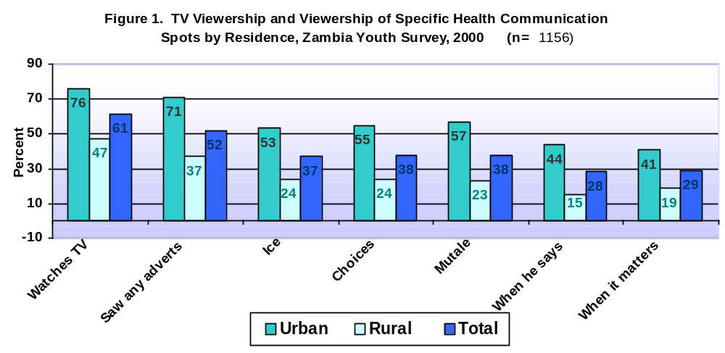To assess the actual impact of the HEART Campaign as opposed to changes that may have happened over time even in the absence of this particular set of interventions, we will also examine differences between impact respondents who saw all or some of the television health communication spots and those who saw none. We refer to these two groups as “viewers” and “non-viewers.”

Awareness/Knowledge of the Campaign

Just over half of the impact respondents reported that they had seen all or some of the television adverts (Figure 1). Viewership of all health communication spots was significantly higher in urban than rural areas, which was anticipated given that 56 percent of urban but only 18 percent of rural respondents reported household ownership of a television set. Nearly 43 percent of urban and about 14 percent of rural youth recalled all five adverts. While significantly more male than female respondents recalled Ice and When It Matters, young men and women were equally likely to recall the other health communication spots (data not shown). Still, on average young men as well as young women recalled two adverts.

Table 2 contrasts the background characteristics of viewers and nonviewers of the HEART Campaign. (Nonviewers include those who reported that they never watch television as well as those who did not recall any of the spots.⁾ Approximately 50 percent of female and 53 percent of male respondents reported that they saw at least one of the TV adverts. Exposure to the campaign was not significantly different between men and women.

That is, young women were as likely to have seen the campaign as were young men. This is an important finding as nationally representative surveys in Zambia typically find that men have better access to television than women do. Indeed, a survey conducted in 1996 found that 38 percent of men age 15-49 but only 29 percent of women age 15-49 reported that they watch television at least once a week. Since the sample for the results reported in this report was younger than is typical of nationally representative samples, this suggests that, as the current cohort of young people ages, the differences in media access between men and women will no longer be an issue in the design and development of communication campaigns.
Table 2. Percent Distribution of Respondents by
Background Characteristics: Viewers & Non Viewers of the HEART Campaign, Youth Surveys, Zambia, 2000¹ (Adjusted Data)
Characteristics | Non-viewers  n=643 | Viewers  n=513 | TOTAL  n=1156
Age  13-14  15-16  17-19 | 27.8  31.2  41.0 | 25.0  31.6  43.4 | 26.4  31.4  42.3
Education**  None  Primary (1-7)  Secondary + | 7.7  67.9  25.4 | 0.8  40.3  58.9 | 4.1  53.5  42.4
Residence**  Urban  Rural | 28.0  72.0 | 61.4  38.6 | 45.4  56.6
Socio-economic Status  Low  Middle  High | 29.8  54.6  15.6 | 11.8  34.0  54.2 | 20.4  43.9  35.7
* Differences between viewers and nonviewers significant at p<0.05.
** Differences between viewers and nonviewers significant at p<0.01.
NOTES: ¹Data presented in this table has been adjusted by residence take into account significant differences between the two samples.

The age distribution of viewers is similar to that of nonviewers. Among both male and female respondents, viewers are on average better educated, of higher socio-economic status and more likely to live in urban areas than are nonviewers. Indeed, though some 55 percent of all respondents reside in rural areas, only 38 percent of viewers are from rural Zambia.

Media Habits
Since media habits are closely linked to the likelihood of campaign exposure, it is useful to examine young people’s media access (see Table 3). Again, the data are not presented separately for male and female respondents because there were no significant differences between young men and young women with respect to media habits. As anticipated, television ownership clearly facilitated access to the HEART Campaign. Viewers of the campaign were more likely to live in households that owned a radio as well as a television set. Fully 80 percent of respondents who report television ownership in their household recall at least one of the TV health communication spots. Interestingly, about 36 percent of female and male respondents who live in households that do not own a television set saw the campaign (data not shown). This suggests that young women are as likely as are young men to watch television in a setting other than their own home.
Table 3. Media Access and Media Habits, Youth Impact Survey
Zambia 2001
 | Non-viewers |  | Viewers |  |  | TOTAL
 | Urban | Rural | Urban | Rural |  | TOTAL
 | n=215 | n=298 | n=469 |  | n=173 | n=1155
Household owns radio | 65.2 | 48.0 | 76.5 |  | 48.0 | 62.4
Ever listens to the radio | 80.6 | 69.6 | 91.4 |  | 90.1 | 83.0
Frequency listens to radio  Everyday/almost everyday  Once/several times a week  Infrequently  Never | 32.2  38.8  9.4  19.4 | 22.0  36.5  11.0  30.4 | 48.9  36.1  5.6  9.5 |  | 37.1  46.4  7.4  9.9 | 34.9  38.5  8.4  18.2
Household owns TV | 36.7 | 6.2 | 65.1 |  | 38.7 | 35.6
Ever watches TV | 23.3 | 17.0 | 100 |  | 100 | 60.5
Frequency watches TV  Everyday/almost everyday  Once/several times a week  Infrequently  Never | 8.8  8.9  4.6  77.8 | 1.0  5.8  9.1  84.1 | 65.5  24.0  10.5  0 |  | 36.3  38.5  25.3  0 | 29.3  18.5  12.0  40.2

Comprehension of Messages

All respondents who recalled a particular health communication spot were then asked (1) what the main message(s) was (were) and (2) what action if any they took as a result of having seen the spot.

The health communication spot Ice portrays a young man who contracts an STI as a result of his cavalier refusal to use a condom. About 48 percent of male viewers and 39 percent of female viewers identified the tag line, “Use a condom every time you have sex,” with the spot. This difference was only marginally significant (p< .06). Recall of this message was not different by urban/rural residence. Approximately 28 percent of viewers thought the health communication spot informed the audience that “you can’t tell by looking” whether one is HIV+ or not. This message was the focus of another advert, though the association with Ice is not illogical as the implied message was that any sexually active person could have an STI.

The health communication spot Choices highlights the prerogative of young men to choose abstinence until they are ready to make another choice and gives them reasons they might choose abstinence. Eighteen percent equated the spot with the message “abstinence is cool,” 18 percent thought the message conveyed the idea that “abstinence is best,” and 13 percent said the advert encouraged them to “wait until marriage for sex.” There were no significant differences between men and women or by residence.

Mutale and Ing’utu discusses the ambitions of two young women and reveals that the plumper of the two friends is HIV+. Of those who saw the health communication spot, nearly 63 of male and 49 percent of female viewers thought it served to inform the audience that “a person who is HIV+ may look just as healthy as someone who is not.” Some 33 percent of males and 20 percent of females said the message exhorts viewers to “avoid judging a person’s HIV status by their appearance.” About nine percent of young men as well as young women thought the take-away message was to avoid sex or use a condom during sex. (Percentages add to more than 100 since multiple responses were allowed.)

“When he says . . .” cautions young women to be wary of men’s efforts to seduce them before they are ready for sex. It endorses virginity and implies that young women should wait until marriage for their sexual debut. Some 47 percent of male and 36 percent of female viewers said the main message was “to say no to sex before marriage.” There were no significant differences by residence. Approximately 15 percent of respondents mentioned that the spot upheld virginity as “cool” or as a source of “pride.”

When it matters depicts a number of scenes, concluding with a playful young couple. As they become seriously involved the spot ends with the tag line: “When there is love…Use it.” At which point, the socially marketed MAXIMUM brand is shown. Nearly 50 percent of those who saw this health communication spot mentioned the tag line. It is also worth noting that this was the first ad aired in Zambia to include brand advertising for condoms.

Self-report of Actions Taken as a Result of Viewing the Campaign
Table 4. Self-reported Actions taken as a result of viewing the

HEART Campaign, Youth Impact Survey, Zambia, 2001
(n=643)
 | Decided to Abstain | Talked with others about advert(s) | Decided to use condoms
Age  13-14  15-16  17-19 | 18.7**  26.4**  36.0** | 29.1*  34.8*  40.6* | 6.8**  12.3**  20.5**
Sex  Men  Women | 31.8  26.2 | 36.8  35.2 | 22.3**  8.6**
Education  None¹  Primary (1-7)  Secondary + | --  15.5**  38.0** | --  26.6**  42.4** | --  8.2**  19.2**
Residence  Urban  Rural | 32.2*  22.8* | 39.2*  30.6* | 16.6  11.4
TOTAL | 28.6 | 35.9 | 14.6
NOTES: ¹Too few cases to report results
* Differences within cell significant (p < .05)
** Differences within cell significant (p < .01)

Viewers were asked what actions, if any, they took as a result of seeing each spot that they recalled. Fully 74 percent of male viewers and 68 percent of female viewers reported that they took at least one action as a result of having seen the Campaign (data not shown). Young men reported an average of 1.9 actions taken and young women took 1.5 actions on average. The action most commonly reported by respondents was that they talked with others—friends, partners, spouses, or parents—about the spots. The decision to abstain was also frequently reported by viewers as a direct result of campaign exposure. As can be seen in Table 4, differences between young men and women were not significantly different with respect to either of these actions.

Age, educational attainment and urban residence were all positively associated with the decision to remain or return to abstinence as well as with the likelihood of talking about the health communication spots to others. Young men as well as older and better-educated respondents were significantly more likely than were their counterparts to report that they decided to use condoms as a result of the Campaign. In short, the resolve to take positive actions is associated with relative power—including access to information—and prestige.

Viewers were asked what action, if any, they took as a result of viewing the various spots. The fact that respondents were more likely to say they chose “to abstain” than to report that they decided to use a condom as a result of viewership, needs to be further explored. The frequency of this response, however, should be highlighted given that a small, but influential faction of Zambian society turned to the media to voice in public their objections to some of the health communication messages. This group argued that the televised health communication spots promoted condom use at the expense of abstinence. ZIHPCOMM responded to these allegations with a public information campaign, which was received favourably by young people and their parents. This data provides evidence that the audience tended to find those messages consistent with abstinence.
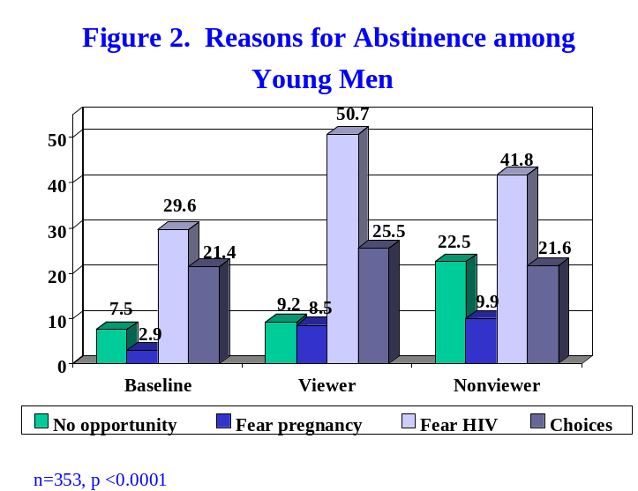
Attitudes towards Abstinence and Campaign Exposure

Only young people who reported that they had never had sex were asked questions regarding their attitudes about abstinence. As seen in Figure 2, young men in the impact survey were significantly more likely than were their counterparts in the baseline survey to express fear of HIV as the major reason for their abstinence. While this secular trend is important and suggests that factors in addition to the HEART Campaign are affecting the 13-19 year-old cohort, Figure 2 shows that those exposed to the campaign were more likely than both baseline and non-exposed impact respondents to cite fear of HIV as their major reason for abstinence. Nonviewers were significantly more likely than either baseline or impact viewers to report that the main reason for abstinence was that they had neither a partner nor the opportunity for sex (i.e., “no opportunity” as shown in Figures 2 and 3). In short, nonviewers were less likely than were viewers to explain their abstinence within the context of fearing HIV.
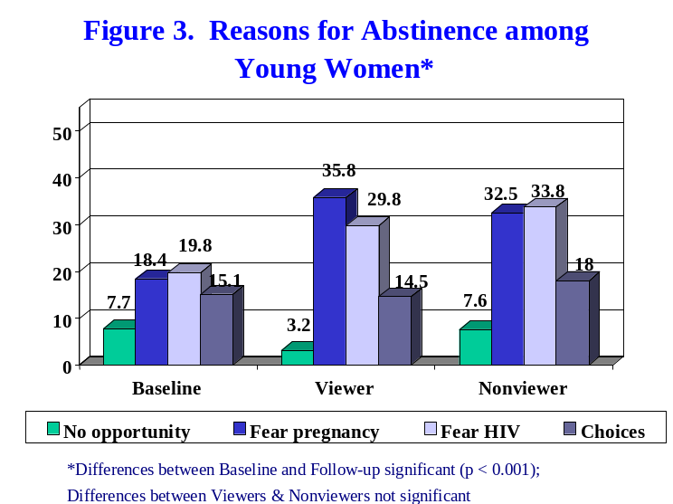

While young women in the impact survey were more concerned about HIV and unplanned pregnancies than was true of women in the baseline survey, there was no correlation between exposure to the campaign and increased concern about these issues (see Figure 3). Nonetheless, it is heartening to see that the secular trend is towards more awareness of the risks associated with unprotected sex. This suggests that the message is reaching young women, if not exclusively through the HEART campaign.

The data show that about 70 percent of abstinent respondents feel comfortable discussing abstinence with others (data not shown). Differences between the pre/post-test were not significant nor did demographic characteristics affect responses. When young people were asked whether they discussed abstinence with a range of people, viewers reported more such discussions than did non-viewers and women discussed abstinence with a wider range of people, on average, than did men (see Figure 4).
The ideational framework anticipates this relationship between viewership and reported conversations about abstinence since several health communication spots—perhaps most notably the adverts Choices and When he says—upheld abstinence as a responsible option before marriage.
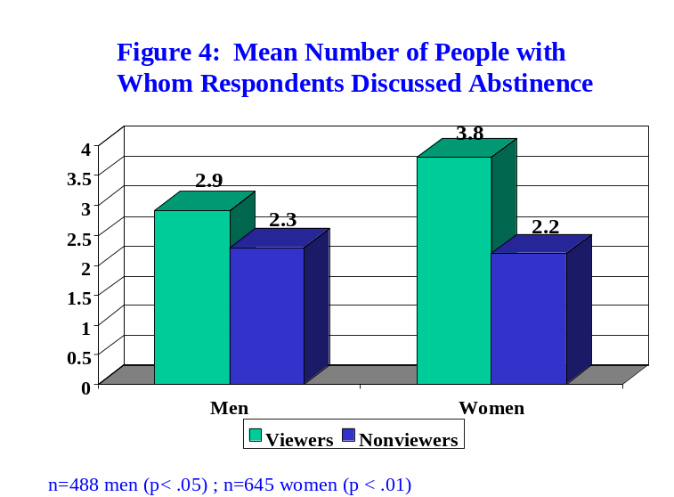

Three-quarters of young women who have never had sex registered a high sense of self-efficacy with respect to their ability to refuse unwanted sexual advances. This did not change between the baseline and impact survey. Among women who are sexually experienced, however, 82 percent of campaign viewers contrasted with 68 percent of baseline and 64 percent of impact non-viewers report that they can “say no to sex.” The differences between viewers and both nonviewers and baseline respondents were significant. There was no significant difference between nonviewers and baseline respondents, suggesting no secular change in this variable (data not shown).

Correlations between Campaign Exposure and Knowledge, Attitudes and Self-efficacy Regarding Condom Use

Baseline respondents were not asked whether they had heard of the male condom or whether they knew where to obtain one. These questions were posed in the impact survey and viewership of the program was significantly and positively correlated with a relatively high level of knowledge about where to purchase male condoms. Overall, 81 percent of viewers versus 72 percent of nonviewers could name a source where condoms could be purchased (p < .05). This was not a specific goal of the campaign, but we could surmise that once the audience’s awareness of the advantages of condom use was heightened, audience members would be more likely to seek such information.

Viewers of the campaign held, on average, more positive attitudes regarding condom users than was true of either baseline respondents or impact non-viewers. Respondents were asked whether they agreed or disagreed with the following statements:

- Boys who use condoms are cool.
- Boys who use condoms are promiscuous.
- Girls who use condoms are smart.
- Girls who use condoms are loose.
Table 5. Self-efficacy score regarding condom use by background characteristics (Score 0-6)
 | Baseline  n=173 | Impact  Non-viewers  n=203 | Impact Viewers  n=236
Age  13-14  15-16  17-19 | 2.2  2.8  3.1 | 2.5  3.1  3.2 | 2.7*  3.7*  3.9
Sex  Male  Female | 3.3**  2.7** | 3.5**  2.7** | 4.2**  3.4**
Education  Non-literate¹  Primary (1-7)  Secondary + | --  2.5**  3.7** | --  2.7**  3.8** | --  3.1**  4.1**
Residence  Urban  Rural | 3.1  2.8 | 3.2  3.1 | 4.1**  3.4**
Total | 2.9* | 3.1* | 3.8*
Notes: ¹ too few cases for comparison
* p < .05 ** p < .01

Respondents were given one point for each response that reflected a positive attitude towards condom users—i.e., agreement with 1 and 3 but disagreement with statements 2 and 4—and were given no points for attitudes reflecting a negative attitude. While only eight percent of baseline and 14 percent of impact non-viewers scored four (on the scale from 0 to 4), 31 percent of female viewers espoused views in keeping with a highly positive attitude towards condom users (that is, they scored four of four). Among men, 15 percent of baseline respondents but 39 percent of nonviewers and 41 percent of viewers held this highly positive stance. The difference between viewers and nonviewers on this score was not significant, but does reflect a positive secular trend towards more positive attitudes about condom users (data not shown).

Respondents were asked a series of questions to help ascertain their “efficacy” with respect to condom use. Among both men and women, the perceived efficacy to use condoms was positively and significantly correlated with viewership (see Table 5). As can be seen, by contrasting baseline and non-viewers, levels of efficacy were constant among those not exposed to the campaign. Men scored higher on the efficacy scale, on average, than did women. Education was highly and positively correlated with self-efficacy to use condoms. Urban residents and young people aged 15 and above registered higher scores than did their younger and rural counterparts.
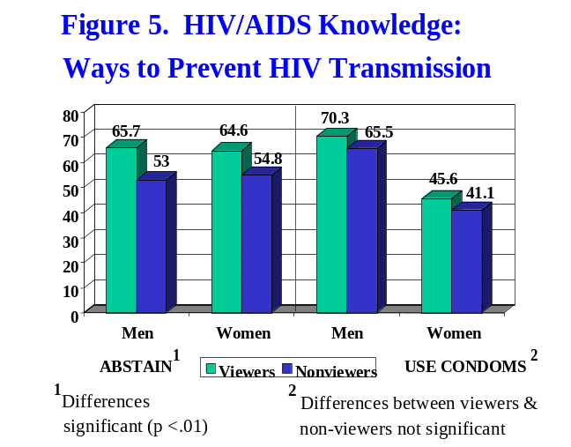

Campaign Exposure and HIV/AIDS Knowledge, Attitudes and Risk Perceptions

Respondents in the impact survey were asked to list the number of ways that one could prevent HIV transmission. Viewers were more likely significantly than were non-viewers to mention abstinence as a way to avoid transmission (see Figure 5). Men were significantly more likely than were women to mention condom use as an alternative. In this respect, there was no difference between viewers and non-viewers. The HEART Campaign included the very clear message that “you can’t tell [if someone is HIV+] by looking.” In both the pre- and post-test, respondents were asked whether they agreed or disagreed with the following statements:

- You can tell if someone has HIV/AIDS by the way that they look.
- You can tell if someone has HIV/AIDS by their reputation.
- Your risk of HIV will become less after you have known your partner for a few months.

As discussed above, there was neither a difference between baseline and impact respondents with respect to the first of these statements nor between impact nonviewers and viewers. At first glance, therefore, it seems that the campaign had no measurable impact. When we separate out those who recall the advert Mutale & Ing’utu—namely the health communication spot that addressed this subject directly—viewers were significantly more likely to answer correctly than were nonviewers (61 and 50 percent, respectively.)
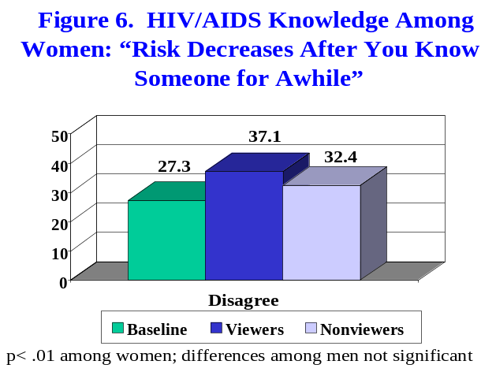

Approximately 50 percent of baseline respondents as well as of viewers and nonviewers of Mutale & Ing’utu responded correctly to the second statement. The advert, however, did not discuss reputation. As seen in Figure 6, impact viewers were more likely to disagree with the statement “Risk decreases after you know someone for awhile” than were either baseline or impact non-viewers.

Overall, impact respondents were more likely than were baseline respondents to disagree with the statement, indicating a secular change in addition to the impact of the campaign. Still, the small percentage of respondents who disagreed with this statement is troubling.

In the post-test, respondents were asked: “Do you think that a person who looks healthy could be infected with HIV?” Nearly 86 percent of viewers of Mutale & Ing’utu compared with 72 percent of nonviewers responded “yes” to this query. Educational attainment was significantly and positively correlated with the correct answer, but other demographic variables were not related to responses.

Discussions Regarding Safer Sex
Further analysis found a positive correlation between viewership and willingness to discuss issues raised by the campaign—i.e., viewers discussed safer sex with more people, on average, than was true of nonviewers (data not shown). Since several of the health communication spots placed condom use very visibly on the public agenda and gave young people words and phrases to use when broaching this very sensitive subject, ideational theory would lead us to expect this increase in discussions around this topic. Differences between male and female viewers were not significant. Sexually active young people and better-educated young people discussed safer sex with a broader range of people than did other respondents.
Table 6. Perceived risk of contracting HIV by background
characteristics ( n=1606)
 | None | Small | Don't Know | Moderate | Great
Age (Ns)  13-14  15-16  17-19 | 61.8  58.6  50.0 | 20.6  23.4  24.0 | 6.6  6.4  8.3 | 5.9  5.2  6.7 | 5.2  6.5  11.1
Sex***  Male  Female | 52.6  57.3 | 24.5  22.3 | 4.7  9.1 | 7.1  5.1 | 11.2  6.1
Education (ns)  Primary  Secondary | 56.7  53.6 | 20.5  26.6 | 8.4  5.6 | 6.3  5.6 | 8.1  8.6
Residence (ns)  Urban  Rural | 55.9  54.8 | 24.5  22.3 | 6.4  7.9 | 5.9  6.0 | 7.4  9.1
SES (ns)  Low  Middle  High | 52.9  53.2  51.9 | 22.7  25.2  29.3 | 6.4  8.0  3.7 | 9.2  3.6  7.0 | 8.9  10.1  8.1
Sexual Status***  Never  Ever  Recent | 67.5  47.6  39.5 | 20.3  28.3  25.5 | 5.1  8.1  10.1 | 3.3  7.7  9.6 | 3.9  8.3  15.3
Condom Use Among Sexually active*** (n=767)  Male nonuser  Female nonuser  Male user  Female user | 45.6  48.3  33.1  33.7 | 25.8  25.8  28.6  26.7 | 5.6  11.9  5.8  16.3 | 8.6  6.4  12.4  10.2 | 14.4  7.7  20.1  13.1
Relative is HIV+*  Yes  No | 43.0  53.4 | 30.6  25.2 | 4.0  6.4 | 4.4  6.4 | 18.0  8.6
Segment  Baseline  Viewers  Non-viewers | 61.7**  54.3**  51.1 | 17.5  22.7  28.3 | 9.7  7.3  5.1 | 5.2  6.8  5.8 | 5.8  8.9  9.7
Total** | 55.6 | 23.3 | 7.2 | 6.0 | 8.3
* p<.05; **p<.01; *** p< .001 ; ns=not significant

Risk of HIV/AIDS

Respondents were asked whether they thought they were at no risk, a small risk, a moderate level of risk or at high risk of contracting HIV. Age, educational attainment, socio-economic status (SES) and residence are all uncorrelated with perceived risk for HIV (Table 6). The most important factors correlated with the perception of moderate to high risk for HIV are related to sexual behaviour. As might be expected, abstinent youth are the most likely to believe they are not at risk of HIV infection. Those who report they have had sexual relations in the past year report higher levels of perceived risk than is true of those who report they are not currently sexually active. Male condom users are most likely to believe they are at ‘great’ risk of contracting HIV (12 percent report they are at ‘moderate’ risk and an additional 20 percent think they are at ‘great’ risk). Female ever-users of condoms are also more likely than are sexually active but non-condom-using respondents to feel they are at a moderate-to-high risk of contracting HIV. While knowing someone who is HIV+ is not related to risk perceptions (data not shown), having a relative who is HIV+ is related to risk perceptions.

Clearly, sexually active young people severely underestimate their risk of HIV infection. While the issue of HIV risk was addressed in the first phase of the campaign (you can’t tell by looking [so] use a condom every time you have sex), there was no significant correlation between exposure to the campaign and risk perception. Still, the fact that there was a significant decrease between the baseline and impact survey in the percentage of sexually active young people who believe they are at no risk of contracting HIV is a positive sign.

Voluntary Counselling and Testing

While the HEART Campaign did raise the issue of HIV/AIDS and other STIs, there was no effort to promote Voluntary Counselling and Testing (VCT). This was appropriate since services sufficient to cover the broader population are not yet available in Zambia. Yet, the question was posed in the impact survey for two reasons: (1) to establish a baseline against which to measure impact of a future campaign that will be aired once such services are in place and (2) to ascertain the correlation between viewership of the HEART Campaign and VCT. It could be hypothesised that exposure to the HEART Campaign would heighten one’s awareness of HIV and, concomitantly, increase one’s effort to learn about and seek VCT. The data seem to demonstrate this relationship. Male and female viewers alike were significantly more likely to have heard of VCT, as shown in Figure 7, than were nonviewers. About 26 percent of female viewers versus 10 percent of nonviewers reported that they had been tested (data not shown).
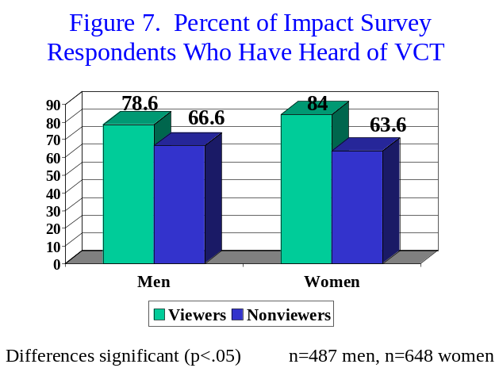

Approximately 84 percent of respondents who are sexually experienced and have heard of VCT (n=338) expressed their willingness to pay for an HIV test. The mean price they are willing to pay is Zambian Kwacha 5,500. When asked the main reasons they are willing to pay, 22 percent said it is necessary to pay for good services; 14 percent espoused the belief that cost sharing is important; and 25 percent reported the straightforward informational need to know their HIV status.

Social Norms Regarding Sexual Behaviour

Beliefs and perceptions are often more important than actual facts in behaviour change. Noelle-Neumann argued that the best predictor of behaviour—whether expressions or actions—is the individual’s perception of what others believe or do. Perceptions about sexual social norms among peers can have a powerful influence on young people’s decisions regarding sex. Therefore, we asked young people to tell us how many of their male friends and how many of their female friends are sexually active. About 60 percent of the abstinent respondents believe that none or only a few of their friends have had sex, while over 55 percent of currently sexually active respondents believe that most or all of their friends have had sex (see Figures 8 & 9). This may be a realistic assessment or it may be pluralistic ignorance—i.e., the situation in which individuals perceive themselves to be in the majority when they are not. This study does not allow us to test whether pluralistic ignorance is a factor, but it does demonstrate that most respondents believe they are in the majority—at least among their friends.
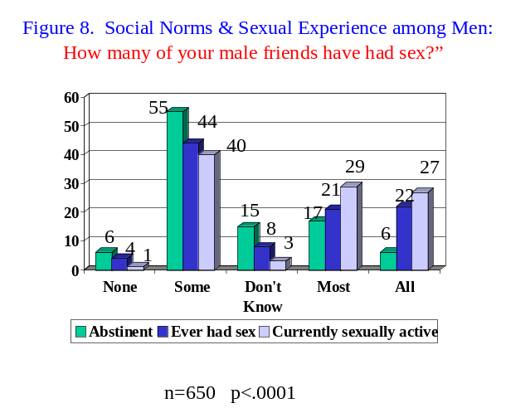
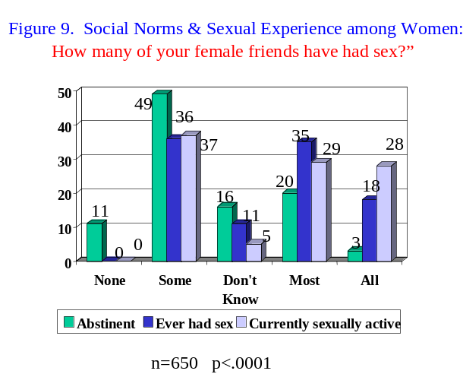
Peer pressure is another factor that is associated with sexual choices. The findings reflect the unhappy fact that 64 percent of currently sexually active young men and 54 percent of young women feel pressure to have sex—primarily from friends (data not shown).

Campaign Viewership and Behaviour Change

We have examined the relationship between campaign viewership and knowledge, attitudes, self-efficacy and increased discussions regarding abstinence, safer sex, HIV and condom use. The ultimate goal of the campaign, of course, is to influence positive behaviour change. In short, we hypothesise that viewership will be positively correlated with abstinence or safer sexual practices, particularly condom use.

First, we examine the relationship between campaign viewership and primary or secondary abstinence (that is, the “return to abstinence”). As reported above, bivariate analysis revealed a positive relationship between primary or secondary abstinence and viewership: in short, nonviewers are significantly more likely to report that they are currently sexually active than were viewers. Since age, sex of respondent, educational attainment, and urban versus rural residence are often correlated with sexual choices and could account for this relationship, we conducted a multiple logistic regression, which allowed us to test whether campaign viewership was related to abstinence even while taking the aforementioned factors into account.

When the independent variables age, educational attainment, urban/rural residence, sex, and campaign exposure were regressed on the dependent variable, sexual status, we found that viewers were 1.68 times more likely to report primary or secondary abstinence then were non-viewers (see Chart 10). Age was positively associated with sexual activity, while education was negatively associated. That is, younger respondents were more likely to be abstinent than were older respondents and, all other things being equal, better educated respondents were more likely to practice abstinence than were their less-educated peers. There were no differences between urban and rural respondents with respect to this outcome variable when taking into account the other variables. Women are less likely to be sexually active than are men.
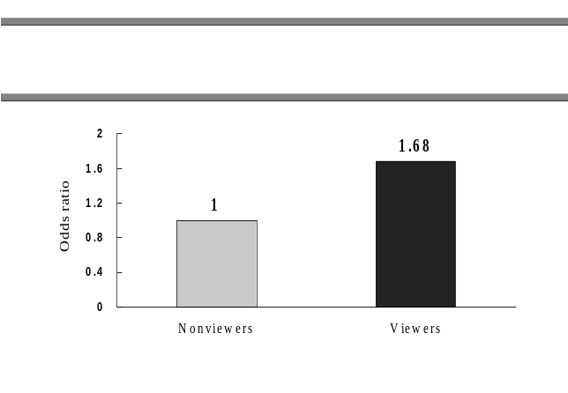
Campaign exposure can also be more finely measured as there were five spots and respondents were asked about each. Communication research often finds a ‘dose effect’: that is, the more messages to which a viewer is exposed, the greater the impact. Therefore, we regressed the independent variables age, educational attainment, urban/rural residence, sex, and campaign exposure (utilising the scaled exposure variable that ranged from 0 to 5) on the dependent variable, sexual status. The findings for this regression were particularly interesting as the number of spots recalled was found to be negatively associated with current sexual activity—an important finding as this demonstrates that the more health communication spots recalled, the greater the likelihood the respondent is abstinent. One might argue that selectivity bias encourages abstinent youth to recall more adverts, but since only two of the adverts directly encouraged abstinence, this seems unlikely. Nonetheless, we tested for selectivity bias and found no statistical evidence for endogeneity.

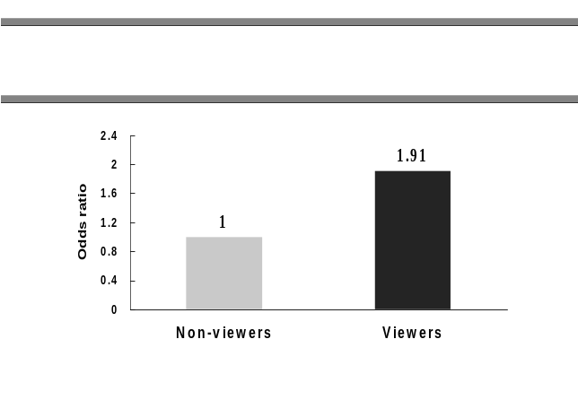Next we turn to the question of whether campaign exposure—holding age, sex, residence, and educational attainment constant—is positively correlated with condom use. Logistic regression analysis found that viewers were 1.91 times more likely to report ever use of a condom when contrasted with nonviewers (Chart 11). As discussed earlier, the perception that one is at risk of contracting HIV is associated with condom use in bivariate analysis. When risk perception is added into the equation, campaign exposure remains highly significant (.005) and the odds ratios of ever use among viewers drops only slightly (viewers 1.87 times more likely to report use than were nonviewers).
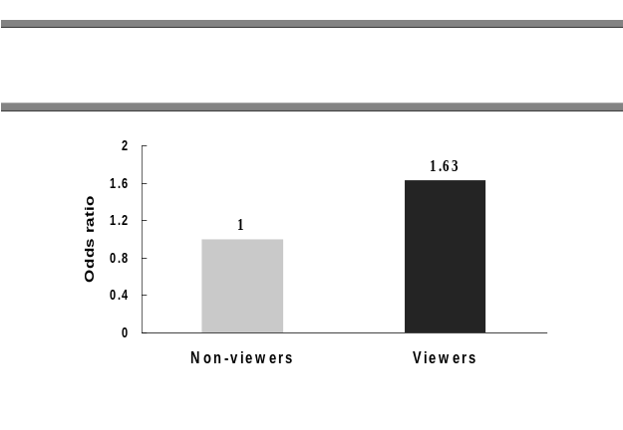
Logistic regression analysis found that viewers were 1.63 times more likely to report condom use during last sex when contrasted with nonviewers. As noted in Chart 12, the odds ratios were obtained while controlling for sex, age, residence and education constant. Respondents ages 17-19 were more likely to report condom use during last sex than were their younger counterparts. Women were more likely to report condom use than were men when holding background characteristics constant.

Conclusions and Recommendations

The findings presented above demonstrate that the overall goals of the campaign were met with only a few qualifications. This section begins with a brief summary of findings that are correlated with campaign goals and concludes with recommendations for the next campaign phase.

Among the salient findings were the following:

- Television is an effective way to reach young people. The HEART Campaign reached over fifty percent of the intended audience. 71 percent of urban and 37 percent of rural youth saw one of more of the health communication spots. Young women—both urban and rural—were as likely as were young men to have seen some or all of the adverts. Still, it is important to use other media in tandem with television to reach the 50 percent of youth that did not recall the campaign.

- Comprehension of the messages was good. Between 60 and 90 percent of viewers spontaneously identified the correct message with any given advert.

- Approximately 74 percent of male viewers and 68 percent of female viewers said that the health communication spots prompted them to talk with others about the advert, decide to abstain from sex until more mature, or use a condom.

- On average, male as well as female viewers discussed abstinence or safer sex with a significantly wider range of people than did their counterparts.

- Among women who are sexually experienced, 82 percent of campaign viewers contrasted with 69 percent of baseline and 64 percent of impact nonviewers reported they feel confident that they have “the ability to say no to unwanted sex.”

- Among both men and women, the perceived efficacy to use condoms was positively and significantly correlated with viewership.

- Overall, viewers were more knowledgeable about HIV/AIDS than were nonviewers. Nearly 86 percent of viewers of Mutale & Ing’utu compared with 72 percent of nonviewers recognised that a person who looks healthy can be HIV+.

- Using logistic regression and holding the independent variables age, educational attainment, urban/rural residence, and sex constant, data show that viewers are 1.68 times more likely to report primary or secondary abstinence then were non-viewers.

- There was a dose effect: the more health communication spots recalled, the greater the likelihood that the respondent is abstinent.

- Logistic regression analysis found that viewers were 1.91 times more likely to have ever used a condom and 1.63 times more likely to report condom use during last sex when contrasted with nonviewers (holding sex, age, residence and education constant). Older, better-educated respondents were more likely than others were to use condoms. Interestingly, women were more likely to report condom use than were men when background characteristics were held constant.

Given these impressive findings, the question remains: How can we enhance the next phase of the campaign so that the impact will be even greater than the first phase? Research has shown that variables related to the desired outcomes--contraceptive use, abstinence, condom use, etc.--can be added together to create a single indicator of ideation. Since questions regarding attitudes about and social support for abstinence were asked only of those who categorised themselves as abstinent, further data analysis will not enable us to ascertain the factors correlated with abstinence beyond background characteristics. Still, the data provide evidence of the dose effect, suggesting that it is important to continue with this theme.

Further data analysis demonstrated that the following factors were related to condom use:

- Knows where to purchase condoms.
- Knows at least three ways to protect self from HIV/AIDS.
- Has a positive attitude towards people who use condoms.
- Has talked with at least three people about safe sex.
- Has an above-average sense of efficacy regarding ability to use condoms even when facing opposition from partner.
- Perceives self to be at moderate-to-high risk of contracting HIV.

Not all of these variables were included in the foregoing discussion, as they were not identified as specific communication objectives of the project. The ideational framework is an important tool to guide impact evaluation, but it can also be used to point out what factors are related to the desired behavioural outcome and should, therefore, be addressed in upcoming programs. For example, data analysis demonstrates that risk perceptions are highly correlated with condom use, yet this message was not explicit in the HEART Campaign. Still, it seems important to identify those factors related to condom use, as it might be important to include them as part of the focus of future programs.

In addition to finding that each variable listed above is correlated with condom use, further analysis demonstrated that the factors operate in a cumulative manner—as has been found in other published studies. In short, the greater the number of ideational elements that apply to someone, the greater the likelihood that one will adopt the behaviour in question. In the two examples that follow, the “cumulative likelihood of adoption” can be determined by examining the percentage of men and women who have ever used a condom by level of ideation.
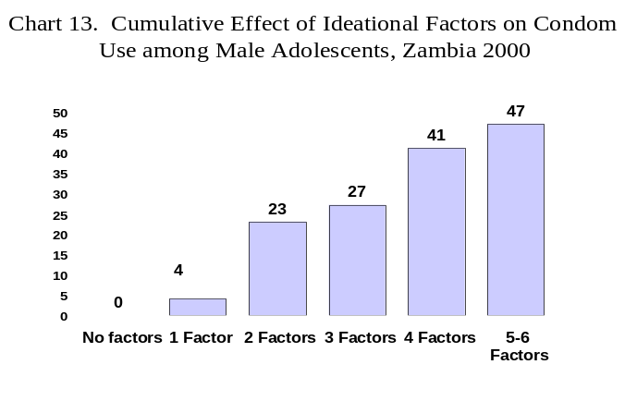

As shown in Figure 13, condom use increased significantly and dramatically with each additional ideational factor. Some 47 percent of sexually active young men who register above the sample mean on five or more factors have used a condom one or more times contrasted with only four percent of those who have only one factor. Young women—at 61 percent—are even more likely than are young men to use condoms when five or six
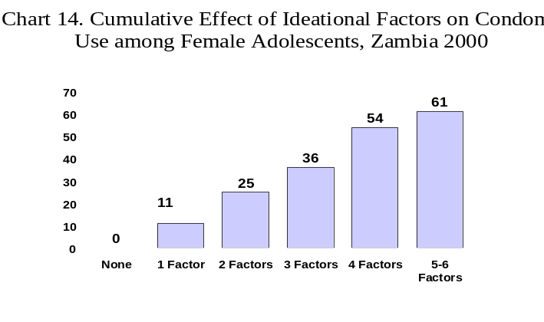
factors obtain (Figure 14).

These findings suggest that when program interventions address these factors in a compelling manner results will follow. It should be emphasised that the variables included in the model above do not necessarily constitute a comprehensive list of ideational factors related to condom use. Indeed, as this research continues with different audience segments, it is anticipated that more factors that will be found that are related to safer sexual practices and that can be positively influenced through communication programs.
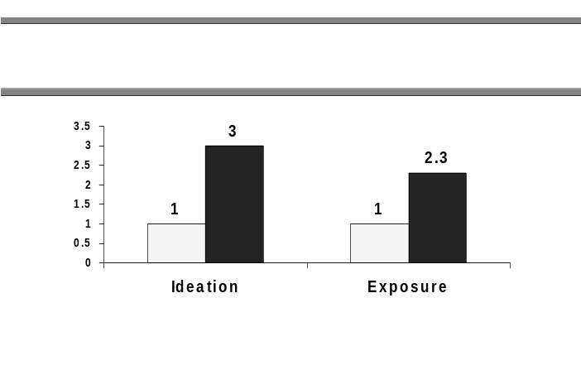
The odds ratio for condom use by those with low (below the median) levels of ideation contrasted with those who express high levels of ideation (at or above the median) are shown in Chart 15. This demonstrates that those with high levels of ideation are three times as likely to report condom use as are those who express low levels of ideation. When campaign viewership is included in the logistic regression along with age, educational attainment, residence, sex, TV ownership and ideation, the correlation remains strong: viewers are 2.3 times more likely to report condom use than were non-viewers.

Given the results from the surveys as well as from our exploratory use of an ideational framework, the following approaches are recommended:

- Continue to support and encourage abstinence or a “return to abstinence” as a viable alternative;
- Convey the idea that abstinence is a social norm among young people;
- Portray the use of consistent condom use as a social norm;
- Address HIV/AIDS misconceptions directly and in multiple adverts;
- Continue to encourage young people to discuss safer sex and/or abstinence with their partners, close friends and family members;
- Continue to encourage consistent condom use;
- Design a health communication spot to help convince all sexually active young people that, while they are at risk, they can practice safer sex. While some element of “fear” may be needed to convey this message in a compelling manner, research shows that it will only be effective if accompanied by information regarding specific ways to protect oneself from the risk. In short, even as it heightens the viewer’s awareness that he or she is at risk, it should seek to enhance his or her self-efficacy by suggesting options.

The HEART Campaign is part of the national HIV/AIDS programme in Zambia. It is one among a range of programs designed to enable young people to protect their reproductive health. Community mobilisation efforts, faith-based projects, school curricula and several media programs have addressed many of the issues central to the HEART Campaign. While the independent correlation between exposure to the HEART Campaign and positive reproductive health choices has been demonstrated, positive secular changes also occurred over the same time frame that could not be attributed to the campaign, which one could argue reflects the synergistic effect of multiple campaigns and interventions. The data show that, while important progress has been made, there is still much to be done. The HEART Campaign should seek to expand the depth and breadth of its reach. At the same time, complementary programmes with a consistent set of messages on risk reduction should be encouraged.

Cook, T.D. and D.T. Campbell. 1979. Quasi-Experimentation: Design & Analysis Issues for Field Settings. Chicago, IL: Rand McNally College Publishing Company.
Phase One Design Team members included Brad Lucas (Society for Family Health (SFH)), Chilufya Mwaba (SFH), , Elizabeth Serlemitsos (ZIHPCOMM), Holo Hachonda (then Youth Activists Organisation Jabulani Chiwaula (SFH), Karen Sichinga (Christian Medical Association of Zambia), , Mary Phiri (Youth Media), Paul Zietz (USAID, Shula Maimbolwa (ZIHPCOMM), Susan Gilbert (Consultant), Uttara Bharath (ZIHPCOMM), and Victor Mawere (then Society of Women Against AIDS in Zambia (SWAAZ)).
Cf., E. Rogers (Diffusion of Innovations. New York: Free Press, 1962 & 1983) applied diffusion theory to the role of communication campaigns in increasing contraceptive use. McGuire (Theory-Oriented Research in Natural Settings: The Best of Both Worlds of Social Psychology. In M. Sherif and C. W. Sherif (eds.), Interdisciplinary Relationships in the Social Sciences. Chicago: Aldine, 1969) introduced the input/output persuasion theory to model how various aspects of the communication process in tandem with audience characteristics influence behavior outcomes. The conceptual framework known as the Steps to Behavior Change and refined by JHU/PCS (Piotrow, P.T., D.L. Kincaid, J.G. Rimon, and W. Rinehart. 1997. Health Communication: Lessons from Family Planning and Reproductive Health. Westport, Connecticut: Praeger), is indebted to Rogers and McGuire, among others.
Cleland, J. and Wilson, C. Demand Theories of Fertility Transition: An Iconoclastic View. Population Studies 1987, 41:5-30.
Those who reported that they never watch television were not asked whether they had seen the television spots.
Central Statistical Office (Zambia) and Ministry of Health and Macro International Inc., 1997. Zambia Demographic and Health Survey 1996. Calverton, Maryland: Central Statistical Office and Macro International Inc.
Self-efficacy with respect to the ability to refuse unwanted sexual relations was assessed by asking female respondents (1) whether they believe they have the right to refuse unwanted sex; (2) whether they know how to refuse unwanted sex; and (3) to describe how they would refuse unwanted sex. A scale from 0 to 3 was created from responses to these questions. A score of three (i.e., the respondent answered yes to the first two questions and was able to give a relevant response to the third question) was considered to reflect a high degree of self-efficacy with respect to the ability to say no to sex.
It should be noted that only sexually experienced respondents who had heard of VCT were asked whether they had been tested (n=192).
Noelle-Neumann, E. 1984. The spiral of silence: Public opinion—our social skin. Chicago: University of Chicago Press.
While perceived risk is correlated with having a relative who is HIV+, condom use is not correlated with having a relative who is HIV+ when risk is included in the regression. In short, having a relative who is HIV+ is indirectly but not directly related to condom use. Risk perceptions, as we have seen, are directly related to condom use.

