MADDEN-JULIAN OSCILLATION (MJO)
DIAGNOSTIC DISCUSSION

issued by

CLIMATE PREDICTION CENTER/NCEP
June 20, 2005

Synopsis: The MJO is forecast to remain weak over the next 6 to10 day period.

During mid March, the MJO became active and strong while completing one cycle around the global tropics with a period of approximately 45 days from late March through early April. Westerly anomalies (Fig.1) during mid-April associated with this MJO activity did not extend far enough east to initiate another Kelvin wave (Fig. 2). The warming along the South America Coast from the previous Kelvin wave has ended. Since mid May the MJO has weakened.

Over the last week convection has been persistent over the central Indian Ocean, Bay of Bengal and South China Sea regions (Fig. 3). The westerly anomalies near 90ºE to the west of the convection have increased in magnitude over the last week (Fig. 1) Forecasts of the MJO continue to indicate weak MJO activity over the next 1-2 week period (Fig. 5).

An increased risk of above normal rainfall exists for the region of Southeast Asia and the Bay of Bengal for week 1. For week 2, the area of tropical convection over the eastern Indian Ocean needs to be monitored to see if the center of upper-level divergence moves into the tropical western Pacific creating favorable conditions for tropical cyclone formation (Fig. 4).

This discussion is a consolidated effort of NOAA and its funded institutions. Weekly updates for SST, 850-hPa wind, OLR and features of the equatorial subsurface thermal structure are available on the Climate Prediction Center web page at http://www.cpc.ncep.noaa.gov. The next MJO Diagnostics Discussion is scheduled for 27 June 2005.

Climate Prediction Center
National Centers for Environmental Prediction
NOAA/National Weather Service
Camp Springs, MD 20746-4304

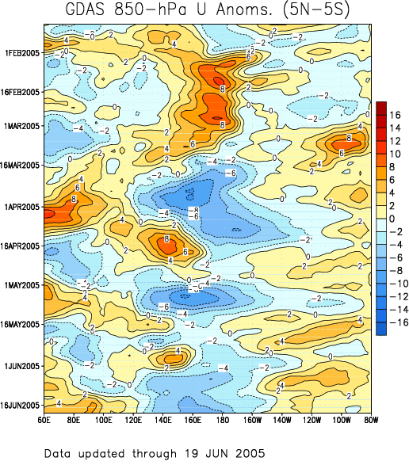

Figure 1: Time-longitude section (5°N-5°S) of anomalous 850-hPa zonal wind (m s⁻¹) (GDAS).
Contour interval is 2 m s⁻¹. Dashed contours indicate negative anomalies. The base period for computing anomalies is 1979-1995. Stronger-than-average easterlies are indicated by blue shading and weaker-than-average easterlies by orange/red shading.

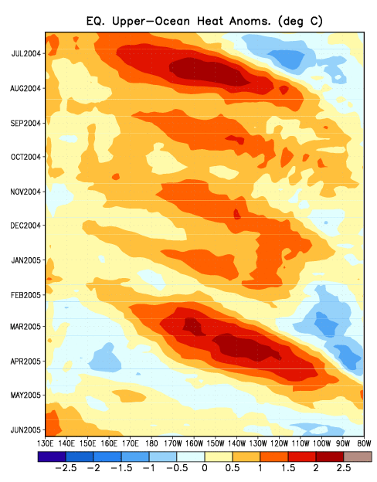

Figure 2: Time-longitude section (5°N-5°S) of upper ocean (0-300 m) heat content anomalies (ºC) in the Pacific Ocean taken from GODAS (Global Ocean Data Assimilation System). Greater heat content (orange/red shading); lower heat content (blue).

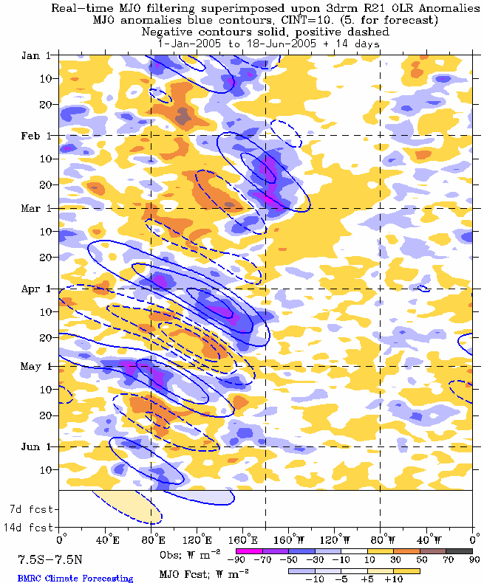

Figure 3: Time-longitude section (7.5°N-7.5°S) of anomalous Outgoing Longwave Radiation (OLR) (W m⁻²). Negative OLR anomalies (wetter-than-normal conditions) are indicated by blue shading while positive OLR anomalies (drier-than-normal conditions) are indicated by orange/red shading.

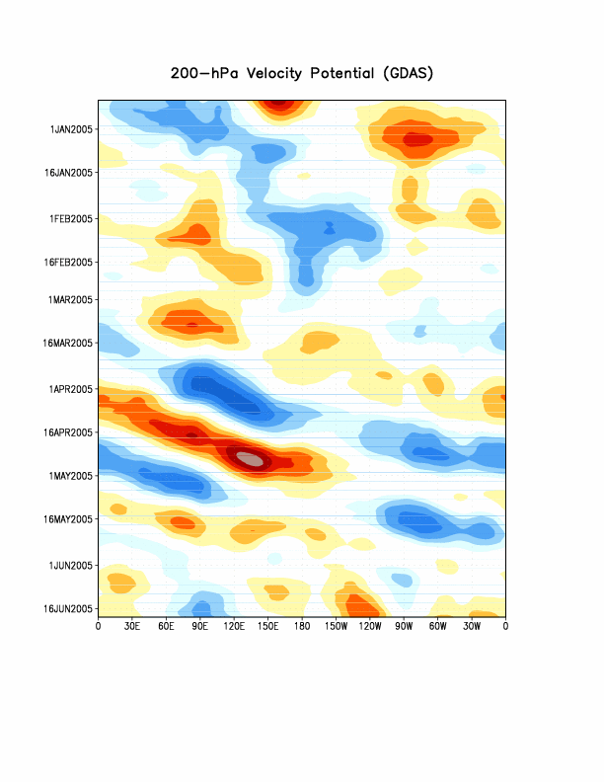

Figure 4: Five day running mean time longitude sections of the 200-hPa velocity potential anomalies averaged from 5°N to 5°S from the Global Data Assimilation System (GDAS). Contour interval is 2 x 10⁶ m² s⁻¹ with the orange/red (blue) shading indicating areas of upper-level convergence (divergence) respectively.

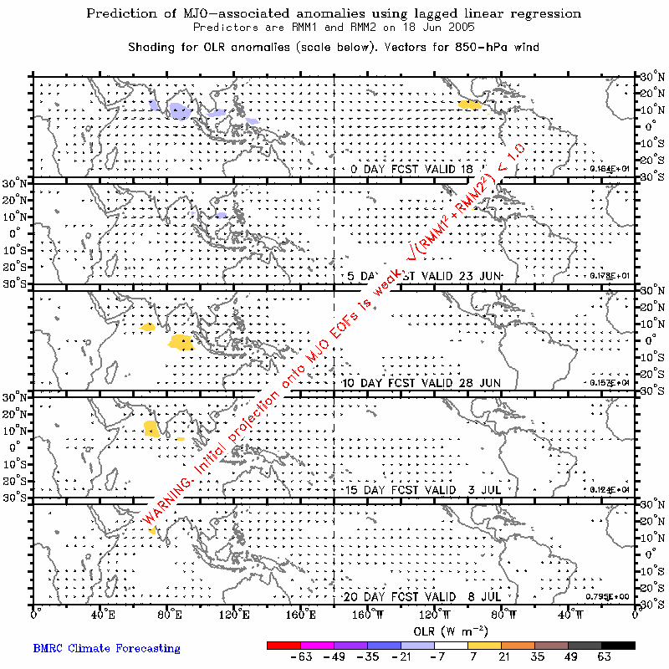

Figure 5: Prediction of MJO-associated anomalies using lagged linear regression with the real-time multivariate MJO index (RMM1) and (RMM2) as predictors.

