MADDEN-JULIAN OSCILLATION (MJO)
DIAGNOSTIC DISCUSSION

issued by

CLIMATE PREDICTION CENTER/NCEP
May 17, 2005

Synopsis: Suppressed convection will influence the Indian Ocean and western Indonesia during the period.

During mid March the MJO became active and strong while completed one cycle around the global tropics with a period of approximately 45 days. Westerly anomalies (Fig.1) during mid-April associated with this MJO activity did not extend far enough east to initiate another Kelvin wave (Fig. 2). The warming along the South America Coast from the previous Kelvin wave has peaked.

During the past week, the MJO has weakened and become less coherent. The convective phase of the MJO is contributing to enhanced convection across South America/Central America and the Caribbean while suppressed convection is influencing eastern Africa and the Indian Ocean (Fig. 3-4). Based on the latest evolution of the MJO and statistical model forecasts (Fig. 5), it is likely during the next week that enhanced convection will continue to impact the western hemisphere and suppressed convection can be expected in the Indian Ocean.

Impacts in the global tropics include the chance of above average rainfall across northern South America and southern Central America into the Caribbean (week 1) with drier than average conditions across the eastern Africa, the Indian Ocean and Indonesia (week 1). Due to the current uncertainty of the MJO, any impacts in the global tropics during week 2 are unclear.

This discussion is a consolidated effort of NOAA and its funded institutions. Weekly updates for SST, 850-hPa wind, OLR and features of the equatorial subsurface thermal structure are available on the Climate Prediction Center web page at http://www.cpc.ncep.noaa.gov. The next MJO Diagnostics Discussion is scheduled for 24 May 2005.

Climate Prediction Center
National Centers for Environmental Prediction
NOAA/National Weather Service
Camp Springs, MD 20746-4304

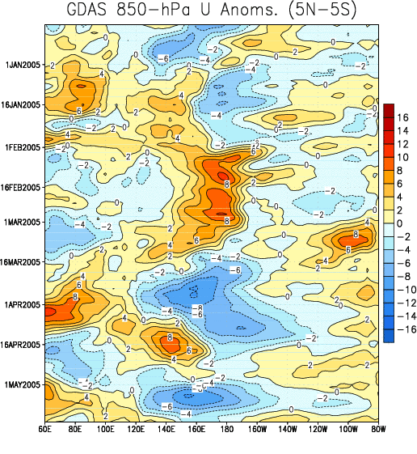

Figure 1: Time-longitude section (5°N-5°S) of anomalous 850-hPa zonal wind (m s⁻¹) (GDAS).
Contour interval is 2 m s⁻¹. Dashed contours indicate negative anomalies. The base period for computing anomalies is 1979-1995. Stronger-than-average easterlies are indicated by blue shading and weaker-than-average easterlies by orange/red shading.

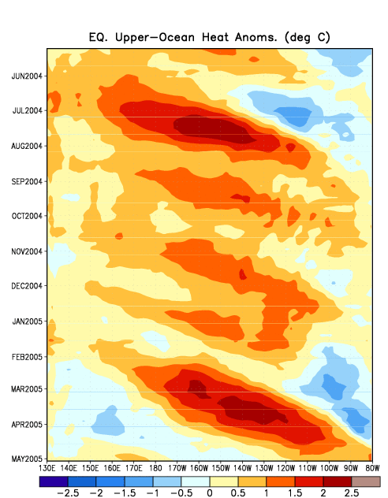

Figure 2: Time-longitude section (5°N-5°S) of upper ocean (0-300 m) heat content anomalies (ºC) in the Pacific Ocean taken from GODAS (Global Ocean Data Assimilation System). Greater heat content (orange/red shading); lower heat content (blue).

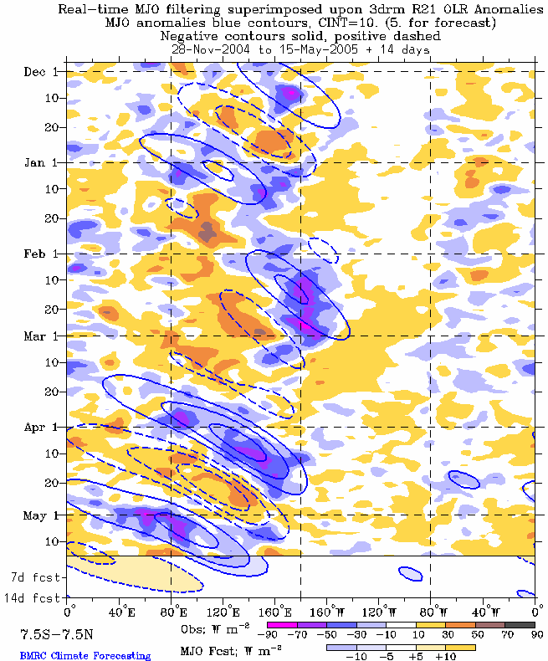

Figure 3: Time-longitude section (7.5°N-7.5°S) of anomalous Outgoing Longwave Radiation (OLR) (W m⁻²). Negative OLR anomalies (wetter-than-normal conditions) are indicated by blue shading while positive OLR anomalies (drier-than-normal conditions) are indicated by orange/red shading.

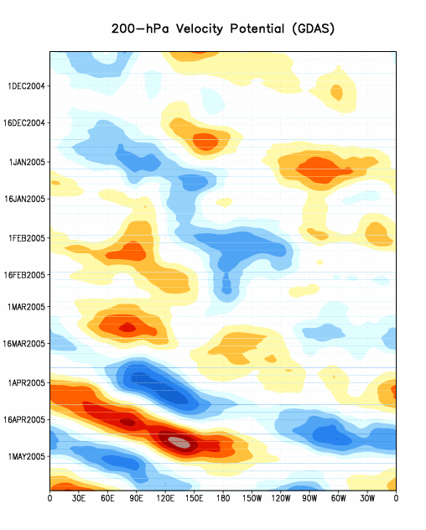

Figure 4: Five day running mean time longitude sections of the 200-hPa velocity potential anomalies averaged from 5°N to 5°S from the Global Data Assimilation System (GDAS). Contour interval is 2 x 10⁶ m² s⁻¹ with the orange/red (blue) shading indicating areas of upper-level convergence (divergence) respectively.

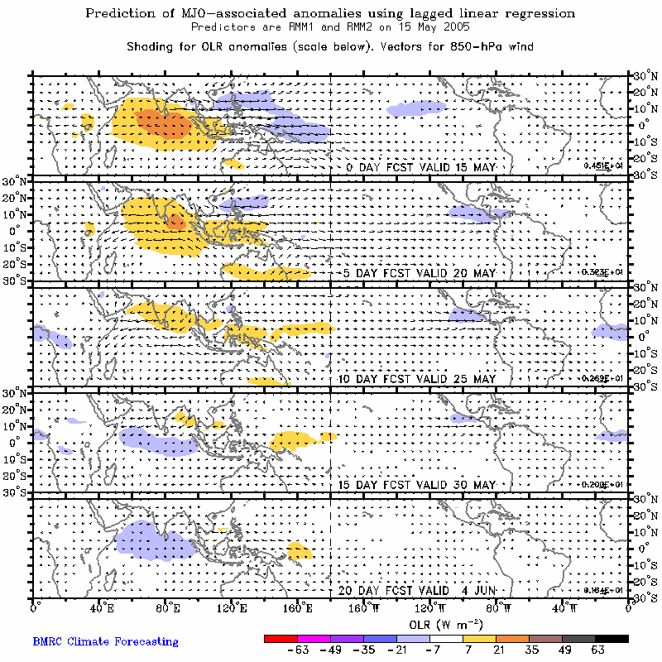

Figure 5: Prediction of MJO-associated anomalies using lagged linear regression with the real-time multivariate MJO index (RMM1) and (RMM2) as predictors.

