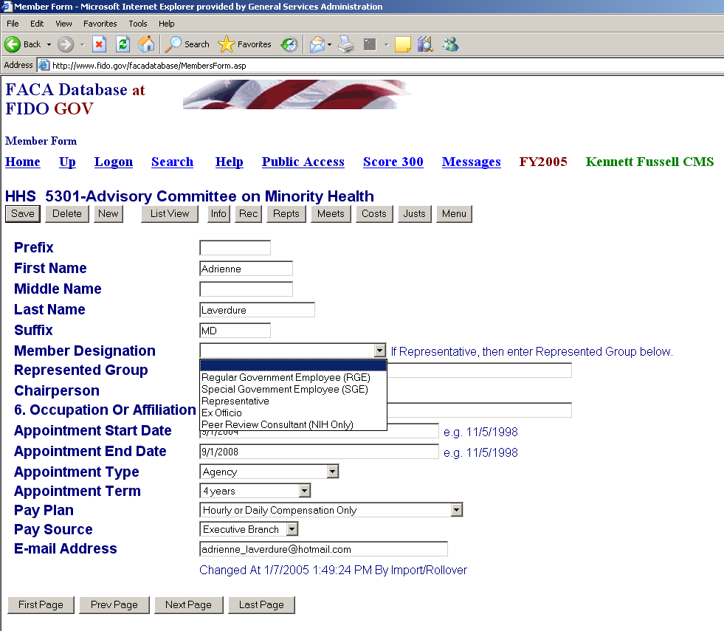
The Member Data Entry Form includes two new fields. The first, Member Designation, has five responses, Regular Government Employee (RGE), Special Government Employee (SGE), Representative, Ex Officio, and Peer Review Consultant (NIH only).

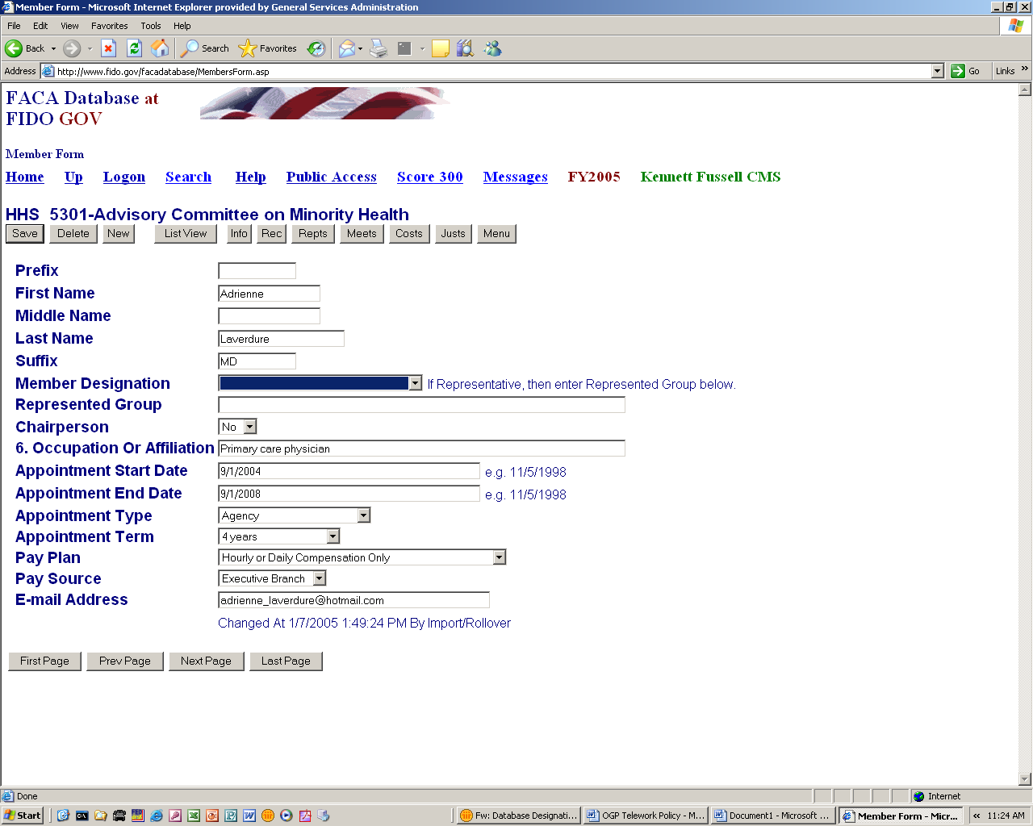
The second, Represented Group, is only filled in when Representative is selected from the above options.

