FEDERAL REAL PROPERTY COUNCIL

published by
GSA Office of Governmentwide Policy

FY 2006
Federal Real Property Report

EXECUTIVE SUMMARY REPORT:
An Overview of the U.S. Federal Government’s Real Property Assets

July 2007

www.realpropertyprofile.gov

INTRODUCTION & BACKGROUND

On behalf of the Federal Real Property Council (FRPC), GSA’s Office of Governmentwide Policy (OGP) is pleased to present the results of the Fiscal Year (FY) 2006 governmentwide real property data collection.
Executive Order 13327 created the Federal Real Property Council, established the role of the Senior Real Property Officer, and mandated the creation of a centralized real property database. At the same time, “real property” was added to the President’s Management Agenda.

The FY 2006 Federal Real Property Report marks the second reporting year for the governmentwide data elements as required by Executive Order 13327.
With the issuance of Executive Order 13327 in February 2004, OGP was formally recognized as the administrator of the centralized real property database, known as the Federal Real Property Profile (FRPP). The FRPC established the initial requirements for reporting real property data as part of the December 2004 guidance document. The FRPC has issued subsequent guidance documents expanding and refining the data reporting requirements. All executive branch agencies are required to submit data to the FRPP, at the constructed asset level, on an annual basis.

This executive summary marks the second reporting year for the governmentwide data elements, as required by Executive Order 13327. For the first time, the Federal real property community can track the trends in the real property inventory and performance data.

The goals of Executive Order 13327 are to:
- Promote efficient and economical use of real property resources.
- Increase agency accountability and management attention to real property reform.
- Establish clear real property goals and objectives.
The goals of the centralized database are to:
- Improve decision making with accurate and reliable data.
- Provide the ability to benchmark Federal real property assets.
- Consolidate governmentwide real property data collection into one system.

Agencies successfully reported data on more than 1.2 million assets with a replacement value of more than $1.2 trillion in the initial FY 2005 reporting to the FRPP. In FY 2006, agencies again successfully reported inventory and performance data on more than 1.2 million assets with a replacement value of more than $1.5 trillion, which comprise the Federal portfolio. Improved asset level reporting is the direct result of agency emphasis on capturing and reporting inventory and performance data for each constructed asset.

Variances between the FY 2005 and FY 2006 reporting periods are the result of:

- Improved agency processes for capturing and reporting the required data to the FRPP. Agencies reviewed internal processes for capturing and reporting inventory and performance data and implemented the necessary steps to improve data quality.
- The expiration of OMB-approved reporting waivers granted in the first year of reporting. OMB had approved a small number of agency waivers for reporting data on specific assets. Waivers were granted, most commonly in the areas of value and performance data, for only the FY 2005 reporting cycle. All agencies have captured and reported all required data at the constructed asset level and closed all data gaps allowed under the FY 2005 waiver process. For example, agency closure of approved waivers resulted in a significant increase to the FY 2006 total replacement value.

We would like to continue to recognize the tremendous effort undertaken by the Federal agencies to capture and report on all of the data elements defined by the FRPC. Agencies have overcome many obstacles in order to successfully report the required data and continue with their efforts to refine both their asset management and data collection methods.

FRPC Organization and Committees

Federal Real Property Council
(FRPC)
Asset
Management Plan
Inventory &
Performance
Measures*
General Services
Administration
Department of
Defense
Systems
Department of
Agriculture
Senior Real Property
Officers (SRPO)
Office of Management & Budget (OMB)
FRPC Committees
FRPC Committee Chairs
*The Performance Measures Committee became a working group of the Inventory Committee in March 2006.

FEDERAL REAL PROPERTY: KEY STATISTICS

 | FY 2005 | FY 2006 | Variance
Total Federal Building Assets  *may include multiple leases in one building | 501,128 | 505,559 | 4,431
Total Area of Building Assets | 3.73 billion square feet | 3.87 billion square feet | 136.4 million square feet
Total Replacement Value of Building Assets | $684.9 billion | $808.8 billion | $123.9 billion
Total Federal Structures | 475,054 | 508,363 | 33,309
Total Replacement Value of Structures | $571.3 billion | $719.2 billion | $147.9 billion
Total Federal Land Acreage | 54,914,928 acres | 56,669,483 acres | 1,754,555 acres
Total Land Records | 234,229 | 239,899 | 5,670
Total Federal Assets | 1,210,411 | 1,253,821 | 43,410
Total Replacement Value of Assets (Buildings and Structures) | $1.26 trillion | $1.53 trillion | $271.8 billion

TOTAL NUMBER OF WORLDWIDE ASSETS: FY 2005 vs. FY 2006

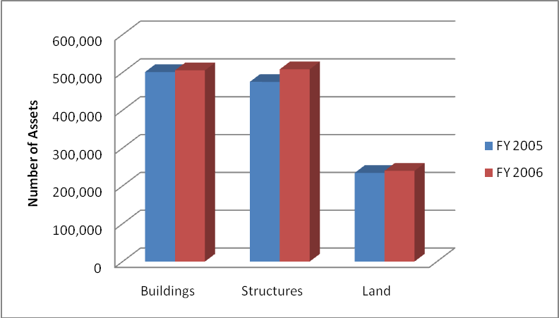

Asset Type | FY 2005 Number of Assets | FY 2006 Number of Assets
Building Assets | 501,128 | 505,559
Structures | 475,054 | 508,363
Land Records | 234,229 | 239,899
TOTAL NUMBER OF ASSETS | 1,210,411 | 1,253,821

Notes
- Executive Order 13327 does not mandate the reporting of data for public domain lands and certain other asset types. Therefore, the FY 2005 and FY 2006 land data does not fully represent the Federal government’s total land acreage. “Total Federal Assets” and “Total Federal Land Acreage” include overseas land owned by a foreign government and provided for U.S. government purposes, or land owned by a foreign entity and leased to the U.S. government.
- Total Federal asset count includes assets in U.S. states, the District of Columbia, U.S. territories, and foreign assets.
  - U.S. assets are located within the 50 states and District of Columbia.
  - Assets in U.S. territories include all those located in American Samoa, Baker Island, Federated States of Micronesia, Guam, Howland Island, Jarvis Island, Johnston Atoll, Kingman Reef, Midway Islands, Navassa Island, Northern Mariana Islands, Palmyra Atoll, Republic of Palau, Puerto Rico, the U.S. Virgin Islands, U.S. Minor Outlying Islands, and Wake Island.
  - Foreign assets are located outside the U.S. and its territories.

AGENCY PROFILE: FY 2006 NUMBER OF ASSETS AND REPLACEMENT VALUE

Agency Name | Number of Assets | Replacement Value
Agriculture | 59,879 | $46,834,160,262
Air Force | 171,352 | $235,808,469,245
American Battle Monuments Commission | 183 | $4,423,800,000
Army | 264,961 | $262,865,575,017
Commerce | 1,340 | $2,315,006,096
Corps of Engineers | 146,838 | $216,877,416,823
Defense/WHS | 203 | $2,787,946,939
Energy | 18,620 | $85,697,308,479
Environmental Protection Agency | 270 | $741,922,448
General Services Administration | 8,847 | $68,818,536,686
Health and Human Services | 3,357 | $9,867,744,843
Homeland Security | 27,079 | $9,935,179,474
Independent Government Offices | 431 | $106,028,671
Interior | 184,347 | $185,218,464,155
Justice | 4,363 | $15,150,700,400
Labor | 2,639 | $4,537,534,555
National Aeronautics and Space Administration | 4,942 | $20,609,244,894
National Archives and Records Administration | 41 | $1,747,256,609
National Science Foundation | 612 | $1,099,880,301
Navy | 143,897 | $228,819,202,172
Office of Personnel Management | 3 | $0*
Peace Corps | 417 | $8,868,943
State | 16,843 | $11,543,484,787
State (USAID) | 1,371 | $672,727,412
Tennessee Valley Authority | 422 | $0**
Transportation | 69,411 | $6,309,796,350
Treasury | 110 | $1,056,055,014
United States Postal Service | 111,960 | $20,262,644,625
Veterans Affairs | 9,083 | $83,930,650,740
TOTAL | 1,253,821 | $1,528,045,505,940

*The Office of Personnel Management reported $0 replacement value in FY 2006.

**The Tennessee Valley Authority did not report replacement value in FY 2006.

PREDOMINANT USE OF BUILDINGS BY REPLACEMENT VALUE:
FY 2005 vs. FY 2006

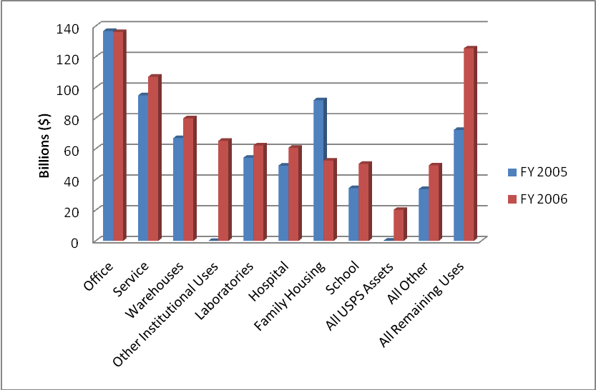

Predominant Use | FY 2005 | FY 2006 | Variance | Percent Variance
Office | $136,805,402,074 | $136,177,296,134 | $-628,105,940 | -0.50%
Service | $97,891,437,690 | $107,036,402,684 | $9,144,964,994 | 9%
Warehouses | $67,009,507,136 | $79,900,600,571 | $12,891,093,435 | 19%
Other Institutional Uses | $47,583,379,697 | $65,242,841,252 | $17,659,461,555 | 37%
Laboratories | $54,220,554,863 | $62,225,172,199 | $8,004,617,336 | 15%
Hospital | $49,067,065,462 | $60,731,746,943 | $11,664,681,481 | 24%
Family Housing | $91,672,138,521 | $52,334,910,437 | $-39,337,228,084 | -43%
School | $34,368,417,731 | $50,203,590,721 | $15,835,172,990 | 46%
All USPS Assets** | $169,127,839 | $20,262,644,625 | $20,093,516,786 | 11,881%***
All Other | $33,777,265,872 | $49,249,313,956 | $15,472,048,084 | 46%
All Remaining Uses**** | $72,313,095,672 | $125,476,546,932 | $53,163,451,260 | 74%
TOTAL REPLACEMENT VALUE | $684,877,392,557 | $808,841,066,454 | $123,963,673,897 | 18%

*The Department of Defense’s privatization of over 145,000 housing units since FY 2005 reporting contributes to the Family Housing variance.

**Due to a coding error, the Post Office category represents Postal Office assets from non-United States Postal Service Federal agencies. The All USPS Assets use category represents all assets submitted by the United States Postal Service.

***Significant variances are the result of improved data collection and additional reporting of data that was not available in the initial FY 2005 reporting of real property inventory and performance data.

****The All Remaining Uses category includes the following predominant uses: Post Office (non-USPS assets); Prisons and Detention Centers; Dormitories/Barracks; Industrial; Communications Systems; and Navigation and Traffic Aids. For a full list of predominant use categories and their definitions for buildings, refer to Appendix A.

PREDOMINANT USE OF BUILDINGS BY SQUARE FOOTAGE:
FY 2005 vs. FY 2006

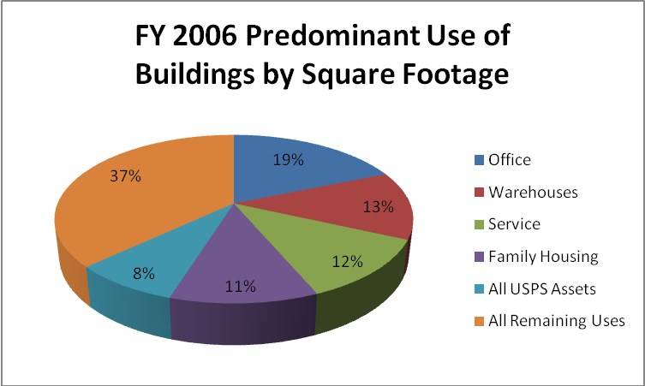

Predominant Use | FY 2006 Square Feet
Office | 723,058,298
Warehouses | 506,058,535
Service | 456,407,527
Family Housing | 435,103,697
All USPS Assets* | 316,425,576
All Remaining Uses** | 1,429,113,497
TOTAL SQUARE FEET | 3,866,167,130

*Due to a coding error, the Post Office category represents Postal Office assets from non-United States Postal Service Federal agencies. The All USPS Assets use category represents all assets submitted by the United States Postal Service.

**The All Remaining Uses category includes the following predominant uses: Post Office (non-USPS assets); Hospital: Prisons and Detention Centers; Schools; Other Institutional Uses; Dormitories/Barracks; Industrial; Communications Systems; Navigation and Traffic Aids; Laboratories; and All Other. For a full list of predominant use categories and their definitions for buildings, refer to Appendix A.

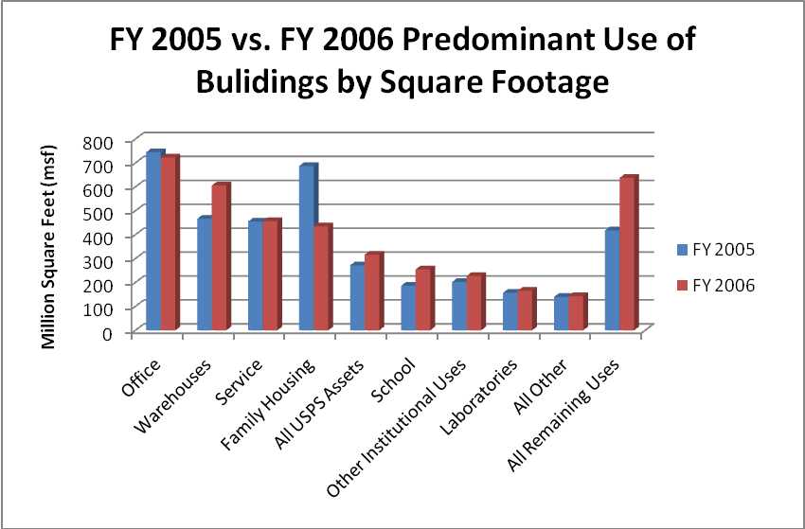

Predominant Use | FY 2005 | FY 2006 | Variance | Percent Variance
Office | 745,201,480 | 723,058,298 | -22,143,182 | -3%
Warehouses | 466,447,830 | 506,058,535 | 39,610,705 | 8%
Service | 455,222,266 | 456,407,527 | 1,185,261 | 0.26%
Family Housing | 687,330,307 | 435,103,697 | -252,226,610 | -37%
All USPS Assets* | 271,994,249 | 316,425,576 | 44,431,327 | 16%
School | 186,453,637 | 255,013,965 | 68,560,328 | 37%
Other Institutional Uses | 202,282,472 | 227,644,203 | 25,361,731 | 13%
Laboratories | 157,107,407 | 165,521,128 | 8,413,721 | 5%
All Other | 139,658,225 | 143,348,808 | 3,690,583 | 3%
All Remaining Uses** | 418,087,329 | 637,585,393 | 219,498,064 | 52%
TOTAL SQUARE FEET | 3,729,785,202 | 3,866,167,130 | 136,381,928 | 4%

*Due to a coding error, the Post Office category represents Postal Office assets from non-United States Postal Service Federal agencies. The All USPS Assets use category represents all assets submitted by the United States Postal Service.

**The All Remaining Uses category includes the following predominant uses: Post Office (non-USPS assets); Hospital; Prisons and Detention Centers; Dormitories/Barracks; Industrial; Communications Systems; and Navigation and Traffic Aids. For a full list of predominant use categories and their definitions for buildings, refer to Appendix A.

LEGAL INTEREST OF DOMESTIC BUILDINGS BY REPLACEMENT VALUE: FY 2005 vs. FY 2006

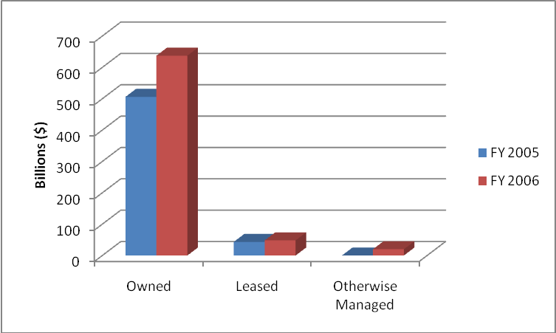

Legal Interest | FY 2005 | FY 2006 | Variance | Percent Variance
Owned | $506,147,527,506 | $637,524,131,414 | $131,376,603,903 | 26%
Leased | $43,406,190,583 | $48,321,549,279 | $4,915,358,696 | 11%
Otherwise Managed | $249,434,445 | $20,026,578,122 | $19,777,143,677 | 7,929%*
TOTAL REPLACEMENT VALUE | $549,803,152,534 | $705,872,258,815 | $156,069,106,281 | 28%

*Significant variances are the result of improved data collection and additional reporting of data that was not available in the initial FY 2005 reporting of real property inventory and performance data.

Definitions:

- Owned: The Federal government has fee-simple interest for the real property.
- Leased: The rights to use the real property have been assigned to the Federal government by a private entity or a non-Federal government entity for a defined period of time in return for rental payments.
- Otherwise Managed: Properties that are state-government-owned, in which a U.S. state holds title to the real property but rights for use have been granted to a Federal government entity in other than a leasehold arrangement.

STATE PROFILE: FY 2006 BUILDING SQUARE FOOTAGE AND LEGAL INTEREST

Top Five States

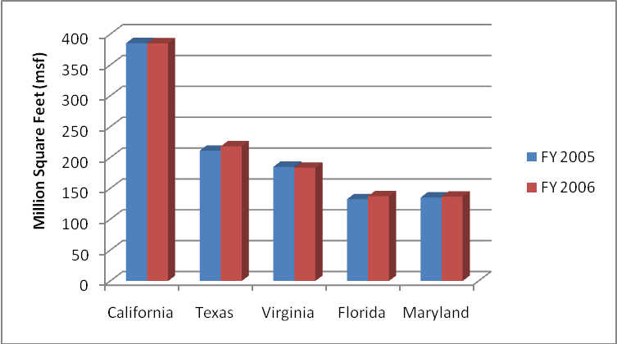

State | FY 2005 Square Feet | FY 2006 Square Feet
California | 385,341,288 | 385,001,571
Texas | 211,003,225 | 218,107,777
Virginia | 184,930,447 | 183,562,473
Florida | 132,464,914 | 137,354,229
Maryland | 135,265,427 | 136,671,839

The Top 5 states (CA, TX, VA, FL, MD) comprise 27% of the total Federal building portfolio, measured by square footage.

State | Owned SF | Leased SF | Otherwise Managed SF | Total SF
Alabama | 51,337,167 | 5,548,905 | 3,306,235 | 60,232,307
Alaska | 51,242,641 | 5,728,665 | 371,822 | 57,343,128
Arizona | 57,930,839 | 4,503,551 | 967,245 | 63,401,635
Arkansas | 20,316,315 | 2,572,009 | 2,940,580 | 25,828,904
California | 350,969,591 | 30,228,438 | 3,803,542 | 385,001,571
Colorado | 55,250,361 | 8,495,723 | 583,109 | 64,329,193
Connecticut | 17,766,273 | 1,915,536 | 1,736,507 | 21,418,316
Delaware | 5,623,430 | 508,343 | 636,421 | 6,768,194
District of Columbia | 74,484,285 | 23,405,560 | 588,723 | 98,478,568
Florida | 116,759,011 | 17,428,397 | 3,166,821 | 137,354,229
Georgia | 106,661,940 | 12,853,957 | 1,656,814 | 121,172,711
Hawaii | 60,260,524 | 1,287,802 | 685,397 | 62,233,723
State | Owned SF | Leased SF | Otherwise Managed SF | Total SF
Idaho | 19,132,046 | 3,149,047 | 721,857 | 23,002,950
Illinois | 79,106,653 | 8,683,133 | 3,506,009 | 91,295,795
Indiana | 36,458,368 | 11,814,034 | 2,408,354 | 50,680,756
Iowa | 12,808,300 | 2,945,680 | 2,969,186 | 18,723,166
Kansas | 33,122,188 | 4,576,228 | 1,562,658 | 39,261,074
Kentucky | 50,108,456 | 4,154,429 | 1,831,077 | 56,093,962
Louisiana | 41,331,551 | 6,192,250 | 6,679,999 | 54,203,800
Maine | 12,743,886 | 1,423,750 | 829,817 | 14,997,453
Maryland | 111,650,965 | 22,751,855 | 2,269,019 | 136,671,839
Massachusetts | 37,521,386 | 5,419,284 | 2,449,491 | 45,390,161
Michigan | 29,936,612 | 7,660,135 | 3,902,891 | 41,499,638
Minnesota | 21,917,854 | 3,646,064 | 4,466,005 | 30,029,923
Mississippi | 37,278,200 | 3,881,809 | 5,328,043 | 46,488,052
Missouri | 49,489,542 | 9,952,846 | 2,424,680 | 61,867,068
Montana | 15,487,951 | 2,934,866 | 693,593 | 19,116,410
Nebraska | 13,330,479 | 2,878,070 | 1,048,667 | 17,257,216
Nevada | 30,710,123 | 2,853,869 | 647,713 | 34,211,705
New Hampshire | 3,725,096 | 1,299,173 | 850,091 | 5,847,360
New Jersey | 50,863,990 | 9,313,505 | 2,173,680 | 62,351,175
New Mexico | 57,471,517 | 5,422,912 | 1,390,706 | 64,285,135
New York | 105,815,867 | 19,872,223 | 4,893,711 | 130,581,801
North Carolina | 83,742,004 | 7,426,517 | 2,220,922 | 93,389,443
Ohio | 71,096,434 | 8,530,451 | 2,445,978 | 82,072,863
Oklahoma | 57,527,938 | 8,689,804 | 2,161,020 | 68,378,762
Oregon | 21,970,276 | 4,357,315 | 2,396,571 | 28,724,162
Pennsylvania | 79,681,600 | 12,328,306 | 2,737,050 | 94,746,956
Rhode Island | 13,988,295 | 699,456 | 502,475 | 15,190,226
South Carolina | 57,099,805 | 3,518,119 | 2,070,076 | 20,943,495
South Dakota | 16,148,697 | 3,402,873 | 1,391,925 | 20,943,495
Tennessee | 68,471,275 | 6,241,649 | 3,174,260 | 77,887,184
Texas | 186,283,710 | 28,744,137 | 3,079,930 | 218,107,777
Utah | 30,309,499 | 4,343,264 | 1,900,686 | 36,553,449
Vermont | 2,914,865 | 1,282,698 | 575,822 | 4,773,385
Virginia | 151,895,190 | 30,381,117 | 1,286,166 | 183,562,473
Washington | 85,012,069 | 8,036,947 | 1,493,856 | 94,542,872
West Virginia | 18,465,981 | 3,728,421 | 1,750,290 | 23,944,692
Wisconsin | 22,618,813 | 4,736,266 | 2,648,452 | 30,003,531
Wyoming | 13,783,857 | 1,002,758 | 1,009,429 | 15,796,044
Locations Not Reported | 169,527,836 | 360,339,812 | 13,491,311 | 543,358,959
TOTAL SF | 2,990,000,148 | 754,841,044 | 121,325,938 | 3,866,167,130

PREDOMINANT USE OF STRUCTURES BY REPLACEMENT VALUE:
FY 2005 vs. FY 2006

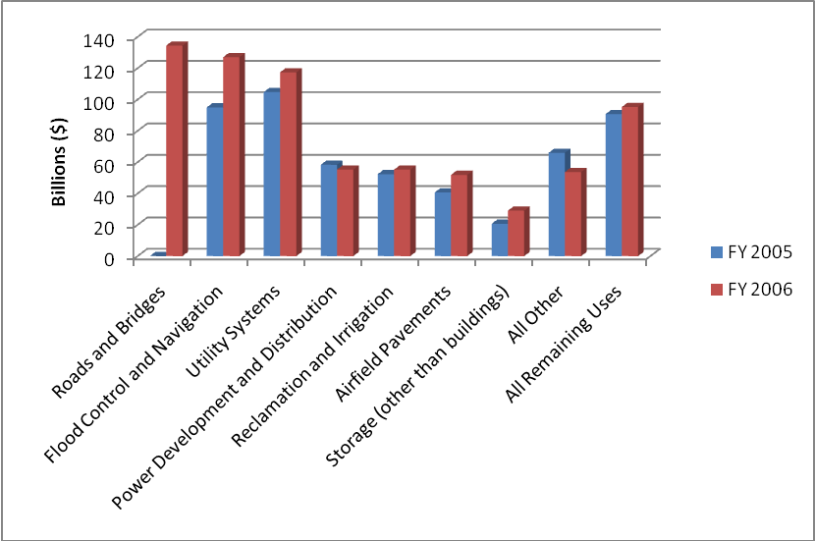

Predominant Use | FY 2005 | FY 2006 | Variance | Percent Variance
Roads and Bridges | $42.964,094,359 | $134,409,523,365 | $91,445,429,006 | 213%*
Flood Control and Navigation | $94,975,607,778 | $127,034,006,443 | $32,058,398,665 | 34%
Utility Systems | $104,737,372,926 | $117,364,540,482 | $12,627,167,556 | 12%
Power Development and Distribution | $58,314,021,116 | $55,294,878,244 | $-3,019,142,872 | -5%
Reclamation and Irrigation | $52,334,201,592 | $55,206,367,156 | $2,872,165,564 | 5%
Airfield Pavements | $40,644,843,254 | $51,880,480,689 | $11,235,637,435 | 28%
Storage (other than buildings) | $20,677,412,111 | $29,033,303,601 | $8,355,891,490 | 40%
All Other | $65,951,527,740 | $53,751,636,990 | $-12,199,890,750 | -18%
All Remaining Uses** | $90,685,847,437 | $95,227,772,650 | $4,541,925,213 | 5%
TOTAL SQUARE FEET | $571,284,928,313 | $719,202,509,620 | $147,917,581,307 | 26%

*Significant variances are the result of improved data collection and additional reporting of data that was not available in the initial FY 2005 reporting of real property inventory and performance data.
**The All Remaining Uses category includes the following predominant uses: Harbors and Ports; Industrial (other than buildings); Service (other than buildings); Space Exploration Structures; Parking Structures; Research and Development (other than laboratories); Communications Systems; Navigation and Traffic Aids (other than buildings); Recreational (other than buildings); Railroads; Monuments and Memorials; Miscellaneous Military Facilities; and Weapons Ranges. For a full list of predominant use categories and their definitions for structures, refer to Appendix B.

TOTAL DISPOSITION VALUE BY FISCAL YEAR

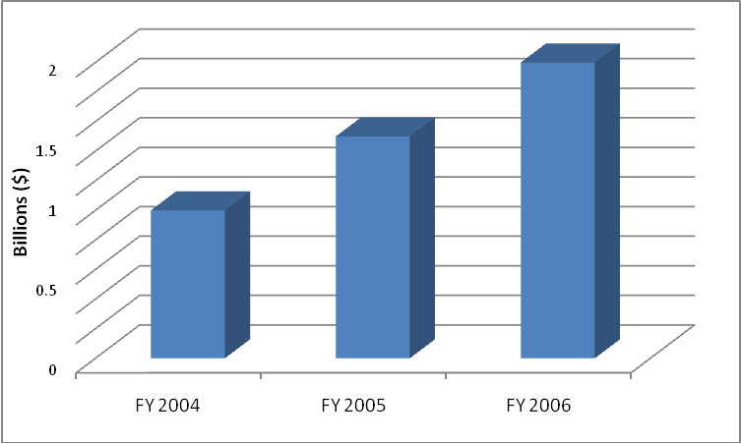
$1 billion
$1.5 billion
$2 billion

TOTAL DISPOSITION VALUE OF FY 2006 WORLDWIDE DISPOSED ASSETS: CIVILIAN AGENCIES

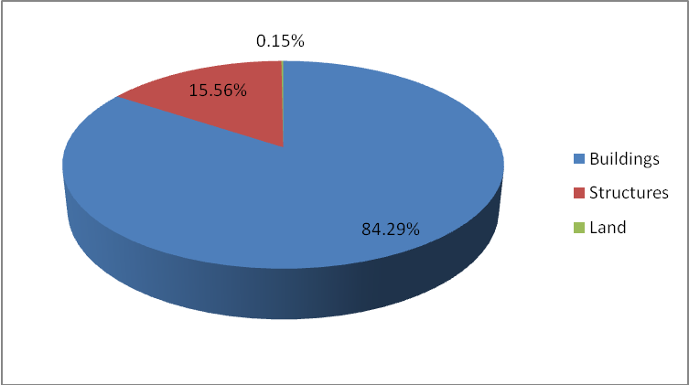

Asset Type | Disposition Value
Building Assets | $1,685,255,725
Structures | $310,990,935
Land Records | $3,066,980
TOTAL DISPOSITION VALUE | $1,999,313,640

TOTAL DISPOSITION VALUE OF FY 2006 WORLDWIDE DISPOSED ASSETS: DEPARTMENT OF DEFENSE

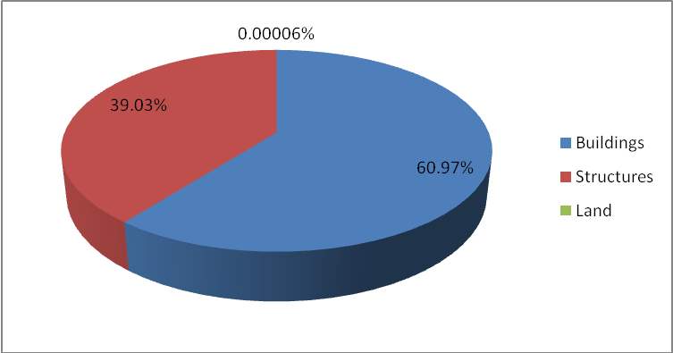

Asset Type | Disposition Value
Building Assets | $7,655,860,995
Structures | $4,990,690,676
Land Records | $7,500
TOTAL DISPOSITION VALUE | $12,556,559,171

FY 2006 TOTAL NUMBER OF DISPOSED ASSETS:
TOP FIVE AGENCIES

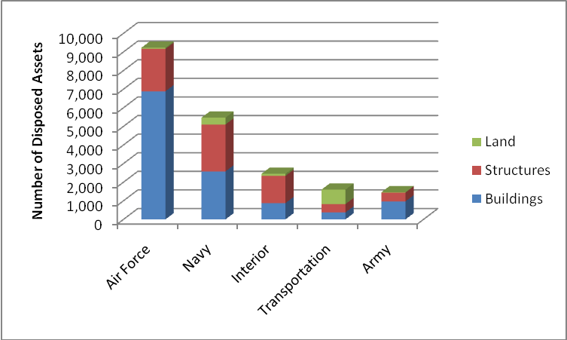

Agency | Number of Disposed Building Assets | Number of Disposed Structures | Number of Disposed Land Records | TOTAL NUMBER OF DISPOSED ASSETS
Air Force | 6,885 | 2,284 | 62 | 9,231
Navy | 2,578 | 2,524 | 366 | 5,468
Interior | 876 | 1,464 | 110 | 2,450
Transportation | 374 | 449 | 779 | 1,602
Army | 965 | 477 | 21 | 1,463

FY 2006 DISPOSAL METHOD BY DISPOSITION VALUE AND NUMBER OF DISPOSED ASSETS

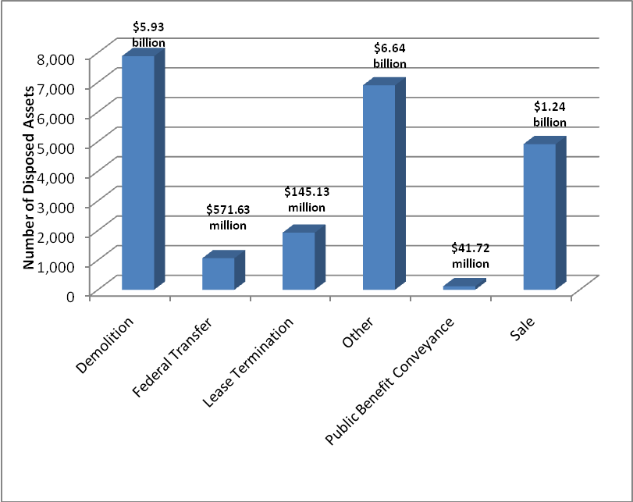

Disposal Method | FY 2006 Number of Disposed Assets | FY 2006 Disposition Value
Demolition | 7,886 | $5,926,919,178
Federal Transfer | 1,065 | $571,632,590
Lease Termination | 1,927 | $145,126,004
Other | 6,902 | $6,635,312,804
Public Benefit Conveyance | 120 | $41,721,960
Sale | 4,916 | $1,235,160,275
TOTALS | 22,816 | $14,555,872,811

CONDITION INDEX: FY 2006 COMMON BUILDING PREDOMINANT USE CODES

The FRPC has mandated the use and reporting of specific performance measures. The use and reporting of specific performance measures was first addressed in the FRPC’s December 2004 guidance. This section provides information on the FY 2006 reporting of Condition Index (CI) and Utilization. CI is a general measure of a constructed asset’s condition at a specific point in time. CI is calculated as the ratio of repair needs to replacement value. It is reported as a percent condition on a scale of 0% to 100% and is calculated as (1 - $repairneeds/$PRV) x 100.
The higher the CI, the better the condition of the constructed asset.

Predominant Use | FY 2006 Average Condition Index | FY 2006 Number of Assets
Hospital | 92.54 | 1,281
Service | 85.63 | 44,708
Warehouses | 81.97 | 83,722
Family Housing | 77.59 | 116,282
Office | 62.27 | 41,669

UTILIZATION

Utilization is defined as the state of having been made use of, i.e., the rate of utilization. Utilization is reported as a percent utilization on a scale of 0% to 100%.

Predominant Use by Utilization Performance Measure (number of assets)

FY 2006 Utilization Performance Measure
Predominant Use | Over-utilized | Utilized | Under-utilized | Not Utilized | Not Reported | Total Number of Assets
Hospital | 714 | 319 | 162 | 86 | 0 | 1,281
Laboratories | 4,289 | 4,811 | 295 | 477 | 0 | 9,872
Office | 20,110 | 18,805 | 2,539 | 209 | 6 | 41,669
Warehouse | 25,766 | 52,419 | 3,760 | 1,765 | 12 | 83,722
TOTAL | 50,879 | 76,354 | 6,756 | 2,537 | 18 | 136,544

Predominant Use by Utilization Performance Measure (percentage of assets)

FY 2006 Utilization Performance Measure
Predominant Use | Over-utilized | Utilized | Under-utilized | Not Utilized | Not Reported
Hospital | 55.74% | 24.90% | 12.65% | 6.71% | 0.00%
Laboratories | 43.45% | 48.73% | 2.99% | 4.83% | 0.00%
Office | 48.26% | 45.13% | 6.10% | 0.50% | 0.01%
Warehouse | 30.78% | 62.61% | 4.49% | 2.11% | 0.01%

Note:

- The FRPC Committee has established the ranges for the following four usage categories of building assets (Office, Warehouses, Laboratories, and Hospital) for each level of utilization (over-utilized, utilized, under-utilized, and not utilized).

APPENDIX A: PREDOMINANT USE CATEGORIES AND DEFINITIONS FOR BUILDINGS

Definitions:

- Office: Buildings primarily used for office space or military headquarters.
- Post Office: Buildings or portions of buildings used as a Post Office by all non-USPS Federal agencies. Due to a coding error, all USPS assets are shown in the separate use category All USPS Assets.
- All USPS Assets: Due to a coding error, the Post Office use category represents Postal Office assets from non-United States Postal Service Federal agencies. The All USPS Assets use category represents all assets submitted by the United States Postal Service.
- Hospital: Buildings used primarily for furnishing in-patient diagnosis and treatment under physician supervision and having 24-hour-a-day registered graduate nursing services. This category also includes medical laboratories used for routine testing. This category excludes buildings used directly in basic or applied medical research.
- Prisons and Detention Centers
- School: Buildings used primarily for formally organized instruction, such as schools for dependent children of Federal employees, Indian schools, and military training buildings including specialized training facilities.
- Other Institutional Uses: Buildings used for institutional purposes other than schools, hospitals, and prisons, such as libraries, chapels, museums, and out-patient clinics. This category also includes food preparation and dining facilities, buildings housing entertainment and recreational activities, and visitor’s centers.
- Family Housing: Buildings primarily used as dwellings for families/dependents. Includes apartment houses, single houses, row houses, public housing, military personnel housing, Federal employee housing, and housing for institutional personnel.
- Dormitories/Barracks: Buildings primarily used as dwellings for housing individuals (without families/dependents).
- Warehouses: Buildings used for storage, such as ammunition storage, covered sheds, and buildings primarily used for storage of vehicles or materials. Also included are underground or earth covered ammunition storage bunkers and magazines. This category excludes water reservoirs and petroleum, oil, and lubricant (POL) storage tanks which are storage structures.
- Industrial: Buildings specifically designed and primarily used for production or manufacturing, such as the production or manufacture of ammunition, aircraft, ships, vehicles, electronic equipment, fish production, chemicals, aluminum, and magnesium. Included are buildings that house utility plants or utility system components such as pump stations or valves.
- Service: Buildings used for service activities, such as maintenance and repair shops, dry cleaning plants, post exchange stores, airport hangars, and buildings primarily used for vehicle maintenance and repair.
- Communications Systems: Buildings used for telephone and telegraph systems, data transmission, satellite communications, and/or associated with radio towers or other communications facilities.
- Navigation and Traffic Aids: Includes buildings that house aircraft or ship navigation and traffic aids, such as beacon lights, antenna systems, ground control approach systems, and obstruction lighting.
- Laboratories: Buildings used directly in basic or applied research in the sciences (including medicine) and in engineering, such as medical laboratories; meteorological research laboratories; and buildings used in designing, developing, and testing of prototypes and processes for chemistry and physics. This category excludes medical or industrial laboratories used for routine testing.
- All Other: Buildings that cannot be classified elsewhere.

APPENDIX B: PREDOMINANT USE CATEGORIES
AND DEFINITIONS FOR STRUCTURES

Definitions:

- Airfield Pavements: Runways, helicopters, landing pads, taxiways, and aprons.
- Harbors and Ports: Docks, piers, wharves, jetties and breakwaters, and other harbor, port, or coastal facilities.
- Power Development and Distribution: Hydroelectric and other power development projects that produce power for resale (generally consisting of dams and powerhouses). Include transmission lines that are an integral part of Federal power development, even if the power is produced by another Federal agency.
- Reclamation and Irrigation: Canals, laterals, pumping stations, storage, and diversion dams.
- Flood Control and Navigation: River improvements, revetments, dikes, dams, and docks.
- Storage (other than buildings): Storage tanks, silos, igloos, underground vaults, and open storage improved areas. This category includes water reservoirs and POL storage tanks.
- Industrial (other than buildings): Structures and facilities (other than buildings) used for production or manufacturing, such as sliding shipways, retaining basins, and pipelines.
- Service (other than buildings): Structures used for maintenance and repair, such as underground fueling systems, vehicle washing and greasing facilities, aircraft bore sight ranges, guided missile maintenance facilities, and ship repair structures.
- Space Exploration Structures: Structures used in direct support of space exploration and testing, including test structures and specialized associated structures that cannot be classified elsewhere.
- Parking Structures: Independent structures for non-residential parking of more than two vehicles.
- Research and Development (other than laboratories): Structures and facilities used directly in basic or applied research in science, medicine, and engineering, such as facilities used in the design, development, and testing of prototypes and processes and space and aeronautics research and development. Excludes facilities used for routine testing.
- Utility Systems: Heating, sewage, water, and electrical systems that serve several buildings or other structures of an installation. When these systems serve a single building that is reported separately, include the utility systems’ cost in the cost of the building. Includes heating plants and related steam and gas lines, sewage disposal plants, storm and sanitary sewer lines, water treatment plants, wells, pump houses, reservoirs, and pipelines. Also includes electrical substations, standby or auxiliary power plants, lighting structures, and conduits.
- Communications Systems: Telephone and telegraph lines, data cables, radio towers, and other communications-related structures.
- Navigation and Traffic Aids (other than buildings): Structures used for aircraft and ship navigation aids, such as beacon lights, antenna systems, ground control approach systems, and obstruction lighting. Includes demarcation lighting along runways, taxiways, and other airfield pavements.
- Recreational (other than buildings): Outdoor recreational structures such as athletic fields and courts, stadiums, golf courses, and ski slopes.
- Roads and Bridges: Federally-owned highways, roads, related culverts, and connecting bridges. Includes surfaced and unsurfaced roads within National parks and forests, military installations, and other Federal institutions.
- Railroads: Tracks, bridges, tunnels, and fuel or water stations servicing railroads.
- Monuments and Memorials: Federal monuments, memorials, and statues.
- Miscellaneous Military Facilities: Structures and facilities of Department of Defense and the United States Coast Guard used for military functions that are not included in any other classification.
- Weapons Ranges: Ranges where weapons are fired and areas where explosives are detonated.
- All Other: Sidewalks, parking areas, fences, and walking trails that cannot be readily classified under the other categories. Includes improvements to public domain lands, such as drainage, grading, and landscaping.

Significant variances, such as the increase in the replacement value of the Federal portfolio of assets, is the result of improved data collection and additional reporting of data that was not available in the initial FY 2005 reporting of real property inventory and performance data. For example, a large landholding agency was unable to report replacement value on all assets as part of the FY 2005 reporting cycle. Full reporting of replacement value by all Federal agencies is represented in the FY 2006 data.
All square feet data is represented in gross square feet.
Replacement value is defined as the cost to replace the existing asset at today’s standards and in today’s dollars.
Executive Order 13327 does not mandate the reporting of data for public domain lands and certain other asset types. Therefore, the FY 2005 and FY 2006 land data does not fully represent the Federal government’s total land acreage. “Total Federal Assets” and “Total Federal Land Acreage” include overseas land owned by a foreign government and provided for U.S. government purposes, or land owned by a foreign entity and leased to the U.S. government.
Appendix A includes a definition for each of the Building Predominant Use codes as defined by the FRPC in the December 2004 guidance. The All Other code captures those building assets that are not captured in one of the other 14 codes. The All Remaining Uses portion of the chart on this page encompasses the remaining six codes not delineated in this chart.
Domestic buildings include those located in U.S. states, the District of Columbia, and U.S. territories.
Appendix B includes a definition for each of the Structure Predominant Use codes as defined by the FRPC in the December 2004 guidance. The All Other code captures those structural assets that are not captured in one of the other 20 codes. The All Remaining Uses portion of the chart on this page encompasses the remaining 13 codes not delineated in this chart.
The above disposition values do not include Department of Defense disposition data. Department of Defense disposals include an additional $12.5 billion in Base Realignment and Closure (BRAC) and non-BRAC-related disposals completed during FY 2006.
Includes Army, Navy (which includes Marine Corps), Air Force, and the U.S. Corps of Engineers. The data for the U.S. Corps of Engineers includes only its civil works assets. The U.S. Corps of Engineers military assets are included with the data for Army.
The above disposition values and number of disposed assets include all reported civilian and military disposal actions.

