EcoNetwrk – a User’s Guide (12 December 2006)
EcoNetwrk is the Windows friendly version of the text-based application 'Netwrk 4.2' by Robert E. Ulanowicz, Chesapeake Biological Laboratory, University of Maryland (http://www.cbl.umces.edu/~ulan/ntwk/network.html). EcoNetwrk performs all of the analyses of Netwrk 4.2, but in a windows-friendly environment. Netwrk 4.2 is copyrighted (1982, 1987, 1998, 1999) and was used with the author's permission and guidance. For a recent article describing Ulanowicz’s network analysis tools, see: Computational Biology and Chemistry, Vol 28/5-6, pp 321-339, “Quantitative methods for ecological network analysis”, by R.E. Ulanowicz, 2004.

The current version of EcoNetwrk yields output identical to that of the original Ulanowicz program. Developing graphical display of the output will be phase II of this software project.

What is Network Analysis?
Network analysis is a phenomenological approach that holistically quantifies the structure and function of food webs by evaluating biomasses and energy flows. The efficiency with which energy and material is transferred, assimilated, and dissipated conveys significant information about the structure and function of food webs (Ulanowicz and Platt 1985; Baird and Ulanowicz 1989 and 1993; Baird et al. 1991; Ulanowicz and Wulff 1991). Network analysis has been used to compare ecosystems of different size, geographical location, hydrological characteristics, and trophic status (Baird et al. 1991; Ulanowicz and Wulff 1991; Baird and Ulanowicz 1993; Monaco and Ulanowicz 1997). Most recently, arguments have been advanced for the use of network analysis to quantify the health and integrity of ecosystems (Ulanowicz 2000) and to evaluate the magnitude of stress imposed on an ecosystem (Ulanowicz 1995; Mageau et al. 1998). There are fundamentally four types of analyses in network analysis: (1) input/output analysis, (2) the determination of trophic status and the identification of an equivalent linear food chain, (3) elaboration and analysis of biogeochemical cycling and the supporting flows, and (4) calculation of ecosystem indices (or properties) derived from information theory that describe the state of the food web.
Getting Started
To run EcoNetwrk, double click on the executable (EcoNetwrk.exe). From the File menu, select ‘open’ to open an existing file or ‘new’ to enter data directly into the spreadsheet. The user has several options for getting started: 1) load a SCOR format file, 2) load a CSV (comma-delimited spreadsheet) file, 3) load an EcoNetwrk file (.eco), or, 4) start with a blank spreadsheet and enter the data manually. If you are entering the data manually, you must do so cell by cell – there is no cut and paste option at this point. When you run EcoNetwrk, the program loads the file that you were working with most recently. To open a different file, simply click on ‘File’ on the spreadsheet and ‘open’ a new file name and type, or ‘new’ to load a blank spreadsheet.

When working with a SCOR or CSV file, it is important to note that certain values (ratios, diet proportions) calculated internally may not be saved on closing. When a file is saved to SCOR or CSV format, it is possible to lose data. These files only preserve biomasses, diet exchanges, imports, exports, and respiration. When saving a large network that is still in the process of data entry, or not yet balanced, it is recommended to use the EcoNetwrk file format. The .eco format is the only way to preserve locked values, ratios that were directly entered, and incomplete or unbalanced spreadsheets.

The spreadsheet consists of 4 linked pages: Summary, Exchanges, Ratios, and Diet Proportions. These pages are inter-connected. A change made on one page will often result in changes on other pages so that internal consistency is maintained. For instance, if the user changes a P/B ratio for a species, a new Production will be calculated and will appear on both the Summary and Exchanges pages. The new Production value may result in new diet exchange values for the prey species.

Input File Formats
Three types of input files are accepted: EcoNetwrk (.eco), SCOR (.dat), and CSV (.csv). The use of EcoNetwrk files is highly encouraged, as saving to any other file format can result in the loss of entered values. SCOR and csv files are supported for historical reasons. It is quite easy to open a SCOR or CSV file and to save it in EcoNetwrk format.
EcoNetwrk files: ASCI file that preserves biomasses, imports, exports, respiration, diet exchanges, consumption, production, ratios, assimilation efficiencies, egestion, diet proportions, and import proportions. The state of each variable (Locked, Unlocked, Undefined) is also saved in this format.
SCOR files: The Scientific Committee on Oceanographic Research was founded in 1957 to promote international cooperation in ocean sciences through a variety of activities. This file format preserves biomasses, imports, exports, respiration, and diet exchanges. Ratios and variable states are not saved.
CSV files: Comma Separated Value files are easily imported into Excel. These files preserve the same values as SCOR files. Users that are going back and forth between Excel and EcoNetwrk should proceed with caution. Excel should only be used to change cell values. If columns of an input file are deleted or rearranged, EcoNetwrk will not correctly interpret the file.

The Summary Page
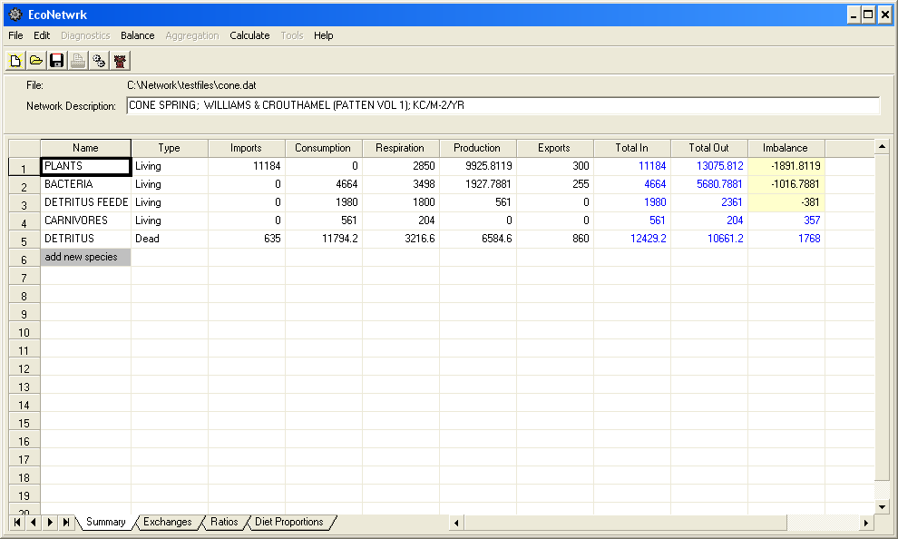

When a file has been loaded, the input structure will open to the Summary sheet, as shown above. Species in the network are listed in the first column. The column headers indicate the components of energy flow for each species: Imports, Consumption, Respiration, Production, Exports, Total In (Consumption + Imports), Total Out (Respiration + Production + Exports), and Imbalance (Total In – Total Out). The Summary page yields a glimpse at the existing state of the network. Values can be changed on this page, they can be locked or unlocked, and compartments may be added or deleted. Generally, the user attempts to ‘balance’ the network (minimizing the imbalances for each compartment) before proceeding with network analysis. The user can have the network balanced automatically by selecting ‘Balance w/ DATBAL’ from the ‘Balance’ pull-down menu. DATBAL is a balancing program written by Ulanowicz that minimizes imbalances between inflows and outflows by adjusting exchange and ratio values.

Adding/Deleting a Compartment
If new species are to be added to the network, they must be added on the Summary page. To add a compartment, enter the name of the new compartment in the gray box that reads ‘add new species’. Note that new compartments are assumed to be of type ‘Living’. If you are adding a new detrital compartment, you must change the ‘type’ to Dead. When a new species is added, those rows are highlighted yellow on every page. This serves as a visual reminder that values may need to be entered for that compartment before performing any network analysis.

To delete a compartment, you must also be on the Summary page. Click the mouse on the name of the compartment that you wish to delete, then press the ‘Delete’ key. A box will pop up for you to confirm your intention to delete that species from all pages of the spreadsheet.

The Exchanges Page
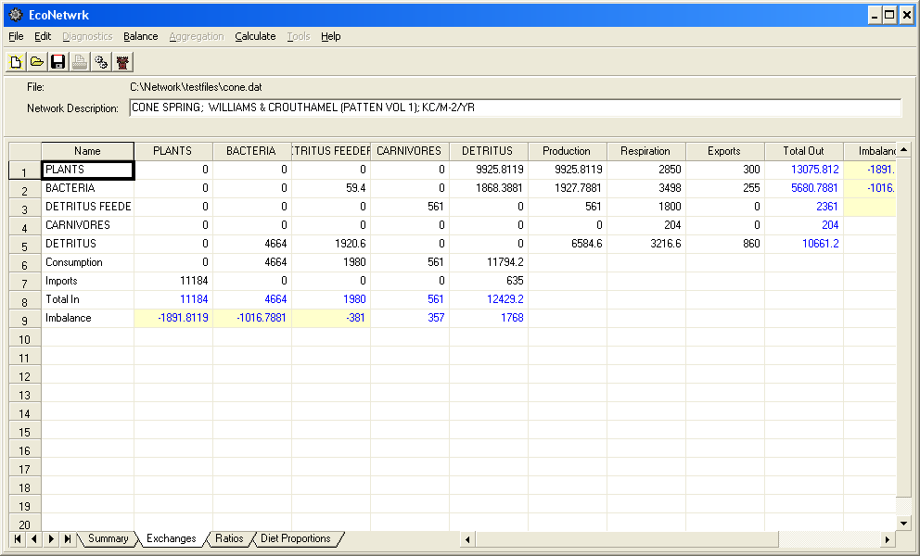

The Exchanges page is a quantitative look at the network…’who eats how much of whom?’ The predators are across the top; the prey species listed along the left hand side. The column sum is ‘Total In’, which consists of Consumption (everything eaten by ‘X’) and Imports (every source of energy that moves into X’s world from somewhere else). Using the above illustration, we can see that detritus feeders consume a small amount of bacteria and a large amount of detritus. Detritus, as a predator, ‘consumes’ plants and bacteria and also has a small portion of energy that comes from elsewhere.

A look across any prey species row reveals ‘who eats me?’ Detritus feeders, for example, are only eaten by carnivores. Bacteria are consumed by both detritus feeders and detritus. The row sum is the Production for that species. Respiration is the energy that each species has spent just on the business of consuming things. Exports indicate energy lost to a different compartment. Total Out is the sum of Production, Respiration, and Exports. Before network analysis can proceed, the imbalances between ins and outs must be minimized. This can be accomplished automatically by selecting ‘Balance w/DATBAL’ from the ‘Balance’ heading on the main tool bar. The user may prefer to balance the network manually by adjusting ratios or diet proportions to minimize imbalances based on the quantities that he or she has most confidence in.
The Biomass and Ratios Page

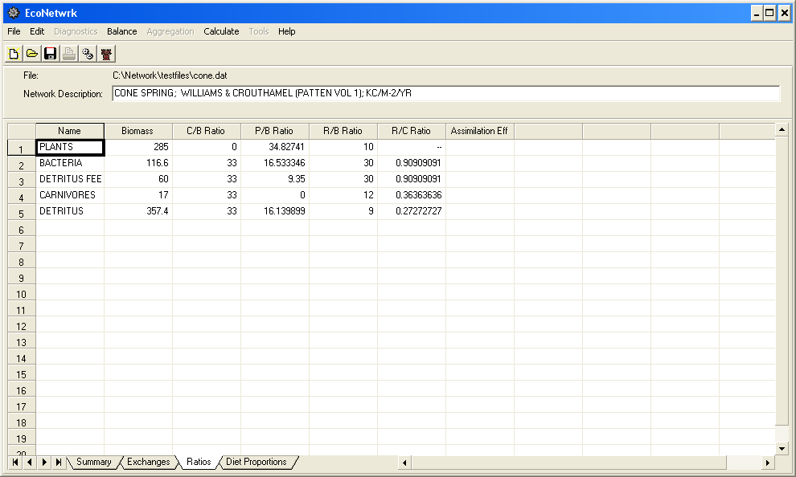

This page contains biomass and ratio information. The ratios listed are C/B (Consumption:Biomass), P/B (Production:Biomass), R/B (Respiration:Biomass), and R/C (Respiration:Consumption). These ratios are used to help fill in and balance the network. Some of these ratios are available in reference material. When a network ecologist is building a network, they are more likely to have good estimates for biomass and C:B ratio for a certain species than they would be to have an estimate of consumption or production. The biomass and ratio values are often used to fill in the exchanges page. Assimilation efficiency, the proportion of consumed material that leads to growth and production, can also be entered on this page. When assimilation efficiency is entered for a compartment, the consumption is recalculated. Assimilation efficiency can be used to calculate consumption, production, or respiration according to: AE = (P+R)/C. Although an assimilation efficiency greater than 1.0 has no physical meaning, it is entirely possible that such values will be calculated by EcoNetwrk. An assimilation efficiency greater than 1.0 is an indication to the person trying to balance the network that something (production, consumption, or respiration) is off. Assimilation efficiency is completely optional! If you have good values for consumption, it may be wise to leave assimilation efficiency blank. When an assimilation efficiency value is added, consumption for that species is recalculated according to: AE = (P+R)/C. The Total Out does not change, however, because it is assumed that the egestion calculated (Egestion = 1 - (Consumption*AE)) by adding the AE was already part of the production.

It should be noted that if you open EcoNetwrk and load a SCOR file, all of these ratios are calculated internally. If you are in the middle of balancing a network and are entering ratios, it is best to save the file in EcoNetwrk format (.eco). This is the only format that preserves ratios as they were entered.

Diet Proportions Page

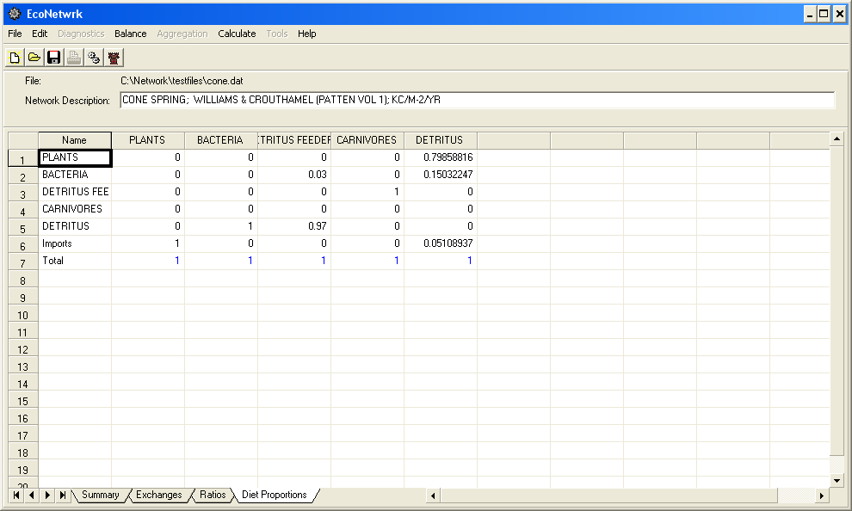

The proportions on this page summarize the relative components of each predator’s diet. Imports are included, making the divisor Total Inputs (Consumption + Imports). The totals must all sum to 1 before network analysis can proceed. Similar to the ratios page, these proportions can be adjusted to balance the network and to fill in the Exchanges page. When the column total is not equal to 1, the cell will be shaded red to remind the user that adjustments must be made before running network analysis.

Locking Values
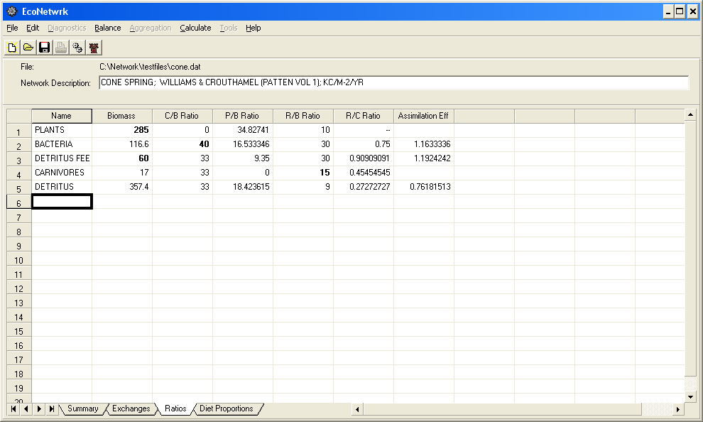

When filling in the spreadsheet, the user may have some values that he/she has more confidence in than others. To protect those values from being changed by other parts of the spreadsheet, these values can be manually locked. In the above illustration, the biomass value for plants and detritus feeders was locked by holding down the Shift key and clicking on those cells. A locked value is bold. A value can be unlocked by repeating the Shift click. To illustrate the locking mechanism, since both biomass and C/B ratio for bacteria are locked, the user will not be able to change the consumption value for bacteria. An attempt to do so will result in a pop-up message: ‘Oops…Biomass and C/B Ratio are already locked!’ and the value for consumption will not be changed.

It is important not to over-use the locking mechanism. For instance, if you locked the ratios, consumption, production, and diet proportions for a single compartment, any attempts to change other values may result in error messages. The locking mechanism is most often used to preserve biomass values or other network quantities referenced in the literature such as production, diet proportions, P/B or C/B ratio. It is primarily a tool to aid the process of filling in the spreadsheet in preparation for balancing and/or running the network analyses.

Another important thing to note is that the locking mechanism only impacts the values in the four linked spreadsheets. For instance, the Ulanowicz-designed balancing routine included with EcoNetwrk (the ‘Balance’ tab) will ignore locking and will balance the network as if you have no locked values.

Why do Some Values Change after they’ve been Entered?

The EcoNetwrk input structure consists of 4 closely related spreadsheets. Changing one value on one page can often result in a series of changes to other values – on the same or different pages. At any one time, all of the values must be internally consistent on all of the pages. For example, if the user changes the P/B value for Plants in the above illustration to 20, the production for Plants will change to 5700. The diet exchange for plants in the detritus column (energy representing the amount of plants ‘eaten’ by detritus) also changes to 5700, which means the consumption (column sum) for detritus also changes. The consumption change results in changes to the C/B and R/C ratios for detritus.

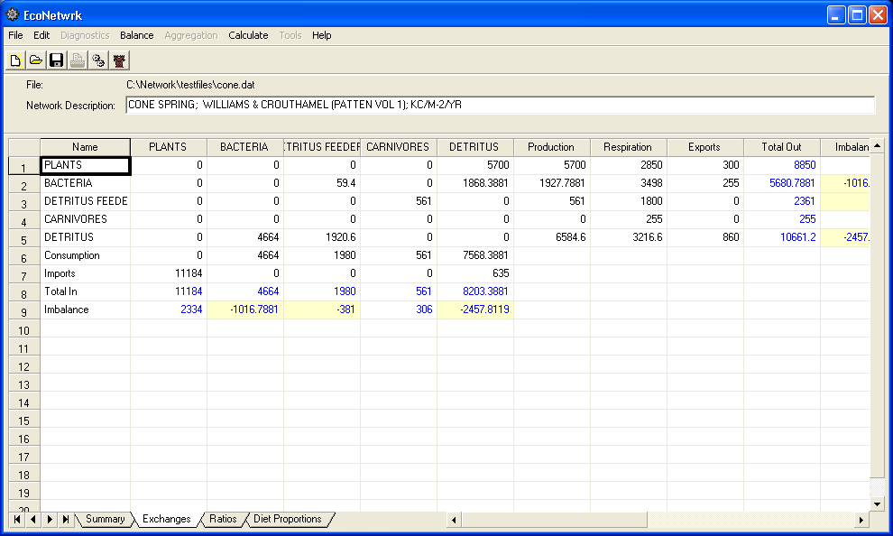

Significance of Shading on the Spreadsheet

Bold values have been locked by the user and are protected from being changed by subsequent changes in the spreadsheet. A locked cell can be unlocked by pressing ‘Shift’ and clicking the cell. Blue values have been calculated by the spreadsheet itself, and cannot be entered directly by the user. When Imbalances (Total In – Total Out) go negative, they are shaded a pale yellow for the benefit of the user. When a new species is added to the network, all of the various rows and columns pertaining to that species on all four pages are highlighted in dark yellow. This is done to help the user see where values might still be missing. When a value is entered in a new cell, the background reverts to white.

A red shaded cell calls the user’s attention to an internal inconsistency with the data. This often is the case for consumption and production values on the exchanges page and diet proportion totals on the diet proportions page. Network analysis cannot proceed while there are red-shaded cells present. The user must resolve the data inconsistency. On the exchanges page, consumption and production values are shaded red when the internal value of production or consumption does not match the row or column sum of the exchanges. This happens frequently as a network is being developed, because a user will often enter biomass and ratio data, as the exchange values are not known. Thus, as in the example below, since biomass and C/B were entered for the two new compartments, consumption values were calculated. However, since there are no exchanges (column sums to 0), the consumption cells are shaded red.

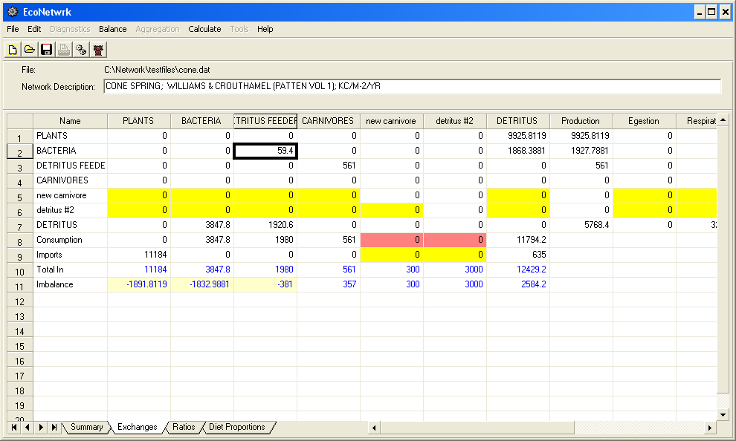

A look at the corresponding diet proportions page indicates red shaded cells for the totals of the new compartments.

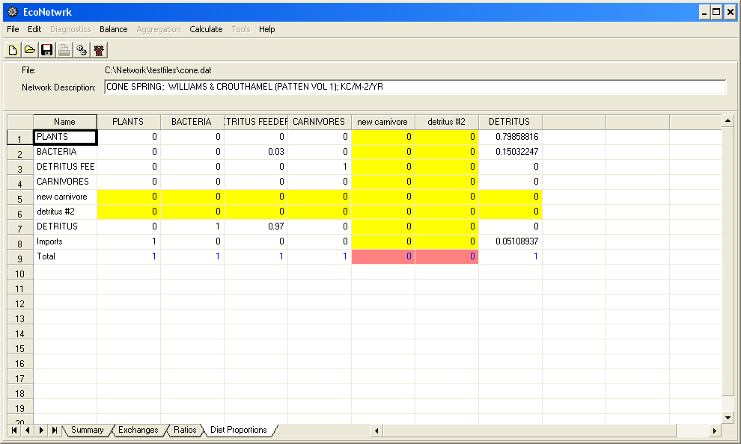

On the Diet Proportions page, the red shading will appear in the ‘Total’ cell any time the total does not equal 1. In this example, the user might make a guess as to what the diet proportions would be for the two new species in order to proceed to network analysis.
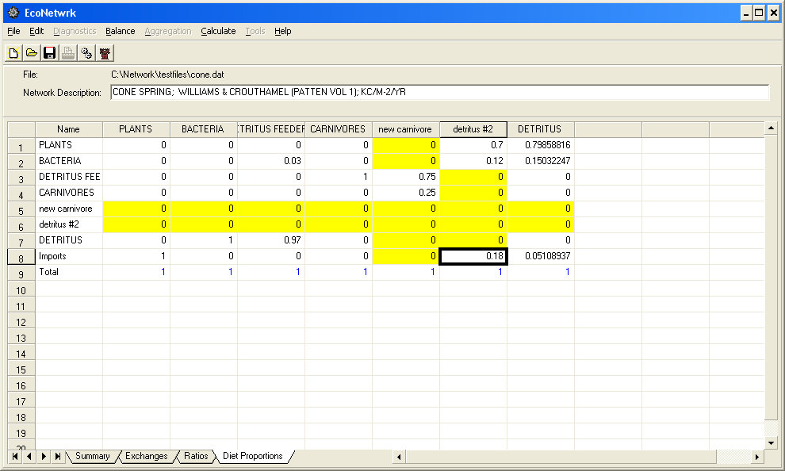

Now that the Diet Proportions page has been filled in, the user will notice that the exchanges page inconsistencies have also been resolved, and the former red shading has disappeared. This is because the diet proportions for the new species allowed exchanges to be calculated. The user may want to adjust some of the exchanges or ratios in order to minimize the imbalances, but network analysis can proceed at this point.

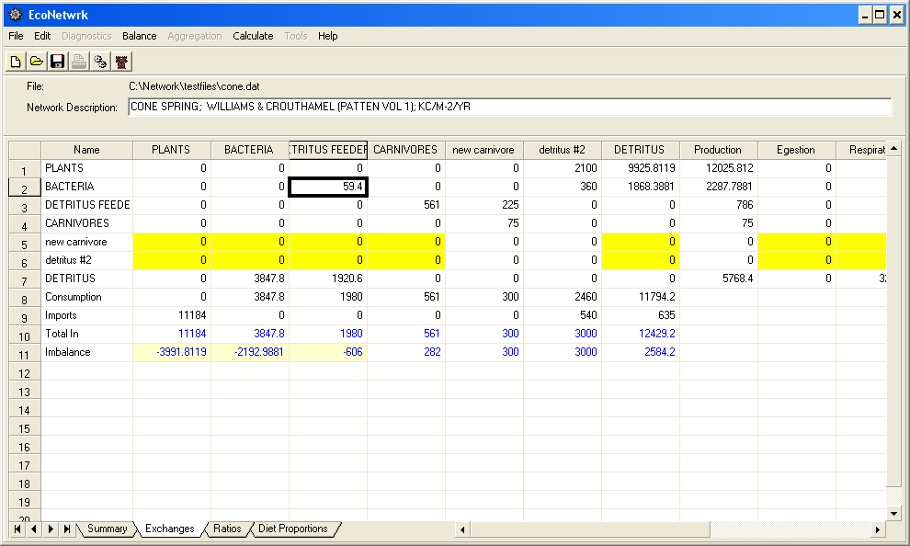

With all internal inconsistencies resolved, the user can now proceed with analysis. If he/she doesn’t want to balance the network manually, the Balance menu includes one of Ulanowicz’s programs, DATBAL. DATBAL forces all of the imbalances to zero. Under the Calculate menu, the user has a number of choices. If they select ‘All’, the full set of network analysis tools available in Netwrk 4.2 will be performed. The user may choose to look at network indices without removing cycles, for example. Output from this early stage of EcoNetwrk is identical to output from Netwrk 4.2. When analyses are run in EcoNetwrk, the output is automatically written to a file called default.out. The output file will be opened at the conclusion of the run. The default.out file is saved in the same directory where the input file is located.

Tips on Manual Balancing

If your objective is to balance your network by hand, favoring certain values that you have a high degree of confidence in, this is somewhat of an iterative process. For example, if you enter Biomass, C/B, R/B, Imports, Exports, and the diet matrix, P/B ratios will be calculated for you and there will be no production inconsistencies (no red-shaded values to be resolved). Then you can compare the calculated P/B or Production values with known values for those species and adjust as necessary. If you enter both C/B ratios and P/B ratios, you are likely to have consumption or production inconsistencies. This occurs when a production or consumption value calculated by an entered ratio does not match a row or column sum on the Exchanges page. You can minimize these inconsistencies by entering fewer ratios (pick C/B or P/B, but not both).

Options for Network Analysis

When the spreadsheet has been filled in and imbalances minimized, network analysis can proceed. To obtain the most information about your network, select ‘All’ from the ‘Calculate’ menu. This will result in the entire suite of Ulanowicz-developed analysis methods. You also have the ability to choose intermediate steps of the complete analysis, perhaps to save time (in the case of a very large network).
All: This choice will conduct Structure Analysis, Lindeman Trophic Analysis, Network Indices, and Cycles.
Structure Analysis: This is also referred to as Input/Output Analysis. Structure matrices are constructed, allowing a detailed look at the effects of any particular flow or transformation on any other given species or flow.
Lindeman Trophic Analysis: A concatenated trophic chain if formed by mapping the structural information.
Network Indices: Global variables describing the state of development of the network are calculated.
Cycles: This choice identifies all of the simple, directed biogeochemical cycles in the food web and separates them from their supporting dissipative flows.
Impacts: When Impacts is chosen, a dialog box pops up to allow the user to choose which species he/she is interested in. Impacts traces indirect competitive interactions through the food web (negative effects a predator directly exerts upon its prey).

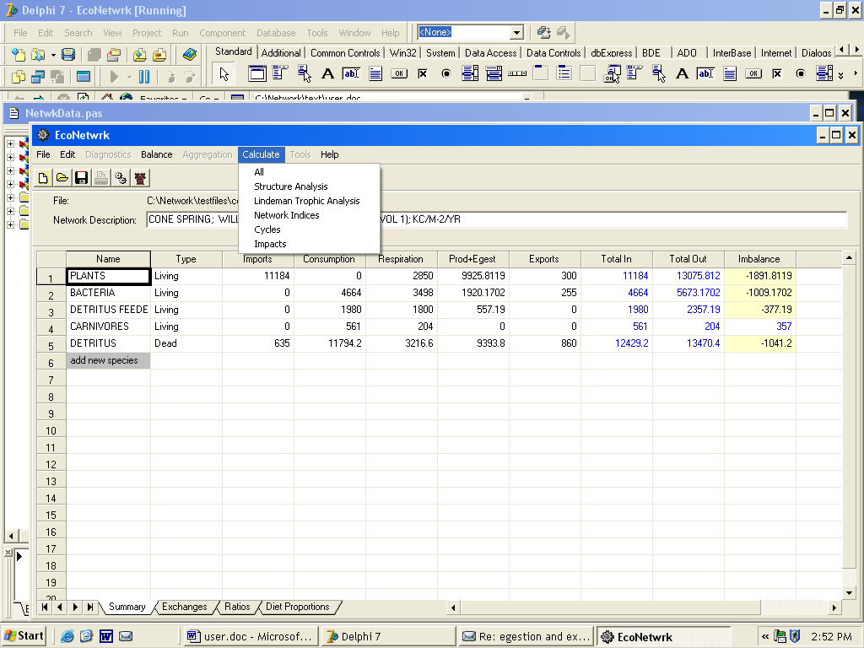

EcoNetwrk is a work in progress. We welcome and encourage comments, suggestions, and questions about the input structure: econetwrk.glerl@noaa.gov.

