ALTERNATIVE OFFICING (AO) INFORMATION

1. Organization (Organization Name, Location city, state): SPRINT

2. Contact (Name/Phone No./Email of contact for AO Program Information): Lori L. Dunkel/913-315-1794/lori.l.dunkel@sprint.com

3. Type of AO Arrangement (Check all that apply to your AO program)

Hoteling__X ; Telework_X_; Work on Customer Premises_X_; Desk Sharing_X_;

Work “on the road”_X_; Free Address__; Other__ (describe):

4. Describe Project Vision or Goals:

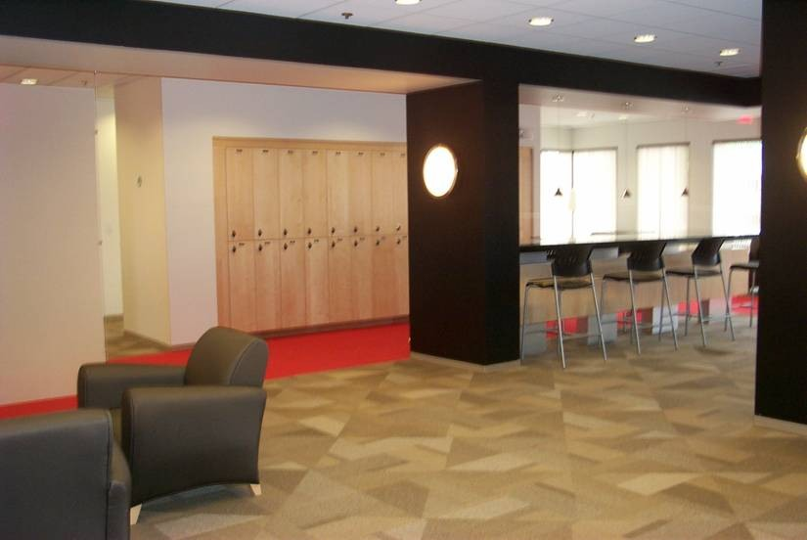
In 2004 Sprint launched a major initiative to mobilize its workforce and, concurrently, save millions of dollars of real estate lease expense. Dubbed the Sprint Powered Workplace initiative, the program focuses on understanding the work practices of branch office employees and adapting space, technology and business processes to deliver a successful alternative officing arrangement. Through detailed analysis of security badge-in data, surveys and direct observations, the Powered Workplace team targets an average of close to 60% of branch office workers who spend significant amounts of time on the move. These workers might be meeting with customers, servicing equipment in the field or traveling through airports, but on any given day, many of them need to work outside of the four walls of the branch. By equipping these employees with new tools (like PDAs, 3G wireless data cards and WiFi), redesigning the office environment, streamlining processes and training workers and managers on new processes and technologies, Sprint enables its employees to work wherever and whenever they need to be productive. Sprint is achieving the following main goals with this program:

- Upon full program rollout, Sprint will have more than 125 Sprint Powered Workplaces in the United States. Over 10,000 associates will work in those locations, and approximately 7000 of them are likely to become Work Anywhere employees. Forecasts call for annualized savings of $50 million in real estate costs with a portion of savings redirected for mobile technology, training, research and workspace improvements.
- Formally recognizing and supporting highly mobile Sprint employees helps them to do their jobs with higher quality and greater efficiency while reducing expenses. They are positioned to be more responsive to customers, and they are trained to communicate better with co-workers, suppliers, and customers. Most of all, mobility empowers associates to do their job in the location that makes them most productive and successful.
- Sprint has decreased its dependency on physical locations and assets that are vulnerable to natural disaster, attack or other business disruptions. Since Work Anywhere associates can work wherever they need to, there is less risk of disruption.

5. Program Status with “as of” date:

Upon full program rollout, Sprint will have more than 125 Sprint Powered Workplaces in the United States. As of February 2006, over 50 branches are completed or are in the process of being impacted by the “Powered” program.

6. AO Site Locations (city, state):

Sprint has locations throughout the US.

7. Main Benefits Achieved/Expected (Check all benefits that apply and provide additional information where requested)

- Real Estate/Real Estate Requirements Reduced or Avoided? _X_;
Sq ft reduced/avoided:_______ sq ft; AMOUNT saved/avoided: savings of approximately $50 million annually in lease expense when fully deployed
- Facility Operational Costs Reduced or Avoided?_X_; AMOUNT reduced/avoided: $________
- Reduced/Avoided Other Expenses?_X_; $ AMOUNT of other expense reduction:________
- Increased/Earned Revenue?_X_; $ AMOUNT of revenue increase:$________
- Improved Facility Management/Utilization Efficiency?_X_
- Improved Workplace Quality?_X_
  - Check all aspects of improved workplace quality that apply to your AO program: Functionality of space_X_; Comfort_X_; Equity of workstation assignments _X_;
Environmental factors (noise, lighting, ventilation, etc.)_X_;
Other__ (describe):________
- Improved Individual/Organization Performance?_X_
- Improved Workplace Flexibility to Accommodate Different Uses/Configurations?_X_
- Other (describe):________

8. Significant Problem Areas, Difficulties, Failures, etc. and Remedies/Advice (if any):

9. Contact Information on Key External Consultants/Experts Utilized:

10. Website with Information on This AO Program:

Sprint Enterprise Mobility is now offering external consultative services for enterprise/government clients interested in mobilizing their workforce. www.sprintemi.com

11. Available Reports or Other Sources of Detailed Information:

