With Telework Everyone Wins

Washington Metropolitan Telework Centers

The U.S. General Services Administration (GSA) works with other U.S. government agencies to design and operate alternative workplace arrangements and programs for the Federal workforce. GSA sponsors several alternative workplace facilities known as telework centers, in Maryland, Virginia, and West Virginia.

A telework center is a multi-agency facility that: (1) provides workstations and other office facilities/services that are utilized (typically on a fee for use/service basis) by employees from several organizations* and (2) is used as a geographically convenient alternative worksite for clients.
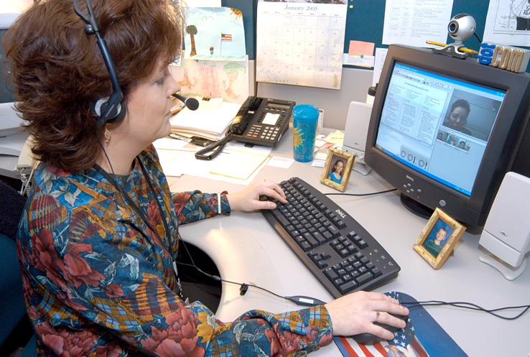
*Private sector clients may also use GSA-sponsored telework centers. Contact a GSA telework center for availability and further details.

There are a number of scenarios for which teleworking and telework center usage may be advantageous.

Why Telework?
• Save gas
• Save time
• Less traffic
• Less stress
• Healthier lifestyle
• Improve job performance
• Improve work/life balance
• More family time
• Employee retention
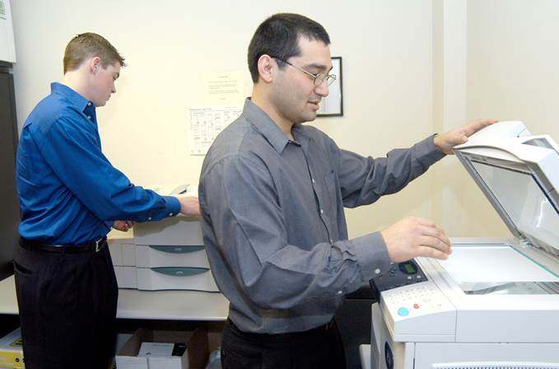
Why Use a Telework Center?
• Convenient to home/community
• Same accountability as other worksites
• Professional environment
• On-site technical support
• High-speed Internet access
• Fewer distractions
• Well-equipped
• Secure

Typical Telework Center Features
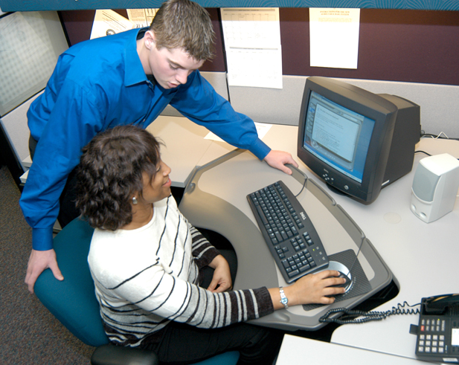
• Current computer technologies
• Secure server with back-up systems
• High speed internet connectivity
• E-mail and file transfer capabilities
• Standard office software
• Laser and color printers
• Digital phone systems with voicemail
• Fax, scanner, and copy equipment
• On-site technical support
• Lockable personal storage
• Kitchenette
• Conference rooms (most with video/web
conferencing)
• 24-hour secured client access
• Accessible to persons with disabilities

GSA Has a Telework Center Near You

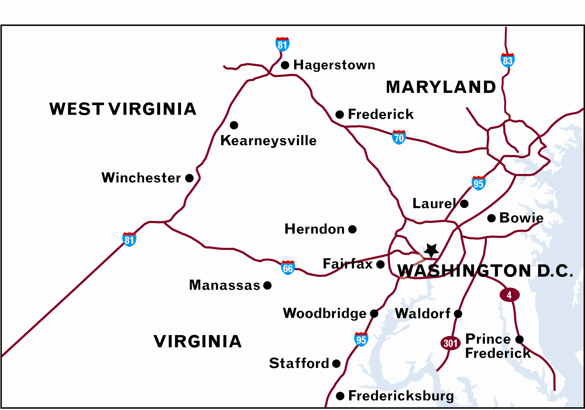 | Maryland  - Bowie  - Frederick  - Hagerstown  - Prince Frederick  - Waldorf  - Laurel  West Virginia  - Kearneysville | Virginia  - Fairfax  - Herndon  - Manassas  - Fredericksburg  - Stafford  - Woodbridge  - Winchester

Visit www.gsa.gov/teleworkcenters for more information.

Teleworker Comments

“I chose the telework center because the atmosphere is conducive to business” – Anne

“Working at the telework center allows me to keep my home life separate from my work life” – Judy

“The telework center provides me with all the equipment and support I need to do my job” – Bill

4 Easy Steps to Register and Start Using a Telework Center

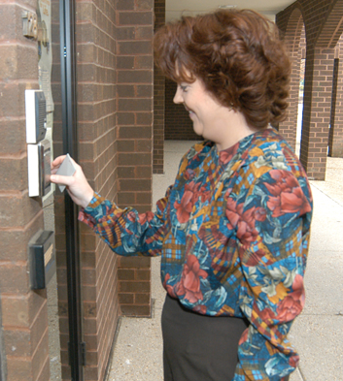

1. Contact your agency Telework Coordinator (www.gsa.gov/teleworkcontacts) for any agency-specific guidelines or procedures.

2. Select the Telework Center that is right for you (www.gsa.gov/teleworkcenters).

3. Contact the Telework Center Director to determine availability and to obtain specific information about the center you select.

4. Register through the Telework On-Line Billing System (TOLBS).

To learn more about GSA partner Washington Metropolitan Telework visit: www.wmtc.org

Revised September 2007

