United States Department of the Interior
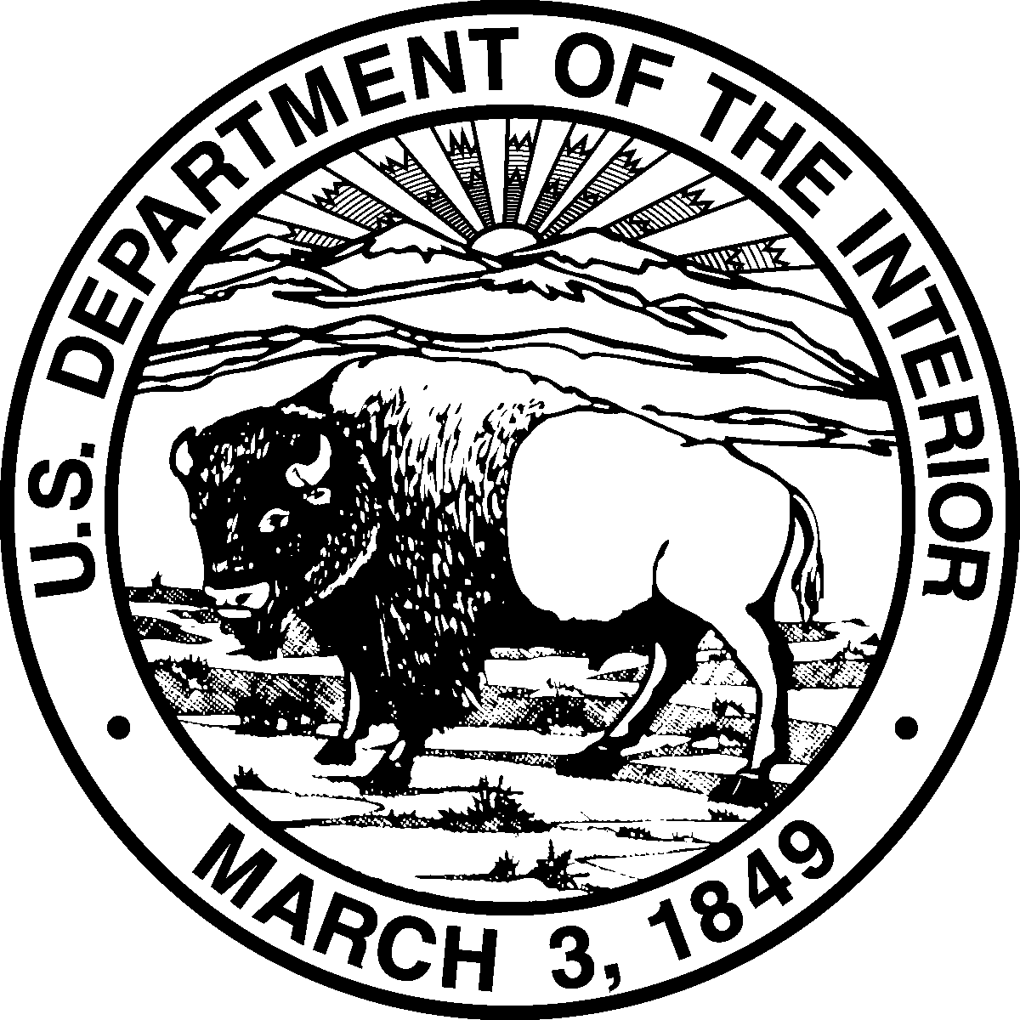
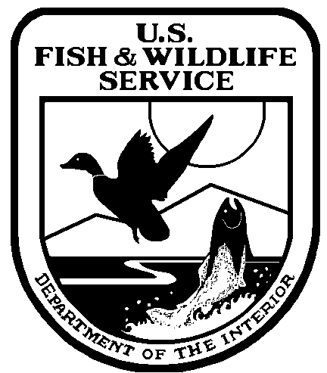
Fish and Wildlife Service

Bloomington Field Office (ES)
620 South Walker Street
Bloomington, IN 47403-2121
Phone: (812) 334-4261 Fax: (812) 334-4273

3 June 2002

James E. Denoncour
Tell City District Ranger
Hoosier National Forest
248 15th Street
Tell City, IN 47586

RE: Tornado Blowdown Fuels Reduction Project (prescribed fire), in Jackson and
Lawrence counties, Indiana

Dear Mr. Denoncour:

This letter is in response to your 25 March 2002 letter requesting that the Hoosier National Forest's (HNF) proposed prescribed fire on 1,361 acres in Jackson and Lawrence counties, Indiana be reviewed and appended to the U.S. Fish and Wildlife Service, Programmatic Biological Opinion (BO) to fulfill consultation requirements under section 7 of the Endangered Species Act, as amended. The U.S. Fish and Wildlife Service's Bloomington Field Office issued a programmatic BO and Incidental Take Statement (ITS) on 31 July 2001 for the continued implementation of the Hoosier National Forest's Land and Resource Management Plan (LRMP), as amended. The BO analyzed anticipated effects from management activities on bald eagles (Haliaeetus leucocephalus), Indiana bats (Myotis sodalis), gray bats (Myotis grisescens), and eastern fanshells (Cyprogenia stegaria).

We understand that the HNF is proposing to use prescribed fire on 1,278 acres in Jackson and Lawrence counties. The project area is located in T7N, R2E, sect. 25, 26, 33, 34, and 35, and in T7N, R3E, sect. 29, 30, 31, and 32. The purpose of the prescribed burn is to remove remaining excess woody fuels lying on the forest floor that resulted from a severe storm/tornado in 1996. Salvage-logging projects in 1997 and 1999 removed some timber from the blowdown area, however, the HNF conducted a fuel assessment in 2001 that revealed threats to firefighter and public safety still remain.

The HNF intends to use four prescribed fire/fuel reduction treatment methods that differ in the level of required site preparation (e.g., construction of fire lines and/or burn piles) and use of heavy machinery. ‘Broadcast burning' will be conducted to burn logs, branches, and other forest debris spread over a large area (686 acres). ‘Pile burns' will be conducted where fuel load debris is found congregated in small areas or piles (35 acres). ‘Machine pile/burns' will be conducted on 257 acres similar to the other pile burns, but with the additional step of using mechanized equipment, such as front-end loaders and skidders, to heap logs and branches into piles for burning. Lastly, prescribed fire ‘treatment by isolation' will be used to burn forest debris on 300 acres adjacent to and surrounding heavy fuel load areas to isolate the heavy fuel load areas from nearby forests that could potentially burn in a wildfire.

The fire treatments would consume herbaceous plant materials, small woody debris, leaf litter, and downed logs and branches. Fire treatments are likely to kill small saplings (average of 2 inches or less in diameter-at-breast height). A limited number of snags will be removed along fire lines. Prescribed fires and burning of piles would be carried out, and snags removed, between 16 September and 14 April to avoid any direct take of Indiana bats.

The Service concurs that this proposed project is not likely to adversely affect bald eagles, gray bats, or eastern fanshells or any designated critical habitat. Although the proposed project is likely to adversely affect Indiana bat summer roosting and foraging habitat, the anticipated effects and resulting level of incidental take are consistent with those analyzed within the programmatic BO and are not likely to jeopardize the continued existence of the Indiana bat. Anticipated effects from prescribed fire and tree removal are discussed on pages 10 and 11 of the BO.

In general, the change to Indiana bat habitat resulting from the proposed prescribed fire and burn pile treatments should be minor. As a result of the fire and associated preparations (e.g., creating fire breaks), some standing snags are likely to be lost, however, some new snags are likely to be created by the fire as well. Therefore, we do not anticipate a large loss in suitable roosting habitat for Indiana bats. Because the proposed prescribed burn will be conducted between 16 September and 14 April, the chance of direct take occurring from the destruction of occupied roost trees or smoke inhalation will be eliminated. Consumption/removal of the leaf litter and ground cover is likely to reduce the production of terrestrial insects within the project area for the first year post-burn because the fire and/or heat will destroy overwintering insects, eggs and pupae. A reduction in the prey base of Indiana bats may force bats to fly farther to forage until insect abundance increases over time. The quality of foraging habitat also may be degraded due to erosion, and subsequent sedimentation of project area streams, associated with the prescribed fire treatments. Sedimentation could affect the production of insects associated with aquatic habitats, which make up a portion of the prey base of Indiana bats. The HNF will utilize best management practices to minimize siltation. Degradation of Indiana bat roosting or foraging habitat resulting from the prescribed burn should be short-lived and bats accustomed to using the proposed project area should be able to meet their life requisites within the large tracts of surrounding forest.

The amount of anticipated incidental take (in the form of harm through habitat loss) from this project is 1,278 acres. This project brings the cumulative total of acres for prescribed burns to 1,978 acres out of the 7000 acres authorized for this management activity in the programmatic BO. As required by Term and Condition No. 5 of the programmatic BO's ITS, the Forest Service attached a spreadsheet showing that 1,278 acres would be altered by this project, leaving a balance of 5022 acres for future prescribed burns. The balance of acreages authorized for each management activity is also shown on the spreadsheet. The Service concurs that the attached spreadsheet is complete and accurately reflects anticipated impacts of the proposed project without exceeding authorized levels of incidental take.

To be in compliance with the ITS of the programmatic BO and to obtain exemption from the section 9 prohibitions of the ESA, the Forest Service must adhere to the Reasonable and Prudent Measures (RPMs) and Terms and Conditions (T&Cs) identified in the 31 July 2001 programmatic BO. Furthermore, we believe the following RPMs and T&Cs are necessary and appropriate to minimize impacts of incidental take of Indiana bats associated with this specific project:

Additional Project-Specific Reasonable and Prudent Measures and Terms and Conditions

None.

To ensure that the impacts of take associated with this project are appropriately minimized and that the exemption of incidental take is appropriately documented, the Forest Service and Fish and Wildlife Service are using an ‘appended' programmatic consultation approach. After assessing the anticipated effects of this proposed project, we concur that they are within the scope of the programmatic BO, and we agree to append the Forest Service's 25 March 2002 letter, spreadsheet, and map along with this response letter to the programmatic BO and label them as "Appendix 2."

This precludes the need for further consultation on this individual project as required under section 7 of the Endangered Species Act of 1973, as amended. If, however, new information on endangered species within the proposed project area becomes available or if significant changes are made to the proposed project, then please contact Andy King at (812) 334-4261 ext. 216 for further consultation.

Sincerely,

Scott E. Pruitt
Field Supervisor
