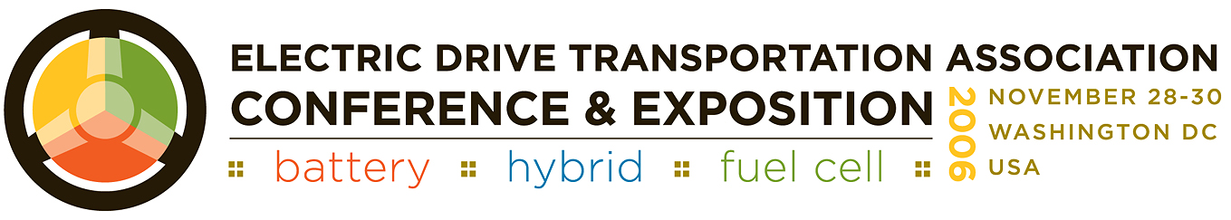

Achieving Energy Independence Through Electric Drive: Industry and Government, Working Together
Volatile oil prices and world events are creating unprecedented pressure in Washington to identify ways to address the nation's oil consumption. The Electric Drive Transportation Association (EDTA ) Conference & Exposition 2006 offers solutions in the form of policy outreach and technology advancements toward the goal of clean and efficient transportation. The EDTA Conference brings all of the players together to examine Federal policy options to accelerate the adoption of electric drive. The conference is the perfect place to:
- identify Federal policy trends
- seek out funding opportunities
- pursue key markets for electric drive
The program agenda includes forums led by government and industry experts addressing hybrids, fuel cells, plug-in hybrids, heavy and medium duty vehicles, fleet issues, and a technology discussion. This year's conference also offers exceptional learning opportunities and networking, including a reception at the Library of Congress. The sold-out exposition offers the latest in electric drive technology, and the signature Ride 'n' Drive puts you behind the wheel of the latest battery, hybrid and fuel cell vehicles.
The conference will be held at the Hyatt Regency on Capitol Hill from November 28-30. For more information and to register for the conference, visit www.edtaconference.com or call 202-408-0774.

