TEST AND EVALUATION OF FUEL CELL VEHICLE TECHNOLOGY IN THE UNITED STATES POSTAL SERVICE

Han T. Dinh
Program Director, Engineering
United States Postal Service

As the owner of the largest non-military vehicle fleet in the world, the United States Postal Service (USPS) has been a pioneer and a leader among all Federal agencies in adopting alternative fuel initiatives, continuing to work in cooperation with the vehicle industry to develop new ways to reduce fuel consumption and air pollution.

In December 2003, General Motors (GM) approached the USPS with the idea of testing and evaluating a fuel cell vehicle in a mail and package delivery environment. In June 2004, GM and USPS signed an agreement for a two-year evaluation of a fuel cell minivan to take place in the Washington, DC area. The vehicle began to deliver mail and packages out of the Fort Belvoir, Virginia post office in early September 2004. In September 2005, after one year of successful operation, the vehicle was relocated to Springfield, Virginia for additional evaluation in a different delivery route environment.

The USPS vehicle fleet of over 30,000 alternative fuel vehicles (AFVs) is the largest in the world and it is growing. This AFV fleet consists of compressed natural gas (CNG) vehicles, flexible fuel vehicles (FFVs), propane, electric, and hybrid-electric vehicles.

Every alternative fuel technology used by the USPS, including hybrid electric and E-85 (85% ethanol and 15% of gasoline), is dependent on fossil fuel such as natural gas. Many experts agree that hydrogen fuel cell vehicles present the greatest long-term potential to radically reduce many problems inherent with fossil fuels.

GM’s fuel cell vehicle, the HydroGen 3 (Figure 1), is based on the Zafira, a popular five-passenger vehicle from its Opel division in Germany. The Zafira’s internal combustion engine has been replaced with a fuel cell propulsion system and its gasoline tank has been replaced by a hydrogen storage tank. All HydroGen3’s steering, acceleration, braking and transmission controls have been modified to work in a vehicle that uses an electric propulsion system.

The HydroGen3 was the first hydrogen fuel cell vehicle certified by the Japanese government for operation on regular roads.
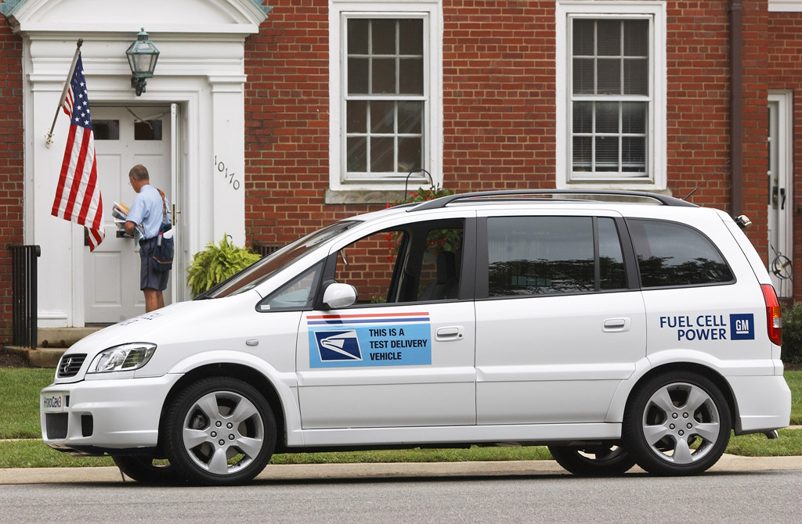
Figure 1 HydroGen3 Fuel Cell Vehicle

Specifications

Vehicle: Opel Zafira minivan with hydrogen fuel cell propulsion system
Seating capacity: 5
Fuel storage system: The liquid tank can store 4.6 kg of hydrogen (-423 degrees F/-253 degrees C).
The compressed tank (10,000 psi) can store 3.1 kg of hydrogen
Range: 249 miles/400 km (liquid storage);
168 miles (270 km (compressed)
Top speed: 99 mph/160 km

The GM engineering team designed and fabricated a special encased flat cargo area for mail storage and the vehicle was put into service in September, 2004.
Either a compressed- or liquid-hydrogen HydroGen3 is fueled and brought to the USPS three days a week for operation. At the end of each delivery day, the vehicle is returned to a GM facility at Fort Belvoir for data acquisition retrieval, system maintenance, refueling, etc.

The results obtained during the year-long operation at Fort Belvoir are as follows:

• 135 days of operation
• 9083 total stops to deliver 284,570 pieces of mail
• 1894 km/1174 mi driven, 734 hours total route time, 469 hours of fuel cell operation
• Average route time of 5:26 hours, fuel cell propulsions system running average 3:28 hours per day
• Weather conditions: 100 dry days, 32 rainy days, 3 snowy days with temperatures ranging from low 20°’s to high 100°’s (F)

The vehicle operated with extremely high reliability (99%) with only one half-day out of service due to a minor component failure. The GM vehicle team and USPS have gained important knowledge about fuel cell vehicle usage requirements for postal delivery, enabling GM to incorporate these lessons into the design of its next generation fuel cell vehicle.

On May 25, 2005, President Bush stopped by the very first retail fuel station in the nation to sell both gasoline and hydrogen—the Shell Hydrogen station in Washington, DC—to discuss hydrogen fuel cell technology (Figure 2).

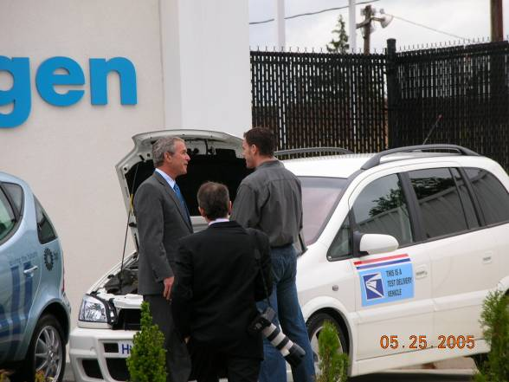

Figure 2
President Bush at Shell Hydrogen Station - GM-USPS Vehicle in Background

The USPS has been working with the White House’s Office of Science and Technology to develop a website at http://www.usps.com/environment/fuelcell.htm which is the USPS central source of information on R&D activities related to hydrogen and fuel cells. This web site is part of www.hydrogen.gov which was developed to further the goals of the President's Hydrogen Fuel Initiative and encourage greater collaboration and sharing of information on hydrogen technology development activities among government departments and agencies; commercial entities; state, regional, and international organizations; and the general public.

For several decades, the USPS has been a pioneer at the forefront of many alternative fuel initiatives and has set examples for many other Federal agencies. The USPS is one of a handful of federal agencies to comply with the Energy Policy Act of 1992 and 2005 in terms of its alternative fuel vehicle requirements. The USPS currently has the largest AFV fleet in the nation and continues to acquire more EPACT-compliant vehicles. In addition, research is underway to explore other avenues, such as biodiesel, hybrid-electric for the short term and hydrogen fuel cells for the long term.

At the present time, fuel cells hold the most promising technology to meet the future needs for transportation. However, several major obstacles such as cost, durability, fuel infrastructure and hydrogen storage need to be overcome before this technology becomes commercially available for the public and the USPS.

