

Winter Institute 2008
Johns Hopkins Center for American Indian Health

ANNOUNCEMENT FOR INDIGENOUS GRADUATE INSTITUTE SCHOLARSHIP OPPORTUNITY

“SOCIAL DETERMINANTS OF HEALTH IN INDIGENOUS POPULATIONS”

JULY 23-27 at JOHNS HOPKINS BLOOMBERG SCHOOL OF PUBLIC HEALTH IN BALTIMORE, MARYLAND

The Johns Hopkins Center for American Indian Health is offering two week-long institute courses during Winter Institute 2008. The two courses to be offered are “An Interdisciplinary Approach to Understanding the Health of Native Americans” and “Using Mass Media for Health Promotion in Native Communities.” Six scholarships, which include tuition, airfare and hotel accommodation, will be awarded to qualified individuals to participate in this Institute.

Course offering and tuition costs:

Mass Media for Health Promotion in Native Communities, 221.668.13 (2 credits)
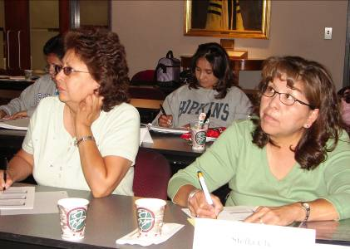
January 7 – 11, 2008 (9:00am to 12:30pm)
Tuition: $1,456 for 2 credits, $1,000 for non-credit

The mass media for health promotion in Native Communities course is designed to train students in developing a mass media campaign directed at health promotion within tribal communities. Students will be introduced to the basics of how to develop and design an effective media campaign. Students acquire skills in developing a media campaign that targets key messages related to identified health needs; understand the components of developing web pages; and develop a web page to educate the public on the area of health concern identified in the needs assessment linking it to the previously developed media campaign.

An Interdisciplinary Approach to Understanding the Health of Native Americans, 221.667.13 (3 credits)
January 14 – 18, 2008 (9:00am to 2:30pm)
Tuition: $2,184 for 3 credits, $1,500 for non-credit

In this course, an interdisciplinary approach is taken to understand different aspects of Native American health. The course will explore health and illness perceptions of Native American cultures, and consider approaches that blend Native American healing with Western or orthodox methods. Course participants will learn to view a priority health issue from the perspective of Native communities, and through the lens of various disciplines such as epidemiology, anthropology, mental health, political science/policy, and sociology. The over-arching emphasis of the institute will be on working at the front line with Native American communities to help them solve their own problems using culturally sensitive interventions

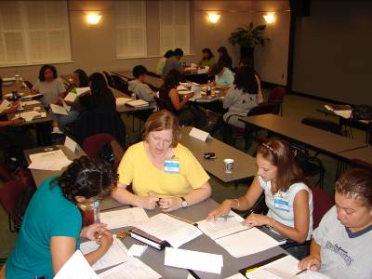

Course details:
- Courses may be taken for credit (bachelor’s degree required) or non credit (60 credits toward a bachelor’s degree AND 2 years of health related work experience required).
- Target audience for the course:
- Tribal and indigenous health leaders;
- Professionals and paraprofessionals serving Tribal and Indigenous communities or similar populations; and
- Potential graduate students interested in public health.

Application and deadline:
- Application deadline for scholarship support: November 1, 2007
- Applications can be downloaded at http://www.jhsph.edu/caih/Training/Current_Course_Offerings.html

For more information contact the following individuals:
Olivia Sloan (osloan@jhsph.edu) or Cathie Frazier (cfrazier@jhsph.edu) or call the Center for American Indian Health at 410-955-6931.

