Donation Success Stories - Oklahoma
The following letter of appreciation was submitted from a satisfied Chief of Police, Lone Grove Police Department, Lone Grove, Oklahoma.
"Recently we learned of the program that GSA has regarding helping smaller departments obtain weapons. We placed an order of several types of weapons and half-heartedly expected some type of response. We were advised that one of the requested weapons in Galena, Alaska, was available. The paper work was completed and the response was great. This far exceeded expectations and the police department is very grateful for the help. Our point of contact was most helpful to make sure that we were satisfied. This is something that you do not run into anymore especially in a government atmosphere."
Emergency Management and Communications
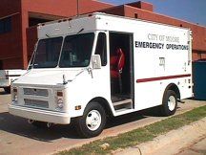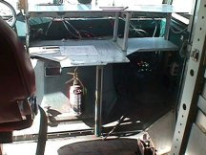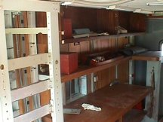

After a tornado struck the City of Moore, Oklahoma, they became aware of a vehicle that was available at the Oklahoma State Agency for Surplus Property. This vehicle had previously been owned by the Federal Emergency Management Agency (FEMA) and had been used by FEMA as a mobile communications post.
It became obvious very quickly that this vehicle could be easily modified into a mobile command post to support the public safety emergency operation in Moore. The community had been looking for such a vehicle for several years, but had never quite found one which would serve their needs and still remain within the limited budget for the project. The City purchased the surplus van and have modified it for their purpose.
This vehicle served as a mobile command/communications platform for fire and police operations. Additionally, it served as a mobile backup to the City's 911 Emergency Operations Center. Finally, it is the focal point for command operations should they experience another disaster.
The vehicle is equipped with both VHF and UHF radio communications; mobile and landline telephones; and a small computer network. It is capable of using either commercial or generator power and has some external lighting for on-scene use.
