The 19th Annual IHS National Research Conference:
June 4-7, 2007  Phoenix, Arizona
Multiple Perspectives on Research Policy in Indian Country
The IHS Research Conference will be held at the
Sheraton Crescent Hotel
2620 West Dunlap Avenue
Phoenix, Arizona 85021
Phone: (602) 943-8200
Fax: (602) 371-2857

http://www.starwoodhotels.com/sheraton/property/overview/index.html?propertyID=102

Hotel Accommodations
Please make your room reservations by calling the toll-free number 1-800-423-4126 and ask for the “Indian Health Service or IHS” group rate. The deadline for making room reservations is May 2, 2007. Single/Double occupancy rate is $74.00 per night plus tax. Check-in is 3:00 pm and check-out is 12:00 pm. Any reservation request received after this date will be accepted on a space availability basis only. Please be advised that you will need to guarantee your reservation with a credit card.

General Directions to the Hotel
From East
Take I-10 West which will merge with I-17 North. Look for the signs to Flagstaff. Stay on I-17 for approximately 8 miles. Take the Dunlap Avenue Exit, and the hotel is at the northeast corner of Dunlap and I-17.
From North
Take Interstate 17 South (towards Phoenix) and take the Dunlap Avenue Exit. The hotel is on the northeast corner of Dunlap and I-17.
From West
Take I-10 East which will merge with I-17 North. Proceed north approximately 15 miles to the Dunlap Avenue Exit. Cross over Dunlap Avenue (the first light after taking the exit) and turn right after the first light onto the property. The hotel is located at the northeast corner of Dunlap Avenue and I-17.
From Phoenix Sky Harbor International Airport
Take Interstate 10 North, which will turn to the west. Continue to I-17 North and travel approximately 7 miles. Take the Dunlap Avenue Exit, and the hotel is on the northeast corner.
The Phoenix Sky Harbor International Airport is 13 miles and about 20 minutes to hotel.

The hotel recommends Super Shuttle service at an approximate rate of $14 one way.
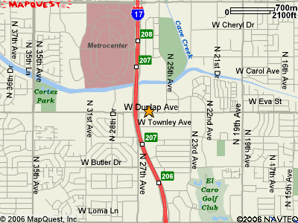


For Registration and Logistical Information:
Contact CDR Dora Bradley at theodora.bradley@ihs.gov
or Gigi Holmes at gigi.holmes@ihs.gov, or
call 602-364-7777.

The IHS Clinical Support Center is the accredited continuing professional education sponsor.

