Philadelphia, PA

LOCATION:
20 North Eighth
Philadelphia, PA 19107

HOTELS:

The hotels listed below participate in GSA’s governmentwide lodging program, FedRooms® – which provides Federal Travel Regulation (FTR) compliant hotel rooms at or below per diem rates for federal government travelers while on official business.

You may find program information and a current list of all FedRooms® preferred properties at: http://www.fedrooms.com (a non-federal website). Also, per diem rates may be found at: http://www.gsa.gov/perdiem

FedRooms® Rates are available using all booking channels: TMC, E-Gov Travel Service, FedRooms® website, and hotel reservation centers.

You MUST ASK for the FedRooms® Rate (NOT the government rate) when you contact the hotels. FedRooms® properties are listed by proximity to the Philadelphia location (closest to farthest).

CTRL + click on any highlighted property below to bring you to booking link:

CLUB QUARTERS PHILADELPHIA 0.1 miles
1628 CHESTNUT STREET
Philadelphia PA 19103

PARK HYATT PHILADELPHIA AT THE BELLEVUE 0.1 miles
200 SOUTH BROAD STREET
Philadelphia PA 19102

CROWNE PLAZA PHILADELPHIA CENTER 0.3 miles
1800 MARKET STREET
Philadelphia PA 19103

HAMPTON INN PHILADELPHIA CONVENTION CTR 0.3 miles
1301 RACE STREET
Philadelphia PA 19107

HILTON GARDEN INN PHILADEPHIA CENTER 0.3 miles
1100 ARCH STREET
Philadelphia PA 19107

RADISSON PLAZA WARWICK PHILADELPHIA 0.3 miles
1701 LOCUST STREET
Philadelphia PA 19103

HOLIDAY INN PHILADELPHIA HISTORIC DST. 0.9 miles
400 ARCH STREET
Philadelphia PA 19106

OMNI HOTEL AT INDEPENDENCE PARK 0.9 miles
401 CHESTNUT STREET
Philadelphia PA 19106
1-215-925-0000

HYATT REGENCY AT PENNS LANDING 1.2 miles
201 SOUTH COLUMBUS BLVD
Philadelphia PA 19106

SHERATON PHILADELPHIA UNIVERSITY CITY 1.6 miles
36TH AND CHESTNUT STREETS
Philadelphia PA 19104

If you have any further questions please feel free to contact us for immediate assistance at:
FedRooms
Phone: 800-226-1741
E-mail: hotels@fedrooms.com

Updated: March 2009

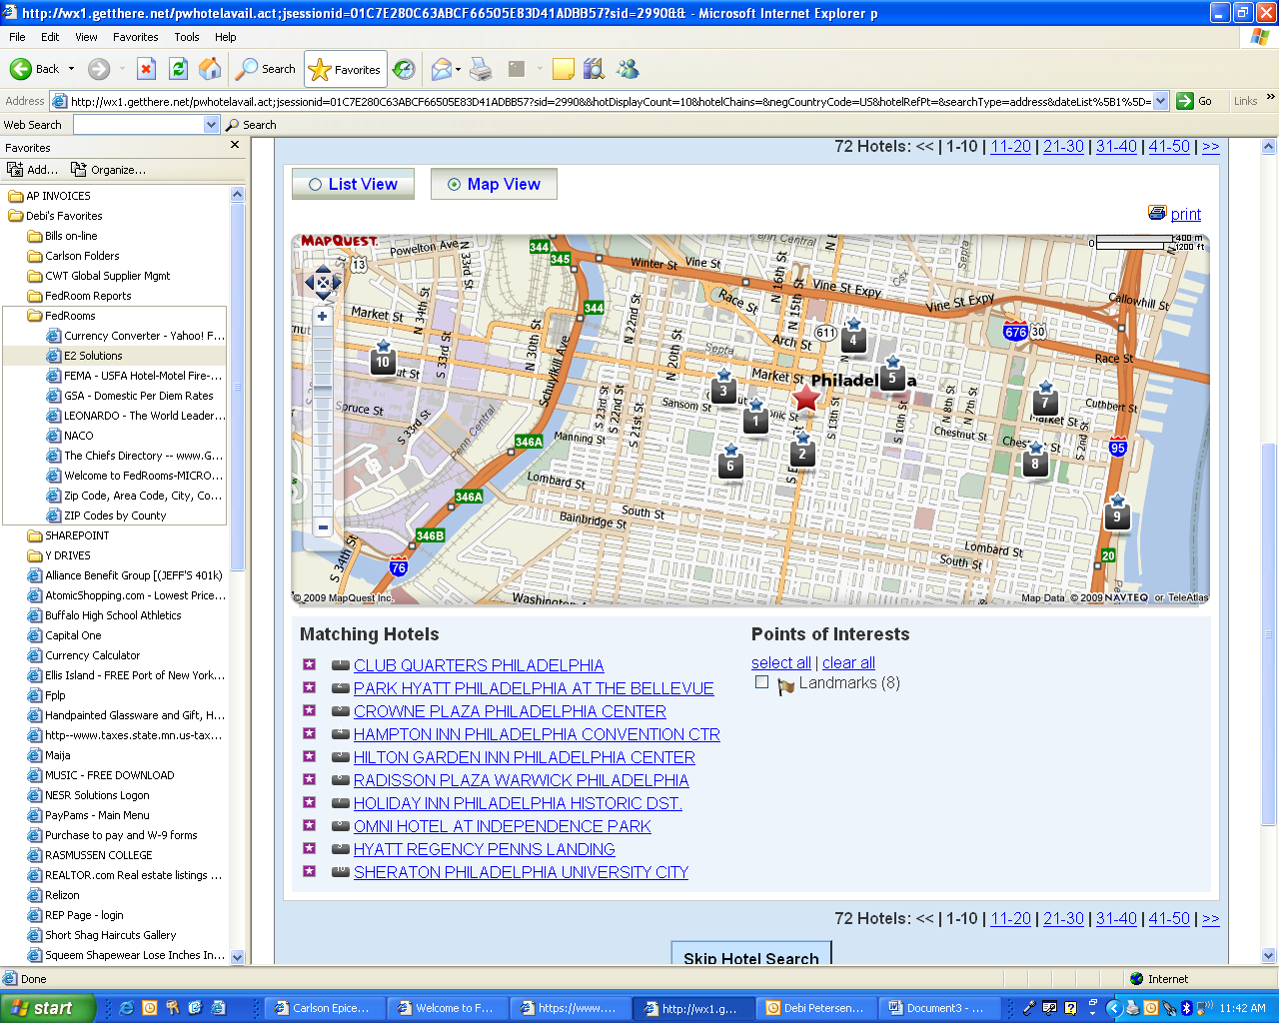

- CLUB QUARTERS PHILADELPHIA
- PARK HYATT PHILADELPHIA AT THE BELLEVUE
- CROWNE PLAZA PHILADELPHIA CENTER
- HAMPTON INN PHILADELPHIA CONVENTION CRT
- HILTON GARDEN INN PHILADELPHIA CENTER
- RADISSON PLAZA WARWICK PHILADELPHIA
- HOLIDAY INN PHILADELPHIA CENTER
- OMNI HOTEL AT INDEPENDENCE PARK
- HYATT REGENCY PENNS LANDING
- SHERATON PHILADELPHIA UNIVERSITY CITY

